A Decision Support Architecture With a Verified Open Decision Space for Wildfire Response
Çağlar Akman and Kemal Leblebicioğlu

Abstract—Decision support systems (DSSs) for wildfire response mostly decide inside a closed decision space, a set of rules fixed before the incident. This work presents the Verified Open Decision Architecture (VODA), which extends this space by verified composition. New interventions are composed from a fixed set of executable physical effects, and a proposal enters the rule base only when the hazard model, not the proposer, forecasts a gain on reseeded futures. A simulation core holds the hazard state, and a decision core reads it through confidence-rated observations. The decision core has a closed layer, a self-tuning sparse Takagi-Sugeno rule base, and an open layer in which a generative model proposes rules and blended or composed interventions, and a chain of gates on shadow forecasts admits at most one object per call. In simulation on 150 paired incidents, VODA lowers burned area by 61% against the closed layer, raises the share of extinguished incidents from 52% to 91%, and lowers priced response by 46% and affected population, the initial residents of burned cells, by 80%. The gated search carries most of the gain: a random proposer behind the same gates reaches three quarters of it, whereas a hand-written doctrine over the same effects gains little. The admitted interventions recur across independent incidents and, recorded as rules, keep most of the gain on unseen ones. The decision core is partitioned over regional agents, decides in under one second between model calls, and its cost grows slowly with the number of regions.

Index Terms—Decision support, open decision space, generative rule proposal, wildfire management.

I. INTRODUCTION
W
ILDFIRE response is carried out by a system of systems [1]. A hazard model turns observations from heterogeneous sources into a forecast of fire spread. Regional teams deploy crews and aircraft and issue evacuation orders, while an operator supervises the whole under a clock set by the fire [2, 3]. Fire seasons are becoming longer and more severe [2]. The most consequential decisions are taken in the first hours, when observations are sparse, forecasts are uncertain, and a wrong commitment is costly [3, 4]. A recommendation after the fire has moved is useless, so support must adapt as the incident develops.
DSSs support parts of this task [5]. Spread simulators forecast fire behavior from fuel, terrain, and weather [6, 7], allocation tools assign crews and aircraft against a forecast [8, 9], and integrated platforms bring these parts together for field use [4, 10]. Yet field studies measure how widely these tools are used, not whether their decisions are better [11, 12]. A critical review finds the same pattern across DSS research, with many systems built and few shown to help [13]. VODA is therefore evaluated by comparing outcomes of the same incidents with and without the open layer.
Three structural limits recur across these systems. First, a rule base, tactic menu, or optimization model fixes available orders before the incident, so the system only ranks what it is given [10]. Decision analysis has long identified alternative generation as its weakest step [14, 15, 16]. Proposed methods either vary a fixed model [17] or depend on operator recall under time pressure [18]. Second, uncertainty treatments require prior distributions or belief assignments that real-time sensing alone cannot supply [19, 20], while the reasoning behind a recommendation may remain accessible only through post-hoc attribution [21]. Third, integrated platforms embed the hazard model and decision logic in one tool [4, 10], leaving the benefit of the decision mechanism unmeasured separately from forecast quality.
VODA answers the first limit with a verified open decision space. Verified here means that admission is checked on the forecasts of the hazard model; it is not formal verification and gives no guarantee on the realized incident. What opens is the doctrine and the intervention repertoire during the incident; the effect basis, sectors and bands are fixed. The closed layer issues orders through a self-tuning fuzzy doctrine over decision concepts. When it falls short, the open layer proposes rules, family blends, and interventions composed from executable physical effects. A pretrained large language model (LLM) supplies candidates in this study, but any proposer returning the same structured objects can be used. The space is closed at effects and open at interventions, extending what hand-written doctrine over the same families can express. Algebraic gates and a paired forecast test on hazard forecasts are applied to every candidate, and the best survivor is admitted. Every fielded order passes a fail-safe and a no-harm guard. Admitted objects enter reusable doctrine that the open layer can extend during an incident. Section V-D tests both transfer and the added value of continued generation under new conditions.
VODA answers the second limit by gating named decision concepts with observation confidence, without a probability distribution. Orders are traceable to their rules, with edits, rejections and generated objects logged.
VODA separates the hazard model from the decision mechanism. Blind hindcast against satellite fire records assesses spatial agreement, while paired comparisons on identical worlds isolate decision benefits, including under planning-model error. The paired comparisons attribute the gain to the composed vocabulary and the gated search together, and to the proposer, under model error and operating limits.
Sections II-IV present related work, the architecture, and the decision core. Section V reports the experiments, and Section VI discusses the findings and concludes.

II. Related Work and Background

A. Wildfire Dynamics and Decision Support
Rothermel-type models predict surface spread from fuel, moisture, wind, and slope [6], underpinning operational tools such as FlamMap [7], cellular simulators such as Cell2Fire [22], and VODA's simulation core. DSSs built on these models cover strategic risk assessment [4, 8], multi-criteria allocation [9], and integrated platforms [10], with offline decision logic and fixed intervention menus. VODA's decision cost follows fire management economics, combining resource expenditure and residual loss [3].

B. Observation Features and Fuzzy Reasoning Over Concepts
Fuzzy sets express graded assessments, such as high fire threat or low suppression feasibility, as partial memberships and encode domain knowledge in IF-THEN rules [23]. VODA uses constant consequents in the Takagi-Sugeno (TS) model [24] to produce executable intensity commands that can be tuned online. Evolving TS models also add rules within a fixed vocabulary [25]. Weighted aggregation maps 10 features to 5 decision concepts addressing recurring response-planning questions [3, 18], namely fire threat level, suppression feasibility, asset exposure risk, intervention urgency, and evacuation pressure. Rules use these concepts, giving $5^{5} = 3125$ full antecedent combinations with five terms per concept while remaining readable for expert review. Observation confidence gates concept activation without requiring a distribution.

C. Closed and Open Decision Spaces
Decision analysis evaluates predefined alternatives [26], leaving generation under time pressure a weak point. Generation precedes choice but remains neglected [14], despite its formalization as recursive decision problems [16]. Hard-wiring a problem's open parts can impede adoption [15]. In ill-structured problems, ideation beyond memory retrieval improves the best option [27], while operators build courses of action from recognized patterns rather than menus [18]. These findings motivate alternative generation subject to external evaluation.
Alternative generation searches fixed models for structurally different solutions [17], combines compatible modules [28], or adds actions at run time [29, 30]. These approaches compose known parts within a specified basis. Generative models also draft recommendations from retrieved context [31]. VODA combines closed-layer tuning and open-layer generation under a satisficing acceptance rule [32], keeping the evaluator independent of the proposer.

D. Generative Components in Disaster Decision Support
Generative DSSs still leave intervention spaces closed or unchecked. Dubey and Dubey [33] map Transformer forecasts to four fixed response levels through expert rules; Chandra et al. [34] check only the consistency of actions from a fixed ontology; Cheng et al. [35] weight fixed indicators with LLMs. Gerolimos et al. [36] seek open-world learning for recognition rather than response. Multi-agent LLMs constrain hallucinations in free-text plans through retrieval, schemas, or post-hoc grading [37]. Cui et al. [38] propose physics-based simulation checks but retain fixed tools. WildfireKR [39] automates calibrated spread simulation, leaving intervention design to analysts.
Beyond disaster response, propose-and-verify loops use external evaluators. FunSearch [40] scores programs, Eureka [41] scores reward functions through simulated training, and SayCan [42] grounds steps in learned affordances. Voyager [43] reuses executable skills while generating new ones in Minecraft. VODA applies this loop to interventions composed from physical effects that a hazard simulation executes and evaluates for admission. Admitted interventions are reusable doctrine that the open layer can extend during an incident.

III. System Architecture

A. Two Cores and the Interface
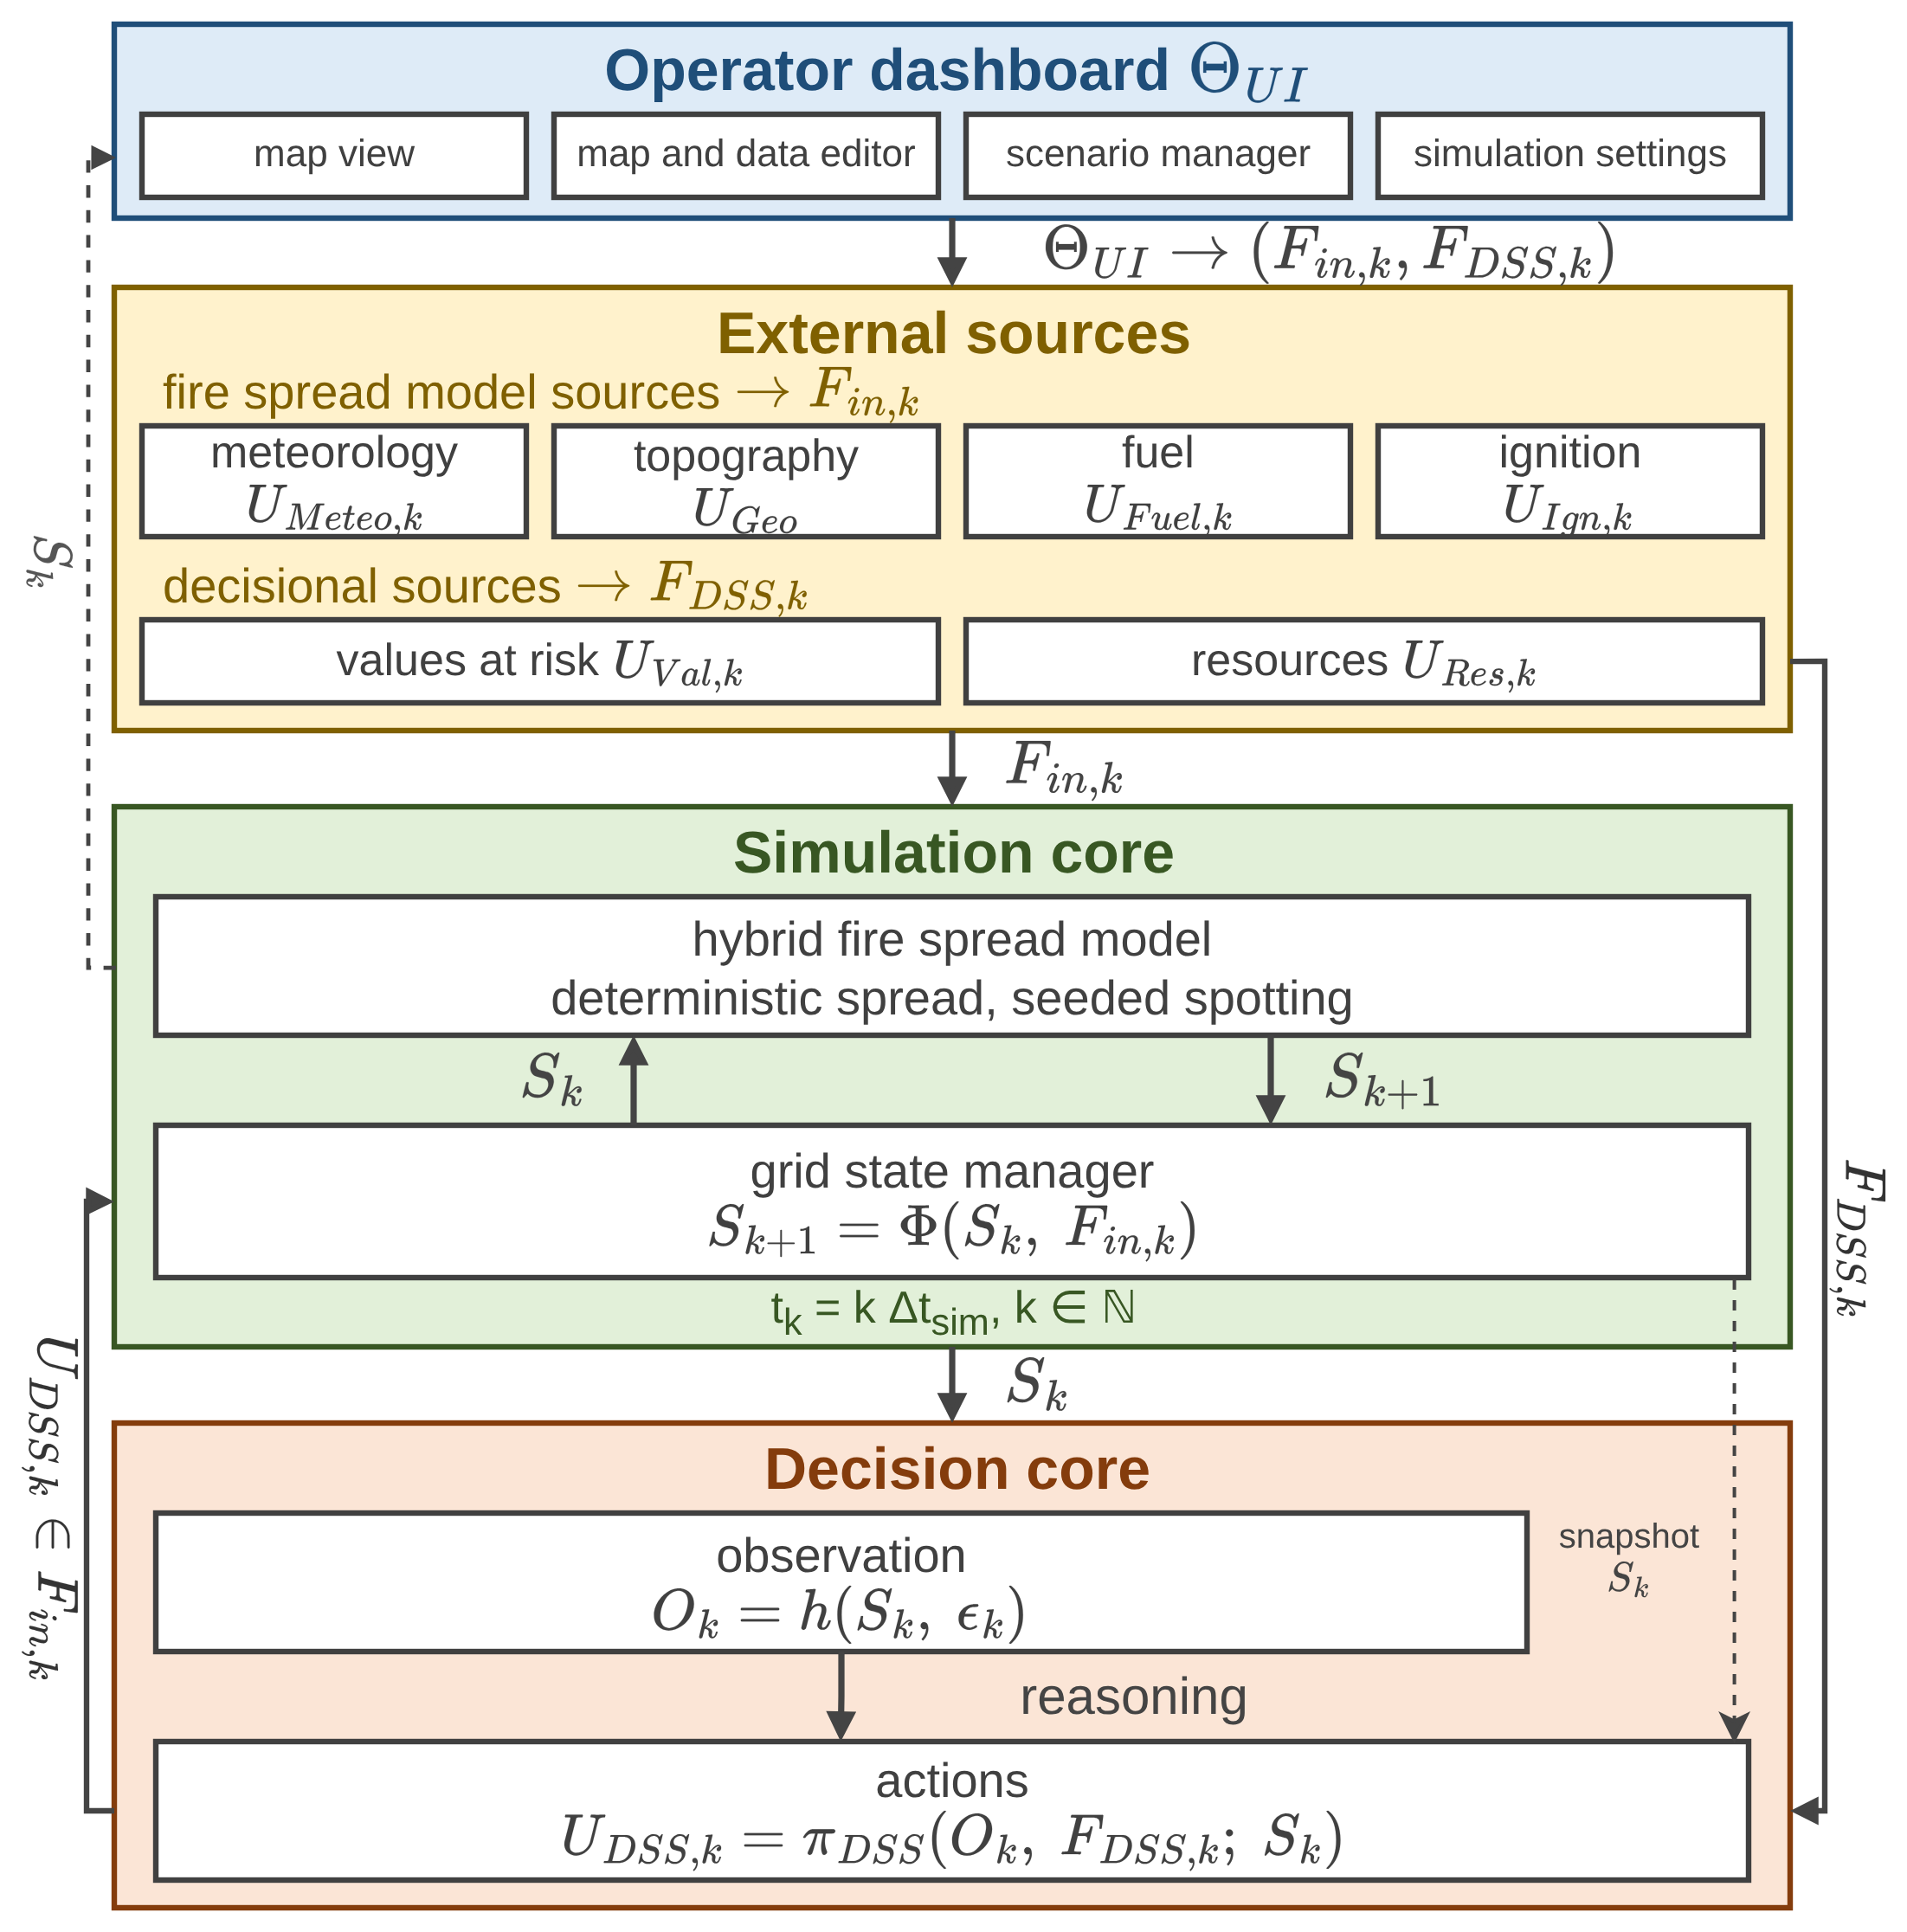
Fig. 1 shows the simulation core, decision core, external sources, and operator dashboard. Sources supply meteorological, geographic, and fuel fields; the operator edits inputs through $Θ_{UI}$, never the state. The simulation core advances its state $S_{k}$ using inputs $F_{in,k}$ in (1), as $S_{k+1}=Φ\left(S_{k},F_{in,k}\right)$. The decision core reads observation $O_{k}$ and decisional set $F_{DSS,k}$ and writes only the intervention field $U_{DSS,k}$ into $F_{in,k}$.
Fig. 1. The system architecture.
$$F_{in,k}=\left\{U_{Meteo,k},U_{Geo},U_{Fuel,k},U_{Ign,k},U_{DSS,k}\right\} \\ F_{DSS,k}=\{U_{Val,k},U_{Res,k}\}$$ | (1)

At step $k$, time is $t_{k}=kΔt_{sim}$, and all fields are defined per cell $\left(x,y\right)$ of grid $G$. $U_{Meteo,k}$ contains wind speed $W_{s,k}$ and direction $W_{d,k}$, air temperature, humidity, and precipitation. $U_{Geo}$ contains elevation, slope $G_{s}$, aspect $G_{a}$, and road access $G_{c}$. $U_{Fuel,k}$ supplies standard fuel type $F_{t}$ [44], initial fuel load, and dead fuel moisture $F_{m,k}$, while $U_{Ign,k}∈\{0,1\}$ specifies scenario ignitions. The decisional fields inform orders but do not enter $Φ$ directly. $U_{Val,k}$ aggregates buildings, critical facilities, population, and evacuation access into value at risk. $U_{Res,k}$ describes crews and water sources by per-cell capacity $R_{c,k}$, availability $R_{a,k}$, effectiveness $R_{e,k}$, and travel time $R_{t,k}$.
$$S_{k}→O_{k}=h\left(S_{k}, ϵ_{k}\right)→U_{DSS,k}=π_{DSS}\left(O_{k}, F_{DSS,k}; S_{k}\right) \\ →U_{DSS,k}⊂F_{in,k}→S_{k+1}=Φ\left(S_{k},F_{in,k}\right)$$  $$\left|ϵ_{k}\right|≤\left(1-γ_{k}\right)ϵ_{max}$$ | (2)

The cores run the loop in (2) each decision cycle. Observation function $h$ introduces epistemic uncertainty $ϵ_{k}$, bounded by cell confidence $γ_{k}$ (Section IV). Full confidence gives exact observations; an unobserved cell admits the worst-case error $ϵ_{max}$. The decision map $π_{DSS}$ uses observations and decisional fields. In this study, the core snapshot $S_{k}$ also supplies the proposer brief and shadow forecasts, whereas closed-layer inference reads observations only. The returned intervention field $U_{DSS,k}$ affects the next state through $F_{in,k}$ and the transition $Φ$. Another hazard model can replace the simulation core if it exposes observations through $h$, accepts interventions through $F_{in,k}$, and supports forecast cloning. Replaying the same random-state snapshot isolates the effect of the issued orders in the paired comparisons of Section V.

B. State, Transition, and Spread
Each cell state in (3) comprises burning status $B_{k}∈\{0,1\}$, the remaining fraction $F_{L,k}∈\left[0,1\right]$ of initial fuel, a bounded fireline intensity proxy $I_{k}$, and time since ignition $τ_{k}$. The transition $Φ$ updates these through (4) to (8). The Iverson bracket $\left[⋅\right]$ equals one when its condition holds and zero otherwise.
$$S_{k}=\{s_{k}\left(x,y\right)\}_{\left(x,y\right)∈G}, s_{k}=\left(B_{k},F_{L,k},I_{k},τ_{k}\right)$$ | (3)

The burning update in (4) takes the maximum of four sources. Persistence $B^{pers}$ requires fuel above extinction load $ϵ_{L}$ and moisture below the fuel-specific extinction value $ϵ_{m}\left(F_{t}\right)$ [6]. Under the same fuel and moisture limits, propagation $B^{prop}$ occurs when neighbor impact $Ψ_{k}$ in (9) exceeds $Θ_{ign}$ [22]. Spotting $B^{spot}$ ignites fuel where a seeded ember lands, while $U_{Ign,k}$ introduces scenario ignitions.
$$B_{k+1}=\max\left\{B^{pers},B^{prop},B^{spot},U_{Ign,k}\right\} \\ B^{pers}=B_{k}\left[F_{L,k}>ϵ_{L}\right]\left[F_{m,k}<ϵ_{m}\left(F_{t}\right)\right] \\ B^{prop}=\left[Ψ_{k}>Θ_{ign}\right]\left[F_{L,k}>ϵ_{L}\right]\left[F_{m,k}<ϵ_{m}\left(F_{t}\right)\right] \\ B^{spot}=\left[\text{ember lands}\right]\left[F_{L,k}>ϵ_{L}\right]$$ | (4)

In (5), combustion consumes fraction $F_{b,k}$ of the remaining fuel in burning cells, and suppression removes $F_{r,k}$ through (6). The suppression map $f_{supp}$ follows initial-attack productivity [45], including intensity and arrival-time effects confirmed by later reviews [46]. Removal scales with fielded capacity $R_{c,k}⋅R_{a,k}$, adjusted for effectiveness $R_{e,k}$, travel time $R_{t,k}$, and access $G_{c}$. Effectiveness decreases with intensity $I_{k}$. Suppression reduces available fuel; extinction follows from the burning update.
$$F_{L,k+1}=max\{0, F_{L,k}-B_{k}F_{L,k}F_{b,k}-F_{r,k}\}$$ | (5)
$$F_{r,k}=f_{supp}\left(R_{c,k},R_{a,k},R_{e,k},R_{t,k},G_{c}\right)$$ | (6)

The intensity proxy in (7) follows the bounded map $f_{int}$ of fuel, wind speed, and slope after Byram [47], parameterized in [6]. It is zero in nonburning cells.
$$I_{k+1}=B_{k+1}f_{int}\left(F_{L,k},W_{s,k},G_{s}\right)$$ | (7)

The clock in (8) restarts at ignition, increments by $Δt_{sim}$ during active burning, and resets to zero at burnout.
$$τ_{k+1}=\left\{\begin{matrix}0 & B_{k+1}=1∧B_{k}=0 \\ τ_{k}+Δt_{sim} & B_{k+1}=1∧B_{k}=1 \\ 0 & B_{k+1}=0\end{matrix}\right.$$ | (8)

Propagation in (9) uses the anisotropic Cell2Fire kernel. Each burning neighbor $\left(i,j\right)$ in the eight-neighborhood $N_{8}$ contributes spread rate $ν_{k}$, weighted by a wind-elongated ellipse at the angle between wind direction $W_{d,k}$ and target bearing $φ_{ij}$. Its eccentricity $e_{k}$ follows the length-to-breadth ratio ${LB}_{k}$, which increases with wind speed in m/s. Neighbor weights $w_{ij}$ are 1/√2 diagonally and 1 otherwise. All Section V runs use this kernel. Spread rate $ν_{k}$ in (10) follows the Rothermel map $f_{ros}$ [6] over wind, slope, aspect, moisture, and fuel type. Each front substep spans at most one cell, and only spotting is stochastic. Precipitation gradually raises $F_{m,k}$ toward $ϵ_{m}$, causing the front to die out progressively.
$$Ψ_{k}=\frac{1}{8}\sum_{\left(i,j\right)∈N_{8}}{B_{k}}\left(i,j\right)ν_{k}\left(i,j\right)g_{k}\left(i,j\right) \\ g_{k}\left(i,j\right)=w_{ij}\frac{1-e_{k}}{1-e_{k}cos\left(W_{d,k}\left(i,j\right)-φ_{ij}\right)} \\ e_{k}={\left(1-{LB}_{k}^{-2}\right)}^{1/2}, {LB}_{k}=1+0.06W_{s,k}, \\ w_ij∈\{1, 1/√2\}$$ | (9)
$$ν_{k}=f_{ros}\left(W_{s,k},W_{d,k},G_{s},G_{a},F_{m,k},F_{t}\right)$$ | (10)

IV. The Decision Core
The decision core comprises $N$ agents over grid regions $G_{i}$. Agent $i$ maps observation $O_{k}^{i}$ through feature extraction, the concept space, and the closed layer to an intervention candidate $U_{DSS,k}^{i}$. The global coordinator allocates the shared pool and merges regional candidates into $U_{DSS,k}$ (Section IV-E). The open layer operates on the shared rule base once per cycle, using the situation of the burning region with the weakest rule coverage.

A. Sources, Features, and Confidence
Sources include weather stations and forecasts, satellite and airborne imagery, terrain and fuel maps, road networks, resource status, asset and population layers, and field reports. The agent reduces them to 10 features in the unit interval (11), namely fire intensity $z_{1}$, spread potential $z_{2}$, weather severity $z_{3}$, ignition proximity $z_{4}$, fuel load $z_{5}$, asset exposure $z_{6}$, resource accessibility $z_{7}$, access and road status $z_{8}$, suppression availability $z_{9}$, and temporal urgency $z_{10}$. Cell confidence is the minimum of observability, coverage, freshness, and reliability (12). Incomplete observation leaves uncertainty about the state [19], while Bayesian or Dempster-Shafer treatments require priors or mass assignments that sensing alone does not supply [20].
Extraction maps and their constants, which follow the fire-weather index [48] and the operational priority method [49], are given in the Supplementary Material; intensity, proximity, fuel and urgency inherit observed-channel confidence. In (11), $ξ_{f}$ is the extraction map for feature $f$. In (12), $γ_{obs}$, $γ_{cov}$, $γ_{fre}$, and $γ_{rel}$ denote observability, sensor coverage, freshness, and source reliability, respectively.
$$z_{f,k}^{i}=ξ_{f}\left(O_{k}^{i}\right)∈\left[0,1\right], f=1,…,10$$ | (11)
$$γ_{k}=min\{γ_{obs},γ_{cov},γ_{fre},γ_{rel}\}$$ | (12)

B. Concept Space
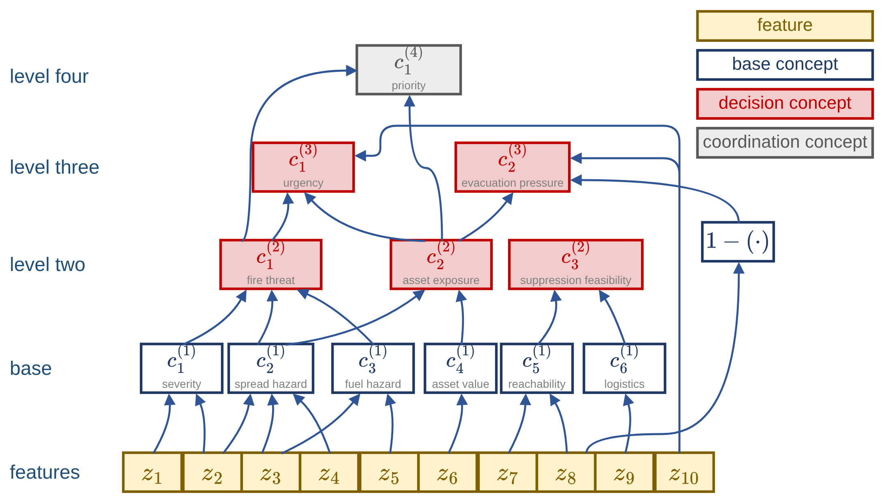
Fig. 2 shows how observations reach the concept space. The five decision concepts feed the rule base; suppression feasibility also gates the quality test in (17), and operational priority feeds the coordinator in (22). Each feature is fuzzified over a five-term partition of unity.
Fig. 2. Observation and concept space of one agent.
The hierarchy in (13) maps features to 6 base concepts, then to 5 decision concepts on two levels, and finally to one coordination concept. Each activation first takes a weighted sum of its inputs, then blends this observed value with its decayed previous value according to confidence (14). Missing observations therefore cause a gradual loss of support. Decay lowers every term membership, including the low terms, and weakens the rules that read them. The crisp reading in (15), used by (17), (18), and the coordinator, also falls with decay. Section V-C evaluates degraded observation.
$$\begin{matrix}C_{1}^{\left(1\right)}=\{z_{1},z_{2}\} & C_{1}^{\left(2\right)}=\{c_{1}^{\left(1\right)},c_{2}^{\left(1\right)},c_{3}^{\left(1\right)}\} \\ C_{2}^{\left(1\right)}=\{z_{2},z_{3},z_{4}\} & C_{2}^{\left(2\right)}=\{c_{2}^{\left(1\right)},c_{4}^{\left(1\right)}\} \\ C_{3}^{\left(1\right)}=\{z_{3},z_{5}\} & C_{3}^{\left(2\right)}=\{c_{5}^{\left(1\right)},c_{6}^{\left(1\right)}\} \\ C_{4}^{\left(1\right)}=\{z_{6}\} & C_{1}^{\left(3\right)}=\{c_{1}^{\left(2\right)},c_{2}^{\left(2\right)},z_{10}\} \\ C_{5}^{\left(1\right)}=\{z_{7},z_{8}\} & C_{2}^{\left(3\right)}=\{c_{2}^{\left(2\right)},1-z_{8},z_{10}\} \\ C_{6}^{\left(1\right)}=\{z_{9}\} & C_{1}^{\left(4\right)}=\{c_{1}^{\left(2\right)},c_{2}^{\left(2\right)}\}\end{matrix}$$ | (13)
$$a_{n,k}^{\left(1\right)}\left[t\right]=\sum_{f∈C_{n}^{\left(1\right)}}{ω_{n,f}μ_{t}\left(z_{f,k}\right)}, t∈T_{n} \\ a_{n,k}^{\left(l\right)}=\sum_{m∈C_{n}^{\left(l\right)}}{ω_{n,m}^{\left(l\right)}x_{m,k}}, ∑ω=1 \\ a_{n,k}^{eff}=γ_{n,k} a_{n,k}^{obs}+\left(1-γ_{n,k}\right) ρ_{dec} a_{n,k-1}^{eff} \\ γ_{n,k}=\min_{f∈C_{n}}γ_{f,k}$$ | (14)

Rules use only fire threat level $c_{1}^{\left(2\right)}$, asset exposure risk $c_{2}^{\left(2\right)}$, suppression feasibility $c_{3}^{\left(2\right)}$, intervention urgency $c_{1}^{\left(3\right)}$, and evacuation pressure $c_{2}^{\left(3\right)}$. In (13), $C_{n}^{\left(l\right)}$ lists the inputs to concept $n$ at level $l$. The base concepts $c_{1}^{\left(1\right)}$ to $c_{6}^{\left(1\right)}$ are fire severity, spread hazard, fuel hazard, asset value, crew reachability, and logistics support. Their weights are given in the Supplementary Material. The last two include temporal urgency, and evacuation pressure also includes inverted road status. The coordination concept $c_{1}^{\left(4\right)}$ expresses operational priority.
In (14), $a$ is a five-term activation vector, $ω$ a nonnegative weight, and $μ_{t}$ the membership of a feature in term $t$. Each input $x_{m,k}$ is either a lower concept's activation vector or a feature's term vector. Confidence blends observed activation $a^{obs}$ with the previous effective activation to obtain $a^{eff}$, which rules consume; $ρ_{dec}∈[0,1)$ controls persistence decay.

C. The Closed Decision Layer
Fig. 3 shows the closed layer. Each TS rule in (15) uses the five decision concepts and a constant consequent over six intervention families $M$, namely suppression effort, resource deployment, containment line, asset protection, evacuation, and public warning. Zero intensity denotes inaction. Rules use weakest-clause firing, firing-weighted averaging and a denominator floor of one. Intervention intensities are translated into executable orders through application-specific execution logic.
$$R_{r}: IF \underset{n=1,…,5}{⋀}\left(a_{n,k}^{eff} is A_{r,n}\right) THEN u_{k}=v_{r}$$  $$u_{m,k}=\frac{\sum_{r∈R_{m}}{μ_{r,k}v_{r,m}}}{max\left(1, \sum_{r∈R_{m}}{μ_{r,k}}\right)}, μ_{r,k}=\min_{n}a_{n,k}^{eff}\left(A_{r,n}\right) \\ \max_{r}μ_{r,k}≥α_{min}$$  $${\bar{a}}_{n,k}={\sum_{t}{c_{t}a_{n,k}^{eff}\left[t\right]}}/{max\left(1,\sum_{t}{a_{n,k}^{eff}\left[t\right]}\right)}$$ | (15)

In (15), $R_{r}$ denotes rule $r$, and $A_{r,n}$ its antecedent for concept $n$. A rule names one to three concepts and leaves the others unconstrained; an antecedent is a single term or an upward set of terms, evaluated by the largest membership in that set. $v_{r}$ is the consequent vector, $u_{m,k}$ the ordered intensity of family $m∈M$, and $μ_{r,k}$ the firing strength. Only rules in $R_{m}$, whose consequents name family $m$, enter that family's average. The inequality tests coverage against floor $α_{min}$. Here $a_{n,k}^{eff}\left[A\right]$ is the activation component for term $A$. The crisp reading ${\bar{a}}_{n,k}$ averages term centers $c_{t}$ by their memberships, with the divisor floored at one so that a decayed activation reads lower.
The five seeds in Table I represent the strongest orders for each family in a hand-written base of 40 rules over the same concepts and families. Readings with no rule firing above $α_{min}$ invoke the fail-safe in (17) and adaptation in (18).
Table I
Seed rules of the closed layer
# | Antecedent | Consequent
R1 | fire threat very high | suppression effort 1.0, resource deployment 0.8
R2 | intervention urgency very high | resource deployment 1.0
R3 | fire threat very high and suppression feasibility very low | containment line 0.9, evacuation 0.6, public warning 0.8
R4 | asset exposure very high and suppression feasibility low | asset protection 0.9,  containment line 0.6
R5 | evacuation pressure very high and suppression feasibility very low | evacuation 1.0, public warning 1.0, resource deployment 0.7
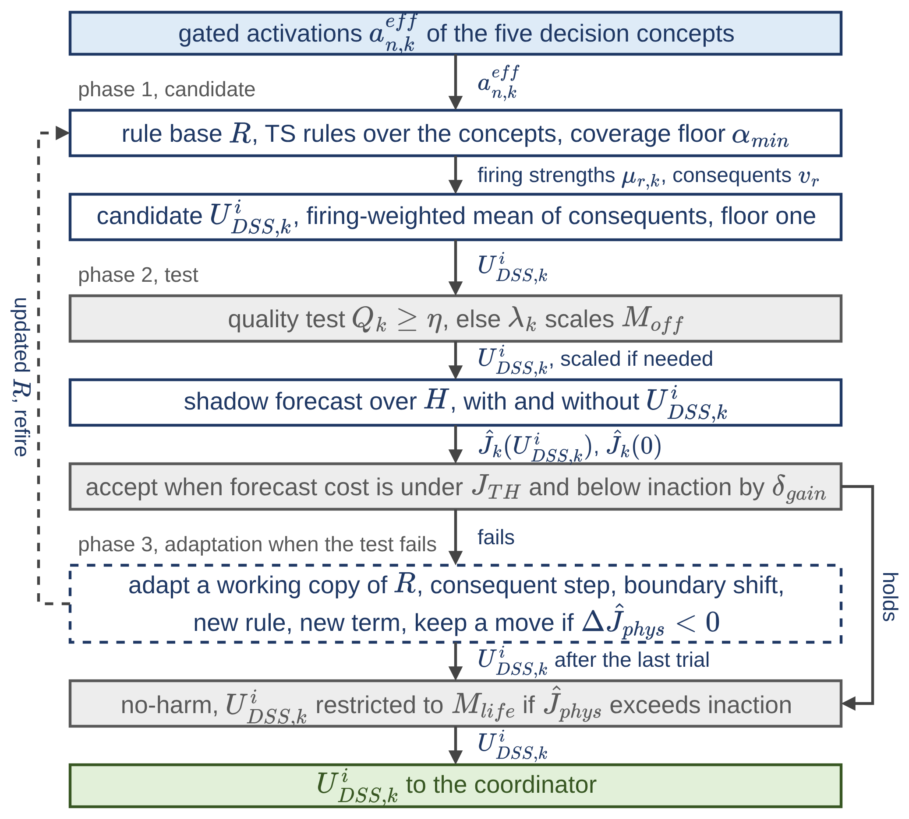
Every candidate is evaluated on a shadow copy of the simulation core. The decision cost in (16) combines five bounded terms, namely burned area, lost asset value, population exposure, committed response, and dispatch delay. The first three form physical cost $J_{phys}$, for comparing configurations, since inaction incurs no response cost.
Fig. 3. Decision layer 1, the closed decision space.
$$J=\frac{\sum_{j}{w_{j}}J_{j}}{\sum_{j}{w_{j}}},j∈\left\{burn,asset,pop,resp,delay\right\} \\ J_{phys}=\frac{J_{burn}+J_{asset}+J_{pop}}{3} \\ J_{burn}=\frac{x_{b}}{1+x_{b}}, x_{b}=\frac{N_{burned}}{ρ_{burn}N_{burnable}} \\ J_{asset}=\frac{V_{lost}}{V_{total}}, J_{pop}=min\left\{1,\frac{P_{steps}}{P_{total}N_{dec}}\right\} \\ J_{resp}=min\left\{1,\frac{C_{steps}}{C_{ref}N_{dec}}\right\}, J_{delay}=min\left\{1,\frac{τ_{disp}}{τ_{ref}}\right\}$$ | (16)

The satisficing rule in (17) requires forecast cost to remain below a ceiling and improve on inaction by a margin. The quality test in (17) compares each scored concept with its strongest matching order. It can reach one when both vanish; the forecast-gain test still rejects zero orders at positive inaction cost. When quality falls below $η$, the fail-safe scales the four offensive families $M_{off}$ by $λ_{k}$. It leaves the life-safety families $M_{life}$, evacuation and warning, unchanged, with $M=M_{off}∪M_{life}$.
$${\hat{J}}_{k}\left(u_{k}\right)≤min\left\{J_{TH},\left(1-δ_{gain}\right){\hat{J}}_{k}\left(0\right)\right\}$$  $$Q_{k}=1-\frac{1}{4}\sum_{n∈C_{Q}}{\left|{\bar{a}}_{n,k}-\max_{m∈M_{n}}u_{m,k}\right|}$$  $$λ_{k}=min\{1,Q_{k}/η\}, u_{m,k}←λ_{k}u_{m,k},m∈M_{off}$$ | (17)

In (16), $N_{burned}$ and $N_{burnable}$ count burned and burnable cells, $ρ_{burn}$ is the reference burned fraction so that burned area is measured relative to it, and $V_{lost}$ and $V_{total}$ are lost and exposed asset value. $P_{steps}$ combines exposed person-steps with ordered-evacuee person-steps weighted by 0.05, $P_{total}$ is the population at risk, and $N_{dec}$ is the fixed 200-step normalization for person-steps and capacity-steps. $C_{steps}$ sums fielded capacity over steps, $C_{ref}$ is the reference capacity, and $τ_{disp}$ and $τ_{ref}$ are the capacity-weighted and reference dispatch times. Coating, tactical ignition, and warning field no capacity but incur fixed charges in capacity units, so every order has a cost. Physical cost averages the three loss terms; total cost is the weighted mean of the five terms with the weights of (16).
In (17), ${\hat{J}}_{k}\left(⋅\right)$ is forecast cost, $J_{TH}$ the ceiling, and $δ_{gain}$ the required gain over inaction ${\hat{J}}_{k}\left(0\right)$. $C_{Q}$ contains the four scored concepts; suppression feasibility gates their quality assessment. $M_{n}$ denotes the families answering concept $n$.
When the standing decision falls short, the layer adapts within its vocabulary through the four moves in (18), following evolving fuzzy models [25].
$$\text{step}\text{: }v_{r,m}←{clip}_{\left[0,1\right]}\left(v_{r,m}±δ\right)$$  $$\text{shift}\text{: }\left(a_{A},b_{A},c_{A^{-}},d_{A^{-}}\right)←\left(a_{A},b_{A},c_{A^{-}},d_{A^{-}}\right)-δ$$  $$\text{new rule}\text{: }A_{new}=\left\{\left(n_{1},t_{n_{1}}^{*}\right),\left(n_{2},t_{n_{2}}^{*}\right)\right\} \\ t_{n}^{*}=\underset{t∈T_{n}}{arg max}a_{n,k}^{eff}\left[t\right]$$  $$\text{new term}\text{: }\max_{t∈T_{n}}μ_{t}\left(x\right)<θ_{ins},x={\bar{a}}_{n,k}⇒$$  $$T_{n}←T_{n}∪trap\left(x-2h_{t},x-h_{t},x+h_{t},x+2h_{t}\right)$$ | (18)

A step changes one consequent. A shift moves a term edge with the facing edge of its left neighbor, preserving the partition of unity. A new rule covers the combination of the two concepts with the highest crisp readings; a new term is inserted where existing terms weakly represent the current value. Each move is tried on a working copy and retained only if forecast physical cost falls. After the last trial, the no-harm guard restricts a candidate to $M_{life}$ if it forecasts more physical cost than inaction. The resulting intervention field $U_{DSS,k}^{i}$ for region $i$ is sent to the coordinator.
In (18), $δ$ is the step size; $a_{A}$ and $b_{A}$ are the left corners of term $A$, and $c_{A^{-}}$ and $d_{A^{-}}$ the right corners of its left neighbor $A^{-}$. $n_{1}$ and $n_{2}$ identify the two concepts with the highest crisp readings. $T_{n}$ is the term set of concept $n$, $t_{n}^{*}$ its term of highest membership, and $θ_{ins}$ the insertion threshold. $trap\left(⋅\right)$ denotes a trapezoid of half-width $h_{t}$ centered on crisp reading $x$.

D. The Open Decision Layer
Fig. 4 shows the open layer, which extends the intervention vocabulary by verified composition. It is triggered by an unresolved deficit, a coverage gap while the fire is active, or renewed spread under applied orders. The closed moves in (18), tuning followed by a new rule, are tried before requesting a proposal. The open layer then generates candidates and passes every one of them through the gate chain on shadow forecasts; the best survivor is admitted. The LLM serves as a context-conditioned proposal mechanism, using the incident description to compose structured intervention candidates from executable physical effects for subsequent simulation-based evaluation.
The proposer can be any generator of objects in the form (19). This study uses a pretrained LLM in context, without fine-tuning, through a command-line interface with default sampling. Each call provides an incident brief $Σ_{k}$ from the core state, the reply schema in (19), and a request for six distinct candidates in one JSON object. The brief reports burning cells, burned area and its trend, front centroid, mean wind, front fuel moisture, the nearest asset's distance and population, water distance, gated activations, firing rules and consequents, quality deficit, and resource state. The schema lists admissible concepts, terms, families, effects, sectors, and bands.
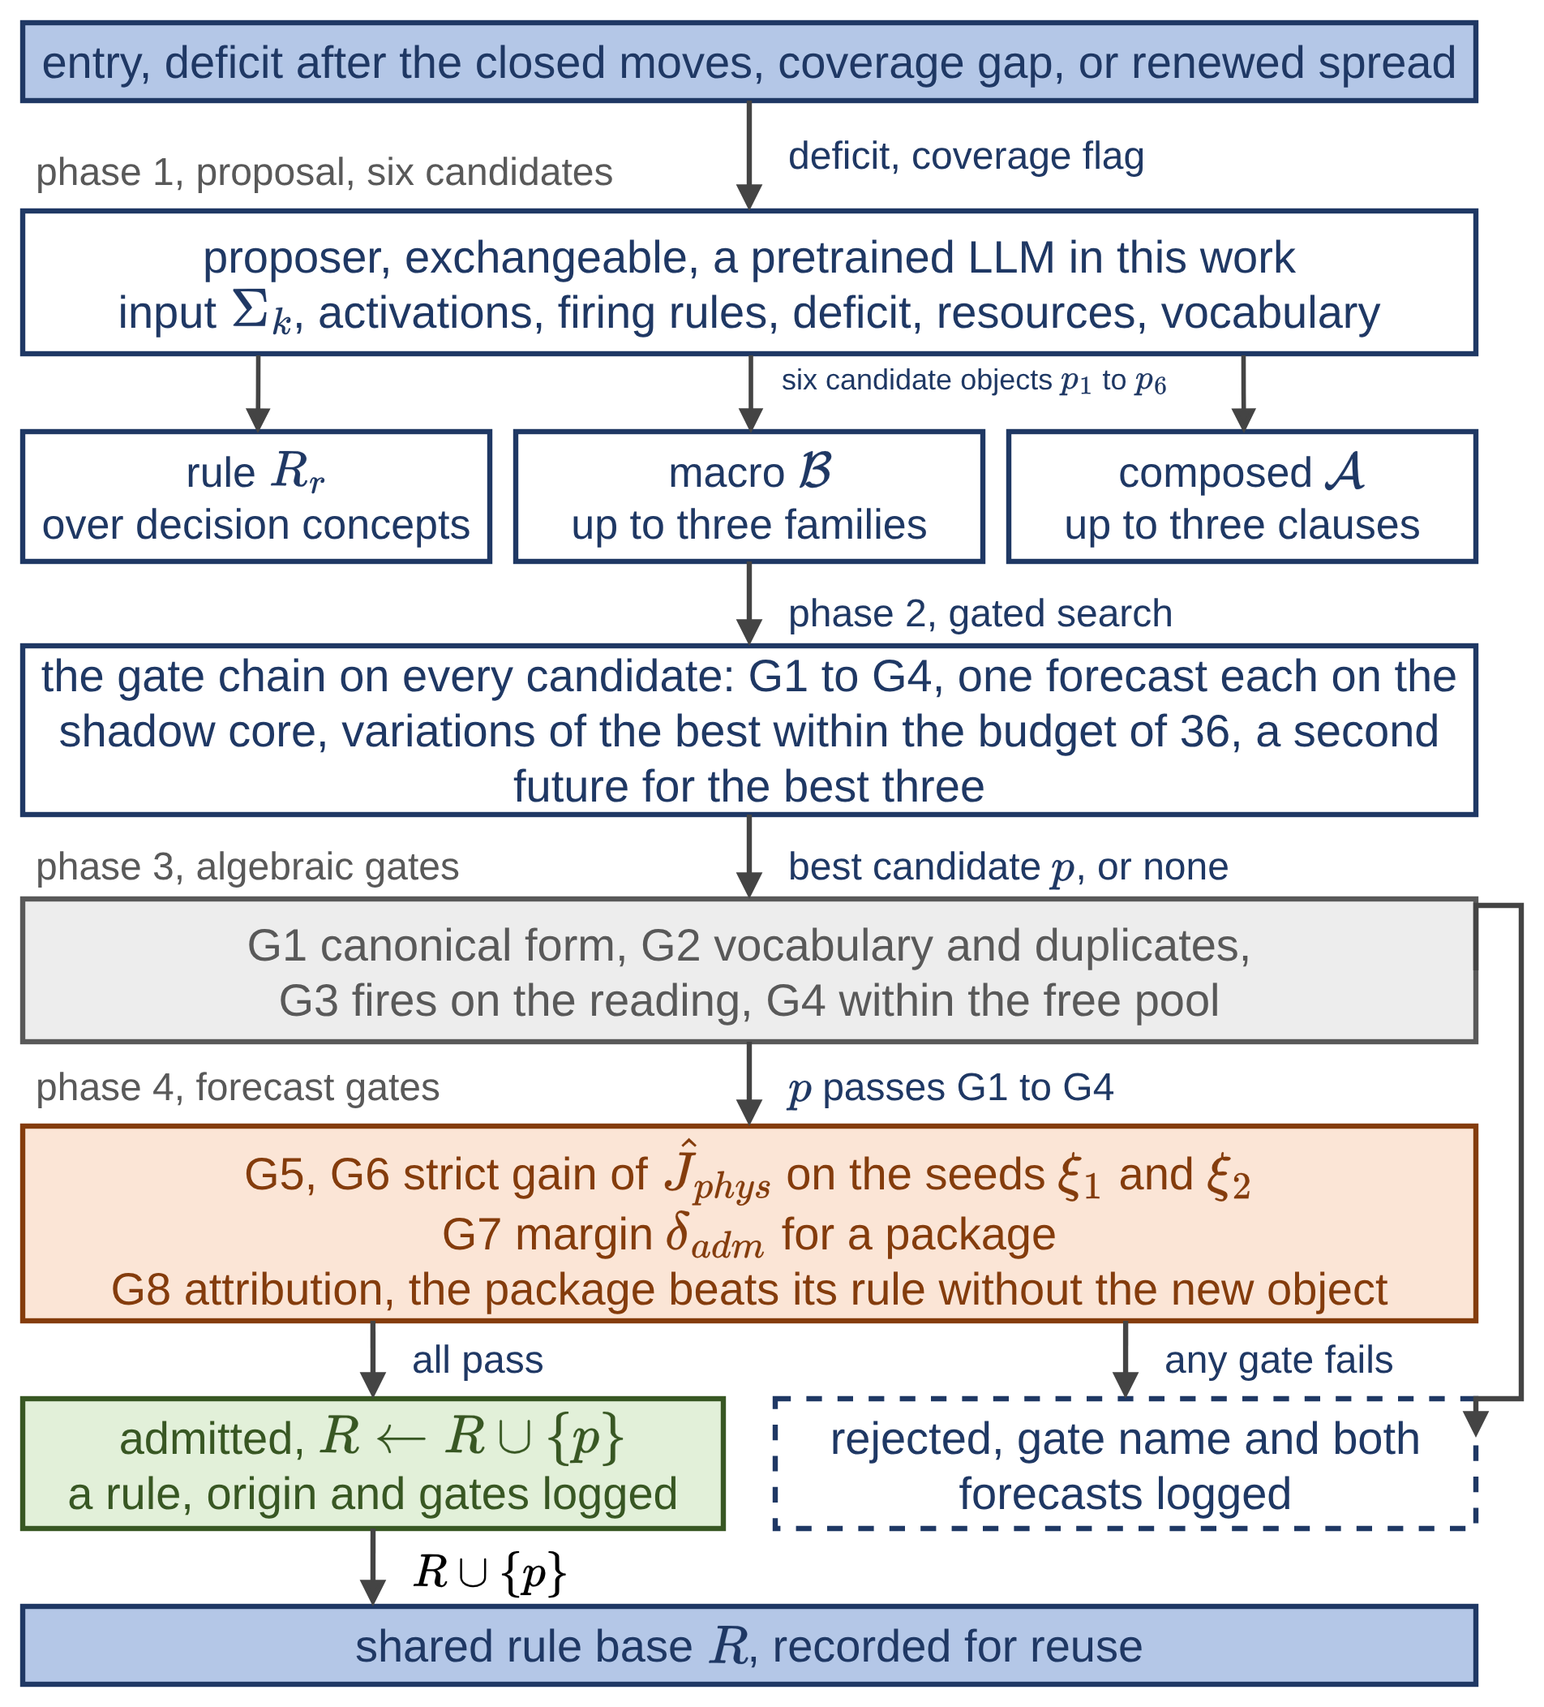
Each candidate in (19) uses the campaign's fixed vocabulary of five decision concepts, six families, and seven effects. It may be a rule of (15), a macro $B$ blending up to three families $b_{j}$ with weights $β_{j}$, or a composed intervention. Macro components enter their family's numerator and denominator in (15) with weight $β_{j}$; the denominator floor in (15) attenuates commands with support below one. A composed intervention $A$ contains up to three clauses. Each specifies an effect $e$ (wet, clear, ignite, coat, draft, evacuate, or prime), a sector $s$ (head, flank, rear, ring, at fire, assets, or populated), a distance band $\left[ρ_{in},ρ_{out}\right]$ in cells, and an amount $α$.
Fig. 4. Decision layer 2, the open decision space.
$$B=\left\{\left(b_{j},β_{j}\right)\right\} _{j≤3}, \\ \left(B,v\right)↦b_{j} at v with weight β_{j}μ_{r,k} \\ A={\{\left(e,s,\left[ρ_{in},ρ_{out}\right],α\right)\}}_{≤3}$$ | (19)

A clause is resolved on the simulation fields by the band geometry and the operators of (20).
$$Z\left(C_{s},ρ_{in},ρ_{out}\right)=D_{ρ_{out}}\left(C_{s}\right)\backslash ∖D_{ρ_{in}-1}\left(C_{s}\right) \\ κ\left(x\right)=\frac{\left(x-c_{F}\right)⋅{\overset{‾}{W}}_{k}}{∥x-c_{F}∥} a_{c}={clip}_{\left[0,1\right]}\left(αμ_{r}\right) \\ r_{ret}^{Ω}←max\left(r_{ret}^{Ω},a\right) \\ r_{cap}^{Ω}←min\left(r_{cap}^{Ω} \left(1+g_{w}\left(d_{w}\right)\right), 1.5 c_{max}\right)$$ | (20)

The band $Z$ contains cells within four-neighbor distance $ρ_{out}$ of sector core $C_{s}$ but outside distance $ρ_{in}-1$; $D_{ρ}\left(C_{s}\right)$ denotes such a neighborhood. The cosine $κ$ between a cell's direction from fire centroid $c_{F}$ and mean wind ${\overset{‾}{W}}_{k}$ separates head, flank, and rear. The scaled clause amount $a_{c}$ combines the requested amount with the rule's firing intensity $μ_{r}$. For coat, retardant field $r_{ret}^{Ω}$ on mask $Ω$ takes the maximum of its current value and the scaled amount. For draft, capacity $r_{cap}^{Ω}$ increases with gain $g_{w}\left(d_{w}\right)$ at water distance $d_{w}$, subject to cap $c_{max}$.
The other effects use maxima over the existing fields on the same mask. Wet raises capacity to a of its cap and availability to 0.3 + 0.7a. Clear sets the cut field and raises capacity to at least 0.8 of its cap. Ignite raises the ignition command to a; above 0.5, the core ignites a nonburning cell if fuel remains and moisture is below extinction, then advances its spread normally. Evacuate raises the evacuation field to a, and prime raises the warning field to a. These fixed physical effects support new compositions of interventions.
Fig. 4 shows the gate chain of eight gates. G1 rejects objects that do not parse into the vocabulary; G2 rejects unknown effects or sectors and duplicates; G3 requires the rule to fire on the current reading; G4 enforces the free pool. Coating and ignition use no crew but are priced in capacity-steps against the funded pool.
G5 to G8 evaluate physical cost on the shadow core (21) over a guard horizon long enough for lines and coating to take effect. G5 and G6, the same test on each of two independently seeded futures, require a strict gain. G7 requires a package to gain at least $δ_{adm}$ on each, and G8 requires the same margin over its own rule without the new object. Rejection returns the gate name and forecast values. Admitted objects join the rule base, with their origin and gate values logged, and fire in later cycles. Recorded as doctrine, they can also be installed in later incidents, as tested in Section V-D. In (21), $p$ is the proposal, $R$ the current base, $ξ_{1}$ and $ξ_{2}$ the seeds, $r_{A}$ the rule carrying object $A$, and $r\backslash ∖A$ the same rule without it.
$$\text{G5, G6: }{\hat{J}}_{phys}^{ξ}\left(R∪\{p\}\right)<{\hat{J}}_{phys}^{ξ}\left(R\right) \\ \text{G7: }{\hat{J}}_{phys}^{ξ}\left(R\right)-{\hat{J}}_{phys}^{ξ}\left(R∪\left\{p\right\}\right)≥δ_{adm} \\ \text{G8: }{\hat{J}}_{phys}^{ξ}\left(R∪\{r\backslash ∖A\}\right)-{\hat{J}}_{phys}^{ξ}\left(R∪\left\{r_{A}\right\}\right)≥δ_{adm} \\ \text{for both seeds }ξ∈\{ξ_{1},ξ_{2}\}$$ | (21)

The gates in (21) are applied to every candidate of a call. G1 to G4 cost no simulation. Candidates passing them receive one shadow forecast over the guard horizon on the first future, the forecast of G5; the call's 36-forecast budget covers candidates and local variations under grammar (19). Up to three additional forecasts evaluate the best candidates on the second future, and the candidate with the greatest gain on its worse future completes G5 to G8. A call admits at most one object and admits nothing when no candidate gains on both futures. The log distinguishes model candidates from their variations.
A variation retains the candidate except for the selected component. For a composed intervention, it changes a clause's effect, sector, band, or amount with probability 0.5, perturbs a consequent intensity by N(0, 0.15) with probability 0.25, and otherwise redraws the antecedents. For rules and macros, the probabilities are 0.75 for an intensity change and 0.25 for redrawn antecedents.
The random proposer in Section V-C samples objects uniformly from the grammar of (19) and spends its budget on fresh samples rather than variations. For both proposers, at most one candidate per call is admitted, and most rejections occur at G1 to G4 and at the first forecast.
The gate chain enforces the structural, resource and forecast-based acceptance conditions before a proposed object enters the rule base, independently of the proposer. First, candidate fields are compared with inaction using forecast physical cost over the 45 min horizon of the no-harm guard and G5 to G8; acceptance in (17) uses the shorter planning horizon. A worse field is restricted to life-safety orders. The guards preserve $M_{life}$ intensities, and (15) averages only named families. Evacuation and warning also carry displacement cost, so retaining them does not guarantee a lower physical cost. Second, every admitted package lowers forecast physical cost by at least $δ_{adm}$ on both sampled futures; extension ends when no candidate passes.

E. Local Agents and Global Coordination
Algorithm 1 gives one decision cycle. The $N$ agents share a rule base and run the closed layer (Section IV-C); the open layer (Section IV-D) operates once per cycle on that base. Agents fire sequentially within one process. The merged forecast determines the deficit, while the proposer receives the situation of the burning region with the weakest coverage. Each agent sends its operational priority $p_{i}$, resource request, and confidence summary to the coordinator, which allocates the pool and returns priority weights and acceptance thresholds without performing inference. Regions ranked by priority receive attention share $σ_{i}$ in (22) by priority, scaling suppression effort and resource deployment. Monitored regions face a stricter quality threshold. The coordinator bounds regional draws from G4’s funded pool. Composed interventions are charged once, by their effects’ capacity-steps as clauses resolve to cells in (20). The merged field in (23) passes the no-harm guard again. If its forecast is worse than inaction, it is restricted to $M_{life}$, preserving life-safety orders. In (22), $p_{i}$ is operational priority $c_{1}^{\left(4\right)}$ of region $i$, $p_{max}$ the highest priority, and $τ_{att}$ the attention threshold. In (23), $A_{DSS}$ merges regional fields, and ${\tilde{U}}_{k}^{i}$ is the field after applying the share once to the two families $M_{σ}$. The other four families retain their regional orders. Admitted objects are decision support rather than autonomous control: each is shown to the operator with its rule text, origin and gate values, and execution in the field remains under the authority of the operator.
$$σ_{i}=\left\{\begin{matrix}1 & p_{i}≥τ_{att} p_{max} \\ 0.5+0.5 p_{i}/p_{max} & \text{otherwise}\end{matrix}\right.$$ | (22)
$$U_{DSS,k}=A_{DSS}\{{\tilde{U}}_{k}^{i}\}_{i=1}^{N} \\ {\tilde{U}}_{m,k}^{i}=\left(1-\left[m∈M_{σ}\right]\left(1-σ_{i}\right)\right)U_{m,k}^{i}, m∈M \\ {\hat{J}}_{phys}\left(U_{DSS,k}\right)>{\hat{J}}_{phys}\left(0\right)⇒U_{DSS,k}←U_{DSS,k}|_{M_{life}}$$ | (23)

Algorithm 1 One decision cycle, $N$ local agents and the coordinator
1: Input: Observations $O_{k}^{i}$, rule base $R$, snapshot of the core, seeds $ξ_{1}$, $ξ_{2}$, thresholds $η_{i}$ of the previous cycle
2: For each agent $i$ in turn, on the base of the cycle, do
3: Features and confidences (11), (12); activations $a^{eff}$ (14)
4: Fire $R$; candidate $u_{k}$ (15); if $Q_{k}<η_{i}$ then scale $M_{off}$ by $λ_{k}$
5: Shadow forecasts over $H$ from the snapshot: ${\hat{J}}_{k}\left(u_{k}\right)$ and ${\hat{J}}_{k}\left(0\right)$
6: End for
7: While (17) fails on the merged forecast, the regional fields merged by (23) and forecast from the snapshot, and trials remain do
8: Closed move from (18) on a working copy of $R$; keep it if $Δ{\hat{J}}_{phys}<0$
9: If the closed moves leave the deficit in place then request a proposal
10: $p←LLM\left(Σ_{k}\right)$; G1 to G4 on every candidate, one forecast each, variations within the budget, a second future for the best three; the best one completes (21)
11: If all gates pass then $R←R∪\{p\}$ else return the gate name and both forecasts; end if
12: Refire $R$ for every agent, lines 3 to 5, on the updated base; update $u_{k}$ and the merged forecast
13: End while
14: For each agent, if ${\hat{J}}_{phys}\left(u_{k}\right)>{\hat{J}}_{phys}\left(0\right)$ then $u_{k}←u_{k}|_{M_{life}}$ (no-harm, guard horizon)
15: Send $U_{DSS,k}^{i}$ written from $u_{k}$, priority $p_{i}$, resource request, and confidence summary
16: Coordinator: Rank the regions by $p_{i}$; $p_{max}←\max_{i} p_{i}$
17: For each region $i$ do $σ_{i}$ (22); allocate from the shared pool in rank order; raise $η_{i}$ if region $i$ is monitored
18: Scale $M_{σ}$ of each $U_{DSS,k}^{i}$ by $σ_{i}$; $U_{DSS,k}←A_{DSS}\{{\tilde{U}}_{k}^{i}\}$ (23); forecast ${\hat{J}}_{phys}\left(U_{DSS,k}\right)$ and ${\hat{J}}_{phys}\left(0\right)$
19: If ${\hat{J}}_{phys}\left(U_{DSS,k}\right)>{\hat{J}}_{phys}\left(0\right)$ then $U_{DSS,k}←U_{DSS,k}|_{M_{life}}$ (no-harm, guard horizon)
20: Output: $U_{DSS,k}$ to the simulation core; $σ_{i}$, allocations, and $η_{i}$ to the agents; updated $R$; log of the cycle

V. Results

A. Experimental Design
Table II defines S1–S5 for the main campaign and S6–S8 for transfer. Each family has 30 worlds (seeds 201–230); development uses 101–120. Each comparison pairs identical worlds and random-state snapshots by family and seed. Recorded tactics are derived on S1–S5 seeds 201–215 and frozen before testing seeds 216–230. Continued generation uses the 90 S6–S8 worlds and a 75-world S1–S5 control, with the same four recorded tactics installed in both arms. Table III groups the tests.
Synthetic worlds have 72 × 50 cells at 30 m resolution, a 2.16 × 1.50 km domain. The physical step is 2 min, the decision interval 12 min, the planning horizon 24 min and the guard horizon 45 min. Episodes end at extinction or the duration in Table II. Fuel moisture is 0.08, except 0.06 in S7. Ignitions are remote in S1, S2, S6 and S8 and near settlements in S3–S5 and S7. S6 and S7 include a lake near the front. S5 selects each reading for corruption with probability 0.25. In selected readings, independent $N(0,0.1)$ perturbations (standard deviation 0.10) are added to all features and clipped to [0, 1]. Confidence is multiplied by 0.8 for every reading; forecasts and the proposer brief use the core snapshot, while inference and order targeting read the degraded observations. S5 models degraded observation through feature perturbations and reduced confidence, representing the effects of incomplete or delayed information on decision inference and targeting.
Table II
Scenario families and operating conditions
ID | Landscape / settlements | Pool | Ignitions | Wind m/s | Hours
S1 | Forest / 2 | 1.0 | 1 | 8 | 12
S2 | Forest / 2 | 0.6 | 2 | 8 | 12
S3 | Interface / 12 | 1.0 | 1 | 8 | 12
S4 | Interface / 12 | 0.6 | 2 | 8 | 12
S5 | Interface / 12 | 0.6 | 2 | 8 | 12
S6 | River valley / 4 | 0.4 | 2 | 9 | 12
S7 | Coast / 12 | 1.0 | 2 | 12 | 12
S8 | Hills / 6 | 0.4 | 3 | 8 | 18
The reference Closed configuration uses the five seed rules with self-tuning; None issues no orders. VODA adds candidate generation and the gate chain over all candidates. Other proposers could supply candidates in the format of (19). The reported runs call Claude Opus 5 through Claude Code with temperature and top-p left unset, one turn per request and tools disabled. The model-error and independent-gate reruns set the effort level to high. Code, configurations and run logs are available from the corresponding author on request. A request asks for six candidates. The closed layer spends two shadow forecasts per cycle on the acceptance test and none on search, so the forecast budget of the open layer is matched only by the random control. Full search allows 36 first-future forecasts and up to three additional finalist evaluations; the candidate-only configuration omits variations, and the small random control sets its search budget to six. Single-candidate controls submit one random or LLM candidate to the gates. The repeat uses the same worlds; the independent-future test selects the best candidate on seeds 101 and 202 and completes G5 to G8 on seeds 303 and 404, so the final test does not reuse the futures of the selection.
The cost weights in (16) are 1 for burned area, asset loss and population exposure, and 0.2 for response and dispatch delay. Coating and ignition cost 6 capacity-steps per cell and warning 0.1 per cell-step. The reference burned fraction is 0.5, capacity reference 100 capacity-steps, normalization 200 steps and dispatch reference 60 min. Nominal coating reduces burning to 0.2 of its rate, sets a moisture floor of 0.45 and decays by 0.003 per min. These coating constants and the effect operators of the open layer are modelling assumptions of this work. Quality is 0.60, the cost ceiling 0.35, the required gain over inaction 5%, and both package margins in (21) are 10⁻⁴. Gates normally use shadow-stream seeds 101 and 202.
Membership terms, adaptation constants and execution thresholds are given in the Supplementary Material. The region count is four except in the partitioning tests.
Model-error tests change the live world while shadow forecasts retain nominal parameters. The suppression tests increase the intensity penalty, travel-effect decay or knockdown threshold by 50% and replay recorded objects. Live generation is rerun for weakened coating (burning factor 0.5, moisture floor 0.30, decay 0.01 per min), ineffective coating (zero effect), wind speed ×1.5 and wind turns of ±30°. Operational limits are known to both the planner and the world and include a coating price of 12 capacity-steps per cell, a stock of 20 ha, or an application delay of 12 min. Each setting has its own paired Closed reference. The 40-rule control comprises the five seeds and 35 additional rules over the same families. A second hand-written control adds to the five seeds six composed tactics written from initial-attack practice over the seven effects, an aerial retardant line ahead of the head, structure protection, a flank line, a rear anchor, an evacuation belt and a burnout behind a cleared line, installed at minute 0. Doctrine tests compare recorded tactics, family withholding, continued generation and object-removal replay.
Timing runs use one process on an Intel Core i9-10900K (3.70 GHz, 10 cores, 20 threads) with 32 GB RAM, 64-bit Windows 11 Enterprise and Python 3.14. Regional agents are logical partitions. The CPU harness uses a local structured proposer to isolate computation; its settings are given in the Supplementary Material. Actual LLM-call cycle times are measured separately in the main campaign.
Table III
Grouped test campaign
Test | Comparison | Worlds | Result
1 | 4 fires; 90 m hindcast grid | 4 × 50 | IV; Fig. 5
2 | None / Closed / VODA | 150 each | V
3 | Source, search and gate futures | 150 each | VI
4 | Model errors and operating limits | 150 each | VI
5 | Doctrine, transfer and online generation | 150 / 75 / 90 | VII; Fig. 6
6 | Agents and grid size | 5 seeds per setting | Fig. 7
Burned area measures cumulative damage; the extinguished fraction measures the end state of an incident. Affected population is the initial population of cells that burn during the episode, including residents evacuated before fire arrival; it is not a measure of casualties or of the population remaining at the time of burning. Population cost instead uses cumulative person-steps and reflects evacuation. These measures and cost components are reported with 95% uncertainty in Table V. Subsequent tables use area and total cost to compare mechanisms without repeating the decomposition. Total cost in (16) includes residual loss, response and dispatch timing. Mean and paired-change half-widths use 1.96 standard errors; extinguished fractions use Wilson intervals in brackets. Changes are differences of paired means relative to the reference mean. Intervals are not adjusted across comparisons; scenario estimates are descriptive. Negative changes indicate lower area or cost. The main 150-world comparison gives a two-sided paired sign-flip p < 0.0001 after Bonferroni correction for 30 aggregate comparisons, namely the main comparison and every row of the search, robustness and doctrine comparisons, using one million random sign assignments. The adjusted p applies to the main comparison only; the remaining rows are reported with unadjusted intervals and are exploratory. Percentage half-widths divide the paired half-width by the reference mean, which is treated as fixed.

B. Hazard Model Validation
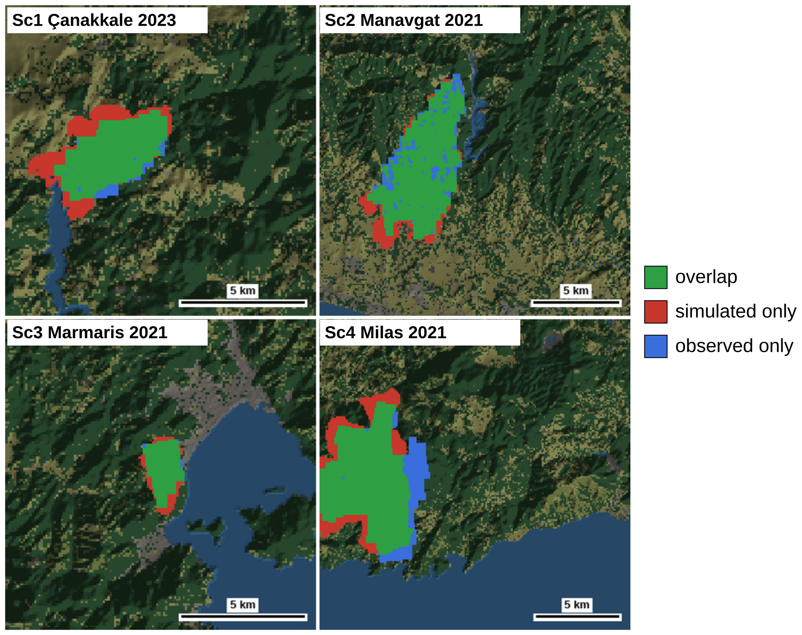
Test 1 assesses spatial agreement on four documented fires in Türkiye: Çanakkale 2023, Manavgat 2021, Marmaris 2021 and Milas 2021 (Sc1–Sc4). Inputs are Copernicus GLO-30 terrain, ESA WorldCover 2021 fuel, ERA5 weather and VIIRS ignitions and burn detections, with no tuning to these fires. The observed first-12-h footprint is rasterized at 90 m and closed by one VIIRS pixel. The free-spread simulation stops at the first step reaching that area. The test evaluates spatial agreement conditioned on the observed extent and does not validate timing; the area ratio in Table IV quantifies the overshoot of the discrete step.
Fig. 5. Hindcast agreement maps, first 12 h footprint.
Table IV
Hindcast spatial agreement
Score | Sc1 | Sc2 | Sc3 | Sc4
Front agreement, $1-d_{f}/R_{obs}$ | 83% | 89% | 89% | 86%
Probability of detection | 92% | 87% | 98% | 82%
Front distance (m), mean | 315 | 345 | 109 | 477
Area ratio (sim./obs.) | 1.37 | 1.00 | 1.24 | 1.03
Across 50 replicates per fire, detection probability is 0.82–0.98 and front agreement 0.83–0.89; the standard deviation over replicates stays below 0.01 in detection probability and below 15 m in front distance, since only spotting is stochastic. An equal-area disk around the ignition point, the reference without a spread model, gives detection probability 0.21–0.47 and front agreement 0.24–0.50 on the same footprints. Front agreement is $1-d_{f}/R_{obs}$, where $d_{f}$ is mean front distance and $R_{obs}$ the radius of the observed-area disk; detection probability is the fraction of observed burned cells reached [22]. The 109–477 m front distances correspond to roughly one to five hindcast cells. Fig. 5 shows the spatial comparison.

C. Decision Quality and Robustness
Table V reports outcomes and scenario changes against Closed; worse counts refer to larger burned area among 30 worlds. Against Closed, VODA reduces burned area from 75.4 to 29.1 ha (61%), affected population from 391 to 79 persons (80%), physical cost by 60% and total cost by 48%. Area falls in 131 worlds, is unchanged in 10 and rises in 9. Response cost also falls by 46%, so resource expansion does not explain the gain. Raising the response and delay weights in (16) from 0.2 to 1 narrows the total-cost advantage from 48% to 31 ± 7%, better in 108 worlds, and leaves the area result unchanged. Later admission raises dispatch-delay cost by 36%, included in the total. Extinguished incidents rise from 52% to 91%; VODA extinguishes 63% in S2 and 100% in S3–S5.
Table V
Main outcomes and scenario comparisons
Measure | None | Closed | VODA
Burned area (ha) | 250.7 ± 4.3 | 75.4 ± 11.9 | 29.1 ± 7.1
Affected population | 5793.4 ± 278.0 | 390.9 ± 77.8 | 79.1 ± 49.3
Extinguished (%) | 0.0  [0.0–2.5] | 52.0  [44.1–59.8] | 91.3  [85.7–94.9]
Burned-area cost | 0.653 ± 0.003 | 0.293 ± 0.032 | 0.142 ± 0.023
Asset-loss cost | 0.935 ± 0.014 | 0.121 ± 0.025 | 0.025 ± 0.014
Population cost | 0.207 ± 0.009 | 0.004 ± 0.002 | 0.001 ± 0.001
Response cost | 0.000 ± 0.000 | 0.428 ± 0.066 | 0.231 ± 0.048
Dispatch-delay cost | 0.000 ± 0.000 | 0.274 ± 0.023 | 0.373 ± 0.024
Physical cost | 0.598 ± 0.008 | 0.139 ± 0.018 | 0.056 ± 0.012
Total cost | 0.528 ± 0.007 | 0.164 ± 0.019 | 0.085 ± 0.012
Scenario | Burned area change (%) | Total cost change (%) | Worse / 30
S1 | −78 ± 31 | −59 ± 22 | 2
S2 | −62 ± 19 | −50 ± 15 | 1
S3 | −59 ± 26 | −42 ± 20 | 3
S4 | −56 ± 19 | −46 ± 16 | 1
S5 | −45 ± 19 | −35 ± 15 | 2

Table VI groups the source and search comparisons with model-error and operating-limit tests. The gated search with a random proposer reduces area by 46%, compared with 61% for VODA, so the gate chain over the candidate set carries most of the gain. The random control is a random search over the grammar of (19) with simulation-based selection, 36 candidates per call priced on the same forecasts and admitted by the same gates, so it is a search controller without a language model over the same vocabulary, and its margin over Closed measures what the composed vocabulary and the search add to doctrine written in families. At this comparable budget, the candidate-only LLM configuration exceeds the small random control by 14 ± 11 percentage points, while adding variations yields a further 16 ± 9 points. A repeat stays within four points of the nominal area advantage. With independent gate futures the advantage is 54 ± 12%; of the 360 calls that reach the final test, 354 admit their best candidate, compared with 359 of 364 nominally.
Table VI
Search and robustness comparisons
Setting | Δ burned area (%) | Δ total cost (%)
Candidate source and search
Random, one | −9 ± 8 | −4 ± 6
LLM, one | −28 ± 9 | −22 ± 6
Random, small | −32 ± 11 | −24 ± 8
LLM, candidates only | −45 ± 11 | −36 ± 8
Random, full | −46 ± 11 | −37 ± 8
VODA | −61 ± 14 | −48 ± 9
VODA repeat | −57 ± 13 | −46 ± 9
Independent gates | −54 ± 12 | −42 ± 9
Model errors and operating limits
Suppression intensity error (replay) | −56 ± 13 | −45 ± 9
Travel-effect decay error (replay) | −54 ± 12 | −45 ± 8
Knockdown threshold error (replay) | −57 ± 12 | −49 ± 9
Weakened coating | −54 ± 12 | −41 ± 8
Ineffective coating | −33 ± 9 | −24 ± 7
Coating price ×2 | −60 ± 13 | −46 ± 9
Coating stock 20 ha | −53 ± 13 | −42 ± 9
Coating delay 12 min | −50 ± 12 | −39 ± 8
Wind speed ×1.5 | −44 ± 12 | −35 ± 9
Wind direction +30° | −58 ± 13 | −47 ± 9
Wind direction −30° | −63 ± 14 | −49 ± 10

The three suppression errors retain area reductions of 54–57%. Weakening coating leaves 54 ± 12%, and removing its effect leaves 33 ± 9%, so the advantage extends beyond the nominal coating assumption. Known price, stock and delay limits retain 60%, 53% and 50%, respectively. Under the 20 ha stock, mean coated area is 11.2 ha. With price doubled, response cost is 0.277 versus 0.231 nominally and 0.428 for Closed. These outcomes identify coating effectiveness and availability as determinants of the attainable gain. In the 44 nominal worlds where VODA fields no coating, a subset it selects itself, area still falls by 34 ± 18% and 36 incidents are extinguished, against 70 ± 16% in the other 106; 181 of the 359 admitted objects contain no coating clause. Wind direction errors retain 58% and 63% area reductions. A 50% speed error leaves 44 ± 12%, with 73% of incidents extinguished.

D. Doctrine Transfer and Adaptation
The nominal open layer admits 359 objects: 233 composed interventions, 88 macros and 38 rules. Of these, 99 originate from the model and 260 from search variations. The gate chain examines 105 857 candidates over 878 calls: G1 to G4 reject 78 662, 514 calls end with no candidate gaining on both futures, the remaining 364 hand their best candidate to the final test, and 359 objects are admitted, one in 300 candidates. Of the 5268 model candidates, 805 fail G1 to G4. The admitted objects lower forecast physical cost on their worse future by a median 0.008; a margin of 0.001 in G7 would have refused 92 of them. Fig. 6 summarizes object types and clause effects. For example, rear holding soak wets the rear within two cells and coats it from one to three cells, carried by a rule requiring at least medium suppression feasibility. The four tactics selected as the recurring archetypes of the 75 derivation worlds, each admitted in at least 7 of them, and used as recorded doctrine in the transfer tests are line and attack, interface hardening, asset collar, and head coating; all four are ordinary initial-attack moves, retardant ahead of the head or around a settlement and lines blended with attack or protection, placed by forecast.
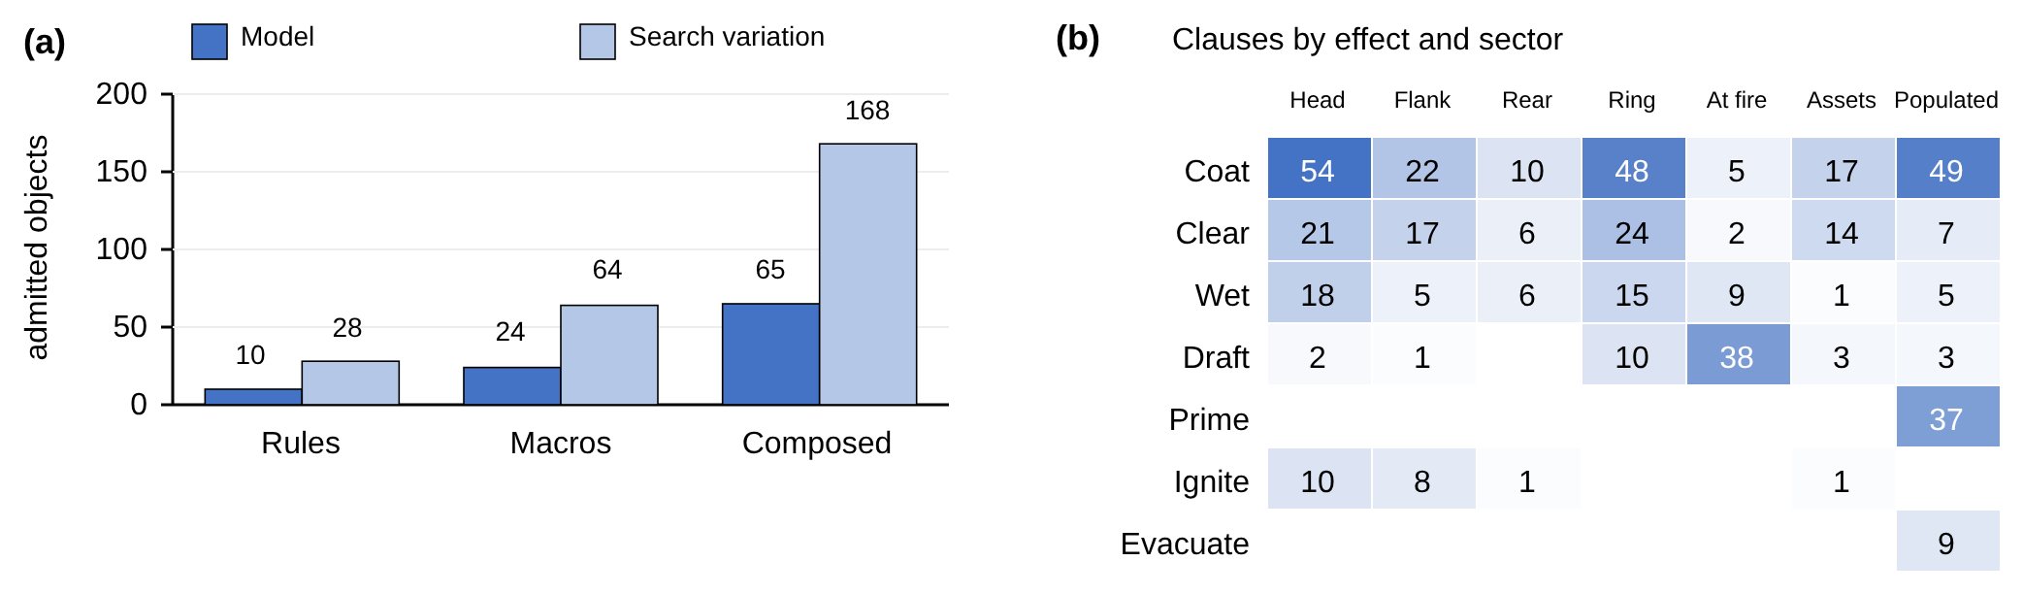
Table VII compares richer initial doctrine with generation during the incident. Seeds and Recorded denote the five seed rules and that base plus four transferred tactics, respectively. Open activates both decision layers; Closed uses only the closed layer. The 40-rule Closed control reduces area by 11% relative to the five-rule reference, while VODA remains 56 ± 14% below that stronger control. The 40 rules use the same six families and cannot write a composed intervention; the six hand-written tactics over the seven effects reduce area by 9 ± 6% and coat 20 ha per world, so access to the effects does not close the gap either. The four recorded tactics, composed interventions installed as fixed rules, carry most of it: derived from 75 worlds and installed before 75 unseen worlds, they reduce area by 50 ± 15%. With resource deployment withheld, Closed increases area by 40%, whereas VODA remains 42% below the complete Closed reference and restores the family in 62 of 150 worlds, at median minute 14. Withholding containment line changes Closed by 2 ± 6%, so resource deployment supplies the more informative recovery comparison.
Fig. 6. Admitted objects (a) by kind and origin, (b) clauses by effect and sector.
On the 90 S6–S8 worlds, recorded tactics with the closed layer reduce area by 43 ± 11% relative to the seed rules alone. Starting from seed rules with the open layer active shows no clear area difference from recorded tactics with the closed layer alone (−1 ± 18%). Keeping the open layer active with the same recorded tactics lowers area by a further 28 ± 10% and raises extinguished incidents from 51% to 72%. The S1–S5 control set gives a 35 ± 21% area reduction. With generation active in both configurations, starting from recorded tactics instead of the seed rules reduces area by 27 ± 16%. Thus recorded doctrine and continued generation contribute jointly on both the additional conditions and the control set.
Object-removal replay provides a complementary attribution test. Installing the admitted objects at their recorded times under the Closed controller yields a joint saving of about 45 ha per world; removing all objects returns the Closed outcome. The summed individual effects, about 32 ha, are smaller than the joint effect, showing interaction between interventions.
Table VII
Doctrine and continued generation comparisons
Configuration / reference | n | Δ burned area (%) | Δ total cost (%)
40 rules + Closed / Seeds + Closed | 150 | −11 ± 8 | +1 ± 6
Seeds + six hand-written effect tactics + Closed / Seeds + Closed | 150 | −9 ± 6 | −2 ± 5
Recorded + Closed / Seeds + Closed | 75 | −50 ± 15 | −40 ± 11
Seeds (no deployment) + Closed /  Seeds + Closed | 150 | +40 ± 12 | +35 ± 9
Seeds (no deployment) + Open /  Seeds + Closed | 150 | −42 ± 13 | −30 ± 9
S6–S8  Recorded + Closed / Seeds + Closed | 90 | −43 ± 11 | −34 ± 8
S6–S8  Seeds + Open / Recorded + Closed | 90 | −1 ± 18 | −4 ± 11
S6–S8  Recorded + Open / Recorded + Closed | 90 | −28 ± 10 | −22 ± 6
S1–S5 control  Recorded + Open / Recorded + Closed | 75 | −35 ± 21 | −22 ± 11
S6–S8  Recorded + Open / Seeds + Open | 90 | −27 ± 16 | −18 ± 11

E. Timeliness and Scalability
Decision computation takes a median 173 ms, a 526 ms ninetieth percentile and a 942 ms maximum in the isolated harness. Actual LLM-call cycles, including the gated search, have a 16 s ninetieth percentile and 55 s maximum, below the 12 min decision interval. Fig. 7 separates the scaling axes. Increasing agents from one to sixteen multiplies decision time by 1.2, whereas quadrupling the grid multiplies it by 2.9. Agent partitioning changes burned area by less than 3% in the tested comparisons, with no clear paired difference; the coordinator bounds regional allocations against the shared pool.

VI. Discussion and Conclusion
VODA extends the decision space of a wildfire DSS through verified composition of executable physical effects. On 150 paired worlds, it reduces burned area by 61%, affected population by 80% and priced response by 46%, while increasing extinguished incidents from 52% to 91%. Two results separate the sources of the gain: a random proposer over the same effects, sectors and bands recovers three quarters of it, so the gain rests on the composed vocabulary and the forecast-guided search rather than on the language model, and a hand-written doctrine over the same effects gains little while the recorded tactics installed in the closed layer carry most of it, so what the closed layer lacks is not access to the effects but the compositions the search finds. Seen as a planner, the gated search is a receding-horizon search over an action grammar; the contribution is the architecture around it, a doctrine that records what the search admits and gates that keep the proposer from deciding, so that interventions are discovered, checked and reused over a fixed executable basis.
The gain persists under the tested model errors and operating limits, including ineffective coating and faster-than-planned wind. Admission nevertheless remains conditional on the hazard model. The forecast-based guard evaluates physical cost over the guard horizon; it does not guarantee improvement on every realized trajectory. The blind hindcast assesses spatial agreement for free spread and does not validate the modeled intervention effects. Degraded-observation results concern inference and targeting, while planning retains the core snapshot, so the robustness claim is limited to those stages.
Recorded doctrine and continued generation provide complementary benefits. With the same recorded tactics available, keeping the open layer active reduces burned area by a further 28 ± 10% on S6–S8. The benefit also appears in the S1–S5 control set, so it cannot be attributed solely to unfamiliar conditions. Transfer supplies a useful initial doctrine while generation retains value within the incident. These tests freeze tactics before transfer and do not establish continuous learning across incidents.
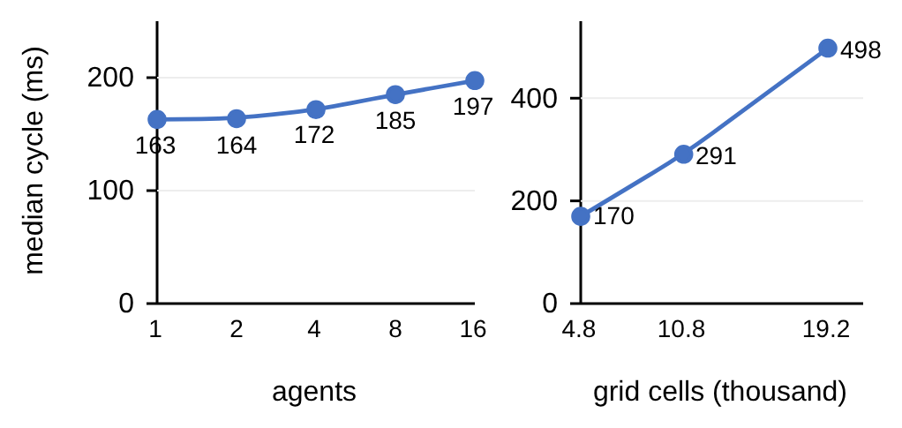
Logical regional partitioning adds little decision overhead within the shared resource pool. Decision computation stays below one second in the isolated harness; measured full cycles, including model calls, stay below the decision interval. Communication delay, partial information between regions and distributed failure are not modeled, so the system-of-systems claim concerns the architecture rather than a distributed deployment. Generated orders, including tactical ignition, remain recommendations under operator authority, and their acceptance by fire officers is untested. Future work will evaluate generated interventions with fire officers, calibrate effect operators against observed operations and test another hazard through its model and intervention vocabulary.
Fig. 7. Decision time by agents and grid size.

References

[1] | M. Turoff, M. Chumer, B. Van de Walle and X. Yao, "The design of a dynamic emergency response management information system (DERMIS)," J. Inf. Technol. Theory Appl., vol. 5, pp. 1-36, 2004.
[2] | D. M. Bowman, C. A. Kolden, J. T. Abatzoglou, F. H. Johnston, G. R. van der Werf and M. Flannigan, "Vegetation fires in the Anthropocene," Nat. Rev. Earth Environ., vol. 1, pp. 500-515, 2020.
[3] | M. P. Thompson and D. E. Calkin, "Uncertainty and risk in wildland fire management," J. Environ. Manage., vol. 92, no. 8, pp. 1895-1909, 2011.
[4] | D. E. Calkin, C. D. O'Connor, M. P. Thompson and R. D. Stratton, "Strategic wildfire response decision support and the risk management assistance program," Forests, vol. 12, p. 1407, 2021.
[5] | F. Vásquez, A. Cravero, M. Castillo and F. Riquelme, "Decision support system development of wildland fire: A systematic mapping," Forests, vol. 12, p. 943, 2021.
[6] | R. C. Rothermel, "A mathematical model for predicting fire spread in wildland fuels," Res. Pap. INT-115, 1972.
[7] | M. A. Finney, "An overview of FlamMap fire modeling capabilities," in Fuels Management: How to Measure Success (RMRS-P-41), 2006.
[8] | C. Pais, J. Carrasco, P. E. Moudio and Z.-J. M. Shen, "Downstream protection value: Detecting critical zones for effective fuel-treatment under wildfire risk," Comput. Oper. Res., vol. 131, p. 105252, 2021.
[9] | T. Orphanoudakis, C. Betzelos and H. C. Leligou, "MORA: A multicriteria optimal resource allocation and decision support toolkit for wildfire management," Algorithms, vol. 18, p. 677, 2025.
[10] | E. K. Noonan-Wright et al., "Developing the US wildland fire decision support system," J. Combust., vol. 2011, p. 168473, 2011.
[11] | C. Rapp, E. Rabung, R. Wilson and E. Toman, "Wildfire decision support tools: An exploratory study of use in the United States," Int. J. Wildland Fire, vol. 29, pp. 581-594, 2020.
[12] | C. Rapp, K. L. Courtney, S. T. Franz, M. M. Colavito, T. Aldworth and A. S. Cheng, "Wildfire decision support tools: barriers, facilitators, and future directions for effectiveness," Fire Ecol., vol. 22, p. 71, 2026.
[13] | D. Arnott and G. Pervan, "A critical analysis of decision support systems research," J. Inf. Technol., vol. 20, pp. 67-87, 2005.
[14] | A. Arbel and R. M. Tong, "On the generation of alternatives in decision analysis problems," J. Oper. Res. Soc., vol. 33, no. 4, pp. 377-387, 1982.
[15] | G. J. Hofstede, "Open problems, formal problems," J. Decis. Syst., vol. 4, pp. 155-165, 1995.
[16] | A. Colorni and A. Tsoukias, "Designing alternatives in decision problems," J. Multi-Criteria Decis. Anal., vol. 27, pp. 150-158, 2020.
[17] | E. D. Brill, J. M. Flach, L. D. Hopkins and S. Ranjithan, "MGA: A decision support system for complex, incompletely defined problems," IEEE Trans. Syst., Man, Cybern., vol. 20, pp. 745-757, 1990.
[18] | G. A. Klein, Sources of Power: How People Make Decisions, 20th anniversary ed., Cambridge, MA, USA: MIT Press, 2017.
[19] | M. G. Morgan and M. Henrion, Uncertainty: A Guide to Dealing with Uncertainty in Quantitative Risk and Policy Analysis. Cambridge, U.K.: Cambridge Univ. Press, 1990.
[20] | G. Shafer, A Mathematical Theory of Evidence. Princeton, NJ, USA: Princeton Univ. Press, 1976.
[21] | M. T. Ribeiro, S. Singh and C. Guestrin, ""Why should I trust you?" Explaining the predictions of any classifier," in Proc. ACM SIGKDD Int. Conf. Knowl. Discovery Data Mining, 2016.
[22] | C. Pais, J. Carrasco, D. L. Martell, A. Weintraub and D. L. Woodruff, "Cell2Fire: A cell-based forest fire growth model to support strategic landscape management planning," Front. For. Glob. Change, vol. 4, p. 692706, 2021.
[23] | L. A. Zadeh, "Fuzzy sets," Inf. Control, vol. 8, pp. 338-353, 1965.
[24] | T. Takagi and M. Sugeno, "Fuzzy identification of systems and its applications to modeling and control," IEEE Trans. Syst., Man, Cybern., vol. 15, pp. 116-132, 1985.
[25] | P. P. Angelov and D. P. Filev, "An approach to online identification of Takagi-Sugeno fuzzy models," IEEE Trans. Syst., Man, Cybern. B, vol. 34, pp. 484-498, 2004.
[26] | S. French, J. Maule and N. Papamichail, Decision Behaviour, Analysis and Support. Cambridge, U.K.: Cambridge Univ. Press, 2009.
[27] | F. Del Missier, M. Visentini and T. Mäntylä, "Option generation in decision making: Ideation beyond memory retrieval," Front. Psychol., vol. 5, p. 1584, 2015.
[28] | P. Struss, "Model-based decision support systems: Conceptualization and general architecture," in Proc. Int. Workshop Qualitative Reasoning (QR), Macao, China, 2019.
[29] | Y. Ding et al., "Integrating action knowledge and LLMs for task planning and situation handling in open worlds," Auton. Robots, vol. 47, pp. 981-997, 2023.
[30] | E. Gizzi, H. Amel, W. W. Lin, K. Rhea and J. Sinapov, "Toward creative problem solving agents: Action discovery through behavior babbling," in Proc. IEEE Int. Conf. Develop. Learn. (ICDL), 2021.
[31] | Y. Xie, B. Jiang, T. Mallick, J. D. Bergerson, J. K. Hutchison and D. R. Verner, "WildfireGPT: Tailored large language model for wildfire analysis," arXiv:2402.07877, 2024.
[32] | H. A. Simon, "Rational choice and the structure of the environment," Psychol. Rev., vol. 63, pp. 129-138, 1956.
[33] | P. Dubey and P. Dubey, "Bridging spatiotemporal wildfire prediction and decision modeling using transformer networks and fuzzy inference systems," MethodsX, vol. 15, p. 103498, 2025.
[34] | R. Chandra, S. S. Kumar, R. Patra and S. Agarwal, "Decision support system for forest fire management using ontology with big data and LLMs," Cluster Comput., vol. 28, p. 548, 2025.
[35] | Y. Cheng et al., "Retrieval over response: Large language model-augmented decision strategies for hierarchical wildfire risk evaluation," Fire, vol. 9, p. 143, 2026.
[36] | N. Gerolimos et al., "Autonomous decision-making enhancing natural disaster management through open world machine learning: A systematic review," Hum.-Centric Intell. Syst., 2025.
[37] | A. Sandeep, S. Jayarathna, S. Sandaruwan, V. Samarappuli, D. Meedeniya and C. Perera, "Context-aware multi-agent architecture for wildfire insights," Sensors, vol. 26, p. 1070, 2026.
[38] | J. Cui, C. Zhai, Y. Wang and Y. Li, "Large language models and AI agents in disaster-resilient infrastructure: Concepts, applications, pathways, and challenges," Reliab. Eng. Syst. Saf., vol. 272, p. 112497, 2026.
[39] | E. Park, J. Park and T. Kim, "WildfireKR: An LLM-agent decision support framework for autonomous wildfire spread simulation in South Korea," IEEE Access, vol. 14, pp. 59185-59208, 2026.
[40] | B. Romera-Paredes, M. Barekatain, A. Novikov, M. Balog, M. P. Kumar, E. Dupont, F. J. R. Ruiz, J. S. Ellenberg, P. Wang, O. Fawzi, P. Kohli and A. Fawzi, "Mathematical discoveries from program search with large language models," Nature, vol. 625, pp. 468-475, 2024.
[41] | Y. J. Ma, W. Liang, G. Wang, D.-A. Huang, O. Bastani, D. Jayaraman, Y. Zhu, L. Fan and A. Anandkumar, "Eureka: Human-level reward design via coding large language models," in Proc. Int. Conf. Learn. Represent. (ICLR), 2024.
[42] | M. Ahn et al., "Do as I can, not as I say: Grounding language in robotic affordances," in Proc. Conf. Robot Learn. (CoRL), 2022.
[43] | G. Wang, Y. Xie, Y. Jiang, A. Mandlekar, C. Xiao, Y. Zhu, L. Fan and A. Anandkumar, "Voyager: An Open-Ended Embodied Agent with Large Language Models," Trans. Mach. Learn. Res., 2024.
[44] | J. H. Scott and R. E. Burgan, "Standard fire behavior fuel models: A comprehensive set for use with Rothermel's surface fire spread model," Gen. Tech. Rep. RMRS-GTR-153, 2005.
[45] | K. G. Hirsch and D. L. Martell, "A review of initial attack fire crew productivity and effectiveness," Int. J. Wildland Fire, vol. 6, pp. 199-215, 1996.
[46] | M. P. Plucinski, "Fighting flames and forging firelines: Wildfire suppression effectiveness at the fire edge," Curr. Forestry Rep., vol. 5, pp. 1-19, 2019.
[47] | G. M. Byram, "Combustion of forest fuels," in Forest Fire: Control and Use, 1959, pp. 61-89.
[48] | C. E. Van Wagner, "Development and structure of the Canadian Forest Fire Weather Index System," For. Tech. Rep. 35, 1987.
[49] | F. Rodríguez y Silva, J. R. Molina Martínez and A. González-Cabán, "A methodology for determining operational priorities for prevention and suppression of wildland fires," Int. J. Wildland Fire, vol. 23, pp. 544-554, 2014.

Çağlar Akman received the B.S. and M.S. degrees in electrical and electronics engineering from Middle East Technical University (METU), Ankara, Türkiye, in 2008 and 2017, respectively, and the Ph.D. degree there in 2026. He manages research and development projects on advanced sensor systems, decision support architectures, and command and control software. His research interests include intelligent decision support systems, fuzzy inference, distributed architectures, and disaster management technologies.
Kemal Leblebicioğlu received the Ph.D. degree from the Department of Mathematics, METU, Ankara, Türkiye, in 1988. He has been a Full Professor with the Department of Electrical and Electronics Engineering, METU, since 1999. He has authored more than 40 journal papers and numerous book chapters and conference papers, and served as the Editor of the journal ELEKTRIK from 1996 to 2009. His research interests include optimization, optimal control, computer vision, intelligent systems, unmanned vehicles, and biomedical signal processing.

(Corresponding author: Çağlar Akman.) Ç. Akman and K. Leblebicioğlu are with the Department of Electrical and Electronics Engineering, Middle East Technical University, 06800 Ankara, Türkiye (e-mail: caglarakman@gmail.com; kleb@metu.edu.tr)

