**WEEK 7 REPORT**

**Sep 30**

**Nobuyoshi Hiramatsu**

**Cultural Reflection**

In Washington DC, we visited to Howard university, Japan Society for Promotion of Science (Nihon Gakujutsu Shinko-kai), and the White House. Dr. Thomas guided us around the campus in Howard university showing experimental equipments in the physics department, and gave an interesting lecture of his research. He talked also about his career and when he was a Ph.D. student under Prof. Kono in Rice University. When we went to Japan Society of Promotion of Science at Washington Office, the Director Dr. Nozaki introduced opportunities for research fellowships (Kakenhi) to us, and we had a casual discussion with him. Mr. Kei Koizumi who is working for federal science policy led us in the White House and we had a casual discussion with him too. Based on his talk, I realized the diversity of contribution to science in the US as well as fundamental importance of their works to establish the policy and education for facilitating scientific research and development. I would say, the whole opportunities in Washington DC were very enlightening for me.

In New York City (NYC), we went to Columbia university and I met with three professors thanks to effortful arrangement by Prof. Uemura in Columbia university. In the visit to Prof. Billinge's laboratory, I had opportunities to discuss physics of beam-line and X-ray with their graduate students as well as their student lives. With Assoc. Prof. Bailey, I have learned magnetic dynamics on a crystal surface, or spin-Hall effect. It was interesting for me to know about the detailed experimental differences of the development method of the magnetic-crystal which may affect the sample quality and the surface roughness. Assoc. Prof. Narayan casually introduced their researches in condensed matter experiments. The opportunities to meet with them were definitely great experiences for me to consider the potential field for my Ph.D. in Physics, and would be beneficial when to apply a graduate school or a job abroad. During free time in NYC, I went to Jazz bar called “Bluenote” where is one of the most historical and popular spot for modern jazz in the world. I accidentally had a seat there without the reservation, and enjoyed the atmosphere very much.

After coming back to Tokyo, we had small discussion with Prof. Maruyama from the University of Tokyo. From his talk I learned a lot including the importance to see research cultures from comparative and objective viewpoints, and the need to design career path by considering the future development of the field as well as the current research environment as he mentioned briefly.

**Question of the Week:** Is there any exceptional or special state law in Washington DC?

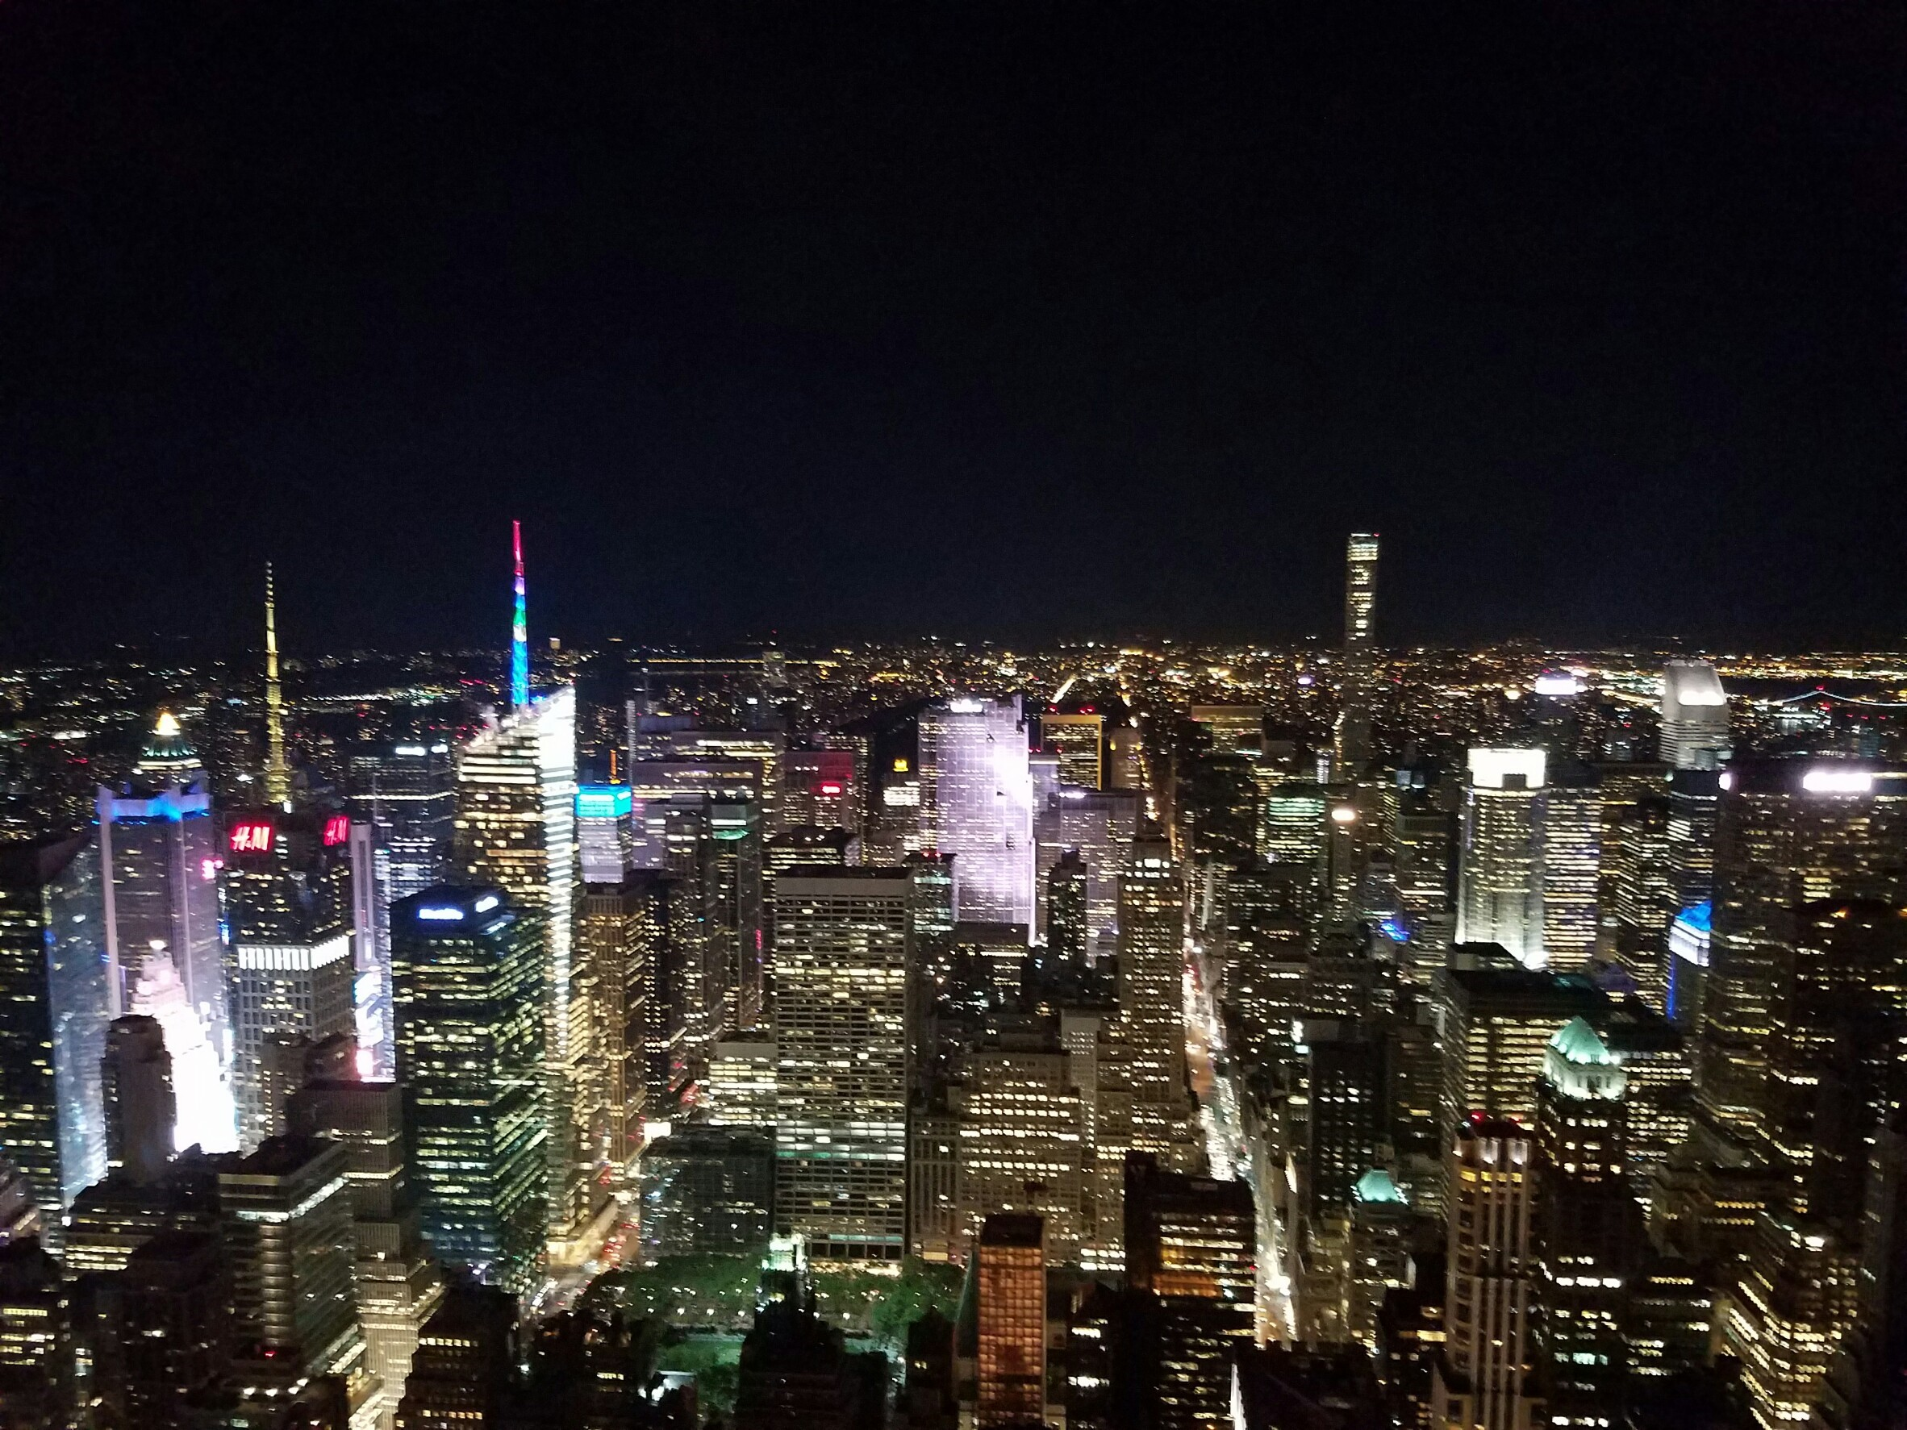

A spectacle view from Empire state building in NY.

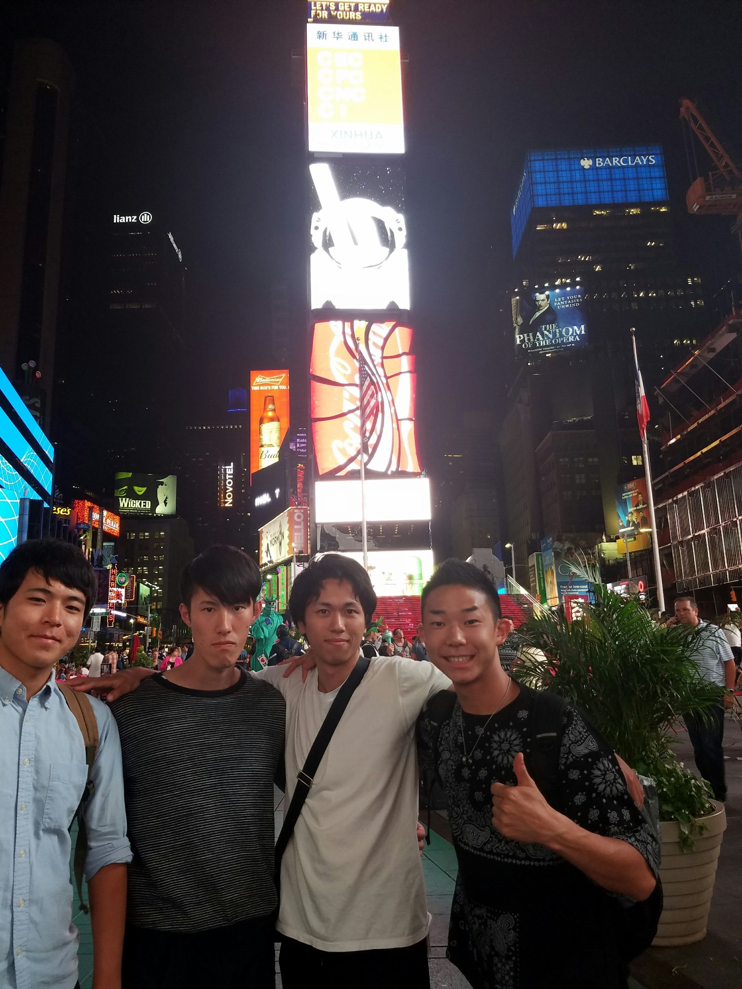

With colleague participants in Time square in NY.