金表面における中赤外プラズモンポラリトンの伝搬長測定

We studied propagation length of surface plasmon polaritons (SPPs) at gold/air interface in the mid-infrared range. We showed that SPPs propagate for a distance of about or above 10 mm at a wavelength of 10.6 μm, in good agreement with the value predicted from dielectric constant of polycrystalline gold. We also demonstrated that a simple treatment of thermal annealing led to noticeable elongation of SPP propagation length, accompanied by increased grain size and decreased surface roughness. Quantitative evaluation of SPP propagation length, in correlation with material's morphology, is important in designing plasmonic devices and beneficial for understanding the mechanisms of SPP's losses that underlie electric-field enhancement.

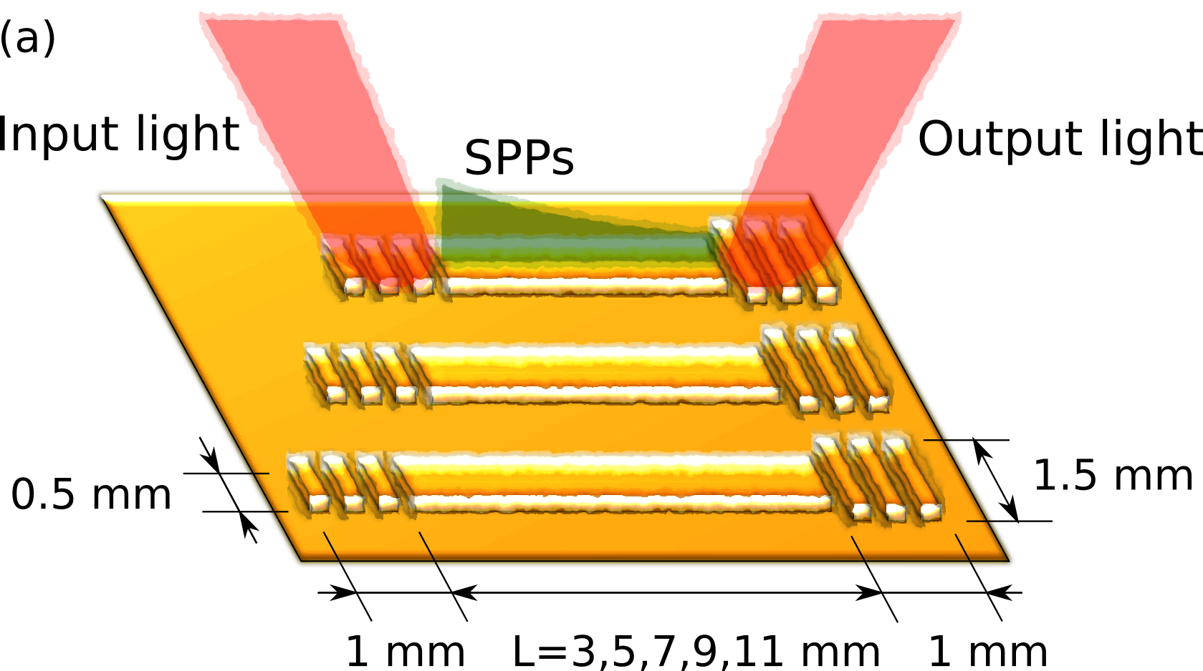

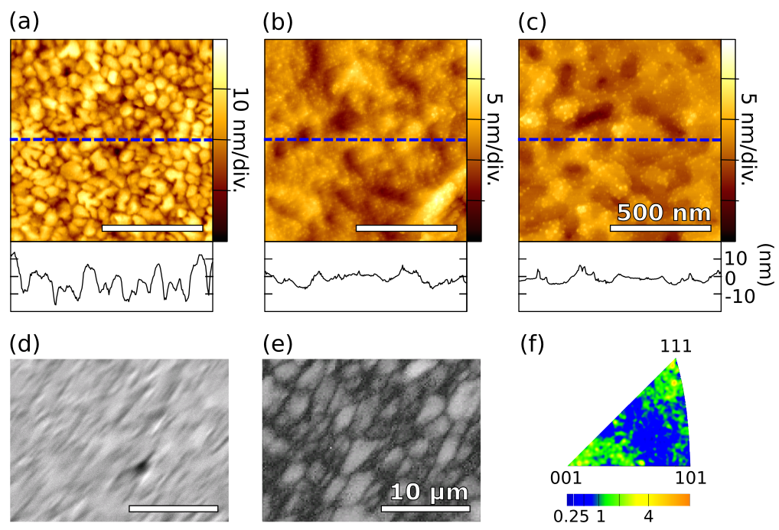
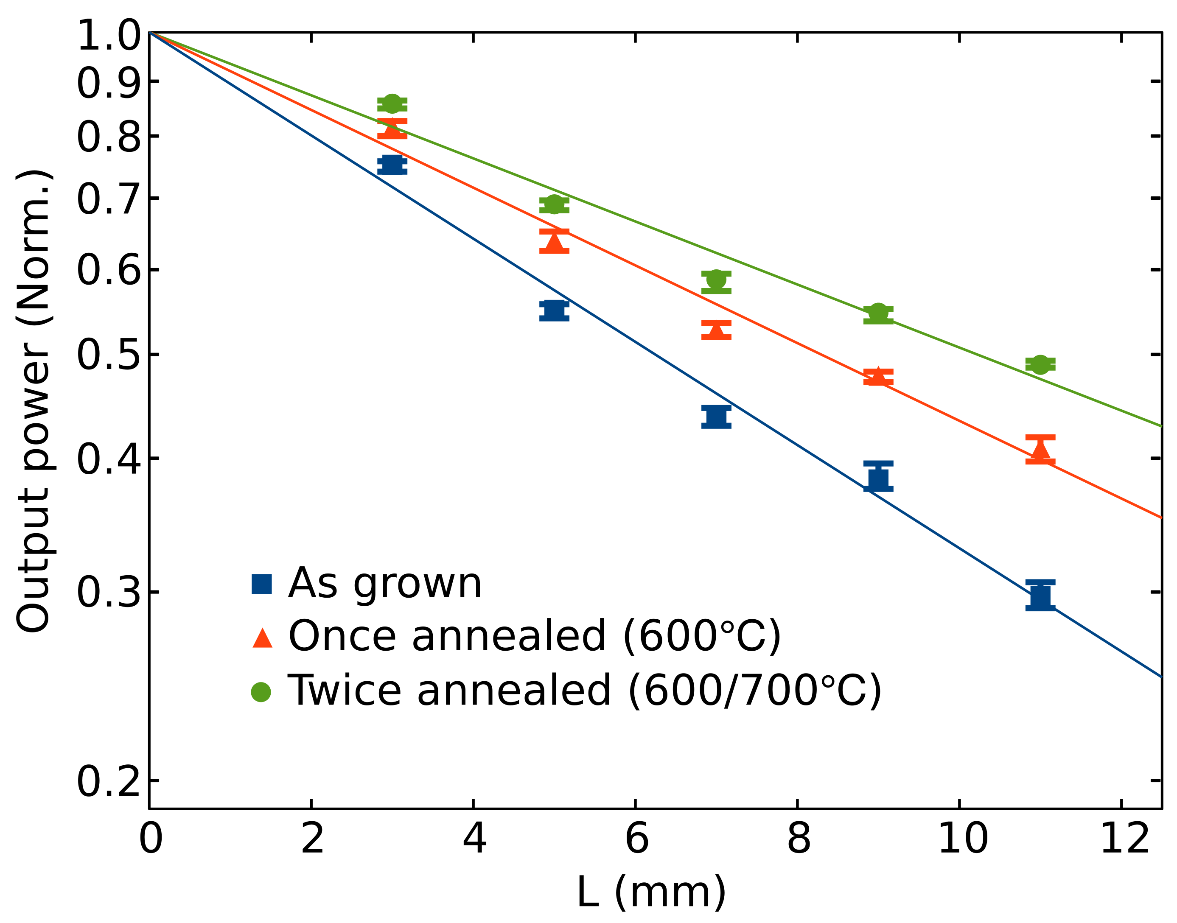

文献
1) 光学太郎，結晶素子：光学 52 (1995) 76.
2) 日本光学会 (編)：光学ハンドブック (光書房，東京，2015) p.100．

