 |   CONFIDENTIAL | INVENTION DISCLOSURE |  |  | Legal Dpt. Docket No.
 | We |  |  | No. of inventors | Date(s) invention conceived
 | Anderson Singulani, Harald Etschmaier |  |  | 2 | 13.01.2016
 | hereby disclose the following invention
 | Packaging for low stress suspension of sensor ICs
II | TO  ams AG - Legal Department  A-8141 Unterpremstätten, Austria |  | Received (date, time, stamp)  ........................................................
III | TECHNICAL BOARD DECISION  INVENTION DISCLOSURE RANKING:  A: INTERNATIONAL Patent Application  B: File at German Patent Office only  C: DO NOT FILE  For Rank A please specify geographic regions for application:  EU Other Countries:  US  Japan  For Rank C please check at least one of the following:  does not exceed prior art  is not within ams business interest  other (please comment):

(Please submit your disclosure in ENGLISH only)

Field of the Invention - Problem solved by this Invention & Summary

Many sensor ICs such as Hall sensors, pressure sensors, gyroscopes or inertial sensors are generally highly susceptible to the influence of stress. The stress can be introduced to the system either by deformation from external forces or generated internally due to the differences in CTE of the materials used in the package.
This can cause severe degradation of sensor performance and may even result in physical damage of the fragile sensor structures. The disclosed invention describes an assembly which enables a mechanical decoupling of the sensor from the substrate while maintaining a low package footprint.

Prior Art – (Known Solutions (References of patents or papers & short description) )

US 8,129,801 B2 (Honeywell, 2012)
The patent describes discrete stress isolation structures which are interposed beween the MEMS die and the substrate. These structures are difficult to assemble and significantly increase package costs and footprint.
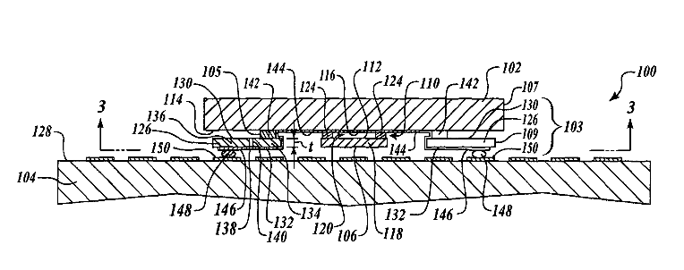

US 7,573,138 B2 (TSMC, 2009)
TSMC proposes interposed stress isolation structures from elastic polymers directly underneath the die. This setup still allows a very direct path for stress and the decoupling is not sufficient for sensitive MEMS devices.
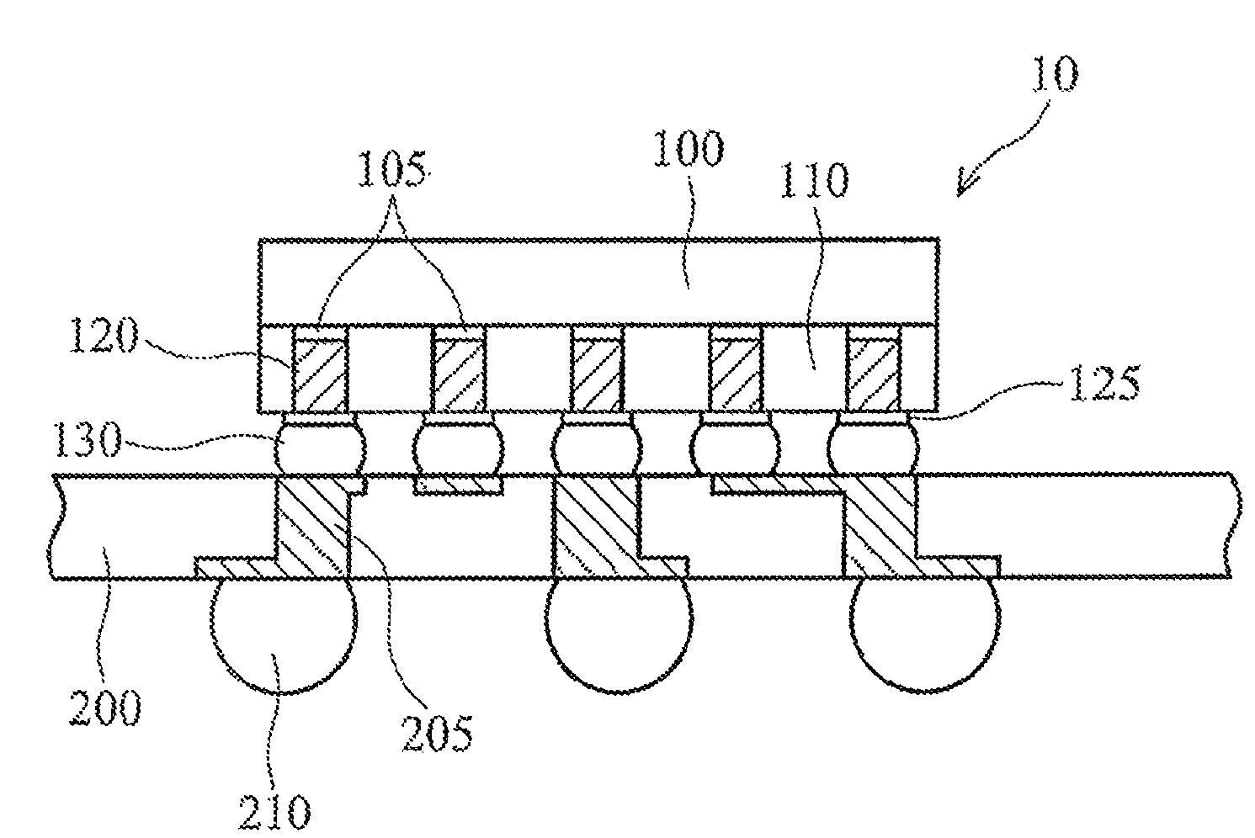

US2013/0168840 A1 (STMicroelectronics)
STM proposes a molded package with trenches in the IC surface and protective coating to decouple a stress sensitive region on the die. This method is not suitable for many environmental sensor (optical, gas, pressure…). Furthermore it significantly increases package height.
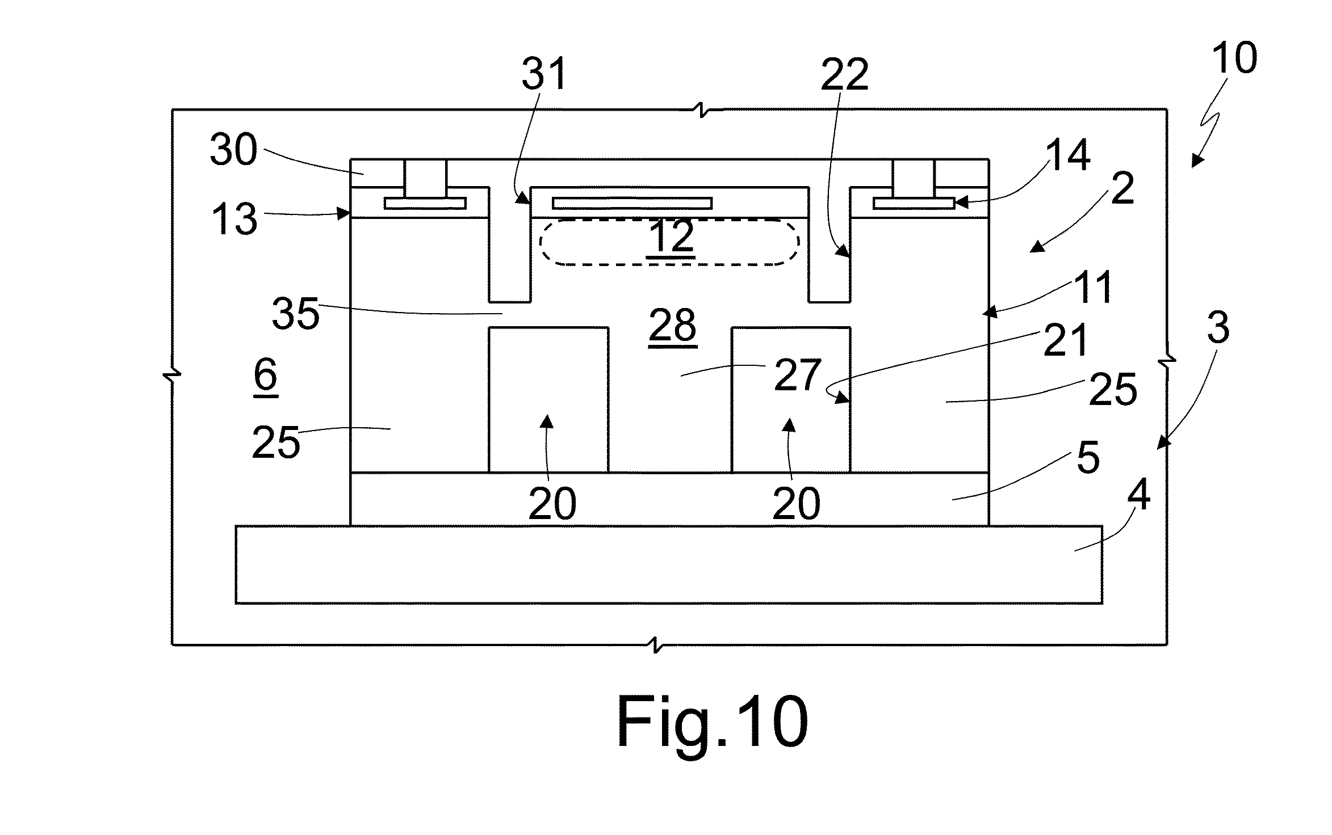

WO2015/124432 (Bosch GmBH)
Bosch uses wafer to wafer bonding in combination with TSV to create a stress decoupled region on the MEMS die. This method enable a very compact package but involves a complex and thus costly process flow (TSV, doube sided trenching).
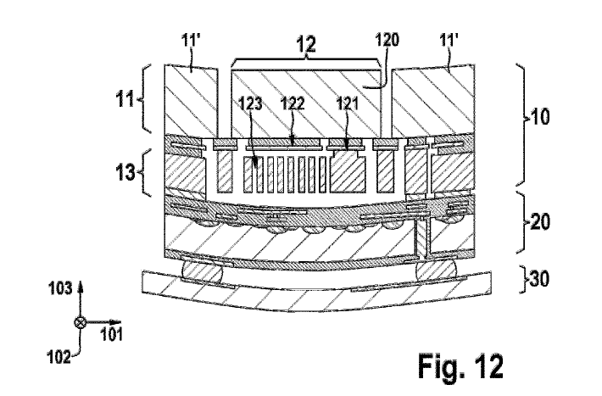

WO2012/037536 A2 (Fairchild)
Fairchild uses the ASIC as an (active) interposer and implements the stress decoupling structures on the MEMS die. This approach requires TSVs in the ASIC which makes the assembly more costly and fragile.
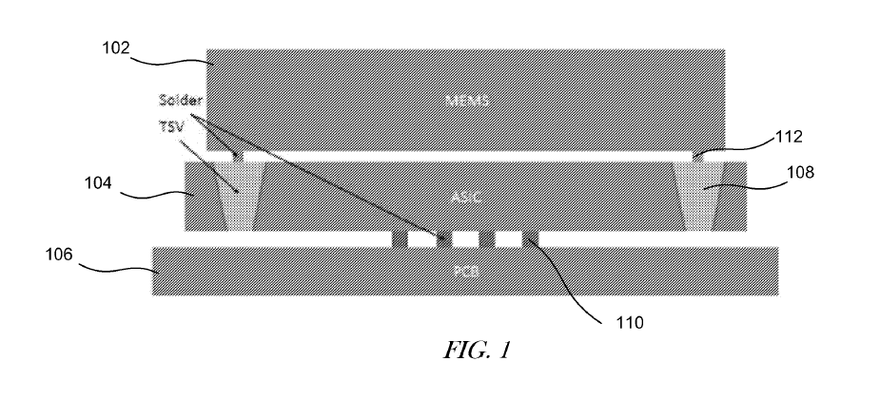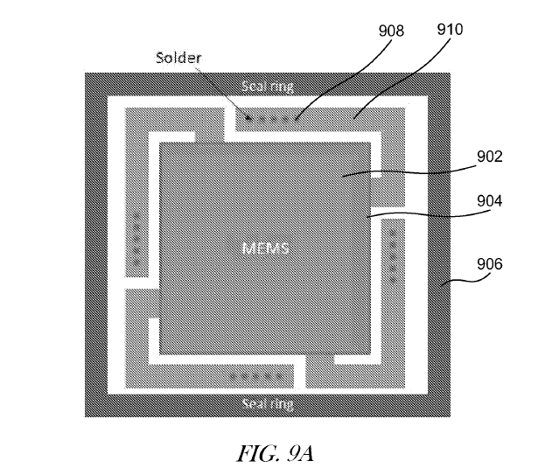

How does the invention advance Prior Art?

What’s new?

- structured passive silicon die as stress decoupling element (interposer)
- interposer on top of sensor die
- sensor die is rotated by 45 degrees relative to interposer
(ASIC and MEMS integrated on single silicon substrate)

Why is it better?

- small footprint
  - The overall package footprint and height is only marginally larger than the sensor die size. This is a clear advantage in comparison to conventional packages
- cheap:
  - the silicon interposer requires only minimal processing (single metal layer, DRIE). No TSVs or trenches trenches are needed and the full area of the interposer is available for making the decoupling structures (springs).
  - die to wafer stacking of sensor ICs can be done as a batch process.
- CTE matching:
  - The interposer is made from the same material as the sensor IC. Thus there is no mismatch in CTE that could cause additional stress
- Physical protection:
  - The fragile surface of the sensor IC (MEMS membrane) is protected from physical harm by the interposer, but there is still an air gap, which is essential for pressure and gas sensors.
- The package is applicable for sensors where the sensing element and the IC are integrated on a single die

Brief Description of Drawings

The sensor IC with the MEMS element is attached to the bottom side of a bare silicon die only at 4 points. These points of contact ly at the end of “arm” structures which are etched into the silicon. The bare silicon die and the active IC are rotated by 45 degrees against each other, such that the corners of the bare silicon overlap the underlying IC. On this overhanging corners the solderballs for the electrical connection are positioned. In the final assembly on the PCB the sensor IC is hanging suspended only from the arm structures, not touching the PCB.

Detailed Description of Preferred Embodiments

(Examples of the invention)

Process flow:
A1 – Front end processing of sensor IC
A2 – Application of gold bumps on IC top surface (stud bumps or ECD)
A3 – singulation of sensor dice

B1 – Single layer routing including bond pad opening on bare wafer
B2 - DRIE
B2 – Gold pad deposition
B3 – under bump metallization
B5 – wafer thinning
B4 – ball drop / reflow

AB1 – die to wafer bonding
AB3 - singulation

Proposed Claims (optional)

- Passive silicon die with stress decoupling structures mounted on top of sensor IC
- Sensor die rotated relative to interposer

Drawings
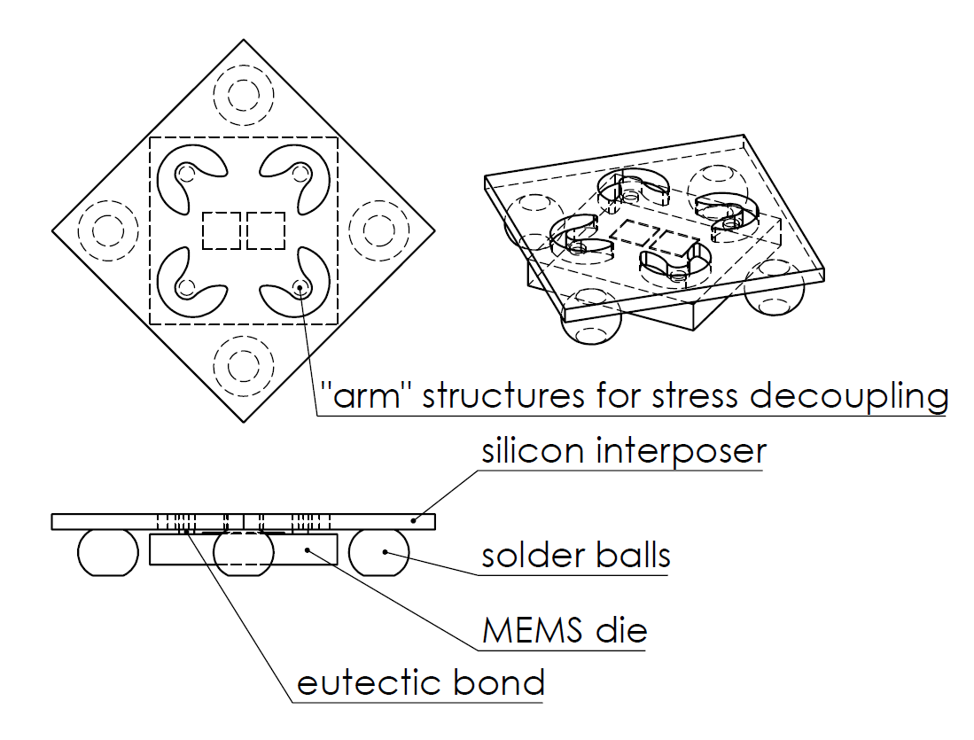

- Supplementary Information

Which business units are potentially interested in the invention? …………… SSI

Which products is the invention applicable to? …………… Hall sensors, pressure sensors

Has the invention been tested already? ……………………………………….. YES: NO:

If yes, please summarize the results

Have you informed persons outside ams about this invention?

Have you published the invention?

Do you plan to do so? …………… YES: NO:

If yes, when?
9. Inventor Information & Signature

INVENTOR 1:  CITIZENSHIP:  ADDRESS:  Street:  Place:  Zip Code:  Country:  Badge Nr.: | Business phone number:  Fax Number:  e-mail Address:  What is the percentage of your contribution to this invention?  Percentage Inventor 1:
INVENTOR 2:  CITIZENSHIP:  ADDRESS:  Street:  Place:  Zip Code:  Country:  Badge Nr.: | Business phone number:  Fax Number:  e-mail Address:  What is the percentage of your contribution to this invention?  Percentage Inventor 2:
INVENTOR 3:  CITIZENSHIP:  ADDRESS:  Street:  Place:  Zip Code:  Country:  Badge Nr.: | Business phone number:  Fax Number:  e-mail Address:  What is the percentage of your contribution to this invention?  Percentage Inventor 3:
INVENTOR 4:  CITIZENSHIP:  ADDRESS:  Street:  Place:  Zip Code:  Country:  Badge Nr.: | Business phone number:  Fax Number:  e-mail Address:  What is the percentage of your contribution to this invention?  Percentage Inventor 4:
INVENTOR 5:  CITIZENSHIP:  ADDRESS:  Street:  Place:  Zip Code:  Country:  Badge Nr.: | Business phone number:  Fax Number:  e-mail Address:  What is the percentage of your contribution to this invention?  Percentage Inventor 5:
INVENTOR 6:  CITIZENSHIP:  ADDRESS:  Street:  Place:  Zip Code:  Country:  Badge Nr.: | Business phone number:  Fax Number:  e-mail Address:  What is the percentage of your contribution to this invention?  Percentage Inventor 6:

