IMAGES WITH SELF-CORRECTING CAPABILITIES

^{a,b}Jiri Fridrich and ªMiroslav Goljan

ªCenter for Intelligent Systems, SUNY Binghamton, Binghamton, NY 13902-6000
^{b}Mission Research Corporation, 1720 Randolph Rd SE, Albuquerque, NM 87501
fridrich, bg22976@binghamton.edu

SUNY Binghamton, Binghamton, NY 13902-6000

ABSTRACT
In this paper, we introduce two techniques for self-embedding an image into itself as a means for protecting the image content. After selfembedding, it is possible to recover portions of the image that have been cropped out, replaced, damaged, or otherwise tampered. The first method is based on transforming small 8×8 blocks using a DCT, quantizing the coefficients, and carefully encoding them in the least significant bits of other, distant squares. This method provides a very high quality of reconstruction but it is very fragile. The second method is based on differential encoding and the quality of the reconstructed image gradually degrades with increasing amount of noise in the tampered image.

1. INTRODUCTION

Powerful publicly available image processing software packages such as Adobe PhotoShop or PaintShop Pro make digital forgeries a reality. Feathered cropping enables replacing or adding features without causing detectable edges. It is also possible to carefully cut out portions of several images and combine them together while leaving barely detectable traces.
In the past, several techniques based on data hiding in images have been designed as a means for detecting tampering. The redundancy of images can be utilized to insert some additional information for the purpose of detecting changes and for image authentication. If the inserted watermark is fragile so that any manipulation of pixels will disturb its integrity, one can easily detect the tampered areas by checking for presence of this fragile watermark. One of the first techniques used for detection of image tampering was based on inserting check-sums of gray levels determined from the seven most significant bits into the least significant bits (LSB) of pseudo-randomly selected pixels [1]. This technique provides very high probability of tamper detection, and it can be implemented in such a manner that creating forgeries from one or multiple authenticated images is highly unlikely without a secret key.
Yeung and Wong [10,11] generate a key dependent binary valued function f, f: {0, 1, …, 255} → {0,1}, that maps integers from 0 to 255 to either 1 or 0. The gray scales are perturbed to satisfy the expression L(i,j) = f_{g}(g(i,j)) for each pixel (i,j). Error diffusion is further employed to preserve the original colors. The image authenticity is easily verified by checking the relationship L(i,j) = f_{g}(g(i,j)) for each pixel (i,j). There are some obvious advantages of this approach. First, the logo can visually represent a particular authentication device or software. By comparing the original logo with the recovered one, one can visually inspect the integrity of the image. Second, the authentication watermark is embedded not only in the LSBs of the image but somewhat deeper (± 5 gay scales). This makes it more secure and harder to remove. Third, the method is fast, simple, and amenable to hardware implementation. This makes it very appealing for various applications. In this report, we show that if the same logo and the same image key are used for watermarking more than one image, it is typically possible to recover a large portion of the binary function, and subsequently the binary logo [10−13].
Van Schyndel et al. [2] modify the LSB of pixels by adding extended m-sequences to rows of pixels. For an N×N image, a sequence of length N is randomly shifted and added to the image rows. The phase of the sequence carries the watermark information. A simple cross-correlation is used to test for the presence of the watermark. Wolfgang and Delp [3] extended van Schyndel’s work and improved the localization properties and robustness. They use bipolar m-sequences of –1’s and 1’s arranged into 8×8 blocks and add them to corresponding image blocks. The watermark presence can be evaluated using classical correlation. The fact that the watermark has some robustness properties can be used to quantify the degree of tampering.
Zhu et al. [4] propose two techniques based on spatial and frequency masking. Their watermark is guaranteed to be perceptually invisible, yet it can detect errors up to one half of the maximal allowable change in each pixel or frequency bin depending on whether frequency [5] or spatial [6] masking is used. The image is divided into blocks and in each block a secret random signature (a pseudo-random sequence uniformly distributed in [0,1]) is multiplied by the masking values of that block. The resulting signal depends on the image block and is added to the original block quantized using the same masking values. Errors smaller than one half of the maximal allowable change are readily detected by this scheme. The error estimates are fairly accurate for small distortions.
Fridrich [7,8] describes a technique capable of distinguishing malicious changes from innocent image operations or LSB shuffling. An image is divided into medium-size blocks and a robust spread-spectrum watermark is inserted into each block. If watermarks are present in all blocks with high probability, one can be fairly confident that the image has not been tampered with in any significant manner (such as adding or removing features comparable in size to the block). If the watermark correlation is lower uniformly over all image blocks, one can deduce that some image processing operation was most likely applied. If one or more blocks show very low evidence for watermark presence while other blocks exhibit values well above the threshold, one can estimate the probability of tampering and with a high probability decide whether or not the image has been tampered with.
In this paper, we present two methods for self-embedding an image into itself as a means for protection of image content and for authentication. In Section 2 and 3, both methods described and their properties are discussed. We conclude the paper in Section 4 and outline some future directions.

Method 1
In this paper, we describe a new anti-tampering technique that can be used to retrieve the original content rather than just indicate which pixels or blocks have been tampered with. The image is divided into 8×8 blocks and each block is DCT transformed. A specified number of the lowest frequency DCT coefficients are quantized using a quantization matrix corresponding to a 50% quality JPEG. The coefficients are ordered in a zig-zag manner and their values are encoded using a fixed number of bits. The number of coefficients and their encoding are carefully chosen so that the resulting bit-string for each block is exactly 64 bits long. Information about block B (e.g., the 64-bit string) is inserted into the LSB of the block B +, where is a vector of length approximately 3/10 of the image size with a randomly chosen direction. If two LSBs are used for selfembedding, more quantized coefficients can be encoded using 128 bits rather than just 64. In this case, the recovered selfembedded image is perceptually indistinguishable from a 50% quality JPEG compressed original. This enables us to recover even very small features comparable to the block size. To prevent a pirate from masking a forged piece of an image, the bit-string should be encrypted.

For obvious reasons, it is certainly not possible to embed a complete image into itself. To lower the information content of the image, we have to use either lossy compression (e.g., JPEG compression), decrease the color depth of the image, or preserve only important image features, such as information about edges, using Laplacian filter.
In Method 1, we decrease the information content of the original image using a procedure similar to lossy JPEG compression algorithm. We start with dividing the original image into blocks of 8×8 pixels. The following three steps are carried out for each block B:

Step 1 (Preparing the image for embedding).
Gray levels of all blocks are transformed into the interval [−127, 128] and the LSBs of all pixels are set to zero. As will be seen later in this section, this step is important and enables automatic discernment between a tampered block and an unchanged block for which the code was lost by tampering with some other part of the image.

Step 2 (Generating the code).
Each 8×8 block B is transformed into the frequency domain using DCT. The first 11 coefficients (in zig-zag order) are quantized with the following quantization table Q that corresponds to 50% quality JPEG:
Q=[16 11 10 16 24 40 51 61
12 12 14 19 26 58 60 55
14 13 16 24 40 57 69 56
14 17 22 29 51 87 80 62
18 22 37 56 68 109 103 77
24 35 55 64 81 104 113 92
49 64 78 87 103 121 120 101
72 92 95 98 112 100 103 99].
The quantized values are further binary encoded. The bit lengths of their codes (including the signs) are shown in matrix L
L=[7 7 7 5 4 3 2 1
7 6 5 5 4 2 1 0
6 5 5 4 3 1 0 0
5 5 4 3 1 0 0 0
4 4 3 1 0 0 0 0
3 2 1 0 0 0 0 0
2 1 0 0 0 0 0 0
1 0 0 0 0 0 0 0].
Coding based on L will guarantee that the first 11 coefficients from each block will be coded using exactly 64 bits. In the rare event when the i-th DCT coefficient has absolute value is larger than 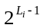, only this maximum available value will be encoded.

Step 3 (Encrypting and embedding).
The binary sequence obtained in Step 2 (e.g., the 64-bit string) is encrypted and inserted into the LSB of the block B +, where is a vector of length approximately 3/10 of the image size with a randomly chosen direction. Periodic boundary conditions (torus topology) are used to get the block B + always inside the image (see Error: Reference source not found).
After selfembedding, the marked image is modified very little. In fact, on average 50% of pixel values will not be changed, and 50% of them will be modified by one gray level. The quality of the reconstruction using algorithm #1 is visibly worse than for an image that has been JPEG-compressed at 50% quality. This may not be sufficient for capturing details smaller than the block size. There is an obvious tradeoff between the quality of reconstruction and the extent of modifications due to selfembedding. By using two least significant bits for selfembedding rather than just one LSB, the image quality of the reconstruction will be dramatically improved while the changes to the original image will still be very minor.


Figure 1 Image reconstructed from the LSB using Algorithm #1.

2.2 Selfembedding algorithm #2

As explained above, this algorithm is similar to algorithm #1 with the exception that two LSBs are now used for encoding the original content of the image.

Step 1 (Preparing the image for embedding).
This step is the same as in Algorithm #1. Two least significant bits are now set to zero.

Step 2 (Generating the code).
Each block is transformed into the frequency domain using DCT. The first 3 coefficients are encoded using the same number of bits as in Algorithm #1. The next 18 bits carry information about coefficients No. 4–21. A zero means that the corresponding coefficient is 0, while ones indicate non-zero coefficients. Following these 18 bits, we encode the values of all nonzero coefficients. Coefficients of higher frequencies are encoded with correspondingly fewer bits. If the length of the code is still short enough, up to two next nonzero coefficients between the 22nd and 36th coefficient are also coded (again, their positions first and then their values). The average code length is about 100 bits (1.55 bits per pixel). The code is shorter for blocks from areas of approximately uniform brightness. If the total length of the code is less than 128, zero padding is applied. All 128 bits are utilized for detection of tampered blocks.

Step 3 (Encrypting and embedding).
This step is the same as in Algorithm #1 with the exception that now 2 LSBs are replaced with the code.
In Figures 3−7, we demonstrate the amazing ability of the presented techniques to retrieve the original, seemingly lost content with a very good quality. Figure 3 is the original image and Figure 4 shows the original image with its content embedded using Algorithm #2. One can easily recover the original license plate (Figure 6) from an image in which the plate has been replaced with a different one (Figure 5). Figure 7 is an image recovered from the encoded information only. Notice the scrambled block corresponding to the code in the tampered license plate.
Another example of recovery of a person's face that has been mosaic-filtered to prevent identification is shown in Figures 8−9.

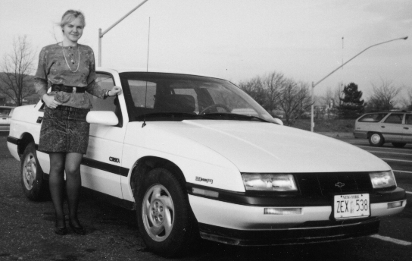
Figure 2 Original image

Figure 3 Self reconstructable modification
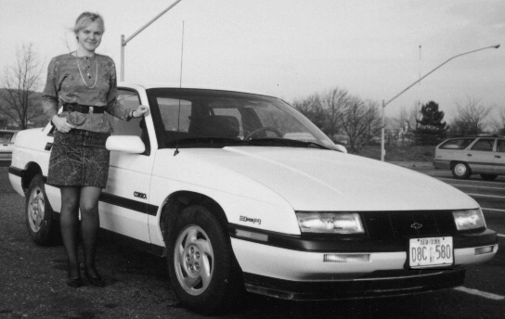
Figure 4 Tampered self reconstructable modification (tampered license plate)

Method 2
The main advantage of Method 1 is the high visual quality of the reconstructed image. However, this has been achieved at the expense of extreme fragility. The embedded information is highly fragile and a simple randomization of the least significant bit will completely erase the embedded information. Even very high quality JPEG compression so commonly used for storing imagery will disturb the embedded data beyond practical use. This severely limits the use of this method because it essentially requires lossless compression. Obviously, in order to achieve robustness of the self-embedded data, one needs to sacrifice the quality of the embedded image. The capacity requirements for self-embedding are just too stringent in order to achieve any reasonable degree of robustness. Method 2 is a step towards achieving a robust self-embedding technique. Even though its robustness is not sufficient for JPEG compression quality lower than 90%, it can successfully survive simple least significant bit randomization. The quality of the reconstructed image gradually decreases with the amount of noise added to the image.
The method is a variation of simple differential encoding. First, the color depth of the original image I is decreased to 16. Then, the gray levels of the recolored image are transformed to the interval [−8,8]. It is this low color depth image that will be embedded in the original image. The embedding process starts in the upper left corner and proceeds by rows from left to right, top down. We denote the gray values of the original image as g_{ij}, 0 ≤ g_{ij} ≤ 255 and the truncated image −8 ≤ t_{ij} ≤ 8. Similar to Method 1, we perform a cyclic shift on t_{ij} by an integer vector s = (s₁, s₂) to obtain a shifted version st_{ij}
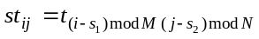.
As the first step, we set g'₁₁=g₁₁. Having adjusted the gray level g_{ij} to g'_{ij} we modify the value g_{ij+1} to g'_{ij+1} by enforcing
g'_{ij+1} − g'_{ij} = st_{ij}.
If we understand the last equation as mod 8, it is clear that we will never have to modify g_{ij+1} by more than ±8, and the average change to the gray level levels will be 4. If g'_{ij+1} spills over 255 or below 0, we subtract 16 or add 16 respectively, to enforce g'_{ij+1} to be in the range [0, 255]. In those rare cases, the change to the original gray level may be larger than 8 not more than 16.
To reconstruct the color truncated approximation to the original image at pixel (i,j), we calculate the difference g'_{kl+1} − g'_{kl}, where k = (i+s₁) mod M and l = (j+s₂) mod N.
Figure X shows the test image "Lenna" and the same image after it has been self-embedded using Method 2. The RMS difference between the original and the self-embedded image is 4.6 gray scales. Without any distortion, the embedded image can be extracted without any loss of information (see Figure Ya). If the self-embedded image has been tampered by randomizing the LSB, the reconstructed image becomes somewhat noisy, but retains its content (see Figure Xb). Adding random noise with maximal amplitude 1 and 2 results in images in Figures Xc and d. Clearly, the quality of the reconstructed image rapidly decreases with the amount of added noise. JPEG compression with quality factor 85% erases the embedded information. Method 2 should b viewed as a step towards practical, robust self-embedding methods that can be used with high quality lossy compression. Its robustness is still not sufficient for practical applications, but it gives us a hope that practical self-embedding method may be within the reach.
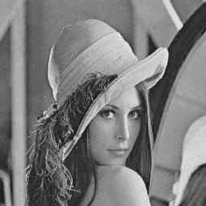
Figure 5 The original and self-embedded image.
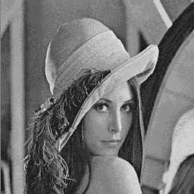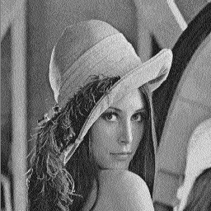
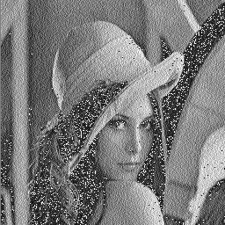
Figure 6 From upper left corner right and down: The recovered images after no attack, after randomizing the LSB, after adding random noise with amplitudes 1, and 2.
4. CONCLUSIONS AND FUTURE DIRECTIONS

In this paper, we overviewed current techniques for tamper detection in digital images. We proposed and tested a new technique for embedding an image into itself. We divide the image into small 8×8 blocks that are DCT transformed, quantized, and carefully encoded into the LSBs of other distant 8×8 blocks. This enables us to recover portions of images that have been cropped or replaced or severely modified. If two least significant bits are used for encoding, the quality of the reconstructed image is indistinguishable from a 50% quality JPEG compressed image. The technique can be easily extended to color images.
The proposed technique has been designed with the intent to maximize the quality of the recovered
image. The embedded information has no redundancy and is therefore very fragile and cannot survive any image modification that modifies the least two significant bits. In order to gain some robustness, we would have to sacrifice the quality of the recovered image. The more robustness is required, the less information can be encoded and the worse the image quality of the reconstructed image.
In our future research, we will study spread spectrum techniques for selfembedding in order to gain some robustness.

5. ACKNOWLEGEMENTS

The work on this paper was supported by Air Force Research Laboratory, Air Force Material Command, USAF, under a research grant number F30602-98-C-0176. The U.S. Government is authorized to reproduce and distribute reprints for Governmental purposes notwithstanding any copyright notation there on. The views and conclusions contained herein are those of the authors and should not be interpreted as necessarily representing the official policies, either expressed or implied, of Air Force Research Laboratory, or the U. S. Government.

6. REFERENCES

[1] S. Walton, “Information Authentication for a Slippery New Age”, Dr. Dobbs Journal, vol. 20, no. 4, pp. 18–26, Apr 1995.
[2] R. G. van Schyndel, A. Z. Tirkel, and C. F. Osborne, “A Digital Watermark”, Proc. of the IEEE Int. Conf. on Image Processing, vol. 2, pp. 86–90, Austin, Texas, Nov 1994.
[3] R. B. Wolfgang and E. J. Delp, “A Watermark for Digital Images”, Proc. IEEE Int. Conf. on Image Processing, vol. 3, pp. 219–222, 1996.
[4] B. Zhu, M. D. Swanson, and A. Tewfik, “Transparent Robust Authentication and Distortion Measurement Technique for Images”, preprint, 1997.
[5] G. E. Legge and J. M. Foley, “Contrast Masking in Human Vision”, J. Opt. Soc. Am., 70(12), pp. 1458–1471, 1980.
[6] B. Girod, “The Information Theoretical Significance of Spatial and Temporal Masking in Video Signals”, Proc. of the SPIE Human Vision, Visual Processing, and Digital Display, vol. 1077, pp. 178–187, 1989.

[7] J. Fridrich, “Image Watermarking for Tamper Detection”, Proc. ICIP ’98, Chicago, Oct 1998.

[8] J. Fridrich, “Methods for Detecting Changes in

Digital images”, ISPACS, Melbourne, November 4th-6th, 1998.
[9] J. Fridrich, “Robust Bit Extraction From Images”, ICMCS'99, Florence, Italy.
[10] M. Yeung, and F. Mintzer, "An Invisible Watermarking Technique for Image Verification", Proc. ICIP'97, Santa Barbara, California, 1997.
[11] P. Wong, "A Watermark for Image Integrity and Ownership Verification", Proc. IS&T PIC Conference, Portland, Oregon, 1998.
[12] R. B. Wolfgang and E. J. Delp, "Fragile Watermarking Using the VW2D Watermark", Proc. SPIE, Security and Watermarking of Multimedia Contents, San Jose, California, Jan 25−27, 1999, pp. 204−213.
[13] D. Kundur and D. Hatzinakos, "Towards a Telltale Watermarking Technique for Tamper Proofing", Proc. ICIP, Chicago, Illinois, Oct 4−7, 1998, vol 2.

