Comparing robustness of watermarking techniques

Jiri Fridrich*^{a,b}, Miroslav Goljanª

ªCenter for Intelligent Systems, SUNY Binghamton, Binghamton, NY 13902-6000

^{b}Mission Research Corporation, 1720 Randolph Rd SE, Albuquerque, NM 87106

ABSTRACT

A methodology for comparing robustness of watermarking techniques is proposed. The techniques are first modified into a standard form to make comparison possible. The watermark strength is adjusted for each technique so that a certain perceptual measure of image distortion based on spatial masking is below a predetermined value. Each watermarking technique is further modified into two versions for embedding watermarks consisting of one and 60-bits, respectively. Finally, each detection algorithm is adjusted so that the probability of false detections is below a specified threshold. A family of typical image distortions is selected and parametrized by a distortion parameter. For the one-bit watermark, the robustness with respect to each image distortion is evaluated by increasing the distortion parameter and registering at which value the watermark bit is lost. The bit error rate is used for evaluating the robustness of the 60-bit watermark. The methodology is explained with two frequency-based spread spectrum techniques. The paper is closed with an attempt to introduce a formal definition of robustness.

Keywords: Digital watermarking, steganography, robustness, spread spectrum, perceptual distortion measures

- Introduction

Digital watermark is a perceptually transparent pattern inserted in an image using an embedding algorithm and a secret key. The purpose of the watermark is to supply some additional information about the image to identify the image owner or a particular customer, to verify image integrity, or to achieve control over the copy process of a particular digital media^{1,2}.

The information carried by the watermark can be can be accessed using a detection algorithm provided the secret key is known. An important property of a watermark is its robustness with respect to image distortions. This means that the watermark should be readable from images that underwent common image processing operations, such as filtering, lossy compression, noise adding, histogram manipulation, and various geometrical transformations. Watermarks designed for copyright protection, fingerprinting, or access control must also be embedded in a secure form. This means that an attacker who knows all details of the embedding algorithm except the secret key should not be able to disrupt the watermark beyond detection. In other applications, such as adding additional captions to images or subtitles in several languages to movies, there is little motivation for intentional removal of the watermark, and the embedding/detecting key can be made public. The number of bits carried by the watermark could be as low as one bit or several hundred bits. Obviously, there is a trade-off between the robustness and the capacity of the watermark. Another important attribute of watermarking is the computational complexity of the embedding and extracting process. In some applications, it is important that the embedding process be as fast and simple as possible (watermarking images in digital cameras for tamper detection) while the extraction can be more time consuming. In other applications, the speed of extraction is absolutely crucial (e.g., extracting captions from digital video).

With the large number of watermarking techniques recently developed, one becomes naturally wondering if it is possible to compare the performance of different techniques in a fair manner. As explained in the previous paragraph, each watermarking scheme possesses the following attributes: robustness, security, capacity, and computational complexity. It is rather difficult to quantify and therefore compare security. Based on our current knowledge of attacks, a method is either secure or is not. Depending on the application, security may not even be an issue. Computational complexity can be easily established by measuring the time for embedding / extraction or by comparing the asymptotic expressions for complexity of the algorithms as a function of the image and message sizes. Capacity and robustness are two conflicting properties and one of them has to be standardized in order to be able to compare different techniques. The goal of this paper is to design methodology for comparing robustness of different watermarking techniques. We will not consider the security and computational complexity attributes as long as the computational complexity stays within a reasonable range.

To develop a fair method for comparing robustness of watermarking techniques, one will have to address the following difficult issues.

- Robustness is not a well-defined concept and it is questionable whether it can ever be formally defined.
- The minimal required robustness is highly application-dependent. It may not make sense to compare techniques intended for different applications.
- Robustness depends on the information capacity of the watermark, the watermark strength / visibility, and the detection statistics (threshold).
- Robustness is also influenced by the choice of images (size, content, color depth).
- In some cases it is possible to trade robustness for security.
- Techniques robust to a wider spectrum of image deformations may not have the best robustness for specific image deformations.

In spite of the problems outlined above, the authors believe that the idea of comparing watermarking techniques is fruitful. The choice of test images could be fixed, as well as a set of parametrized image deformations. Each watermarking technique could be put into standard forms to embed just one bit or a 60-bit watermark. The watermark strength (or visibility) can be adjusted using a model of the human visual system so that the number of pixels with visible changes is less than a specified fraction. Each watermarking scheme would also have to be adjusted so that the probability of false detections and missed detections is below certain specified limit. Watermarking techniques standardized in this manner could probably be meaningfully compared. The robustness of different techniques can be measured by finding the value of the distortion parameter (e.g., quality factor for JPEG compression) at which the watermark is lost. For techniques that embed multiple-bit watermarks, one can use the bit error rate as the discriminating parameter. This way, we may be able to compare robustness of different techniques to specific image distortions. The results of the comparison can actually be used for finding the most useful application for a particular technique. Pointing out the strong points of different schemes will lead to better applications, composite schemes, and new schemes. A good methodology for comparing would also give us a useful tool for identifying what schemes have good potential and should be further developed and which are weak.

There are dozens of different watermarking techniques that have been described in the literature during the last decade. In addition to that, each technique can usually be implemented with many modifications. Clearly, it would be an unwieldy task to try to compare all of them. Fortunately, the techniques can be roughly divided into groups depending on the procedure for watermark embedding. Only typical representatives selected from each group would be involved in the comparison study.

Assuming that a methodology for comparing schemes is available, there are several possible ways how to approach the comparison study. The first possibility is that one researcher implements all typical representatives available in the literature and performs all the tests. This, however, has a serious drawback because for some techniques the implementation issues are critical and are not always adequately described in papers. In some cases, the inventors may not even be willing to share their experience. Thus, our researcher could end up comparing bad implementation of one technique with a fine-tuned implementation of another technique. It seems that a better way of achieving a truly fair comparison would be to get the authors of the techniques involved in the whole process.

The second possibility is to ask every participant to send a source code for his/her technique, and one person would run all standard tests. However, this again may not be a practical solution because distributing the source code may not be acceptable for everybody, especially for private companies or industrial research centers.

It appears that the best choice would be to make the testing methodology and guidelines together with associated routines publicly available for download and challenge every participant to perform the tests. One researcher would gather the data, evaluate, and publish the results. The purpose of this paper is to describe such a methodology and guidelines and initiate the process of comparing watermarking schemes.

In Section 2, we describe a methodology for comparing watermarking schemes. We also present a family of image deformations with a parameter with respect to which the robustness will be evaluated. In Section 3 we explain the methodology on an example of two frequency-based spread spectrum techniques. The results of tests are summarized and discussed in Section 4. Finally, in Section 5, we conclude the paper and outline some directions towards a formal definition of robustness.

- Testing Methodology

Most watermarking schemes contain one or more parameters that directly influence the watermark strength or visibility. In order to compare robustness of schemes in a fair manner, the parameter(s) for each scheme should be adjusted so that watermarks of approximately the same visibility (strength) are produced. The mean square error or energy of the watermark does not have to necessarily correlate with human perception. This is why we propose to use a better model of the human visual perception for watermark visibility evaluation. The spatial masking model of Girod³ is based on the physics of human visual perception and accurately describes the visibility of artifacts around edges and in flat areas in digital images. The model is even more general and can be applied to videos. In this paper, we use only the spatial portion of the model and neglect the temporal part. The Matlab implementation of this model is available for download at our web page http://ssie.binghamton.edu/~jirif/masking.html.

The next step is to modify the schemes so that a watermark of length 1 and 60 can be embedded. Some watermarking schemes are naturally formulated for embedding only one bit, while others easily accommodate multiple bits. In this paper, we present a method for converting a multiple-bit technique into a one-bit technique, and for converting techniques that embed a single bit using a spread spectrum principle into a technique that can handle multiple bits. Details of the procedures will become clear in the next Section 3 when we apply them to two frequency-based spread spectrum watermarking techniques.

The robustness is directly influenced by the watermark extraction statistics. Majority of watermarking schemes are based on thresholding a correlation between an extracted vector and a pseudo-random sequence. With decreasing threshold the probability of missed detections also decreases and the robustness increases. But at the same time, the rate of false detections will also increase. In this paper, we propose to adjust the detection statistics so that the probability of false detections is less than 10⁻⁶. For some watermarking schemes under simplified conditions one can actually derive the appropriate value of the threshold⁴, or a set of numerical experiments can be done to estimate the probability distribution of the correlations (one could assume a Gaussian distribution and set the threshold to the mean of correlations plus 5 standard deviations). Watermarking schemes that use an adaptive threshold⁴ should be converted to a fixed threshold by dividing the correlation by the threshold.

The robustness is usually tested using typical image processing operations that can be divided into two groups: gray scale manipulations (filtering, noise adding, lossy compression, gamma correction, color quantization, color truncation to a finite palette, etc.) and geometric transformations (scaling, cropping, rotation, affine transforms, general rubber sheet deformations of StirMark-type⁵ ). It is significantly easier to achieve robustness with respect to gray scale transformations than to geometrical transformations. Vast majority of watermarking schemes embeds the watermark by modifying the gray scales while leaving the image geometry untouched (one exception is the watermarking method based on geometric warping due to Maes⁶ ). One can say that geometric transformations do not erase watermarks but make the detection difficult if not entirely impossible. In theory, for any combination of rotation, shift, and scale an extensive search could be applied and the watermark recovered. However, this is not a practical solution due to extensive computational complexity of the search. Those schemes that are robust with respect to geometrical transformations usually utilize a separate synchronization pattern or transformation invariants for detecting the geometrical transformations applied to the watermarked image⁷⁻¹¹. Once the geometric transformation is estimated, an inverse transform is applied and the actual watermark is read from the transformed image (it is likely the image will be resampled and/or cropped). Since the synchronization pattern can be combined with different watermarking schemes, we did not include the tests of robustness with respect to geometric deformations in our methodology.

The guidelines for comparing watermarking techniques are as follows:

- Adjust watermark strength so that Girod's model indicates less than α % of pixels with visible changes (α =1).
- Modify the scheme so that a one-bit watermark and a 60-bit watermark can be embedded.
- Set decision thresholds so that the probability of false detections is less than 10⁻⁶.
- For each test image, run robustness tests for the following operations:

Operation Parameter
JPEG compression Quality factor
Blurring Number of operations/kernel size
Noise adding Noise amplitude (SNR)
Gamma correction Gamma exponent
Permutation of pixels Kernel size
Mosaic filter Kernel size
Median filtering Kernel size
Histogram equalization N/A

We make no claim that this list is the most comprehensive one possible. Other common lossy compression techniques, such as wavelet compression should probably be included in the test.

For each operation, find out at which value of the parameter the watermark becomes undetectable.
For the 60-bit watermark, plot the bit error rate.

- Repeat the experiments for all test images

- COMPARING TWO FREQUENCY-BASED SPREAD SPECTRUM TECHNIQUES

We chose two techniques that embed the watermark by modulating the DCT coefficients. To the best of our knowledge, these two techniques have the most impressive robustness properties in the category of oblivious frequency-based spread spectrum techniques acting on large blocks. The first technique has been described by Ó Ruanaidh⁶ and is based on modulating the middle band of frequencies of disjoint image blocks by a random Gaussian signal. The second technique due to Piva et al. ^{12,13} also modulates DCT coefficients but uses a different frequency band of lower frequencies. The watermark strength is further adjusted according to a perceptual mask.

Method 1: An image is first divided into 128×128 blocks. Each block is DCT transformed, the coefficients are ordered in a zigzag manner as in JPEG compression, and the middle 30% of the coefficients D_{k} are modulated by a Gaussian signal S_{k} with zero mean and unit standard deviation by simply adding both signals

D'_{k} = D_{k} + α S_{k} , k = 1, …, N_{m} ,

where D'_{k} denotes the modulated DCT coefficients, α is the watermark strength, and N_{m} is the number of modified coefficients. The watermarked block is obtained by performing the inverse DCT using the modulated coefficients D'_{k} . The particular frequency band is chosen as a compromise between the watermark visibility and robustness.

First, we explain the version of the method that embeds multiple bits, as described in the original paper by Ó Ruanaidh⁶. We will assume that the information carried by the watermark consists of M symbols and each symbol s_{i} is represented using r bits, 1 ≤ s_{i} ≤ 2^{r}. For each i, a sequence ξ ^{(i)} of pseudo-random numbers of length N_{m}+2^{r} uniformly distributed in [−1,1] is generated. Each symbol s is represented using the segment η^{(i)} =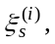…, 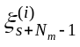of consecutive N_{m} pseudo-random numbers. For each symbol, a new sequence of pseudo-random numbers is generated. The seed for the PRNG serves as the secret key. The message of M symbols is then represented as a summation

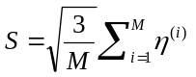.

The spread spectrum signal S is approximately Gaussian with zero mean and unit standard deviation even for moderate values of M (e.g., M ≈10).

The detection of the message of M symbols proceeds by first transforming the watermarked (and possibly attacked) image blocks using a DCT and extracting the middle N_{m} DCT coefficients. The secret key is used to generate M pseudo-random sequences of length N_{m}+2^{r} needed for coding the message symbols. For each sequence, all 2^{r} segments of length N_{m} are correlated with the middle N_{m} DCT coefficients. The largest value of the correlation determines the encoded symbol.

If a one-bit message is to be encoded, we have found out that better robustness properties result if, instead of inserting just one bit of information, a fixed message consisting of 10 6-bit symbols is encoded. The detector then simply tests for the presence of this fixed message. We point out that this detection method provides significantly more robustness when compared to a simple correlation of DCT coefficients with the spread spectrum signal and thresholding with a fixed threshold. Since relative values of correlation are compared rather than absolute values, traces of the fixed message can be detected even after the image has been severely distorted. The probability of a false detection can be estimated as follows. The probability P(k,M) that at least k r-bit symbols from the recovered message of length M are correct is

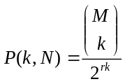. (1)

For M = 10 and r = 6 we have P(k,M) < 3×10⁻⁷ when k ≥ 5. Consequently, we set the decision threshold for the watermark presence to at least 5 correctly recovered symbols. The probability of a false detection is less than 3×10⁻⁷.

The spatial masking model of Girod³ was used to adjust the watermark strength α, so that the watermarked image is perceptually identical to the original image. Since Method 1 is not image adaptive, a fixed value of α can be used. Girod's model indicated that α = 7 produced watermarks with less than 1% of pixels with visible changes.

Method 2: This method has been introduced and studied in a series of papers by Piva et al.^{4,12,13}. It has recently been extended to DFT¹⁴. The image is transformed using a DCT and the coefficients are ordered in a zigzag manner. The first M coefficients are skipped (to avoid creating visible artifacts) and the next L coefficients are modified using the rule

D'_{k} = D_{k} + α | D_{k} | S_{k} , k = 1, …, N_{m} ,

where α is watermark strength / visibility, and S_{k} is a Gaussian sequence N(0,1). The numbers M and L depend on the image dimensions and can be adjusted to achieve a compromise between watermark robustness and visibility. For a 512×512 image, Piva et al. ¹³ recommend M=L=16000. Again, the modified image I_{m} is obtained by calculating the inverse DCT using the modified DCT coefficients D'_{k} . As the next step, the watermark image I_{w} is computed as a convex combination of the modified image I_{m} and the original image I (addition proceeds in a pixel by pixel manner)

I_{w} = s I_{m} + (1−s) I.

The weight s at pixel (i, j) is computed as a local standard deviation σ(i, j) at pixel (i, j) calculated from a 9×9 square centered at (i, j) divided by the maximal standard deviation over the whole image max_{i,j} σ(i, j). This convex combination adjusts the watermark strength to the local properties of the image. Higher standard deviation allows the modified image to dominate, while areas with low activity (low standard deviation) will only contain a weak watermark.

The detection proceeds by calculating the correlation C between the extracted L coefficients D*_{k} and the random sequence S_{k} , and thresholding the result with an image-dependent threshold Th derived from the watermarked/attacked image

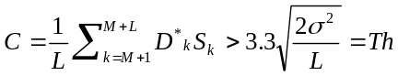, (2)

where is an average watermark strength defined as = α , where denotes the value of s averaged over the whole image, and σ is the standard deviation of the sequence D*_{M+1}, …, D*_{M+L}. Since Method 2 is highly image dependent, we cannot fix the value of α. Instead, it appears that a fixed value of produces similar percentage of visible pixels^{12,13}. As a result, we set = 0.2, which on average corresponds to the probability of false detections of the order of 10⁻⁶.

For a multiple-bit watermark, we can synthesize the Gaussian signal S similarly as in Method 1.

- Results of Comparison

The following test images were used in our study: “Peppers”, “Bridge”, “Mandrill”, and “Airfield”. All images were gray scale images with 512×512 pixels.



4.1 One-bit watermark

The performance of Method 1 was evaluated using the probability P(k,N) defined in Eq. (1). In the figures below, we plot base 10 logarithm of P(k,N) as a function of the distortion parameter. We recall that k=5 leads to the probability of false detections of roughly 3×10⁻⁷. In Method 2, we plot the ratio between the correlation C in Eq. (2) and the image dependent threshold Th as a function of deformation parameter. This modification allows us to consider the detector as a nonlinear detection function with a fixed threshold.

The horizontal dashed line in all figures indicates the threshold. Values above the line correspond to a successfully detected watermark, while values below the line indicate that the watermark presence can no longer be established.

Robustness to JPEG compression: Method 2 appears to have slightly better robustness to JPEG compression. It was able to withstand JPEG compression with quality factor up to 1% for all images except the image “Peppers”. We attribute this to the abundance of large smooth patches in this image, which weakens the watermark strength (recall that Method 2 weights the watermark strength according to local standard deviation).

Robustness to blurring: Both methods exhibit very good resistance to multiple blurring (see Figure 1). In both methods, the watermark can typically survive 5 successive applications of a blurring filter with the kernel

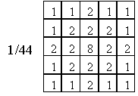
Figure 1 Blurring kernel.
Robustness to noise adding: As expected for spread spectrum techniques, both methods are remarkably robust to noise adding and practically insensitive to gamma correction adjustment (Figures 4 and 5). Method 1 appears to have better robustness properties with respect to noise adding and can survive extremely high noise levels. Both methods, however, provide sufficient robustness to noise adding for all practical purposes.

Watermark of Method 2 survived in all four images for median filtering with kernel sizes up to 5. Method 1 exhibited very curious behavior when the watermark has always been removed after median filtering with kernel 3, but survived filtering with kernel 5. We hypothesize that the kernel size 3 influences the frequencies that carry most of the watermark information, while larger kernel sizes affect a different frequency bandwidth. Neither method was able to survive median filter with kernel size 7.

Watermarks of both methods easily survive histogram equalization in all four images. Actually, Method 2 benefits from this operation because the ratio between the correlation and the threshold increases.

Mosaic filtering: Method 2 appears to perform somewhat better than Method 1 surviving the mosaic filter on 3×3 blocks and 2×2 blocks, respectively. This is to be expected because the watermark of Method 2 is spanned by lower frequencies when compared to Method 1.

The watermark can be detected after randomly permuting pixels in 2×2 blocks (for Method 1) and 3×3 blocks (for Method 2), thus making Method 2 slightly better. Again, the reason is that the frequency band on which the watermark is spanned is shifted to lower frequencies for Method 2.

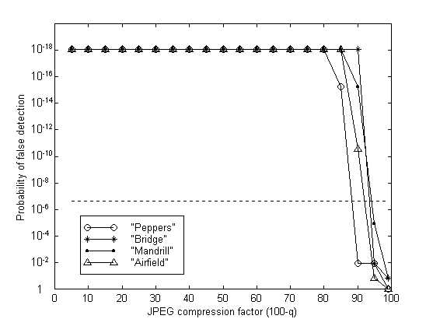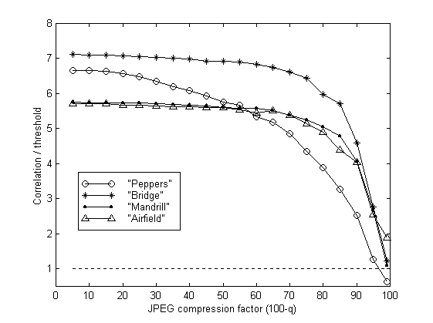  Figure 2 JPEG compression (Method 1 and 2, 1 bit) | 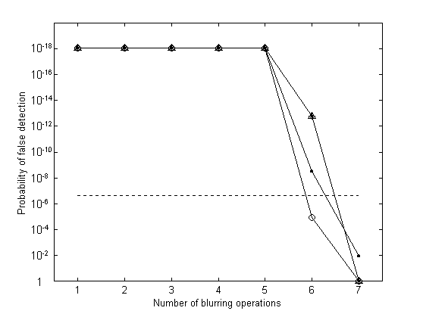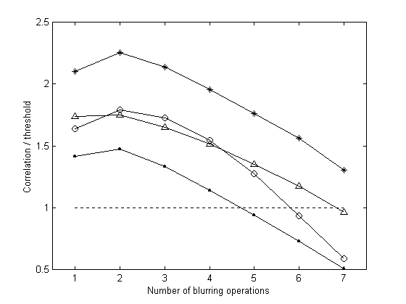  Figure 3 Multiple blurring (Method 1 and 2, 1 bit)

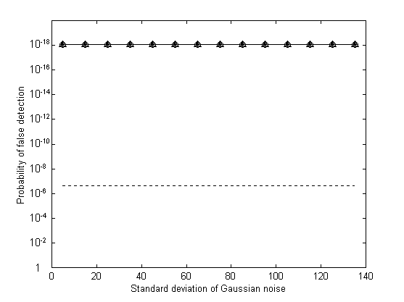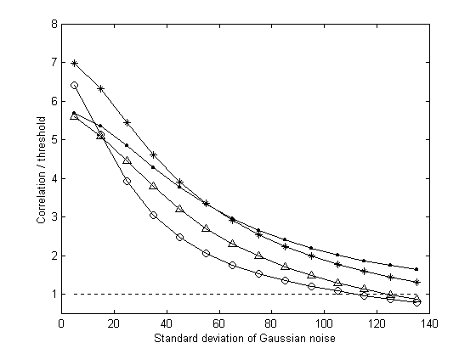  Figure 4 Adding Gaussian noise (Method 1 and 2, 1 bit) | 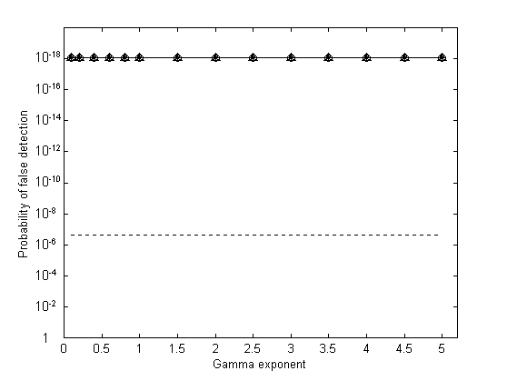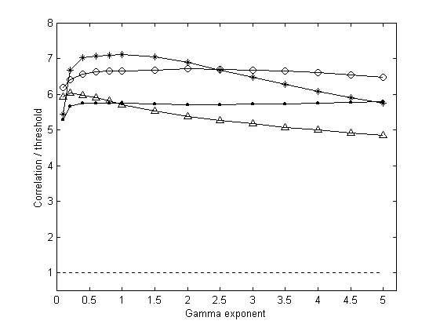  Figure 5 Gamma correction (Method 1 and 2, 1 bit)

The robustness of Method 2 is more influenced by image content than Method 1. Again, this is quite understandable because the watermark adapts to the human visual system based on the image content. As can be seen from Figures 2−5, Method 1 exhibits more "sudden" changes in its behavior than Method 1. This is caused by the detection method in which the values of correlation of symbols rather than bits are compared to each other.

4.2 Multiple-bit watermark

Method 1 was originally proposed for a multiple-bit, readable watermark embedding⁷, while Method 2 was formulated for a 1-bit detectable watermark¹². Therefore, we adjusted Method 2 by synthesizing the pseudo-random Gaussian sequence in the same manner as in Method 1 instead of generating it from a secret key. The performance of both techniques was evaluated using a bit error rate.

JPEG compression: Both methods perform very well and achieve 0% BER for quality factor as low as 20%. For very low quality factors, Method 2 performs somewhat better than Method 1.

Multiple blurring: Both watermarks can be recovered with 0% BER after 5 consecutive blurring operations with the blurring kernel shown in Figure 1. Further blurring quickly increases BER with Method 2 being slightly better than Method 1.

Robustness to noise adding: Method 1 exhibits remarkable robustness with 0% BER for additive Gaussian noise with standard deviations over 135 gray scale levels. Method 2 keeps 0% BER for noise standard deviation up to 35 gray levels and then the BER increases. There are relatively big differences in performance for different images. Overall, Method 1 clearly outperforms Method 2 in noise adding. This result is to be expected because the watermark of Method 1 is spanned by higher frequencies than in Method 2.

Gamma correction in the range 0.1−5 did not raise the BER above zero for either method.

Median filter with kernel size of 7 or larger practically removes the watermark message for both methods (BER around 50%). Method 1 again exhibits a curious behavior with a high BER for a 3×3 kernel, while after filtering with a 5×5 kernel the BER decreases below 10%. In Method 2, the BER for a 3×3 kernel is 0%, and it stays below 30% for a 5×5 kernel.

Mosaic filtering: Method 2 performs slightly better than Method 1. While the BER for Method 1 increases above 50% for mosaic blocks of 3×3 pixels, Method 2 achieves BER of 30% or less for 3×3 blocks. Both methods lose the watermark message for block sizes of 4 and higher.

Permutation of neighboring pixels: Both methods achieve a 0% BER for random pixel permutations in 2×2 blocks. Method 1 and 2 achieves BER of 70% and 10% for 3×3 blocks, respectively.

Histogram equalization for both methods did not increase BER above 0%.

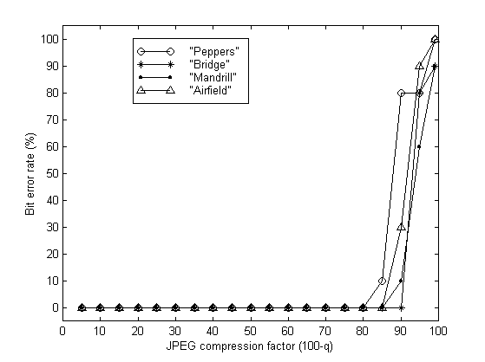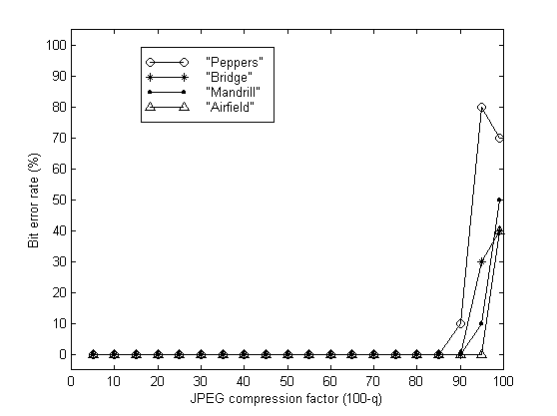  Figure 6 JPEG compression (Method 1 and 2, 60 bits) | 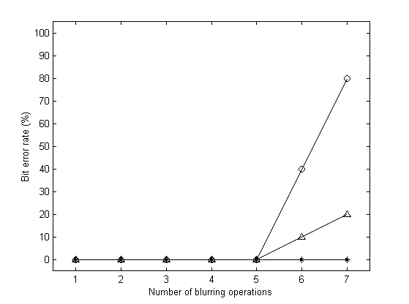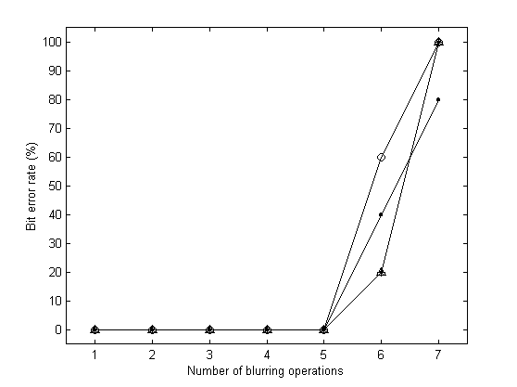  Figure 7 Multiple blurring (Method 1 and 2, 60 bits)

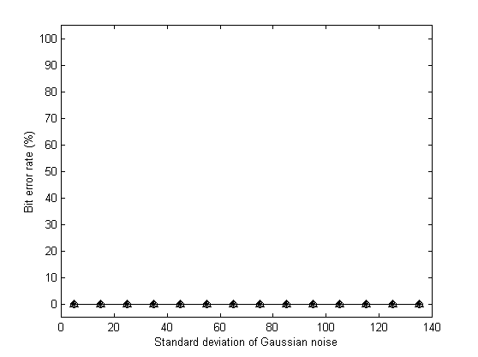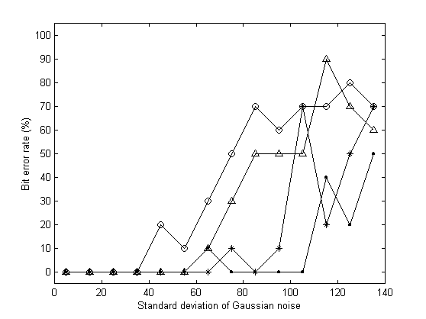Figure 8 Gaussian noise (Method 1 and 2, 60 bits) | 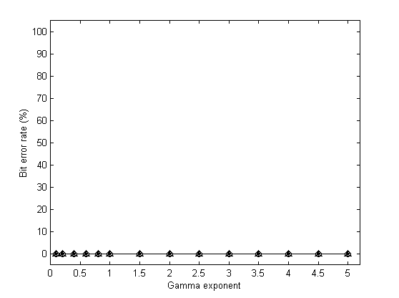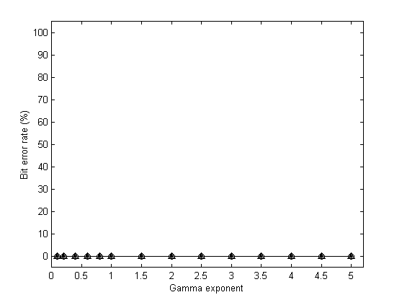  Figure 9 Gamma correction (Method 1 and 2, 60 bits)

- CONCLUSION AND FUTURE DIRECTIONS

In this paper, we presented a methodology for comparing the robustness of watermarking schemes. In order to compare the techniques in a fair manner, we propose to adjust the watermark strength so that a fixed model of the human visual system detects the same extent of artifacts (the spatial masking model of Girod³ is proposed for this purpose). Furthermore, we describe a methodology for converting a detectable, one bit watermark into a readable watermark and vice versa. Finally, the detection statistics (threshold) is adjusted so that the probability of false detections is less than 10⁻⁶. Having fixed the watermark strength, the message length, and the detection statistics, we introduce several typical image processing operations and evaluate the scheme performance. For the detectable one-bit watermark, we plot the correlation as the distortion parameter increases. For the readable watermark, we use the bit error rate. As an example of the comparing methodology, we have chosen two frequency-based spread spectrum watermarking techniques (Method 1 and 2) previously described in the literature. Method 2 provides overall better performance for both 1-bit and multiple-bit message embedding with the exception of noise adding, where Method 1 performs better for noise levels with standard deviation of 35 gray levels and higher. While investigating robustness properties of Method 1, we have found that when the middle 30% of DCT coefficients are set to zero, which will completely wipe out the watermark, an acceptably looking image with a commercial value results (Figures 10 and 11). Although the attacked image is little bit blurred and some ringing appears around edges, for larger images, these artifacts become less visible. This suggests that a lower frequency band should be used for modulation so that a simple replacement of coefficients with zeros will not produce acceptably looking images. So far, we could not develop a similar general type of an attack that would seriously disturb the watermark of Method 2. Therefore, as a conclusion, we prefer Method 2 to Method 1 because of better security properties and slightly better robustness.

  Figure 10 Original 256x256 image | 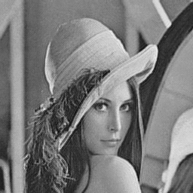  Figure 11 Attacked image without watermark

In the rest of this section, we make an attempt to formally define robustness. Our motivation is that it may not make a good sense to define robustness using a finite list of benchmark image processing operations. New filters and lossy compression techniques will certainly appear in the future, and one can combine already existing operations in infinitely many combinations as well. Thus, it appears that robustness could be meaningfully defined as the watermark's ability to withstand blind random distortions of the image that lead to images that still have a commercial value. Below, we elaborate on this concept.

A gray scale image with N₁×N₂ pixels with continuous gray scales can be represented as a point x in an N-dimensional Euclidean space X = [0,1]^{N}, N = N₁×N₂. Almost all watermarking schemes start with a selection of a specific orthonormal basis of functions (images), f₁, …, f_{N}. For example, the trivial spatial image representation is obtained by making the support of each f_{i} correspond to exactly one pixel. Functions f_{i} can be spatially localized (watermarking by disjoint blocks) or localized in the frequency space (DCT, DFT), or localized in both spatial and frequency domains (wavelets). The image x is represented in the new base as

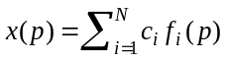, for each pixel p, 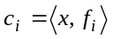 for all i = 1, …, N.

For watermarking, an index subset S ⊂ {1, 2, …, N} is selected and the coefficients c_{i} are modulated to obtain c'_{i}

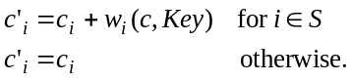

The watermarked image x_{w} is obtained from the modified coefficients c'_{i}

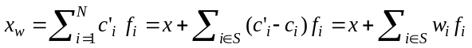.

In oblivious watermarking, we can extract w_{i} if w is approximately orthogonal to c (uncorrelated with c). For example, if we choose w as a random sequence, say a Gaussian N(0,1), then we could recover one bit of information by looking at the sum

.

If the value of this sum is larger then a certain positive threshold Th, the presence of the watermark w in x_{w} has been established. The set of images watermarked with watermark w (denoted by W ) is obtained as an intersection of the set X with a hyperplane determined by its normal vector w_{i} :

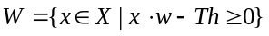.

The set of perceptually equivalent images can be determined by calculating the maximal allowable changes for each c_{i} (or x_{i} ) using a suitable HVS model. For example, a simplified spatial masking model of Girod³ could be used to estimate imperceptible changes to each pixel value. Let us denote this change as m_{i}. The set E of all perceptually equivalent images can then be approximated as a Cartesian product
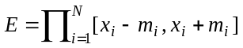.

This approach has some obvious limitations. For example, it does not account for the interference between changes to coefficients of individual basis functions. The model can also misinterpret small, imperceptible spatial deformations that can introduce large changes to the coefficients c_{i} (the principle of StirMark attack). Consequently, we consider the set E as a rough, first-order approximation to the set of perceptually equivalent images.

The set of acceptably looking images A (images with a commercial value) is a superset of E. It is even much more challenging to define this set, and perhaps it should be modeled as a fuzzy set because the concept of an image with a commercial value is inherently subjective. In this paper, we approximate A with E scaled by a parameter ρ > 1. Referring to the first paragraph of this section, one can attempt to define the robustness as the ratio

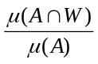, (3)

where μ is an |S|-dimensional measure corresponding to the probability distribution of typical image distortions.

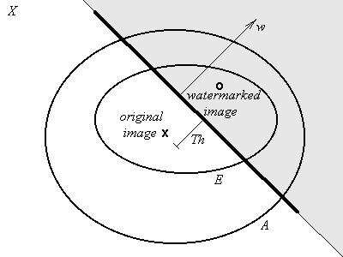
Figure 12 Structure of the image space

The practical impact of definition (3) is likely to be small because it is almost impossible to get even a rough estimate of the measure μ. A simpler, maybe less accurate quantity that could be used for measuring robustness is the ratio of the watermark energy and the energy of the maximal acceptable modification

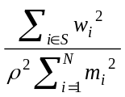. (4)

This measure of robustness can be used for practical computations. Note that it is not important which image basis is used for evaluating the quantity (4) as long as the basis is orthonormal. We used the spatial masking model of Girod³ to obtain estimates of m_{i} in the spatial domain. Several different watermarking techniques were then compared based on the quantity (4) with ρ set to 1. The results are shown in Table 1.

 | Peppers | Bridge | Mandrill | Airfield
Method 1 | 0.61 | 0.56 | 0.57 | 0.51
Method 2 | 0.35 | 0.45 | 0.44 | 0.42
NEC | 0.33 | 0.33 | 0.32 | 0.29
Watermark of fixed  depth d = 1, 2, … | 0.025 d ² | 0.021 d ² | 0.020 d ² | 0.017 d ²
Table 1 Robustness of several watermarking techniques.

On the third line is the NEC method introduced by Cox et al¹⁵. The watermark strength for the NEC method had to be adjusted for the four test images to 0.043, 0.057, 0.072, and 0.054 in order to keep the number of pixels with visible changes below 1%. The fourth row is the robustness for watermarks of fixed depth d as introduced in a paper by Maes¹⁶. It is to be expected that methods^{17,18} that utilize models of the HVS will generally have larger values for robustness than non-perceptual techniques.

ACKNOWLEGEMENTS

The work on this paper was supported by Air Force Research Laboratory, Air Force Material Command, USAF, under a Phase II SBIR grant number F30602-98-C-0049. The U.S. Government is authorized to reproduce and distribute reprints for Governmental purposes notwithstanding any copyright notation there on. The views and conclusions contained herein are those of the authors and should not be interpreted as necessarily representing the official policies, either expressed or implied, of Air Force Research Laboratory, or the U. S. Government.

REFERENCES

- M. D. Swanson, M. Kobayashi, and A. H. Tewfik, “Multimedia Data Embedding and Watermarking Technologies”, IEEE Proc. 86, (6), pp. 1064−1087, 1998.
- F. Mintzer, W. Braudaway, and M. M. Yeung, “Effective and Ineffective Digital watermarks”, Proc. ICIP'97, Santa Barbara, CA, pp. 9−12, 1997.
- B. Girod, “The information theoretical significance of spatial and temporal masking in video signals”, Proc. of the SPIE Human Vision, Visual Processing, and Digital Display, vol. 1077, pp. 178–187, 1989.
- A. Piva, M. Barni, F. Bartolini, V. Cappellini, “Threshold Selection for Correlation-Based Watermark Detection”, Proceedings of COST 254 Workshop on Intelligent Communications, L'Aquila, Italy, June 4-6, 1998.
- M. G. Kuhn, “Stirmark”, available at http://www.cl.cam.ac.uk/~mgk25/stirmark/, Security Group, Computer Lab, Cambridge University, UK (E-mail: mkuhn@acm.org), 1997.
- M. J. J. Maes and C. W. A. M. van Overveld, “Digital watermarking by geometric warping”, Proc. of the ICIP'98, Chicago, Illinois, 1998.
- J. J. K. Ó Ruanaidh and T. Pun, “Rotation, scale and translation invariant digital image watermarking”, Proc. of the ICIP'97, vol. 1, pp. 536–539, Santa Barbara, California, 1997.
- J. J. K. Ó Ruanaidh, W. J. Dowling, and F. M. Boland, “Watermarking digital images for copyright protection”, IEE Proc. Vision, Image and Signal Processing, 143(4), pp. 250–256, 1996.
- A. Herrigel, J. Ó Ruanaidh, H. Petersen, S. Pereira, T. Pun, “Secure copyright protection techniques for digital images,” Proc. of the 2nd Int. Information Hiding Workshop, Portland, Oregon, 1998.
- H. Choi, H. Kim, and T. Kim, “Robust Watermarks for Images in the Subband Domain”, Proc. of The 6th IEEE International Workshop on Intelligent Signal Processing and Communication Systems (ISPACS'98), Melbourne, Australia, pp. 168−172, 1998.
- D. J. Fleet and D. J. Heeger, “Embedding Invisible Information in Color Images”, ICIP '97, pp.523−535, Santa Barbara, California, 1997.
- A. Piva, M. Barni, F. Bartolini, V. Cappellini, “DCT-based watermark recovering without resorting to the uncorrupted original image”, ICIP'97, Santa Barbara, California, 1997.
- M. Barni, F. Bartolini, V. Cappellini and A. Piva, “A DCT-domain system for robust image watermarking”, Signal Processing, Special Issue in Copyright Protection and Access Control for Multimedia Services, (66)3, pp. 357−372, 1998.
- A. Piva, M. Barni, F. Bartolini, “Copyright Protection of Digital Images by Means of Frequency Domain Watermarking”, Proc. SPIE Mathematics of data / Image Coding, Compression, and Encryption vol. 3456, pp.25−35, San Diego, California, 1998.
- I. J. Cox, J. Kilian, F. T. Leighton, and T. Shamoon, “A secure, robust watermark for multimedia”, Proc. of the 1st Information Hiding.Workshop, edited by R. Anderson, LNCS, vol. 1174, pp. 183–206, SpringerVerlag, New York, 1996.
- M. Maes, “Twin Peaks: The Histogram Attack to Fixed Depth Image Watermarks”, Proc. of the 2nd Int. Information Hiding Workshop, Portland, Oregon, 1998.
- M. D. Swanson, B. Zhu, and A. H. Tewfik, “Robust data hiding for images”, Proc. of the IEEE Digital Signal Processing Workshop, pp. 37–40, Loen, Norway, Sep 1996.
- M. D. Swanson, B. Zhu, and A. H. Tewfik, “Transparent robust image watermarking”, Proc. IEEE Int. Conf. on Image Processing, vol. 3, pp. 211–214, 1996.

* Correspondence: Email: fridrich@binghamton.edu; WWW: http://ssie.binghamton.edu/~jirif; Telephone/Fax: 607 777 2577

