To set up QGIS and Avaframe to run MoT Vollemy:

Go to: [OSGeo4W](https://trac.osgeo.org/osgeo4w/) and download the OSGeo4W network installer (make sure you note where the installer .exe file saves for future use):

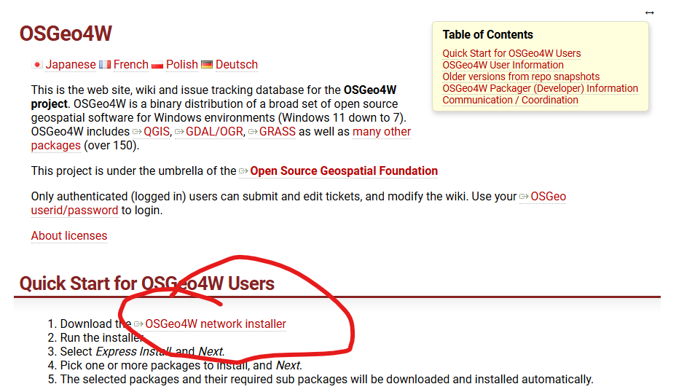

Run the installer and choose Express Install:

It’s fine to use both system proxy settings and the default download site (click next on both):

In the express package selection select QGIS LTR (long term release) and GDAL:

You’ll be asked to agree with a bunch of license terms before the download starts, then let the download run and install (this took me around 90 minutes).

####Here I’m a bit unsure what happens…..

Once the installation is complete….

Rerun osgeo4w-setup.exe (ideally moved to local storage from your downloads folder) and select advanced install:

Choose install from internet:

I created my root directory locally on C:\\ :

Use system proxy settings again:

And the same system proxy settings and download site as in the express install:

Now we will make sure gdal and python all “match up” for our OSGeo4W installation of QGIS via the “Select Packages” interface.

On the opening window, click on “view” to change to full:

Then search gdal:

This will, in the top line, display the currently installed version of gdal, here 3.11.4-1. This is ok ,make sure the New column is selected as “Keep” as in the example above.

At the bottom of this screen you will have three packages, gdall311-runtime (or similar), plus python3-gdal and python3-gdal-dev.

Upon initial installation you may not have installed python3-gdal-dev. Do so now by clicking on the “Skip” symbol so that it displays 3.12.0beta (or similar) and automatically selects the binary checkbox corresponding to the installation.

Make sure gdal, python3-gdal both have “Keep” in the New column.

Then press next and install…..

Now we will install the latest version of avaframe following the recipe here:

[com9MoTVoellmy: NGI MoT-Voellmy — AvaFrame documentation](https://docs.avaframe.org/en/latest/moduleCom9MoTVoellmy.html)

start the OSGeo4W shell (.bat file, e.g. "C:\OSGeo4W\OSGeo4W.bat") and run the avaframe pip command

Once this is complete, you can open your installation of QGIS via the osgeo4w shell via “qgis-ltr”:



This boots QGIS, ideally with the proper Avaframe, GDAL , and Python dependency installations.

Avaframe is accessed via the Processing Toolbox:

Com9 brings up the following Dialog box:

Here all inputs must satisfy the requirements of Avaframe (e.g. same CS, “thickness” as an attribute in RA shapefile, .asc ESRI format for the DEM) and the destination folder should be an EMPTY local directory…

Adding the release area .shp and clipped .asc DEM in the Lavangsdalen_Data.zip file should result in a successful run, given the destination directory is local and empty…