ONLINE COURSE MANAGEMENT SYSTEM
Project Report
Technology: PHP, MySQL, HTML and CSS
Submitted by: ______________________________
Class / Course: _____________________________
Roll Number: _______________________________
Institution: _________________________________

1. Introduction
The Online Course Management System is a web-based application designed to organize online courses and student enrollments. It provides a public course catalogue, student registration and login, course enrollment, and an administrator dashboard.

2. Problem Statement
Managing course details and student registrations manually can be time-consuming and may lead to duplicated or inconsistent records. This project centralizes course information and enrollment records in a MySQL database.

3. Objectives
- Provide secure student registration and login.
- Allow administrators to add and remove courses.
- Allow students to browse and enroll in courses.
- Display each student's enrolled courses.
- Store user, course, and enrollment data in a relational database.
- Apply basic input validation and password hashing.

4. Scope of the Project
The system is intended as an academic prototype for a small online learning portal. It includes course catalogue management and enrollment tracking. It does not include online payments, lesson video streaming, quizzes, certificates, email verification, or password recovery.

5. Technologies Used
Technology | Purpose
HTML | Page structure and forms
CSS | Responsive visual layout
PHP | Server-side processing and sessions
MySQL | Persistent relational storage
PDO | Prepared database queries
XAMPP | Local Apache/PHP/MySQL environment

6. System Modules

6.1 Public Course Catalogue
Visitors can view available courses, categories, descriptions, durations and prices.

6.2 Student Registration
Students register with name, email and password. The email must be unique and the password is stored as a secure hash.

6.3 Login and Logout
The login page verifies credentials and creates a PHP session. Logout clears the session.

6.4 Administrator Dashboard
The administrator can add and delete courses, view summary counts and see registered students.

6.5 Course Enrollment
Logged-in students can enroll in a course. A unique database constraint prevents duplicate enrollments.

6.6 Student Dashboard
Students can see the courses in which they are enrolled.

7. Database Design
The database is named online_course_db and contains three tables:
- users: id, name, email, password_hash, role, created_at.
- courses: id, title, category, description, duration_hours, price, instructor_id, created_at.
- enrollments: id, student_id, course_id, enrolled_at.
The enrollments table uses foreign keys to connect students and courses. A unique constraint on (student_id, course_id) prevents the same student from enrolling in the same course more than once.

8. System Requirements
- Windows, macOS or Linux computer
- XAMPP with Apache, PHP 8 or later, and MySQL/MariaDB
- Modern web browser
- Minimum 2 GB RAM recommended for local development

9. Installation and Execution
- Install and open XAMPP. Start Apache and MySQL.
- Copy the project folder into the XAMPP htdocs directory.
- Open phpMyAdmin at http://localhost/phpmyadmin.
- Import the provided database.sql file.
- Confirm the database credentials in config.php.
- Visit http://localhost/online_course_management_system/ in a browser.
- Log in with the demo administrator account, then test adding a course.
- Register a student account, log in, enroll in a course, and verify the student dashboard.

10. Demonstration Credentials
Administrator email: admin@coursehub.test
Administrator password: Admin@123
Students should create their own account using the registration page. If the seeded admin password hash does not work in a particular environment, generate a fresh hash with PHP password_hash() and update the admin row as described in README.md.

11. Testing
Test case | Expected result | Status
Open course catalogue | Available courses are displayed | To verify locally
Register valid student | Account is created and user can log in | To verify locally
Register duplicate email | Validation message is displayed | To verify locally
Login with wrong password | Generic login error is displayed | To verify locally
Admin adds course | New course appears in catalogue | To verify locally
Student enrolls | Course appears in student dashboard | To verify locally
Enroll twice | Duplicate enrollment is prevented | To verify locally
Student opens admin page | Access is denied and login is requested | To verify locally
Note: Testing statuses are intentionally marked 'To verify locally'; the application should be run in the user's XAMPP environment to confirm actual behavior.

12. Security Considerations
- Passwords are stored with PHP password_hash() and checked with password_verify().
- PDO prepared statements are used for database operations.
- Output is escaped with htmlspecialchars() to reduce HTML/script injection risks.
- Role checks protect the administrator and student pages.
- Session IDs are regenerated after successful login.
- For a production system, add CSRF tokens, login rate limiting, HTTPS, secure cookie settings, audit logging and a security review.

13. Limitations
This prototype is not a full learning management platform. It does not currently provide lesson content, video streaming, online assessments, payment processing, certificates, instructor-specific permissions, password reset or email verification.

14. Future Enhancements
- Upload course materials and video lessons.
- Add quizzes, assignments and completion tracking.
- Issue downloadable certificates.
- Integrate a secure payment gateway.
- Add password reset and email verification.
- Add course search, filters, edit-course functionality and reports.

15. Conclusion
The Online Course Management System demonstrates how PHP and MySQL can be used to build a basic web application with authentication, role-based access, course administration and student enrollment. It provides a foundation for further development into a more complete learning management system.

Appendix A: Screenshots
The project ZIP includes illustrative sample screen designs for the course catalogue, login, administrator dashboard and student dashboard. They demonstrate the intended appearance and should not be treated as screenshots captured from a live PHP server.

Figure A1: Course catalogue (illustrative sample)
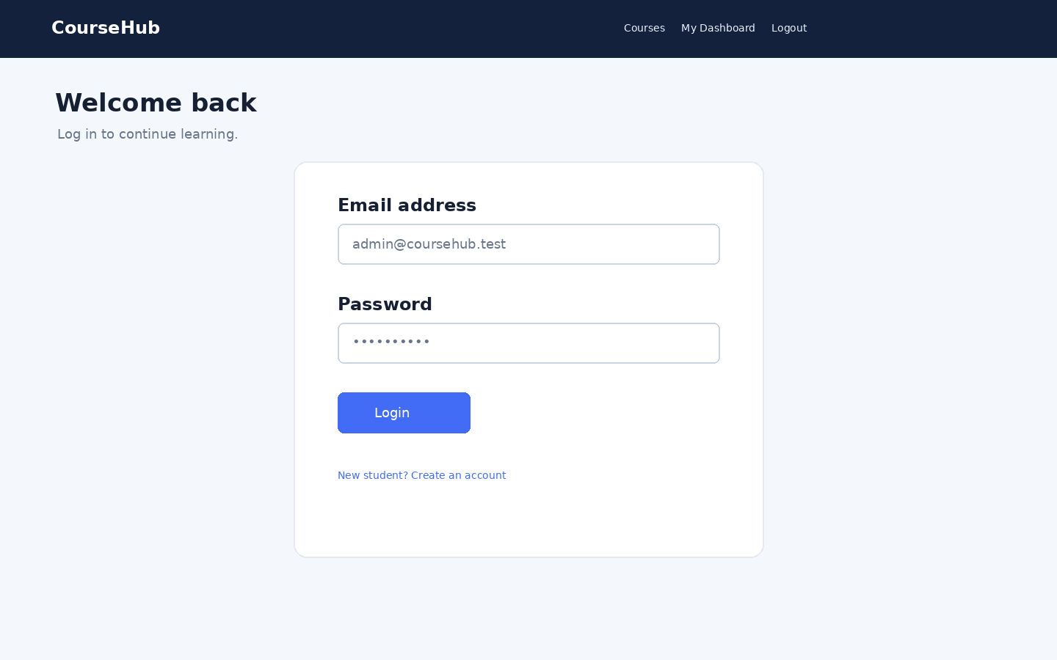
Figure A2: Login page (illustrative sample)
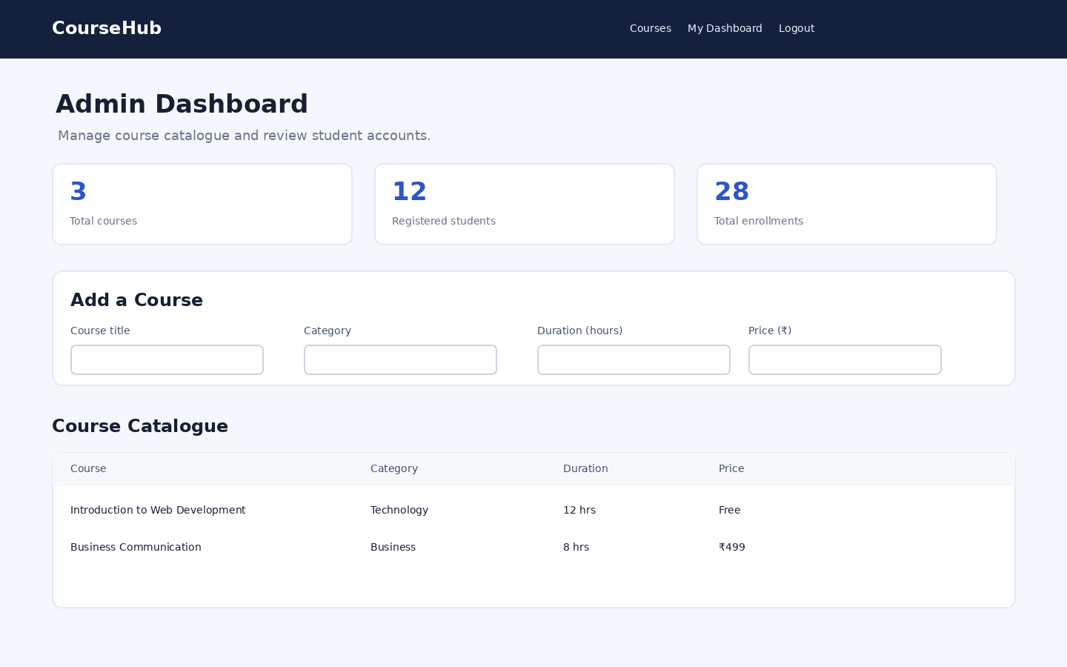
Figure A3: Admin dashboard (illustrative sample)
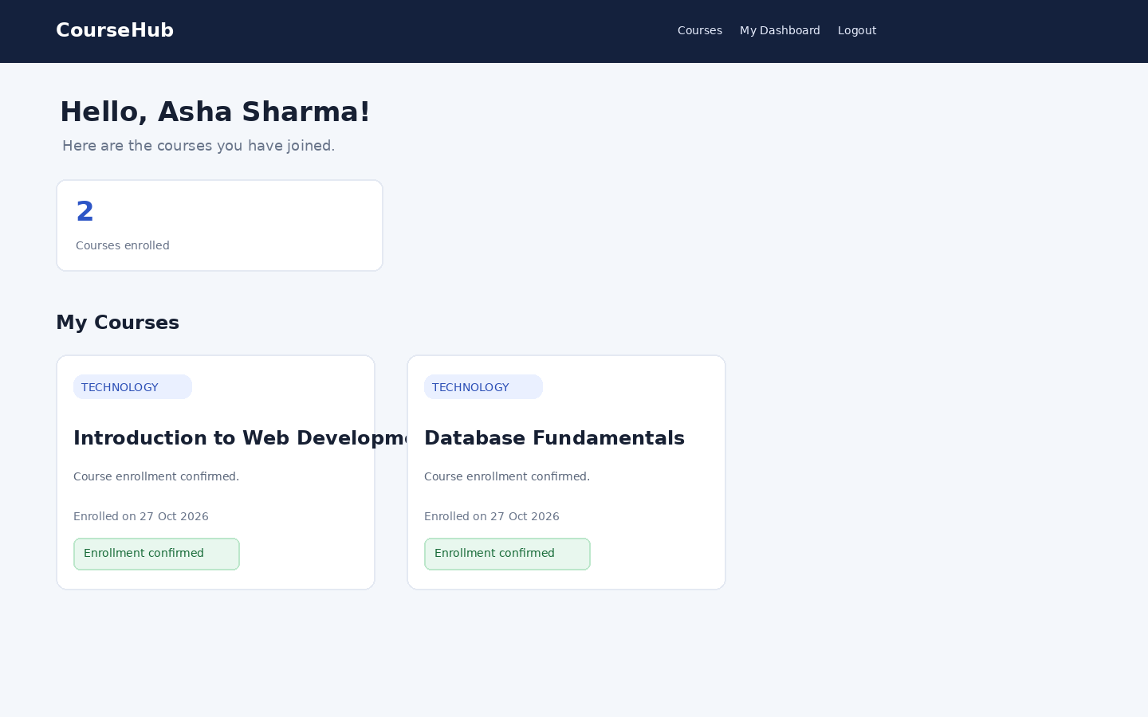
Figure A4: Student dashboard (illustrative sample)

