1.

a). **First phase** is finding out all data needs of the future database users.

**Second phase** if choosing a data model. This phase also includes 3 subphases:

- Applying the concepts of the chosen data model.

- Translating these requirements into a conceptual scheme of the DB.

- This conceptual scheme will indicate all the functional requirements of the company, when it is fully developed, so the third subphase is to describe all the operations/transactions that can be performed on the data.

**Third phase** is the last one – implementation of our abstract data model(or creating the actual DB). This phase has 2 subphases:

- Logical Design – deciding on the database schema(what relation schemas, attributes will DB have and how they all should look like).

- Physical Design – deciding on the physical layout of the database.

b). **ER Model i**s a graphical representation of entities and their relationships:

* + Based on Entity, Attributes & Relationships
    - Entity is a thing about which data are to be collected and stored
      * e.g. EMPLOYEE
    - Attributes are characteristics of the entity
      * e.g. SSN, last name, first name
    - Relationships describe an associations between entities
      * i.e. 1:M, M:N, 1:1
  + Complements the relational data model concepts
    - Helps to visualize structure and content of data groups
      * entity is mapped to a relational table
    - Tool for conceptual data modeling (higher level representation)
  + Represented in an Entity Relationship Diagram (ERD)
    - Formalizes a way to describe relationships between groups of data

2.

a).

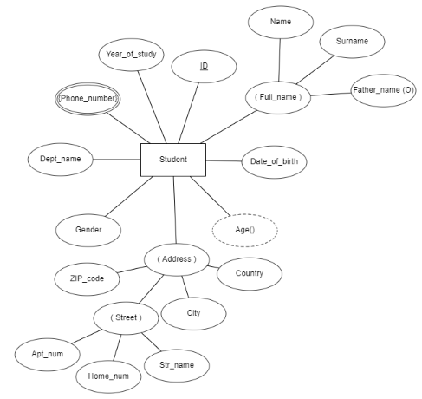

b).

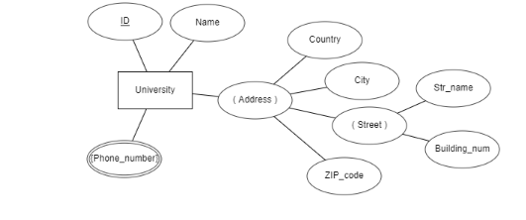

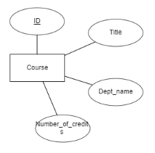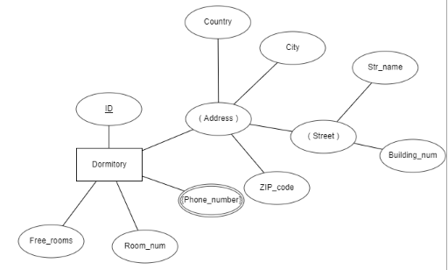

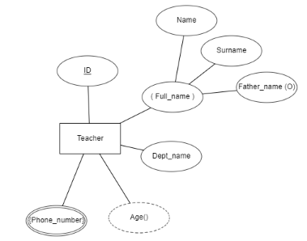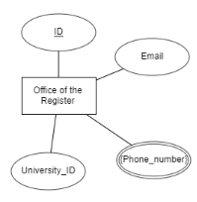

3.

1-1

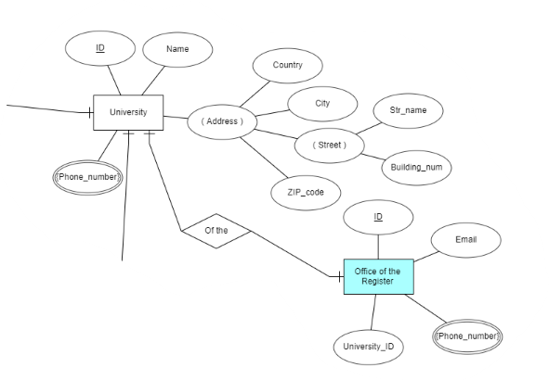

1-M

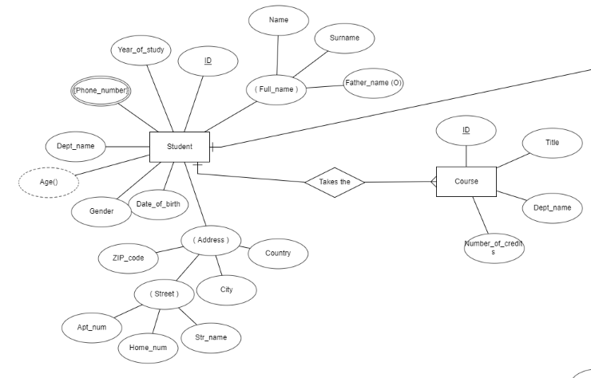

M-M

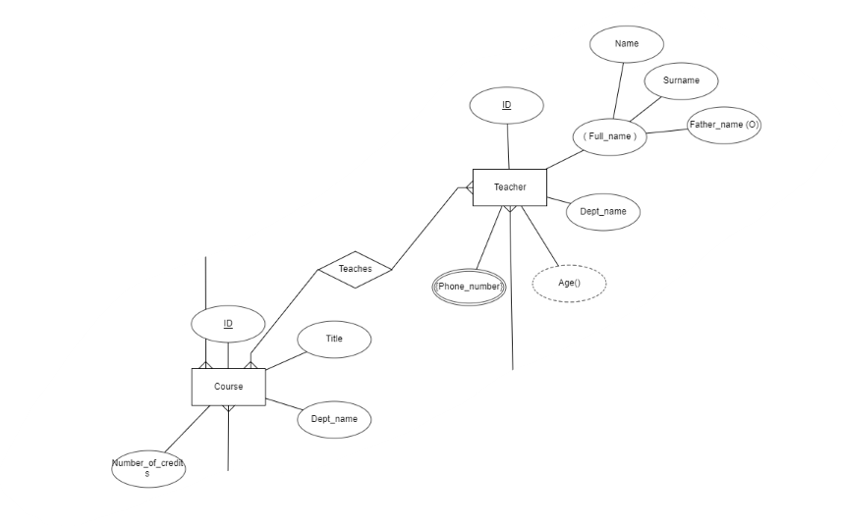

M-1

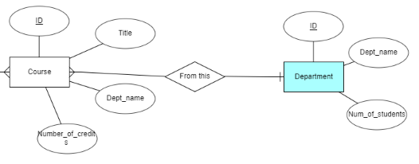

4.

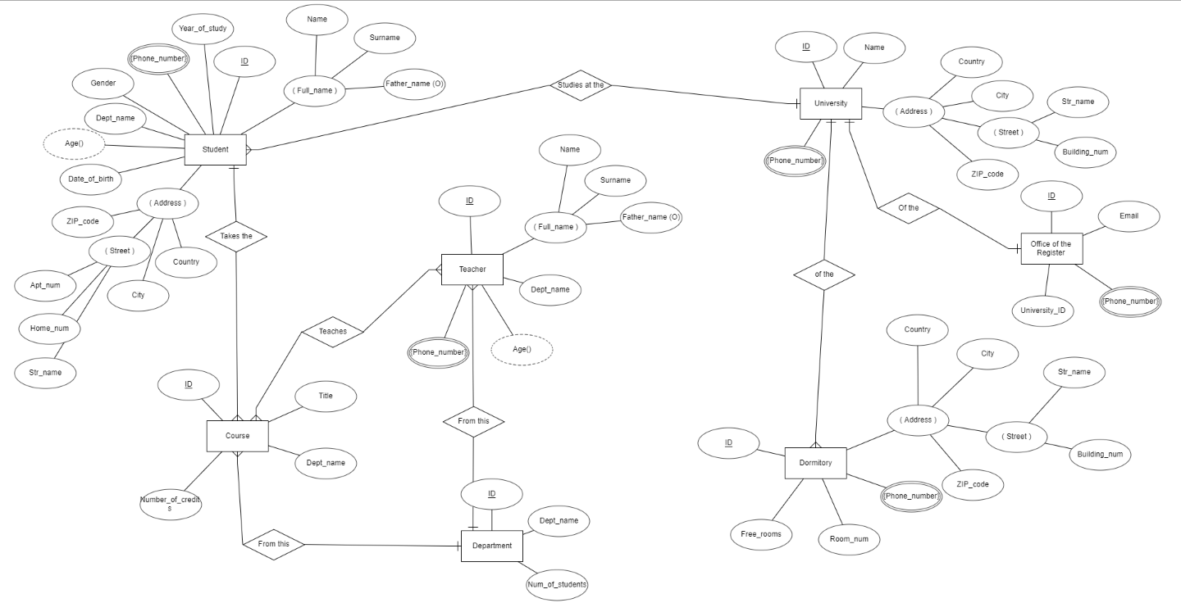

5.

