

Name-Ahmad Raza

Course-DevOPS PRO

1. **Assignment- 01**

* As I logged nonexistent user through GUI, it throws error 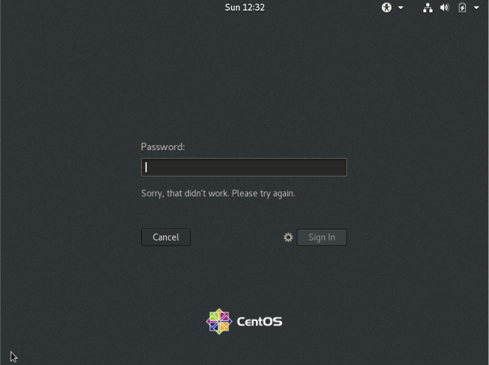
* As I logged nonexistent user through CLI, it throws error

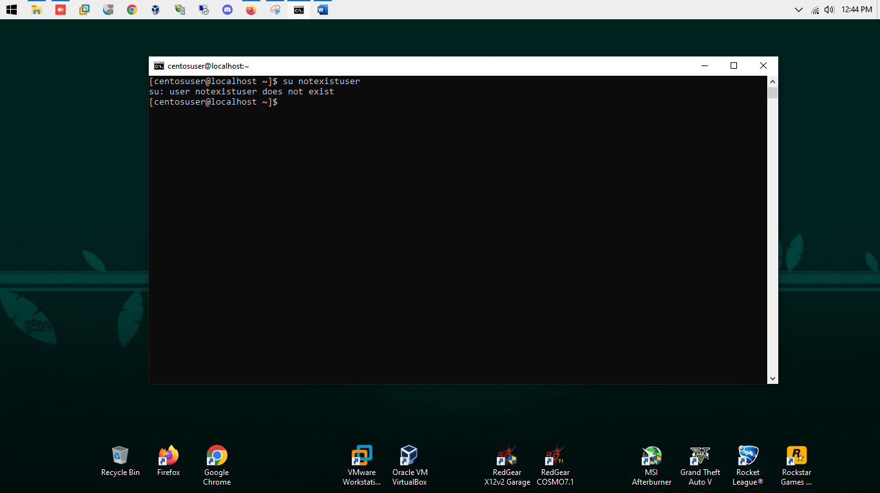

1. Assignment- 02

* Changing password to IneuR0n#42 has been successfully updated. (Password has been changed)

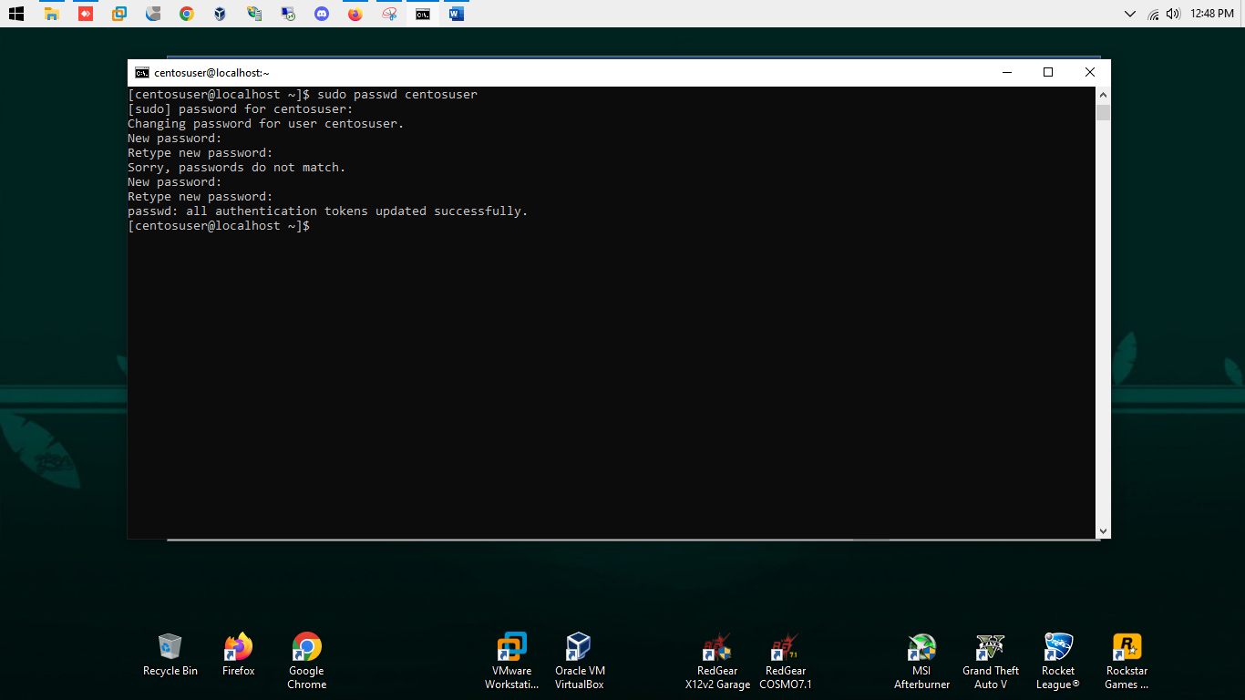

* Changing password to 1234 or abcd is successfully updated but throwing alert that password is shorter than 8 characters (BAD PASSWORD)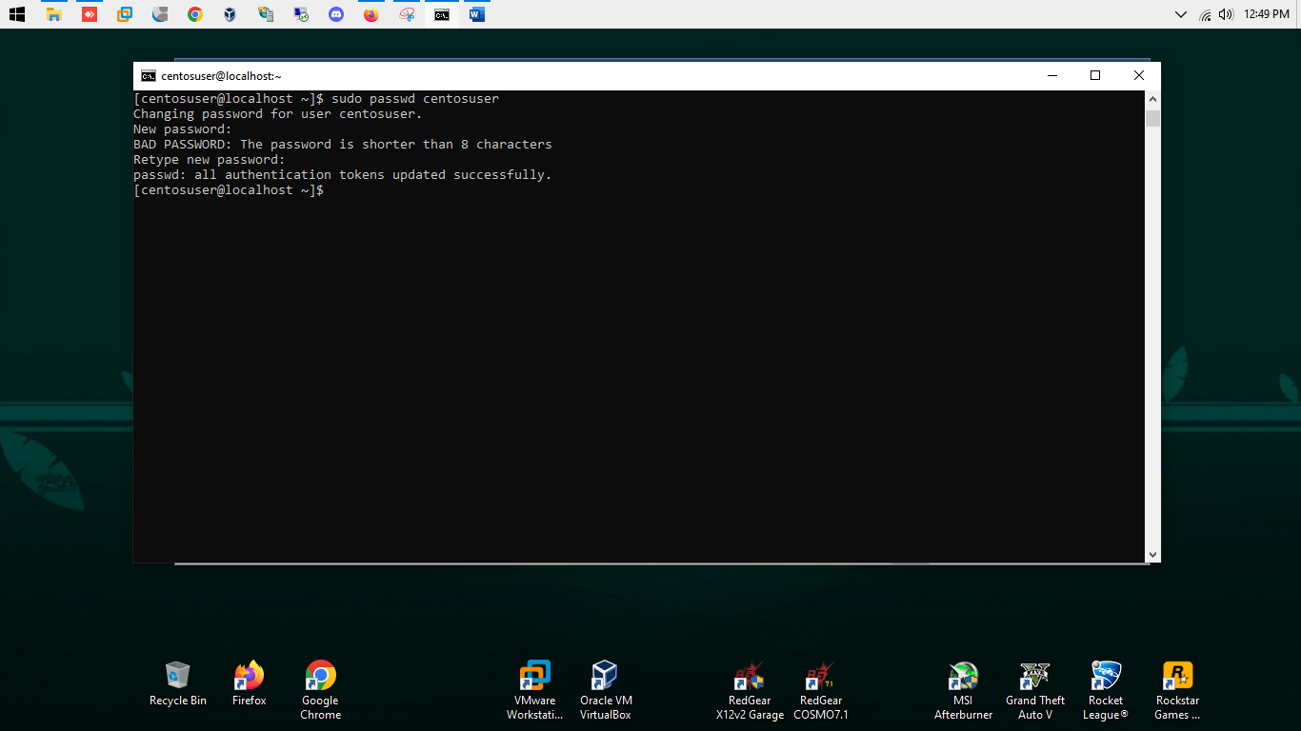
* Password changing to no password or empty password throwing an error that Authentication token manipulation error.
* Means empty password cannot be applied to any user.

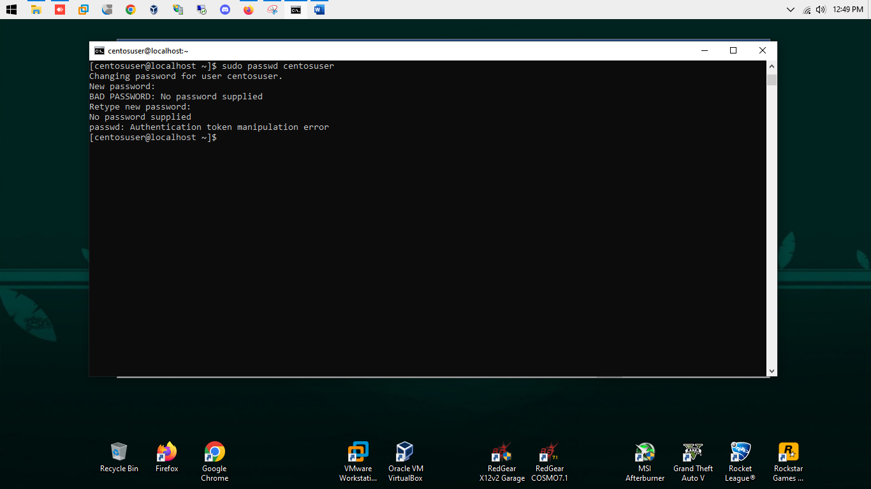

1. Assignment- 03

* Cd / then ls
* Cd / means changing directory path to root directory and ls means listing the directory content
* This shows all the directory in root (home, var, etc, run, etc)

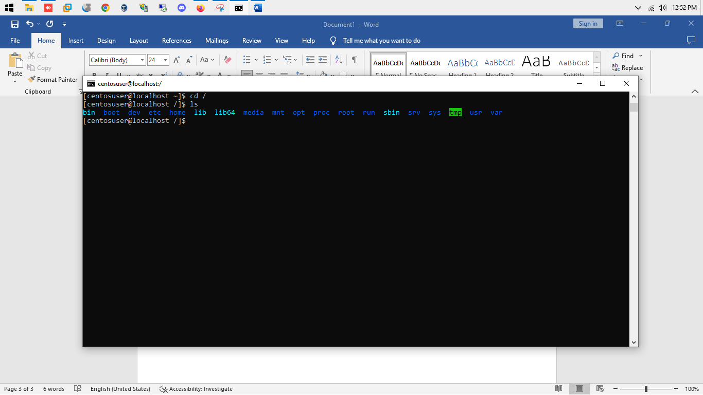

* Cd /home then ls
* Changing the Director to home & showing all the directory and files in the home director
* Home directory showing – all the directory of user (currently we having only one user named centosuser)

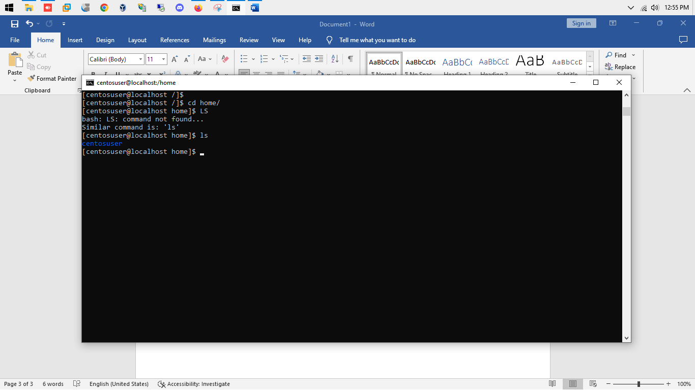

* Cd /var/www/html 🡪 changing the directory to html folder but is throws an error that (No such file directory ), because the directory named www/html is not present in the /var directory.

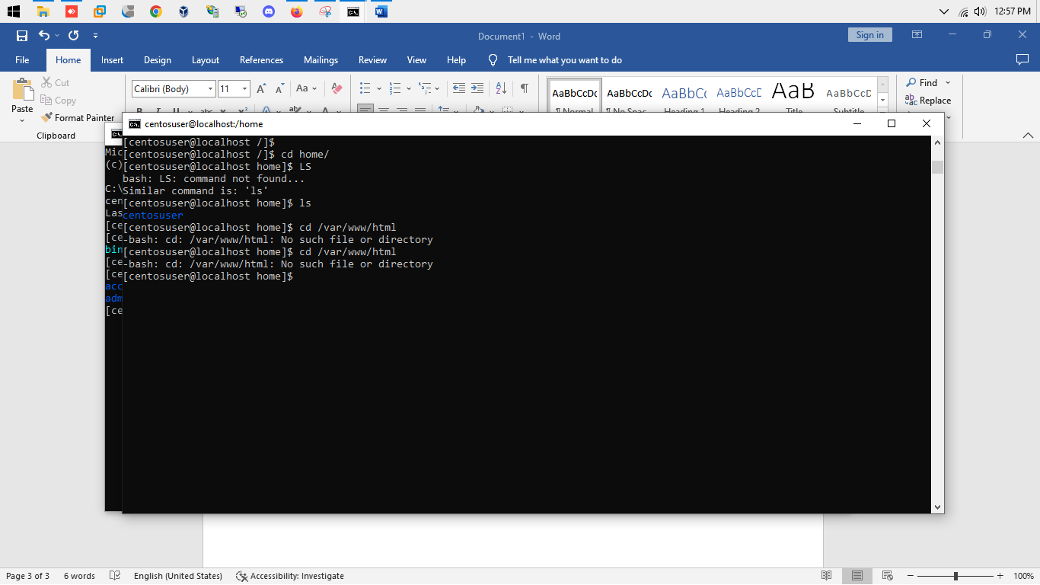

* Cd /root – changing the directory to root folder but other user don’t have permission to get into root folder because it is protected
* So I used sudo cd /root to get into root folder and provide the root password
* ls –>is used to show the current directory files and folders where only centosuser user is present which is basically and admin user with administrative privilege.

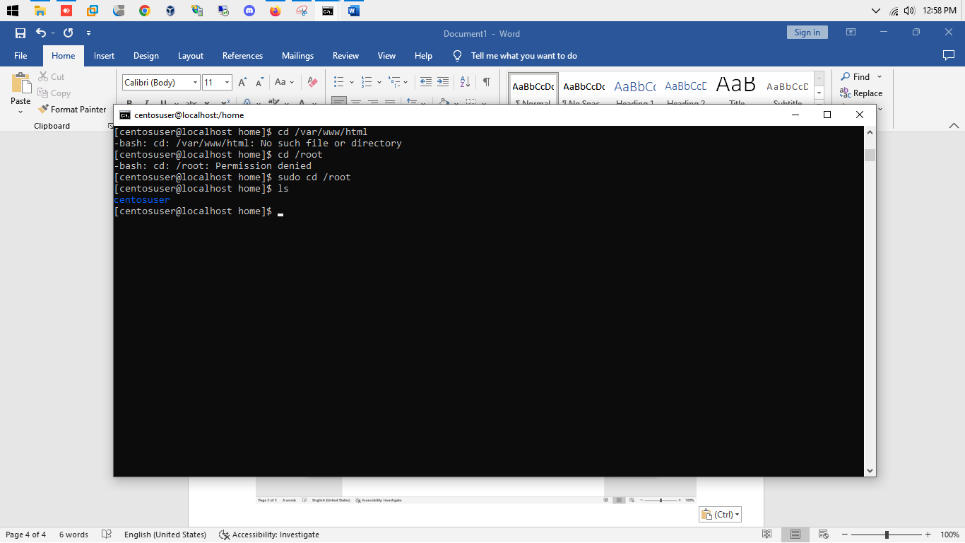

1. Assignment- 04

* cd /etc – changing the directory to etc folder
* /etc directory is user to store the configuration files of Linux operating system
* Ls – is used to list the files and folders in directory
* There we got all the configuration files ( e.g.-network, ssh, cron, sudoers )

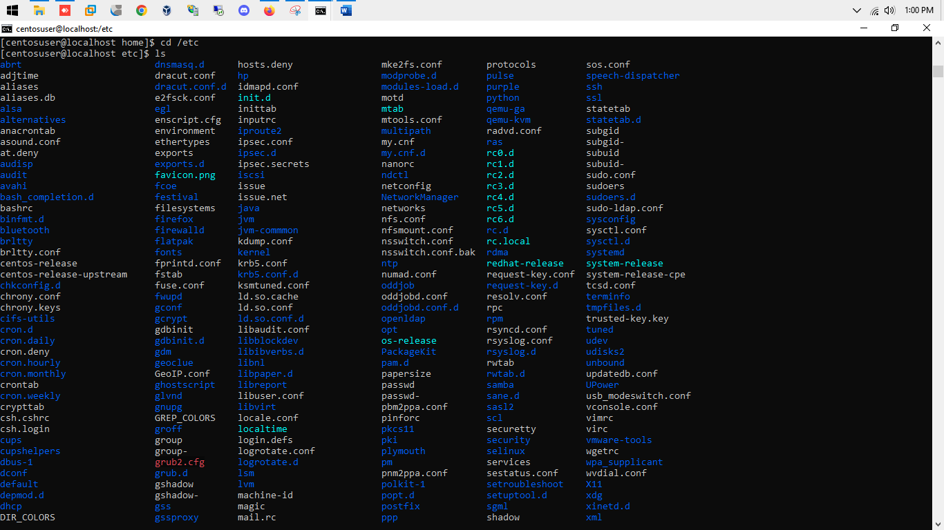

* Ls -al -> this command is user to list the files and folders in long listing manner, where we can see file/folder permission, group, ownership, size, creation data/time etc.

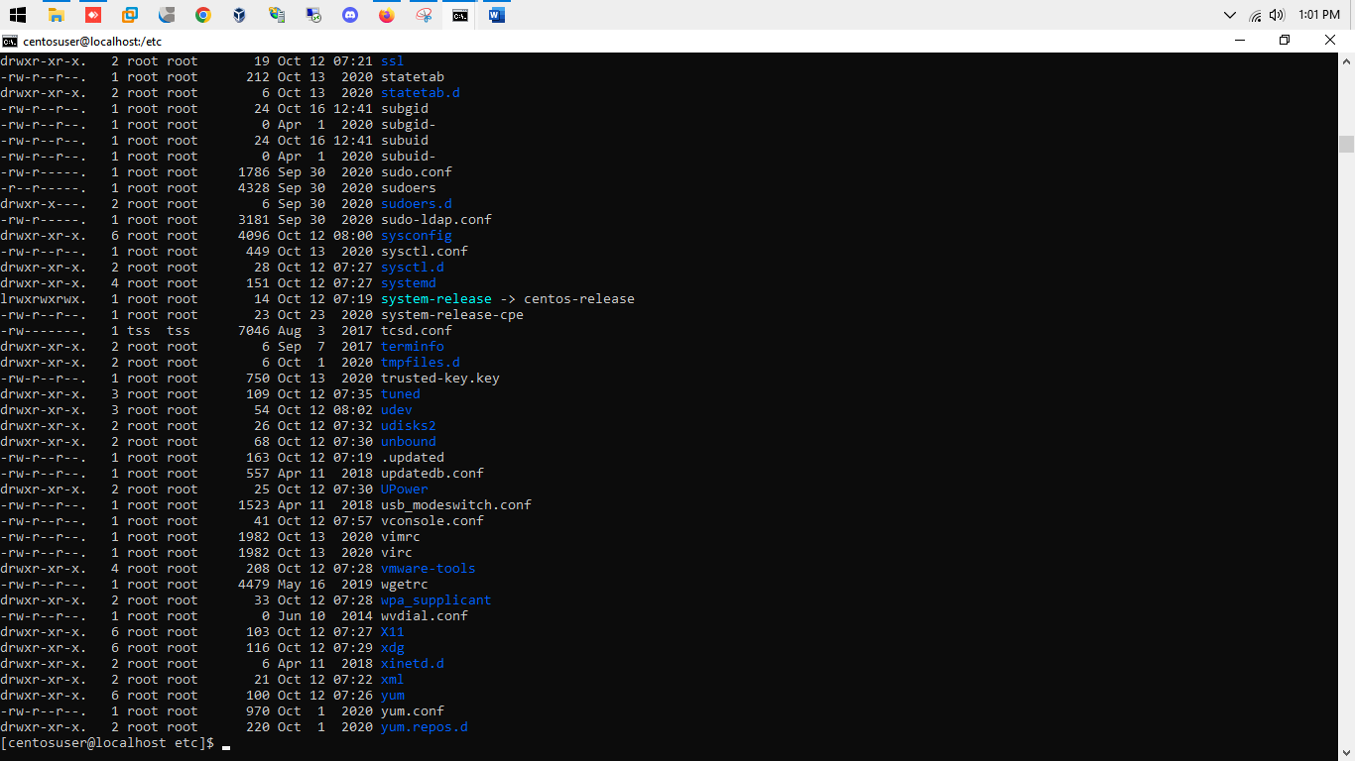

* Ls -I -> this command is used to show the inode number of all files and folder in current directory.

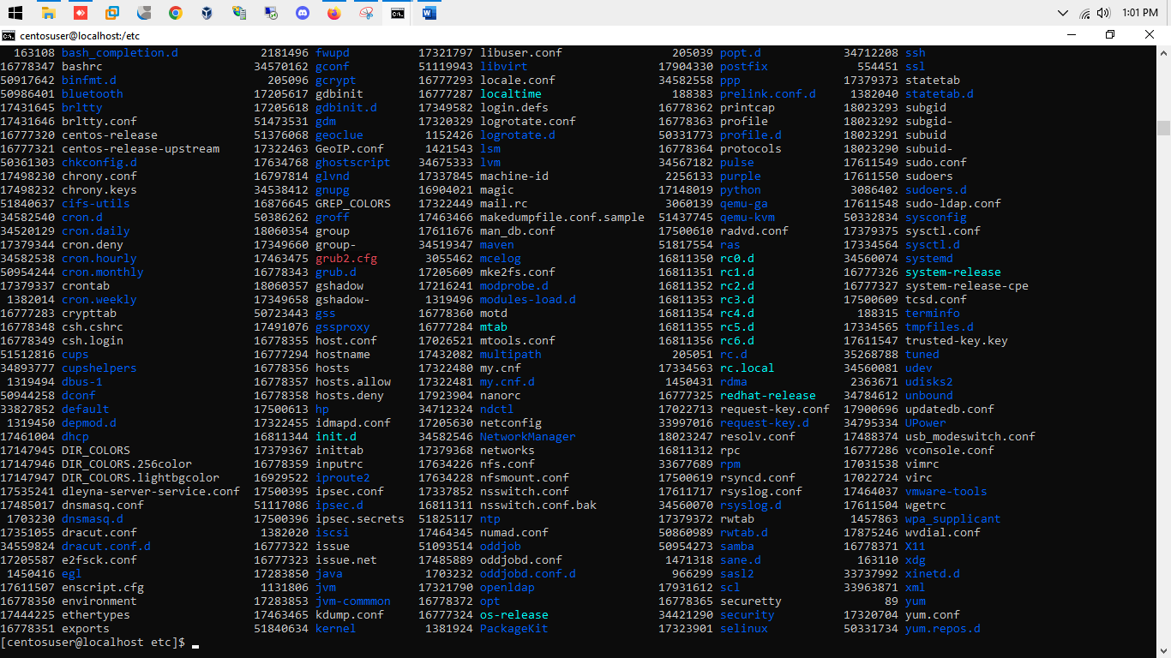

* Ls –help -> command is user to show the manual page of this command where we learn more about this command & other options used with this command.

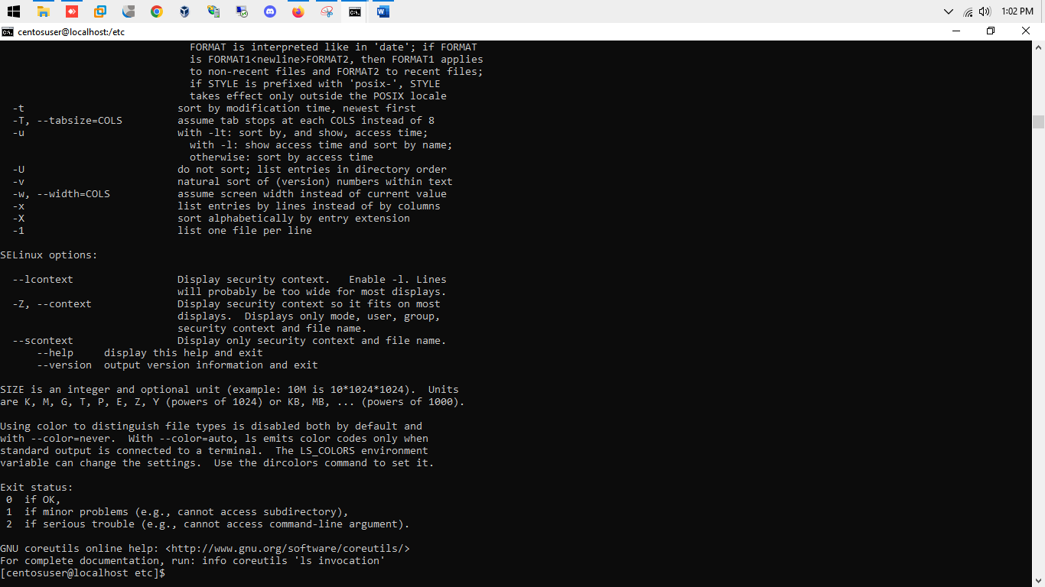

1. Assignment- 05

* Pwd – this command shows the present working directory inside the terminal.
* As shown in screenshot - /home/centosuser/Desktop – shows that my present working directory is Desktop inside user centosuser

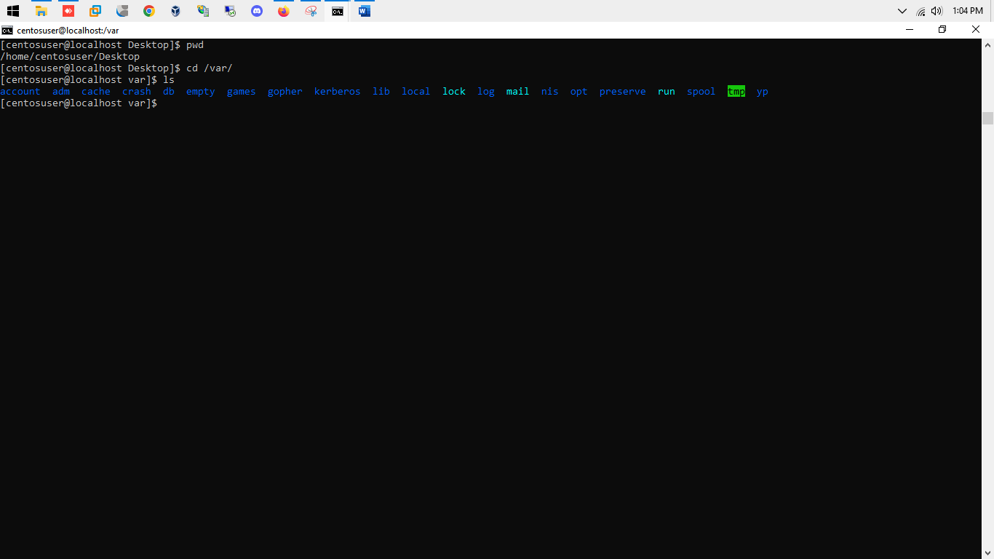

* Cd /var then ls 🡪 changing the directory to var folder where we store all the variables.
* Some of the directory of var are- www, run, local, mail etc.
* AS /var/www/html directory is user for hosting the webpages.

