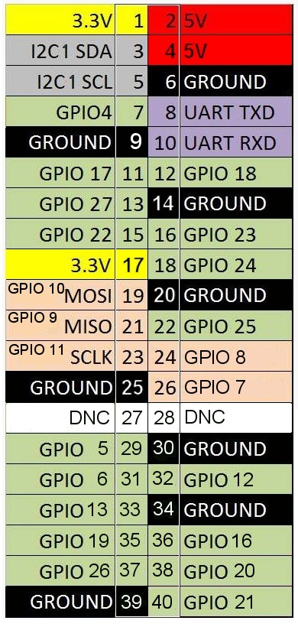
Com farem servir tambe el codi per HiFiBerry DAC+, Digi+ and Amp+ que ocupa I2c, y tambe els GPIO del 18 al 21, mirarem de fer servir el GPIO 21, que es facil de identificar.

apt-get update

apt-get install gcc python-dev python-pip i2c-tools libi2c-dev python-smbus

pip install RPi.GPIO

mv bye.py.off_button.py

mv bye.py.off_button.py

sudo nano /etc/rc.local
before exit 0; add python /home/pi/.off_button.py

Now when you connect the GPIO pin to ground you should see immediately that the green LED starts flashing and after a few seconds it will flash 10 times, signalling a safe shutdown. Now you can remove the power supply.

