Git repo: <https://github.com/noshen-atashe/csci2020u_noshen-atashe/tree/master/lab02>

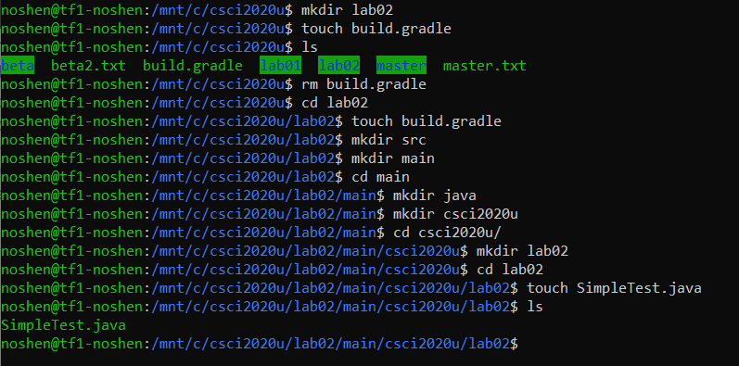

Local directory:

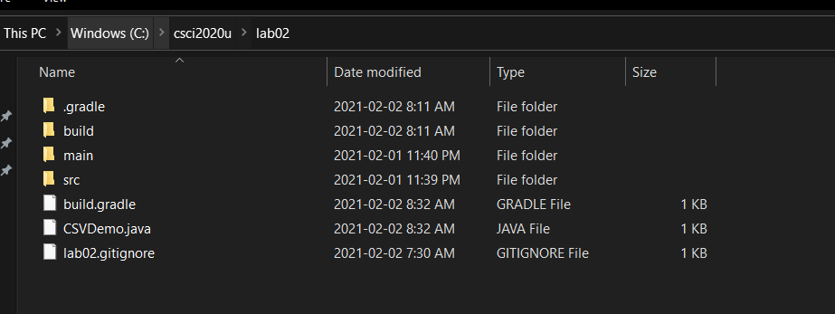

Git repo:

