Git repo: https://github.com/noshen-atashe/csci2020u_noshen-atashe

Part 1:

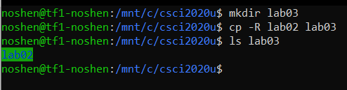

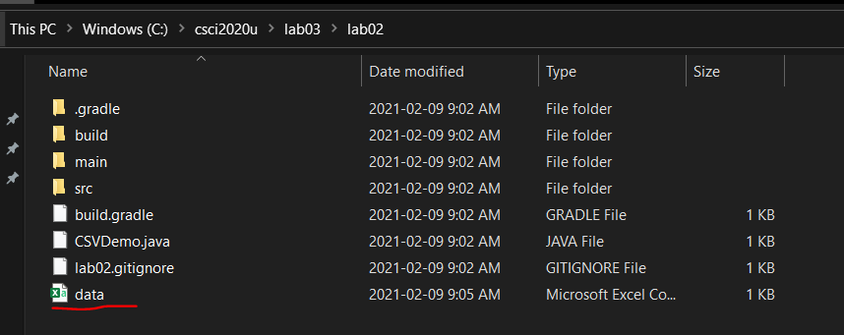

Part2:

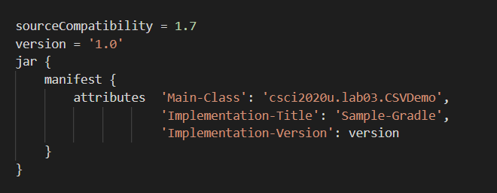

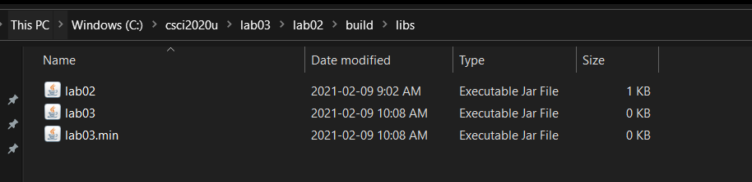

Part 3:

After extraction:

