Github repo: <https://github.com/noshen-atashe/csci2020u_noshen-atashe/tree/master/lab09>

UI window:

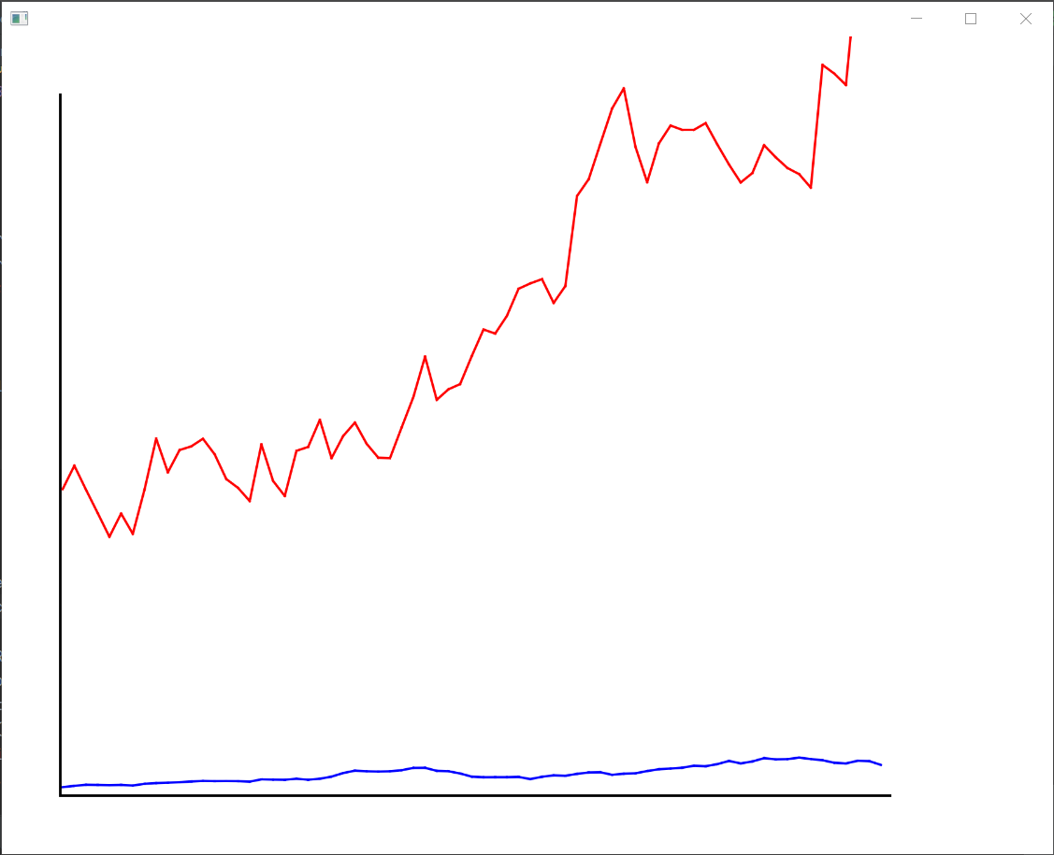

Local repo:

