Release Slate Density Supports Above-Seasonal Paid Streaming Growth
Consensus models for WMG typically embed calendar Q1 softness in paid streaming growth, reflecting post-holiday engagement normalization and subscriber churn patterns. We think the FY26 release slate — particularly the concentration of tentpole albums in fiscal Q4 2025 and fiscal Q2 2026 — provides a concrete, bottom-up reason to expect paid streaming revenue to outperform that seasonal assumption.
WMG’s fiscal Q4 2025 (calendar Q3) delivered three major new album releases in the final ten weeks of the quarter: Cardi B’s Am I The Drama? (Sep 19, #1 Billboard 200, 3x Platinum), Ed Sheeran’s Play (Sep 12, #1 UK, #5 US), and Alex Warren’s You’ll Be Alright, Kid (Jul 18, gold-certified day one, “Ordinary” #1 Hot 100 for five weeks). This late-quarter concentration created a streaming halo effect that carried directly into fiscal Q1 (calendar Q4), where all three were again cited as top sellers alongside new releases from Fred again.., Aya Nakamura, and Robert Plant. The result: subscription streaming revenue grew 10.9% Y/Y constant currency in FQ1, defying typical seasonal deceleration.
Looking ahead to FQ2 (calendar Q1 2026), the release slate is the densest in recent WMG history, with tentpole albums from Zach Bryan (#1 Billboard 200 on release), Bruno Mars (The Romantic, preceded by a #1 Hot 100 single), Charli XCX, Jack Harlow, Don Toliver, and a Gnarls Barkley comeback — stacking 8 tentpoles versus 4 in the year-ago quarter. For context, FY25’s FQ2 produced the softest subscription streaming print of the year at +3.2% Y/Y CC, driven in part by a lighter release slate and challenging Linkin Park comps.
Layer this on top of management’s commentary that contractual DSP rate increases begin in FQ2 and phase through FY26, and you get a double tailwind — higher share-of-streams from a stronger release slate plus higher per-stream economics from pricing — that consensus models anchored to seasonal norms are likely underweighting. Additionally, prior-year tentpoles (Ed Sheeran’s Play, Cardi B, Alex Warren) continue to generate elevated catalog streams into FY26 H1, providing a floor under WMG’s share-of-streams even before the new slate’s impact.

Exhibit 1: WMG Notable Release Count & Paid Streaming Growth, FY25 vs FY26
 | FQ1  Oct-Dec | FQ2  Jan-Mar | FQ3  Apr-Jun | FQ4  Jul-Sep | FY Total
FY2025
Tentpole Albums | 3 | 4 | 3 | 3 | 13
Total Notable Releases | 7 | 13 | 10 | 7 | 37
Sub Streaming YoY (CC) | 10.0% | 3.2% | 5.0% | 8.2%
FY2026
Tentpole Albums | 3 | 8 | TBD | TBD
Total Notable Releases | 10 | 18 | TBD | TBD
Sub Streaming YoY (CC) | 10.9% | TBD | TBD | TBD
FQ2 Tentpole Delta (Y/Y) |  | +4 (+100%)
Source: WMG 10-Q/8-K filings, Wikipedia album databases, trade publications. Tentpole = major artist with chart-topping commercial expectation. Green = key Y/Y comparison.

Exhibit 2: Tentpole Release Count vs. Subscription Streaming Growth
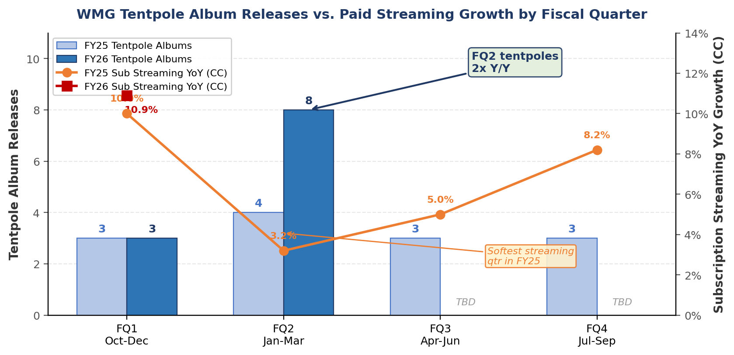
Source: WMG SEC filings (streaming growth), company release tracker (tentpole counts). FY26 Q3/Q4 TBD. Chart demonstrates positive correlation between tentpole density and subscription streaming growth acceleration.

Exhibit 3: WMG Fiscal H1 Named Release Slate, FY26 vs FY25
Artist | Album | Release | Label | Context
FY26 H1 — New Releases & Catalog Carry (Oct 2025 – Mar 2026)
Cardi B | Am I The Drama? | Sep 19 * | Atlantic | #1 BB200, 3x Plat. Catalog carry into H1.
Ed Sheeran | Play (Deluxe / Remixes) | Oct-Nov 25 | Atlantic | Deluxe Nov 28; Remixes EP Oct 17.
Fred again.. | TBA | Q4 2025 | Atlantic | Mgmt-cited as FQ1 anticipated release.
Aya Nakamura | TBA | Q4 2025 | Warner FR | Mgmt-cited. Major French market tentpole.
Robert Plant | TBA | Q4 2025 | Nonesuch | Mgmt-cited. Legacy artist.
Zach Bryan | With Heaven on Top | Jan 9, 26 | Warner | #1 BB200 on release.
Bruno Mars | The Romantic | Feb 27, 26 | Atlantic | 'I Just Might' #1 Hot 100 pre-album.
Charli XCX | Wuthering Heights | Feb 13, 26 | Atlantic | Soundtrack album. Post-Brat momentum.
Jack Harlow | Monica | Mar 13, 26 | Atlantic | Major hip-hop tentpole.
Don Toliver | Octane | Jan 30, 26 | Atlantic | Cactus Jack / Atlantic. Trap tentpole.
Gnarls Barkley | Atlanta | Mar 6, 26 | Atlantic | First album in ~18 years. Comeback.
Alex Warren | FEVER DREAM | 2026 | Atlantic | Follow-up to #1 Hot 100 single.
Hilary Duff | Luck... or Something | Feb 20, 26 | Atlantic | Mid-tier with crossover potential.
MiSaMo | Play | Feb 4, 26 | Warner JP | TWICE sub-unit. Japan/K-pop market.
FY25 H1 — Comparison (Oct 2024 – Mar 2025)
Linkin Park | From Zero | Nov 15, 24 | Warner Rec | #1 BB200. Biggest WMG rock release in years.
Charli XCX | Brat Remix Edition | Oct 11, 24 | Atlantic | Deluxe/remix extending Brat cycle.
Benson Boone | Fireworks & R. (Dlx) | Oct 2024 | Warner Rec | Deluxe edition.
Mac Miller | Balloonerism | Jan 17, 25 | Warner Rec | Posthumous release. Top physical seller.
FKA Twigs | Eusexua | Jan 24, 25 | Atlantic | Critical darling. Moderate commercial.
Teddy Swims | ITEB Therapy Pt 2 | Jan 24, 25 | Warner Rec | Franchise extension.
Jisoo | Amortage | Feb 14, 25 | Warner | BLACKPINK solo. K-pop tentpole.
Mumford & Sons | Rushmere | Mar 28, 25 | Island | Major act return.
Source: WMG earnings calls, Wikipedia List of 2025/2026 Albums (label-verified), Billboard, Apple Music. * Cardi B released Sep 19, 2025 (FY25 Q4); catalog carried into FY26 H1. Green = FY26 Q2 new releases.
We see FY26 H1 release slate strength as an underappreciated driver of near-term streaming outperformance and a key reason our paid streaming estimates sit above consensus through fiscal Q2.

