Release Slate Density Supports Above-Seasonal Paid Streaming Growth
Consensus models for WMG typically embed calendar Q1 softness in paid streaming growth, reflecting post-holiday engagement normalization. We think the FY26 release slate — particularly the concentration of tentpole albums in fiscal Q4 2025 and fiscal Q2 2026 — provides a bottom-up reason to expect paid streaming revenue to outperform that seasonal assumption. WMG’s fiscal Q4 2025 delivered three major album releases in its final ten weeks: Cardi B’s Am I The Drama? (Sep 19, #1 Billboard 200, 3x Platinum), Ed Sheeran’s Play (Sep 12, #1 UK, #5 US), and Alex Warren’s You’ll Be Alright, Kid (Jul 18, “Ordinary” #1 Hot 100 for five weeks). This late-quarter concentration created a streaming halo that carried into fiscal Q1, where all three were again top sellers alongside new releases from Fred again.., Aya Nakamura, and Robert Plant. Subscription streaming grew 10.9% Y/Y CC in FQ1, defying typical seasonal deceleration.
Looking into FQ2, the slate is arguably the densest in recent WMG history: Zach Bryan (#1 Billboard 200), Bruno Mars (#1 Hot 100 pre-album single), Charli XCX, Jack Harlow, Don Toliver, and a Gnarls Barkley comeback — 8 tentpoles versus 4 in the year-ago quarter. FY25’s FQ2 produced the softest streaming print of the year (+3.2% sub CC), driven partly by a lighter slate. Layer on management’s commentary that contractual DSP rate increases begin in FQ2 and phase through FY26, and you get a double tailwind — higher share-of-streams from a stronger slate plus higher per-stream economics from pricing — that consensus models anchored to seasonal norms are likely underweighting.

Exhibit 1: Tentpole Album Releases vs. Subscription Streaming Growth by Fiscal Quarter
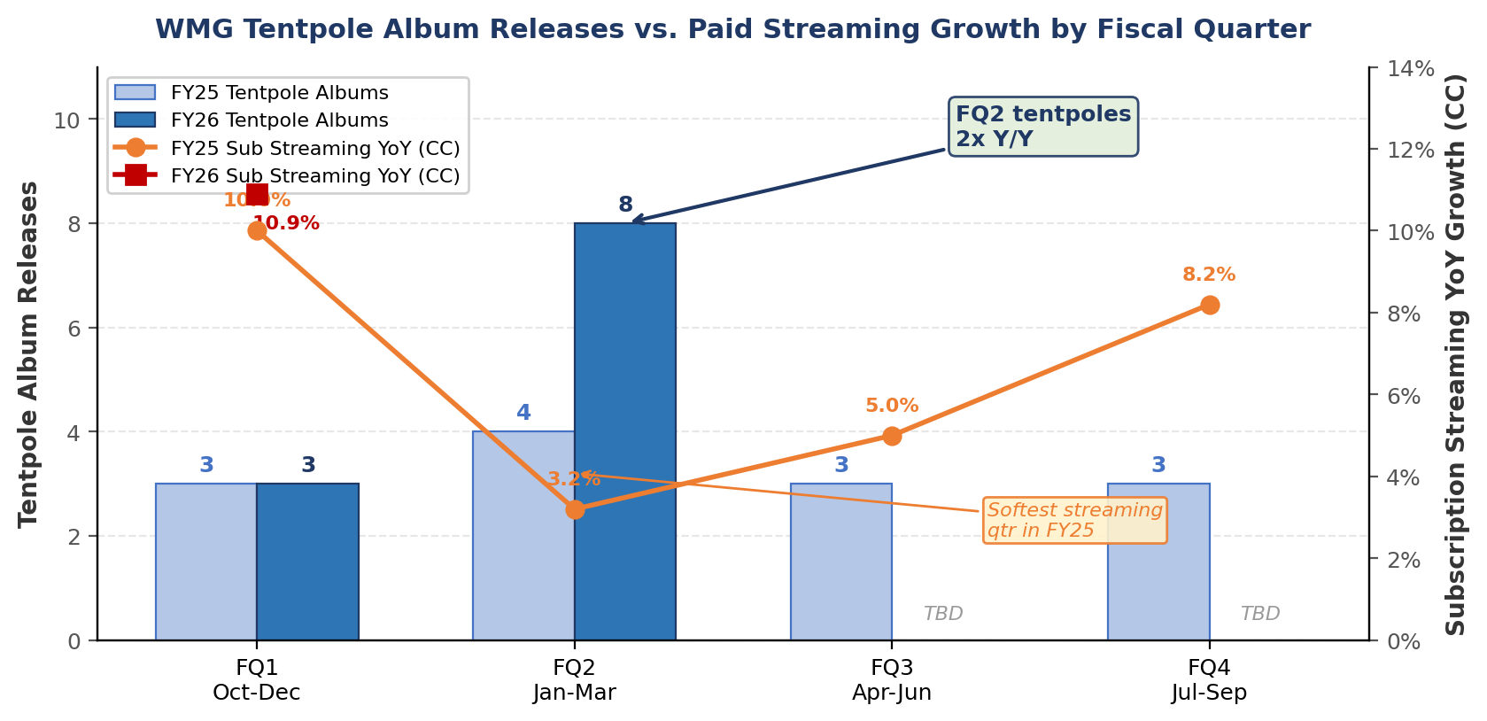
Source: WMG SEC filings (streaming growth), release tracker (tentpole counts). FY26 Q3/Q4 TBD.

Exhibit 2: WMG Fiscal H1 Release Slate — FY26 vs FY25
Artist | Album | Release | Label | Context
FQ1 (Oct–Dec 2025) — Catalog Carry + New
Cardi B | Am I The Drama? (cont.) | Sep 19 * | Atlantic | #1 BB200 debut, 3x Plat. 8 wks top 10. Deluxe editions Oct–Nov.
Ed Sheeran | Play (Deluxe / Remixes) | Oct–Nov | Atlantic | Deluxe Nov 28 (14 new tracks). Remixes EP Oct 17. Loop Tour Jan 26.
Fred again.. | TBA | Q4 2025 | Atlantic | Mgmt-cited ‘highly anticipated’ FQ1 release.
Aya Nakamura | TBA | Q4 2025 | Warner FR | Mgmt-cited. Biggest French-language pop artist globally.
Robert Plant | TBA | Q4 2025 | Nonesuch | Mgmt-cited. Legacy tentpole.
FQ2 (Jan–Mar 2026) — New Releases
Zach Bryan | With Heaven on Top | Jan 9 | Warner | #1 BB200 on release week.
Bruno Mars | The Romantic | Feb 27 | Atlantic | ‘I Just Might’ hit #1 Hot 100 pre-album.
Charli XCX | Wuthering Heights | Feb 13 | Atlantic | Soundtrack album. Post-Brat critical momentum.
Jack Harlow | Monica | Mar 13 | Atlantic | Major hip-hop tentpole.
Don Toliver | Octane | Jan 30 | Atlantic | Cactus Jack / Atlantic. Trap tentpole.
Gnarls Barkley | Atlanta | Mar 6 | Atlantic | First album in ~18 years. Major comeback.
Alex Warren | FEVER DREAM | 2026 | Atlantic | Follow-up. ‘Ordinary’ was #1 Hot 100 five weeks.
Hilary Duff | Luck... or Something | Feb 20 | Atlantic | Mid-tier with crossover potential.
FY25 H1 comparison: Linkin Park (From Zero, #1 BB200), Charli XCX (Brat Remix), Mac Miller (Balloonerism, posthumous), FKA Twigs (Eusexua), Teddy Swims (Pt 2), Jisoo (Amortage), Mumford & Sons (Rushmere). FQ2 FY25 had 4 tentpoles vs. 8 in FQ2 FY26.
Source: WMG earnings calls, Wikipedia (label-verified), Billboard, Apple Music. * Cardi B released Sep 19, 2025 (FY25 Q4); catalog carried into FY26 H1. Green = confirmed FQ2 FY26 new releases.
We see FY26 H1 release slate strength as an underappreciated near-term streaming catalyst and a key reason our paid streaming estimates sit above consensus through fiscal Q2.

