**Project Title:** Personal Document Management API with Django REST Framework

**Postman Public Workspace:**

<https://elements.getpostman.com/redirect?entityId=28813431-5983888a-3690-4a4f-bb68-367a75afb204&entityType=collection>

**API Documentation using swagger:** <http://127.0.0.1:8000/api_doc/>

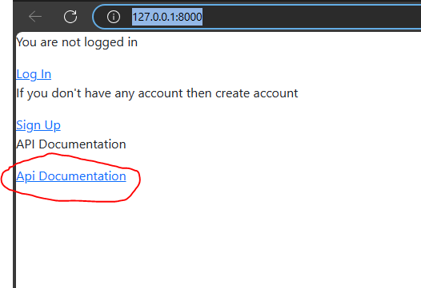

Figure 1: link the documentation in homepage

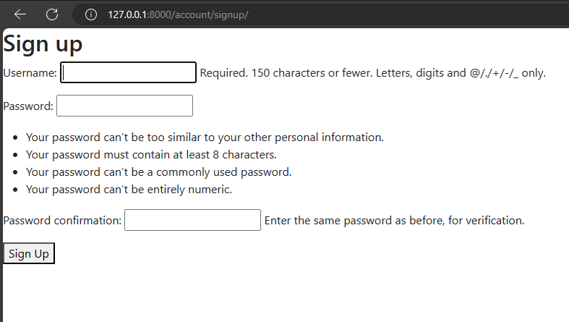

Figure 2: Registration View

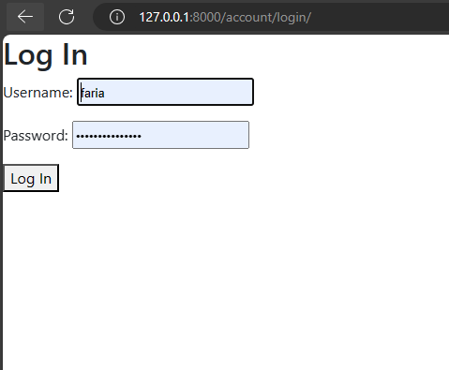

Figure 3: Log in view

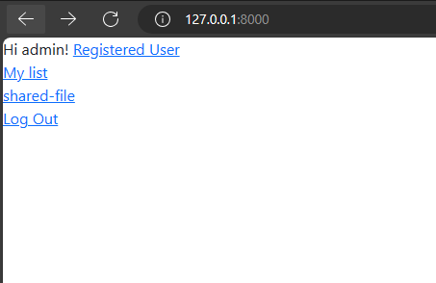

Figure 4: Home page view

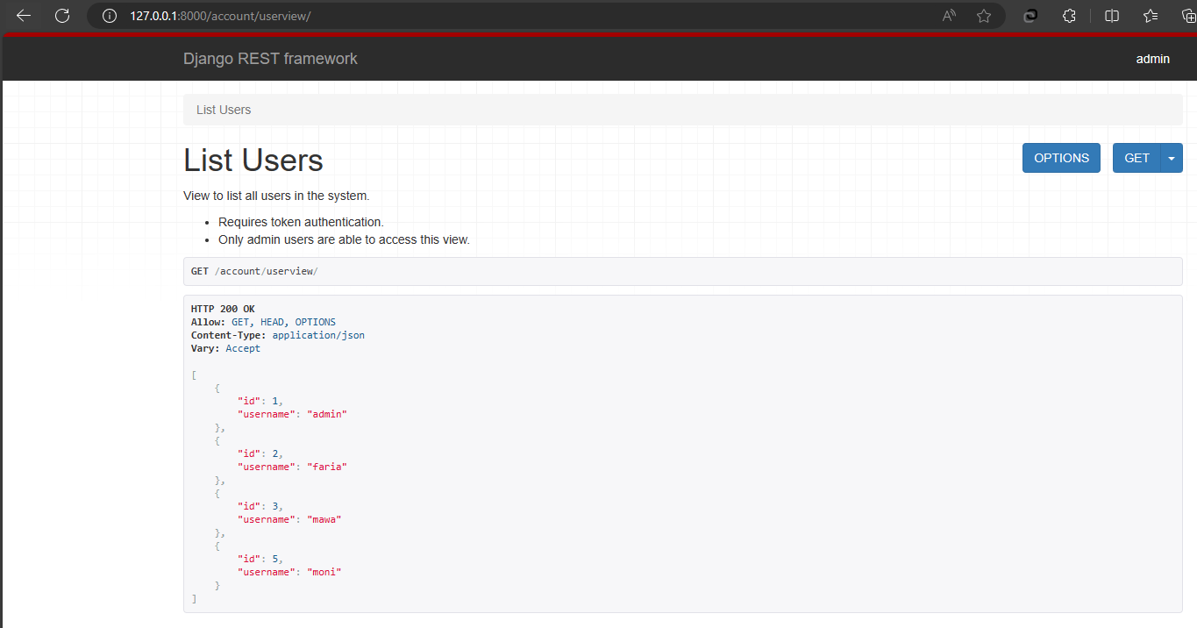

Figure 5: User list view (Only admin user can view this page)

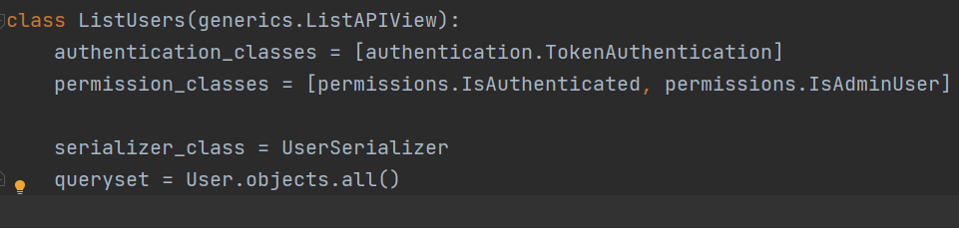

Figure 6: Token Based Authentication and role based access control

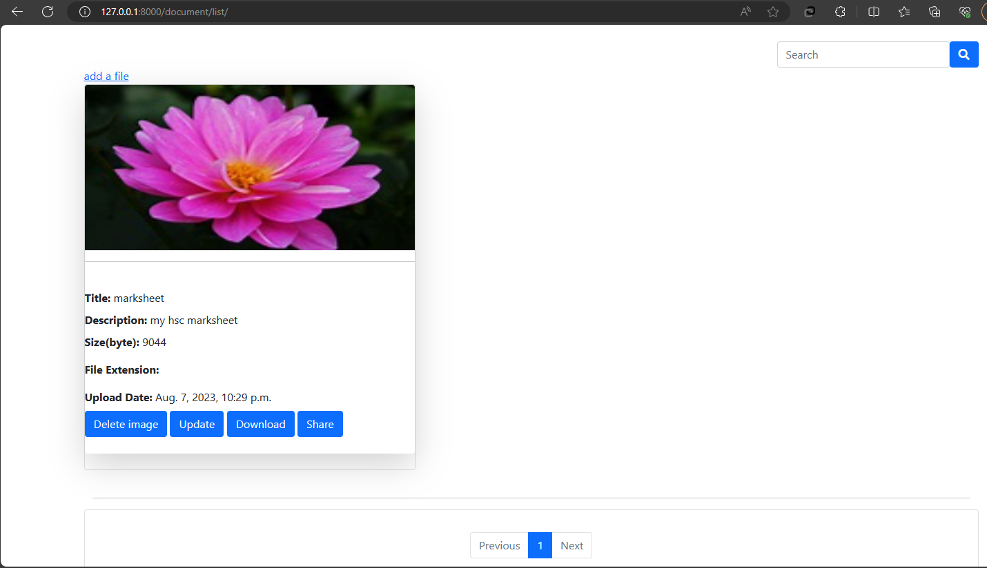

Figure 7: List of upload documents (only author can view, delete, update, share him item)

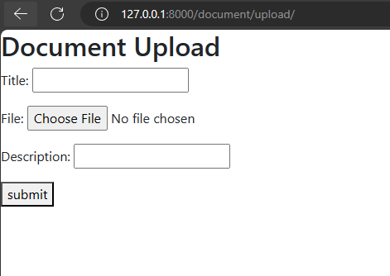

1. Form

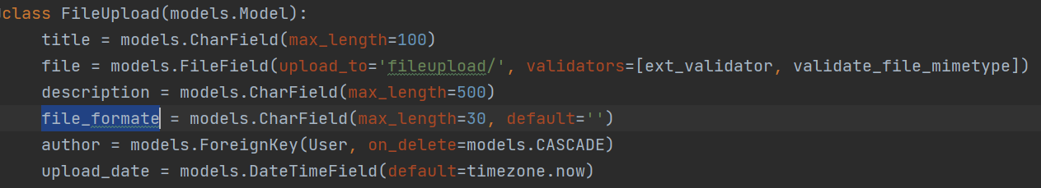

1. Other field will fill up automatically

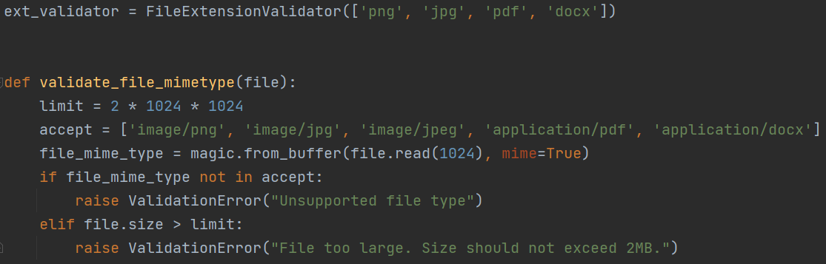

1. File extension validation process

Figure 8: Upload Document View

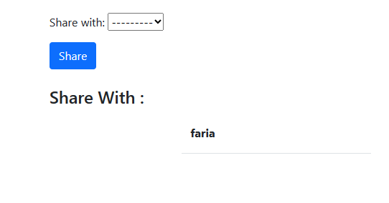

Figure 9: Choose user to share document (Only author have access of this page)

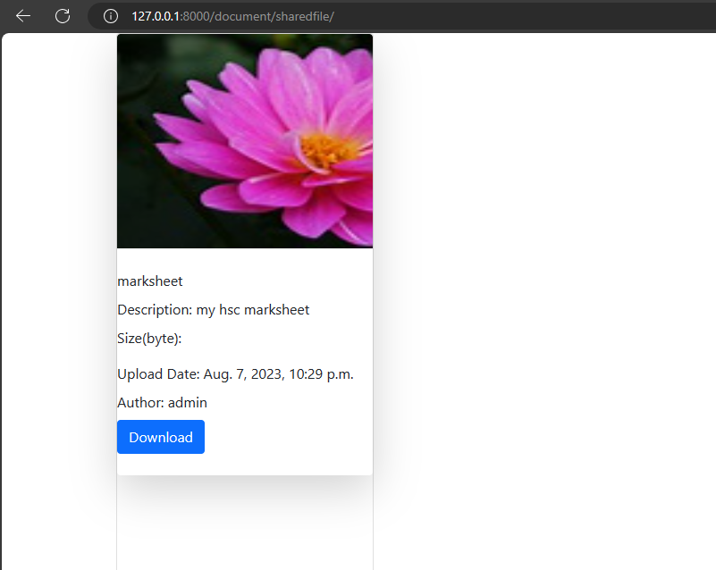

Figure 10: shared document (shared user can view item details and download it)