STUDENT NUMBER: ST10547352
FULL NAME: NOSIPHO LYANAH SIBANDA
MODULE NAME: PROGRAMMING FOR DATA ANALYTICS
MODULE CODE: PDAN8411W
COURSE NAME: POSTGRADUATE DIPLOMA IN DATA ANALYTICS

Table of Contents
1. Introduction 3
1.1 Executive Summary 3
1.2 Problem Statement and Objectives 3
1.3 Dataset, Source and Suitability 3
2. Data cleaning and Exploratory Data Analysis 3
2.1 Data Cleaning 3
2.2 Exploratory Data Analysis 4
3. Methodology and model settings 5
3.1 Data preparation and split 5
3.2 Baseline Logistic Regression 5
3.3 Feature Selection. 6
3.4 Cross-Validation and Hyperparameter Tuning 6
4. Results, Evaluations and Limitations 6
4.1 Model Performance on the Test Set 6
4.2 Cross-Validation and Tuning Results 7
4.3 Interpretation 7
4.4 Limitations 7
5. Conclusion and recommendations 8
5.1 Conclusion 8
5.2 Recommendations 8
References 8
Appendix 9

1. Introduction
A prominent medical scheme in South Africa is looking for ways to identify customers who may qualify for dread disease benefits, starting with cancer. This report analyses the Breast Cancer Wisconsin (Diagnostic) dataset, and it develops classification models to differentiate between benign and malignant breast tumour observations using numerical measurements (Wolberg et al., 1995).
Malignant cases are the main class of interest for this analysis because failing to identify them could delay further review, and delay patients receiving dread disease benefits.

1.1 Executive Summary
The dataset used contains 569 observations, 30 numerical tumour measurements and a diagnosis label. After removing an empty column and excluding the identifier from the predictors the dataset was divided into training and test sets using an 80/20 split. A logistic regression pipeline with standardisation was evaluated followed by a 10-feature model, five-fold stratified cross validation and lastly a grid search.
According to the results recorded in the analysis, the tuned logistic regression model performed best on the test set. It achieved 97.37% accuracy and 95.24% malignant recall and missed only two of the 42 malignant observations in the test set. This compares with three missed malignant observations for the baseline model and the four in the 10-feature model. The improvement was minor and the model should on support decision-making and not replace existing clinical review methods.

1.2 Problem Statement and Objectives
The medical scheme wants to speed up and improve how it identifies customers who may qualify for dread disease benefits, and it wants to start with cancer. The objective of the analysis to train and evaluate logistic regression models that predicts whether a tumour is benign or malignant from recorded image measurements, so that the patients who have malignant tumour can be identified for further review to determine if they qualify for the dread disease benefits.

1.3 Dataset, Source and Suitability
The Breast Cancer Wisconsin (Diagnostic) dataset was used for the analysis. The dataset contains 569 records, an identifier, a diagnosis field, and 30 numerical measurements derived from images of breast tumour samples. The diagnosis field contains B and M values with B being the benign observations and M the malignant observations.
The dataset is suitable for a binary classification algorithm because it includes numerical predictors and known diagnosis labels. It has 357 benign observations which is approximately 62.7% and 212 malignant observations which are approximately 37.3% of the total observations.
Dataset source: https://archive.ics.uci.edu/dataset/17/breast+cancer+wisconsin+diagnostic.

2. Data cleaning and Exploratory Data Analysis

2.1 Data Cleaning
The initial dataset contained 569 rows and 33 columns of data. The unnamed: 32 column, contained 569 missing values, which means that the entire column was empty, so it was removed as it had no useful information. There were no duplicated rows identified and no missing values were remaining after the unnamed: 32 was removed. The diagnosis labels were standardised by removing surrounding white space and converting them into uppercase. The identifier column was excluded from the predictors for this analysis because it identifies records rather than measuring tumour characteristics.

2.2 Exploratory Data Analysis
The diagnosis distribution showed that benign cases were more common than malignant cases.
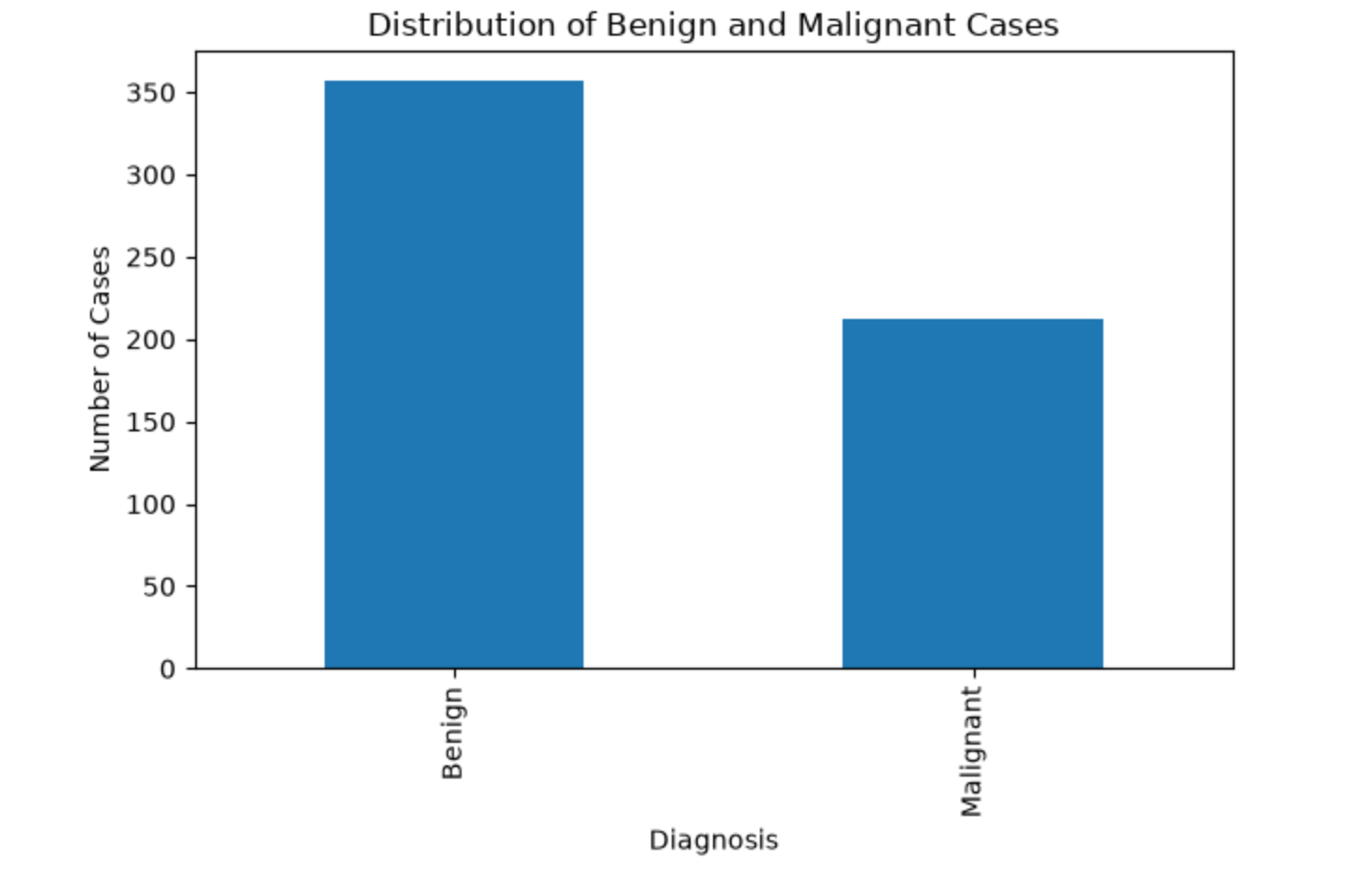
Figure 1: Distribution of Benign and Malignant cases
Summary statistics were calculated for the 30 numerical measurements and plots compared to selected measurements by diagnosis. It was found that malignant observations generally had higher mean radius and mean area values although there was overlapping between the distributions of both the benign and malignant cases. Concavity and concave-point measurements also tended to be higher for malignant observations while texture and smoothness showed more overlap between the cases.
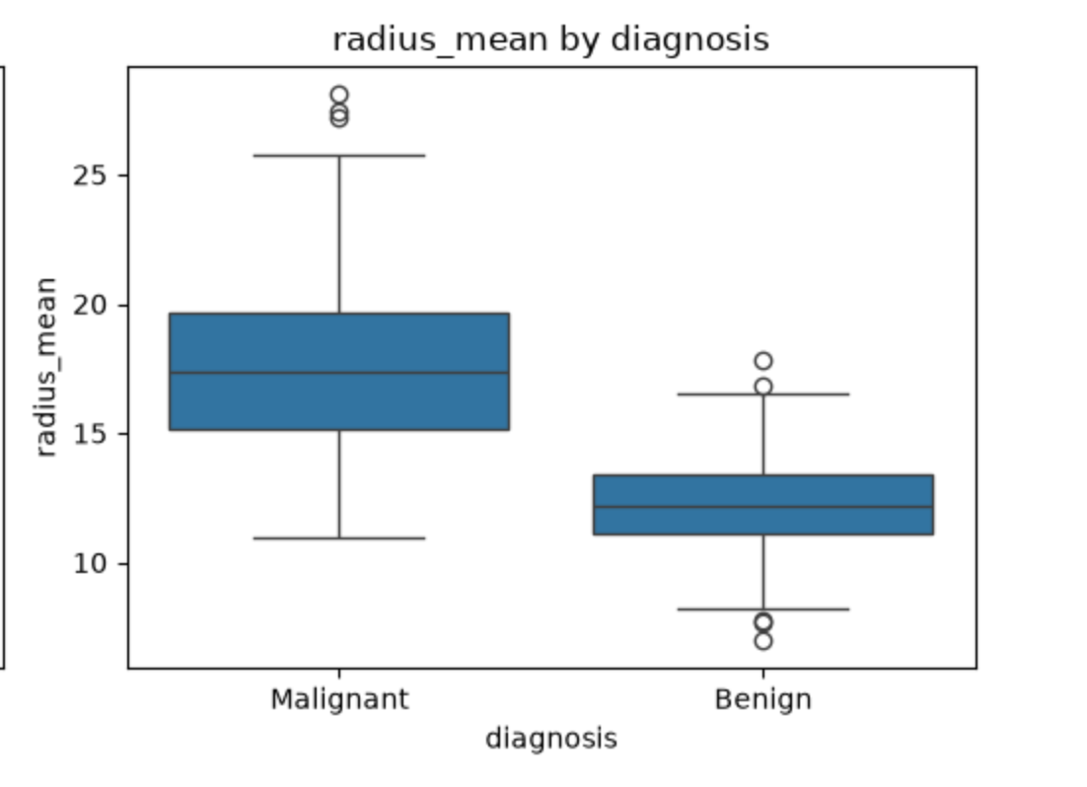
Figure 2: Distribution of mean radius by diagnosis
These patterns suggest that radius, area and concavity may help differentiate malignant observations from benign observations. The overlap between the classes shows why it is necessary to use multiple measurements rather than relying on a single feature.
The correlation analysis found a correlation of 0.998 between radius mean and perimeter mean and 0.987 between radius mean and area mean. The strong relationships between these measurements suggest that some measurements contain similar information. Potential outliers were kept in the analysis because the analysis did not have evidence that they were data entry errors
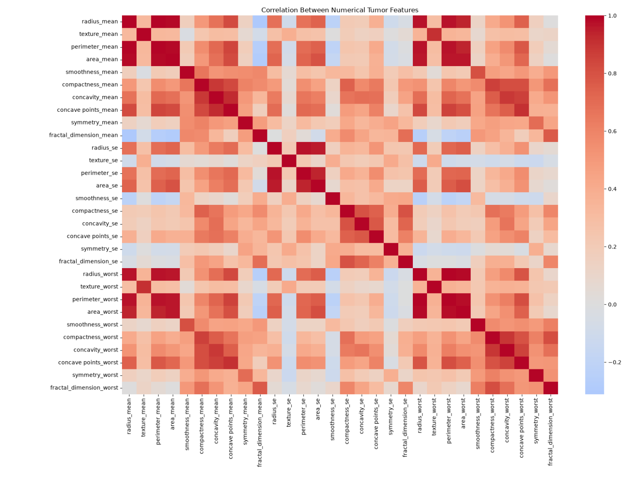
Figure 3: Correlation between numerical tumour features

3. Methodology and model settings

3.1 Data preparation and split
Diagnosis labels were changed from B and M to Benign and Malignant to make them easier to read. The 30 numerical tumour measurements were used as predictors while diagnosis values were retained as the target variable for the analysis. The data was divided into 80% training and 20% test sets using stratification and random_state=42. This helped preserve the class proportions in each subset. The training data was used to fit the models while the test data was used for the final evaluation of the models.

3.2 Baseline Logistic Regression
The baseline pipeline had StandardScaler followed by logistic regression. Standardisation was included in the pipeline so that the scaler could be fitted using the training dataset within each cross-validation fold. Logistic regression was selected because the target has two categories and the model provides a simple and straightforward classification baseline (Pedregosa et al., 2011)

3.3 Feature Selection.
A second pipeline used SelectKBest with the ANOVA F-test to select 10 measurements based on their individual statistical association with the diagnosis. The selection step was fitted on the training data, and the training model used the same split and logistic regression settings as the baseline which allowed the effect of using fewer predictors to be compared in the analysis.

3.4 Cross-Validation and Hyperparameter Tuning
Five-fold stratified cross-validation was done on the training data for the baseline model, and accuracy and malignant recall were recorded for each fold. Grid search was then used to evaluate the five values of C (0.01, 0.1, 1, 10 and 100) and two class_weight settings (none and balanced), using five-fold stratified cross-validation with malignant recall as the scoring measure (Scikit-learn developers, 2026). The test set was kept separate from the tuning process.

4. Results, Evaluations and Limitations

4.1 Model Performance on the Test Set
114 test observations, including 72 benign and 42 malignant cases where in the test set. The table summarizes the results recorded in this analysis.
Model | Accuracy | Malignant Precision | Malignant recall | Missed malignant | Benign flagged
Baseline (30 measurements) | 96.49% | 97.50% | 92.86% | 3 | 1
10 measurements | 95.61% | 97.44% | 90.48% | 4 | 1
Tuned model | 97.37% | 98% | 95.24% | 2 | 1

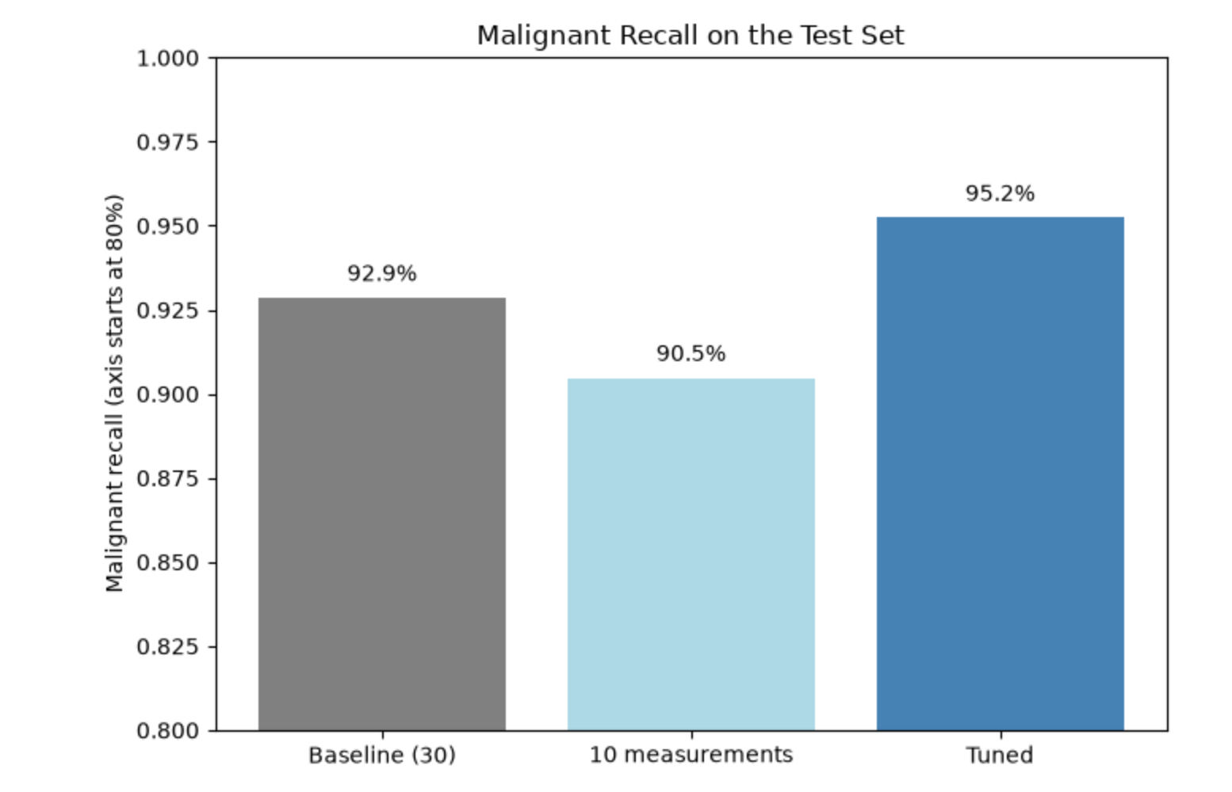
Figure 4: Malignant recall on the test sets
The baseline model correctly classified 110 of the 114 test observations but predicted three malignant cases as benign. The 10-measurement model had a lower accuracy and malignant recall, and it wrongly predicted four malignant cases as benign while predicting one benign case as malignant. This shows that reducing the number of measurements did not improve the performance of the model. The tuned model performed best, it correctly classified 111 of 114 cases, and it wrongly predicted two malignant cases as benign and one benign case as malignant.

4.2 Cross-Validation and Tuning Results
Over the five folds, the baseline model had a mean accuracy of 97.36% (standard deviation 1.49 percentage points) and a mean malignant recall of 95.29% (standard deviation 3.99 percentage points). Malignant recall ranged from 88.2% to 100% across folds, showing that findings vary depending on the data split. Grid search chose C = 1 and class_weight = balanced, resulting in a cross-validated malignant recall of 95.88%. The tweaked model was then evaluated against the test set.

4.3 Interpretation
Malignant recall is important in this analysis because it shows the proportion of malignant cases correctly identified by the model. The tuned model’s recall of 95.24% means that 40 of 42 malignant test cases were identified and two were wrongly predicted.
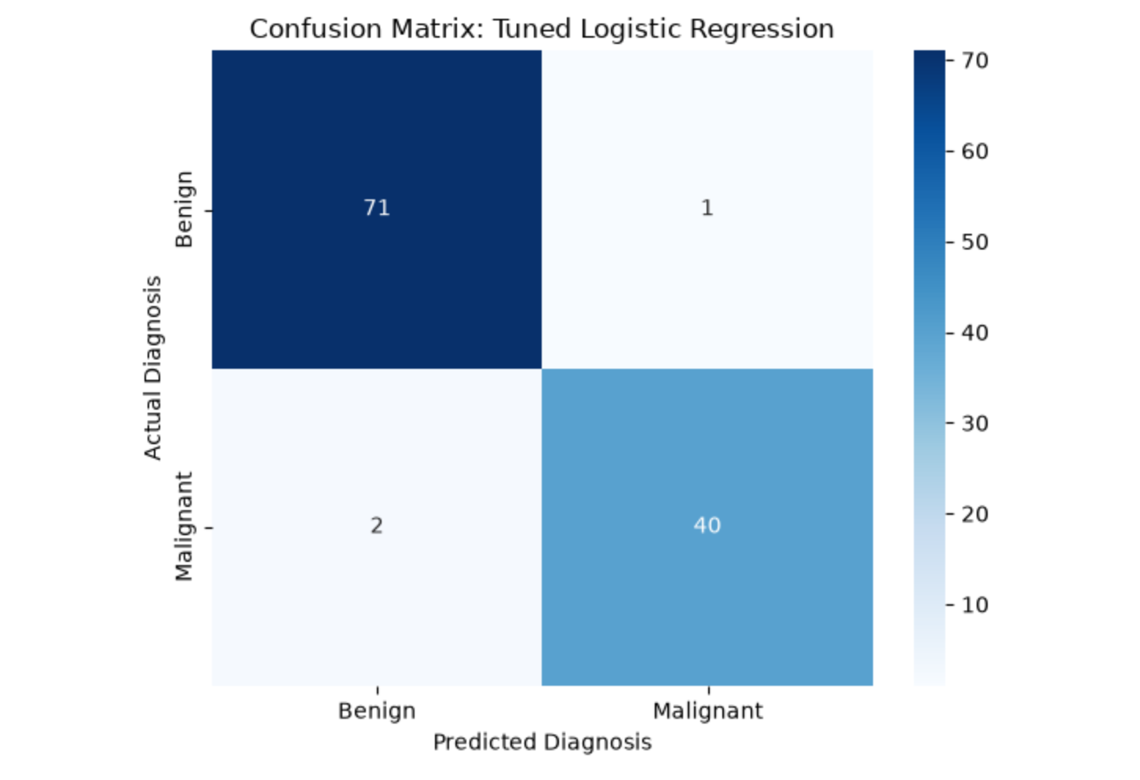
Figure 5: Tuned model confusion matrix
Accuracy alone would not show this detail, so recall and confusion matrix counts give useful additional information (Scikit-learn developers, 2026). A false positive (a benign case being predicted as malignant) would lead to additional review but a false negative (a malignant case predicted as benign) could mean that a customer who qualifies for the benefits is overlooked or their claim is delayed.

4.4 Limitations
- The dataset covers breast tumour diagnosis and does not represent every cancer type.
- It contains no medical-scheme eligibility, policy, member or claims data, so the model cannot determine benefit eligibility.
- The results are based on one stratified train-test split; performance may differ with another split or dataset.
- The 10 selected measurements were not shown to be the optimal feature subset.
- Only 42 malignant cases were present in the test set, so each case changes malignant recall by approximately 2.38 percentage points.
- Classification errors remain, and the model has not been established as clinically validated or suitable for real-world decisions.

5. Conclusion and recommendations

5.1 Conclusion
This analysis showed how logistic regression can classify breast tumour observations as benign or malignant using numerical measurements. The baseline model achieved 96.49% test accuracy and 92.86% malignant recall. Selecting 10 measurements reduced the performance of the analysis slightly. Grid search selected C = 1 and class_weight = balanced and the tuned model achieved the best test results with 97.37% accuracy and a malignant recall of 95.24%, and only two wrongly predicted malignant cases. The tuned model performed the best out of the three models evaluated in the analysis, but the improvement was minor and would need further validation on more data.

5.2 Recommendations
Based on the results of this analysis, it is recommended that the medical scheme use the tuned logistic regression model only as decision support and not as an automatic decisionmaker. The model identified 40 of the 42 malignant cases in the test set, but it still missed two, and a missed case could mean that a customer who qualifies for the dread disease benefit is overlooked or has their benefit delayed. Every result should therefore be reviewed by a qualified person before a benefit decision is made. Because the dataset covers breast cancer only, is small, and contains no information about the scheme's own members, policies or claims, the model should first be tested on larger and more varied data, and on other types of cancer, before it is used for the scheme's customers. Combining these measurements with the scheme's own data would also be needed before the model could judge benefit eligibility. Finally, malignant recall should remain the main measure when comparing any future models, since failing to identify a malignant case has the most serious consequences.

References
Pedregosa, F. et al. 2011. Scikit-learn: Machine Learning in Python. Journal of Machine Learning Research. 12, pp. 2825–2830. Available at: https://www.jmlr.org/papers/v12/pedregosa11a.html [Accessed 19 October 2026].
Scikit-learn developers. 2026a. LogisticRegression. Available at: https://scikit-learn.org/stable/modules/generated/sklearn.linear_model.LogisticRegression.html [Accessed 19 October 2026].
Scikit-learn developers. 2026b. GridSearchCV. Available at: https://scikit-learn.org/stable/modules/generated/sklearn.model_selection.GridSearchCV.html [Accessed 19 October 2026].
Scikit-learn developers. 2026c. Metrics and scoring: quantifying the quality of predictions. Available at: https://scikit-learn.org/stable/modules/model_evaluation.html [Accessed: 19 October 2026].
Wolberg, W., Mangasarian, O., Street, N. and Street, W. 1995. Breast Cancer Wisconsin (Diagnostic). UCI Machine Learning Repository. Available at: https://archive.ics.uci.edu/dataset/17/breast-cancer-wisconsin-diagnostic. [Accessed: 02 October 2026].

Appendix
Appendix: Main Model Settings
• Target variable: diagnosis (Benign or Malignant).
• Predictors: 30 numerical tumour measurements; identifier excluded.
• Train-test split: 80:20, stratified, random_state=42.
• Preprocessing: StandardScaler in a scikit-learn pipeline.
• Classifier: LogisticRegression(max_iter=2000).
• Feature-selection experiment: SelectKBest(score_func=f_classif, k=10).
• Cross-validation: five-fold StratifiedKFold with shuffle=True and random_state=42.
• Grid-search parameters: C = [0.01, 0.1, 1, 10, 100]; class_weight = [None, balanced].
• Grid-search scoring: recall for the Malignant class.

