How to use BlueController with Arduino environment
This packages requires Arduino 1.0. When you want to use it with older versions, please have a look at the chapter “What to do when upgrading to a new Arduino version?“

ATmega88PA based BlueController
In this documentation, I assume, that you have the ATmega328P variant of the BlueController board. If you own the ATmega88PA based board, you have to adapt the commands appropriately.
The optiboot bootloader of the ATmega88PA identifies itself as ATmega88 because the ATmega88PA is not supported by Arduino 1.0 (and also not by avrdude 5.10). This makes it possible to use the BlueController with ATmega88PA in the Arduino IDE.

Hardware setup (only needed when not already delivered with optiboot bootloader)
- Burn adapted optipoint bootloader (hardware/bluecontroller/bootloaders/optiboot/optiboot_bluec328_19200bps.hex)
- Set fuses and lockbits (refer to hardware/bluecontroller/boards.txt)
- Open the sketch “BlueController_Setup” from the hardware/examples folder, adapt it to your needs (e.g. change the bluetooth name), upload it and run it once. It is finished after the LEDs has blinked 8 times.

Unsupported: When you want to use a different baudrate, you have to set the parameters of the BTM-222 before flashing the bootloader, because you cannot upload anything using the bootloader when the baudrate between bootloader and BTM-222 doesn't match.

Software setup for Mac OSX
Copy the „bluecontroller“ folder to Documents\Arduino\hardware in your home directory.

Your directory structure should look like this now:
/Users/
<yourUsername>/
Documents/
Arduino/
hardware/
bluecontroller/
avrdude/
boards.txt
bootloaders/
doc/
examples/
variants/

Software setup for Windows XP / Windows Vista / Windows 7
Copy the „bluecontroller“ folder to My Documents\Arduino\hardware.

Your directory structure should look like this now:
C:\ (this depends on the drive where you installed Windows)
Users\ (or a language specific name like “Benutzer”, or “Documents and Settings” on older Windows versions)
<yourUsername>\
Documents\
Arduino\
hardware\
bluecontroller\
avrdude\
boards.txt
bootloaders\
doc\
examples\
variants\

How to activate the bootloader mode using buttons
- Press both buttons (reset + INT0)
- Release the reset button while still holding the INT0 button
- Release the INT0 button
- The LED will light very dim as long as the bootloader is ready to accept uploads

Bluetooth connection problems
The BTM-222 is not able to manage pairing with multiple computers. When you pair it with a second computer, it forgets the key of the first computer, so you have to pair it again or at least refresh the key.

Solve connection problems on Microsoft Windows
To be able to connect your Bluecontroller after connection problems, you have to delete the pairing with the BlueController and add it again.

Solve connection problems on Mac OSX (refresh Bluetooth key)
Sometimes you might get a connection error box from the Arduino IDE:
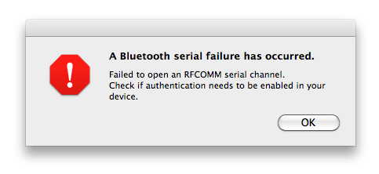

Open the Bluetooth System Preferences, select your BlueController device and choose „Edit Serial Ports...“. In the dialog which appears, you can toggle the setting „Require pairing for security“ twice (so that it has its original state again) and press “Apply”:
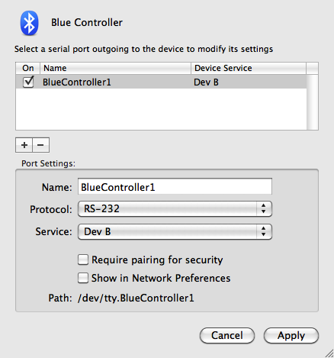
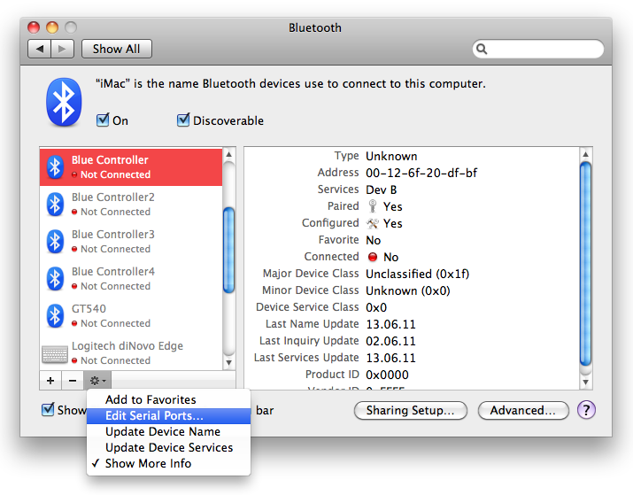

How to activate the bootloader mode from your sketch
Look at the files bootloadertools.cpp and bootloadertools.h in the “examples / Serial_and_Blink_BlueController” sketch. Copy these two files to your own sketch and put a #include "bootloadertools.h" line at the beginning of you main sketch file. Call the function enter_bootloader() to activate the bootloader.

How to upload sketches / Hex-files without the Arduino IDE
Put the BlueController in bootloader mode and use avrdude to upload your program, for example:
avrdude -p atmega328p -b 19200 -c arduino -P /dev/cu.BlueController -U flash:w:myprogram.hex:i
When using a standard Linux or MacOS (e.g. from www.macports.com) version of avrdude, use the programmer type “arduino”. If you use the avrdude which comes together with an Arduino package older than V1.0, you have to use the programmer type “stk500v1”. Since Arduino V1.0 you also have to use “arduino” for this one.
The device name (/dev/cu.BlueController), hex-filename (myprogram.hex) and mcu type (atmega328p) have to be adapted to your environment. When programming a ATmega88P, you have to use “atmega88” as mcu type here.

Differences between BlueController and Arduino
The BlueController hardware is more like the Arduino Pro than the Arduino Uno
Here the list of differences
- The BlueController onboard LED is connected to PB6 and not to PB5. The Arduino pin number is 20, so you have to change the LED pin number from 13 to 20 in your Arduino sketches or connect a additional LED (with 1 kOhm current limiting resistor) to PB6.
- Additional two I/O pins: PB6 and PB7.
- PB7 is used to control the RESET line of the BTM-222 bluetooth module and cannot be used for any other purpose. The Arduino pin number is 21.
- PB6 is connected to a LED, but can additionally be used as normal output. The Arduino pin number is 20.
- PB5 is completely free and can be used as input or output. The Arduino Uno uses this pin for its LED.
- Instead of a 16 MHz crystal, the BlueController uses the internal ATmega oscillator with a clock frequency of 8 MHz.
- The voltage is 3.3V instead of 5V
- No auto-reset feature, use the reset button + boot-loader button or the reset-magic mechanism instead
- Reset magic mechanism: Entering the boot-loader can be controlled by your sketch, so you don't need the buttons and can upload you sketch remotely, even if you don't have physical access to the BlueController board. Look at the “Serial_and_Blink_BlueController” sketch for a demo how it works.
- Serial communication speed is fixed to 19200 bps
- Bluetooth interfaces instead of USB serial interface
- Level shifters for some I/Os to make it possible to use 5V hardware
- The Arduino shields cannot be used with BlueController
- The bootloader is different, it uses an enhanced optiboot bootloader

Home of this project
The current version of this distribution can always be found here:
https://code.google.com/r/michaeldreher42-bluecontroller/

Information about the hardware can be found in the online shop:
http://lynx-dev.com/ or http://rf-store.com/

What to do when upgrading to a new Arduino version?
The delivered package is for Arduino 1.0. There should be no changes necessary when Arduino is updated to newer versions. The pins PB6 and PB7 are not supported on a standard Arduino, therefore an own copy of variants/bluecontroller/pins_arduino.h is used.

Former Arduino versions (Arduino 22 and 23) required a patched core which is still delivered together with this distribution in bluecontroller/cores/bluecontroller. It is almost a copy of the original Arduino core directory, except for the file pins_arduino.c.

Unfortunately it is not possible to make boards.txt entries which work with Arduino 1.0 and versions before 1.0 at the same time.
If you really need to use an Arduino version 22 or 23, you can patch the build.core lines in boards.txt. Replace the lines
bluecontroller<XXX>_<YYY>o.build.core=arduino:arduino
with
bluecontroller<XXX>_<YYY>o.build.core=bluecontroller:bluecontroller

Where <XXX> and <YYY> are the mcu type and baudrate.

How to get support
You can use help in the Arduino forum at http://arduino.cc/forum/. There are also international groups if your are not so familiar with the English language.

The people at http://www.mikrocontroller.net/ are also very helpful for all electronic hardware and software questions. The forum is available in German and in English.

For advanced AVR topics, I recommend http://www.avrfreaks.net/.

When you find a bug in this documentation, the BlueController optipoint bootloader or any other part of this BlueController distribution, you can contact me using the following address:
bluecontroller@5dot1.de

/Applications/Arduino.app/Contents/Resources/Java/hardware/tools/avr/bin/avrdude on OSX

