**Lập trình hướng đối tượng – IT3103 – 744523**

Họ và tên: Bùi Thị Xuân

MSSV: 20225957

**LAB 02**

1. **Use case diagram:**

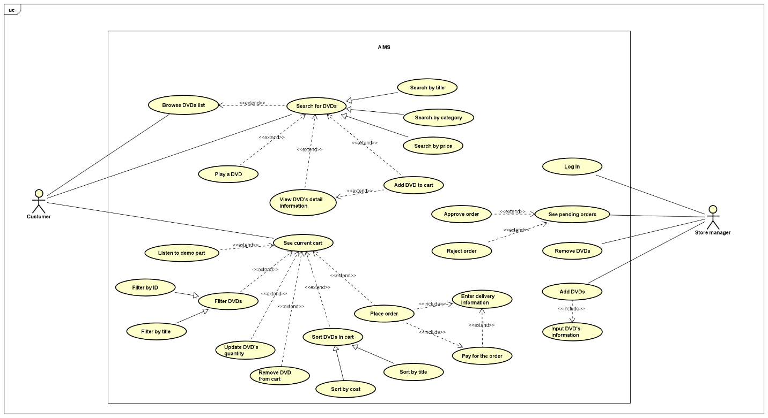

1. **Class diagram:**

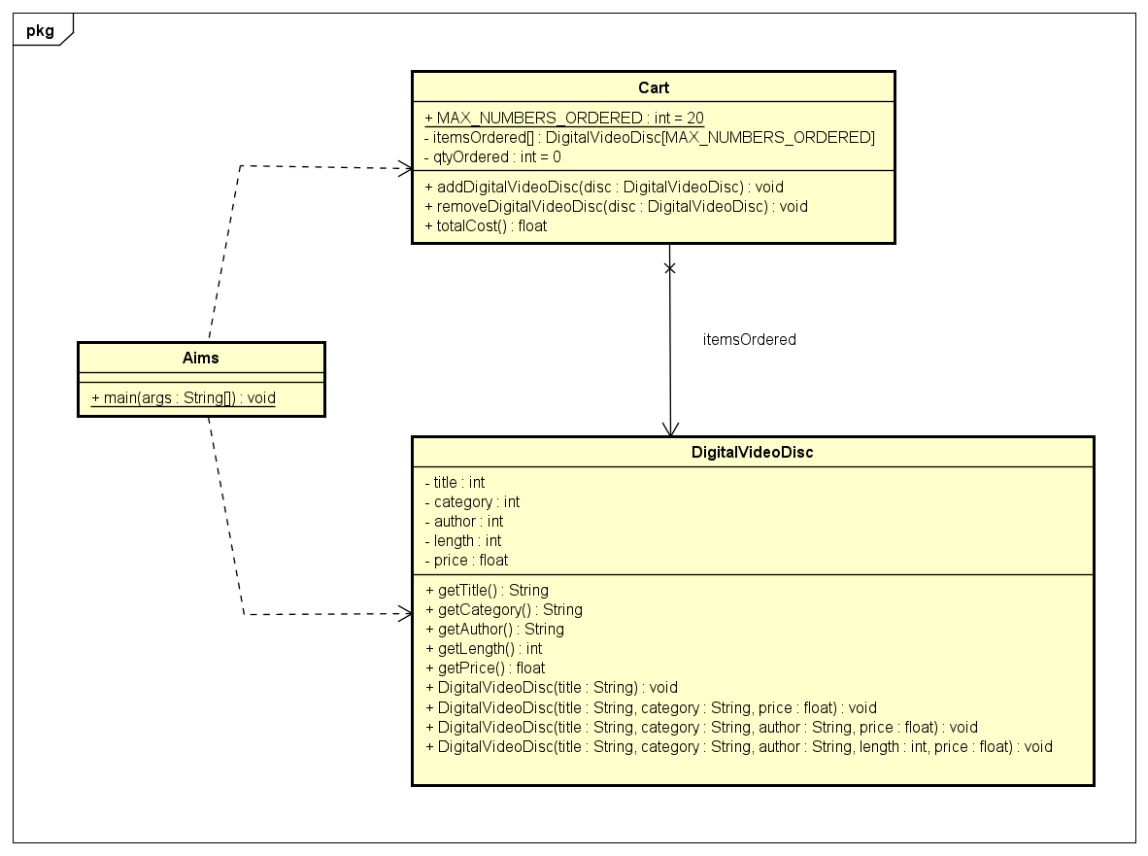

1. **Reading Assignment**

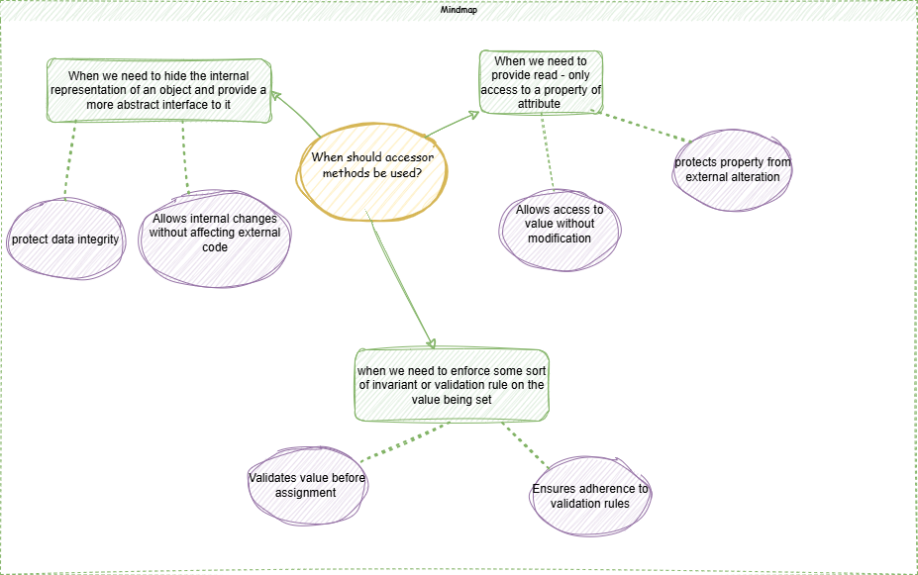

1. **Question**

If you create a constructor method to build a DVD by title then create a constructor method to build a DVD by category. Does JAVA allow you to do this?

**Answer:** Yes, Java allows users to create multiple constructor methods for a class, as long as the parameter lists are different, which helps Java distinguish between the methods. This is known as constructor overloading.