Group 40 - Scientific approach

Members of the group:

* Haytam Borchani
* Paul Guillermit
* Anthony Ivanier
* Nossa Iyamu
* Louis Simon

# Description

During this Hackathon, we developed a web app that predicted the sales of the fourth month of a quarter for a given product and country and estimated the environmental impact of using these predictions.

Our group was composed of the following fantastic 5:

- Nossa and Anthony, our business people, imagined everything we built and gave us guidelines

- Louis, who dug into the data to produce the best model

- Haytham, who made our product usable by developing a nice user-friendly app

- Paul, who used our predictions to boost the sustainability of the supply chain

# Model explanation

Our final approach boils down to:

* **Feature engineering:** we compute the average value at the same date for the following subgroups: product line proxy, strategic product family proxy, cluster, and an interaction term between product line proxy and zone (same product line proxy and same zone). We ensured that there were at least 10 data points at each date for each sub-group.
* **Model:** we use the three last month sales, the features we engineered (descibed above) and two categorical variables (site and customer persona proxy). We then use a catboost model.

# Sustainability

We estimated the environmental impact of using our model. We considered that without our model, the production would correspond to the following naive prediction (linear interpolation):

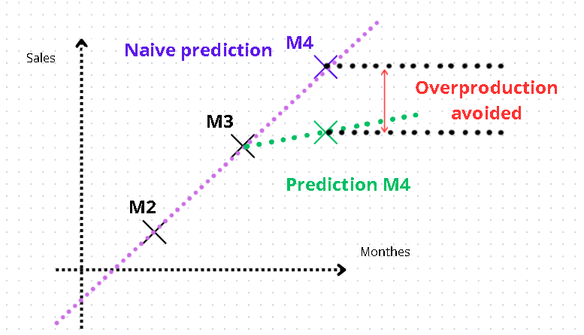

Based on these values, we have calculated two sustainability indicators:

* The *“waste avoided”* metric (unit: number of products), that corresponds to: $(1-recycling rate_{country})* overproduction avoided_{country}$

(the recycling rate being country-dependent).

* The *“CO2 transport total”* and *“CO2 transport saved”* metrics (unit: mass of CO2), that correspond to:

$average distance_{country}* average mass product*production_{country}* CO_{2}/km.kg$

For *“CO2 transport saved”*, we replaced the production with the overproduction avoided.

Those metrics emphasize the sustainability gain of using our model.



 