Anycubic Vyper MCU-Board: STM32F103
TriGorilla+ 0.0.5 & 0.0.6 PinOut
date: 2021-12-04

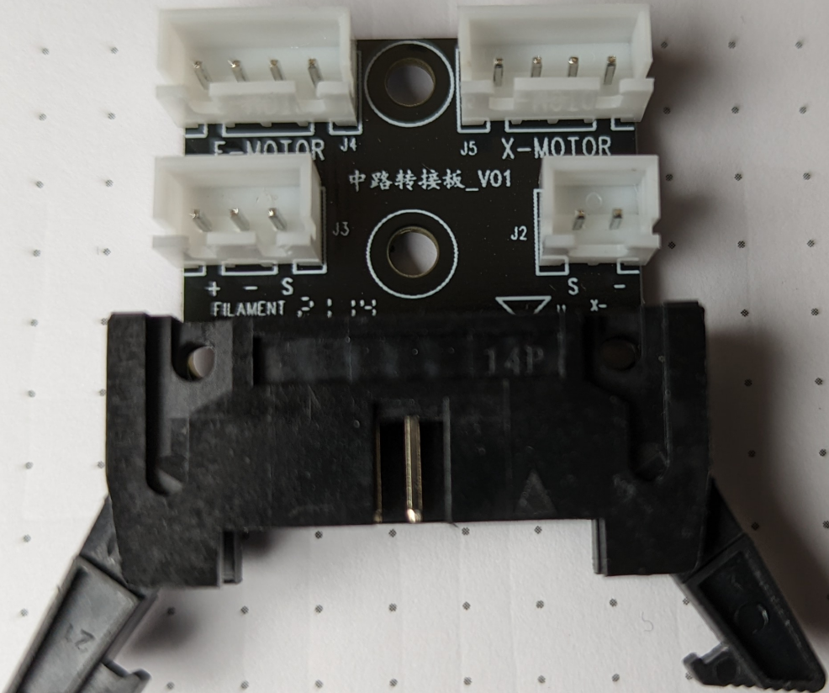
FREE USE AT YOUR OWN RISK!!!

01 Signal X-Endstop (PA7) 08 2A of E-Stepper
02 GND 09 1A of E-Stepper
03 1B of X-Stepper 10 1B of E-Stepper
04 1A of X-Stepper 11 + Filament-Sensor
05 2A of X-Stepper 12 – Filament Sensor (NC)
06 2B of X-Stepper 13 Signal Filament Sensor (PA5)
07 2B of E-Stepper 14 NC

13 1 11 1
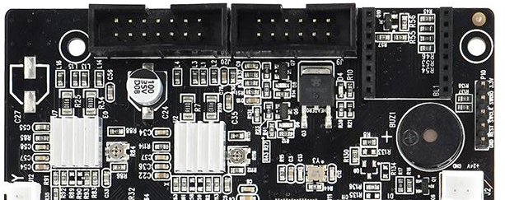
14 2 12 2

01 Hotend Power (24VDC) 07 FAN0 & FAN2 +24VDC
02 Hotend Power (24VDC) 08 FAN0 GND
03 Hotend Power (24VDC) 09 ??
04 Hotend Power (GND) 10 ??
05 Hotend Power (GND) 11 Thermistor T0 (a)
06 Hotend Power (GND) 12 Thermistor T0 (b)

to be continued :-)

