Black Rock City Honoraria
2020 Letter of Intent Form Preview
Burning Man is now accepting Letters of Intent (LOIs) for the Black Rock City Honoraria Program. LOIs are due by November 14, 2019 at 5:00pm Pacific Time. You will be notified by December 17 whether or not you are invited to submit a full proposal. Full proposals will be accepted by invitation only and will be due on January 22, 2020 at 5:00pm Pacific Time.

Before submitting an LOI, please read more about the Black Rock City Honoraria program here.

You are accessing this preview through Google Docs; please make a copy of this file so that you can compose your responses. We recommend that you compose and edit your responses in a text editing application (such as Word or Google Docs) before beginning the online form, and then paste your responses into the form.

Thank you in advance for sharing your creativity!

BRC Honoraria LOI Form
*Asterisk Indicates Response Required

Lead Artist Name (Leave Blank if YOU are the Lead Artist)
Up to 80 characters of text

Only if Lead Artist is someone other than you.

The name and contact info from the Burner Profile submitting this Letter of Intent will be the primary contact that we use regarding this application. If the lead artist is DIFFERENT from the primary contact, enter the name of the lead artist here.

How many years has the Lead Artist attended the Burning Man event in Black Rock City?

5

List any previous art projects the Lead Artist has worked on in Black Rock City.

2015 – Jason Turgeon, Blunderwood Portable typewriter
Doug Ruuska, Charnival
2018 – Doug Ruuska,
RayActivation

Artist Group, Collective or Organization Name
Up to 255 characters of text

Nostalgia Purgatory

Project Website

If you already have a website for this project, share the link here. Please use a valid URL format, including “http://” and use all lower-case letters.
(None)

Art Installation Title*
Up to 80 characters of text

Revolutionary Labyrinth

Project Summary*
Up to 300 characters of text

Briefly describe the project for which you are requesting funding.

A labyrinthine grid of revolving darkroom doors that link together unique works of installation art. Unique revolving pathways will entice the participant to come back many times to try new combinations of revolutions, leading them to find a microcosmic multiverse of art that has yet to be seen.

Physical Description*
Up to 800 characters of text
Each cylindrical space, in total 13, reveals a different work of interior installation art on a stationary platform with revolving walls. Each revolving door is a threshold to the next, with three branching pathways. Perimeter doors of the structure escape the viewer to the playa. When the participant is inside one space, they will manually revolve the walls of the cylindrical installation either left or right, leading to one of three other installations. This creates a unique pathway of Left-Right-Center combinations through the immersive universes of individual artists, each in succession. Doors that are adjacent to each other may interact with one another, or isolate one of the senses to provide the viewer with an indulgent and interactive moment.

Physical Dimensions*
Up to 255 characters of text

Provide all measurements in feet. Round up to the nearest whole foot.

Generally a Cube/Diamond shape, 18' by 18' by 7.5', with the longest dimension being the diagonal from corner to corner at 25'.

Interactivity*
Up to 500 characters of text

How will the citizens of Black Rock City interact with your art?

Please keep in mind that citizens of Black Rock City have minds of their own and may not interact with your art in the ways you expect.

The labyrinth must be moved manually by grasping handles to turn the walls of each cylinder, in a style like that of a darkroom door. It is a “choose your own adventure” style labyrinth, with no wrong paths and a unique experience through every turn. Additionally, many of the installations contained within the project will be interactive LED artworks, and triggered effects that begin when a guest enters the threshold.

Mission*
Up to 500 characters of text
The goal of this project is to embody the theme of Burning Man 2020. With this labyrinth of artwork leading to artwork, we are showcasing a microcosm of the possible multiverse. We would like to see how people choose direction, left, right, or the middle path one wouldn't see unless bypassing the first presented opening. We would create installations that interact with the works adjacent, to see how to make transitions thoughtfully between one person's artwork and the one beside it.

The Mission of Burning Man Arts is to change the paradigm of art from a commodified object to an interactive, participatory, shared experience of creative expression.

Please don’t explain how your project relates to the 10 Principles; we’re interested in learning how it supports our mission.

What is the philosophy of your piece?*
Up to 1000 characters of text

What are you hoping to express with the manifestation of your installation? What does the art mean to you? What do you hope to communicate to participants?

The archetypical version of a maze or labyrinth is not what we are trying to achieve here. It is an anti maze, with no solution, and no empty dead ends. Every decision made is a revolution of the walls, the art, around you. You are choosing between the belly of the beast or a cylinder of harp strings; the color indigo or the sound of crickets and the smell of freshly cut grass. It is immersive, taking up the entire field of vision. In that way you are experiencing shards of imaginary universes. It is a microcosm of the multiverse.

Where do you see your art project being experienced? At the annual Burning Man event, in other locations, or both?*
- Both

Is this an existing artwork or a proposed concept?*
- Proposed Concept
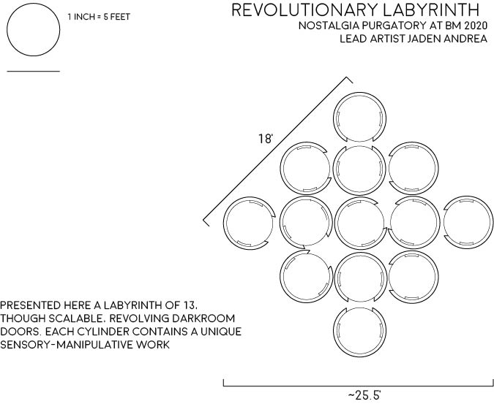

Estimated Total Budget*

What is the total projected cost of the project described in this application? We understand this is an anticipated cost and the amount may slightly change at the stage of submitting a full proposal.

Please enter a whole number in US Dollars, not a range.

24500

Estimated Funding Request*

Approximately how much funding are you requesting from Burning Man for this project?

Note that, for the most part, Burning Man only partially funds honorarium projects, so we strongly recommend that your Funding Request not be 100% of your total budget.

Please enter a whole number in US Dollars, not a range.

14500

Supporting Image(s)
You may upload up to two additional images here, following the same requirements.
(None)

Video
If you would like to include a video or other media available online (e.g. on YouTube or Vimeo), you may share the URL with us here.
(None)

Is there anything else you think we should know?
Up to 500 characters of text

Thank you for taking the time to read these proposals and have fun thinking of how you see yourself experiencing them!

Thank You!

Thank you for submitting your Letter of Intent! We look forward to reading it.

We will notify you via email by December 17, 2019.

More information about the process and timeline is available here.

? This question only appears if you enter a Lead Artist Name, if the Lead Artist isn’t you. If you are the Lead Artist your Burner Profile info on Burning Man Projects and Affiliations is already collected through your Profile.

