# Name of the game

AI Game

# Goal of the game

The goal of this game is to create a game that implements intelligent AI. This game has 4 levels, where the level must collect 5 dinosaur eggs to escape the maze. I had an interesting idea where I gave the player a sidekick called “Buddy”. Buddy is a dinosaur that helps the player, but the player must also look after buddy too and not let him die.

# Features that have been implemented

Every single feature that has was listed in the spec has been implemented.

|  |  |
| --- | --- |
| **Feature listed in spec** | **Implemented** |
| The player needs to collect a finite number of objects before moving to the next level | Yes |
| NPCs are present in the maze and will follow the player accordingly | Yes |
| If the NPCs collide with the player, then the latter loses a life | Yes. I modified this slightly though. Instead of losing a life, I just reduce health as I have a health bar as the health. |
| The player has a initial number of three lives available | Yes |
| The game ends when the player either has completed all levels or when s/he has no more lives available | Yes |
| The game may include several levels of increasing difficulty (e.g., NPCs with increasing intelligence) | Yes |
| FPS view | Yes |
| An indoor environment using built-in shapes and/or imported 3D objects | Yes |
| Can include walls, lights, and water | Yes |
| Can include traps (where the player and/or NPCs can fall) | Yes |
| Can include safe and dangerous areas | Yes |
| Rigid Bodies | Yes |
| Using either First-Person Controller or Third-Person Controller | Yes |
| Multiple different kinds of enemies | Yes |

# Minimum Features to be included

|  |  |
| --- | --- |
| **Minimum Feature** | **Implemented** |
| NPC’s | Yes |
| Breadcrumbs | Yes |
| FSM | Yes |
| Paths | Yes |
| Waypoints | Yes |
| Line of sight | Yes |
| Multi-Level | Yes |
| Randomization | Yes |

# Gameobjects and Attached Scripts

|  |  |
| --- | --- |
| **GameObject** | **Script Attached** |
| Buddy | BuddyScript – This controls the behaviour for the AI dinosaur that helps you |
| Button | ButtonAction, OpenRaptorCage |
| Mage | ChimeraScript – This is a type of enemy. This controls the mage enemy |
| ClawBug | ClawBugScript, Clawbugsback |
| Egg | CollectEgg |
| HealthPack | CollectHealth |
| GUI_Controller | EggTextureScript, HealthManager, RandomlyPlaceHealth |
| Elemental | ElementalScript |
| On all enemies | EnemyHealth |
| On the camera at the main menu | MainMenuCamera |
| Cage | Make_Not_Kinematic – This stops characters being able to move the cage after its activated |
| EvilSlime enemy | PatrolWaypoints |
| Plant enemy | PlantScript |
| First Person Controller | PlayerControlScript |
| IronSpike | SpikeTrap |
| Wasp enemy | WaspScript |
| Weapon | WeaponHitsEnemy, WeaponPickUp |
| The main menu system on the MainMenu level | MenuSystem_SciFi_Level |
|  |  |

# Sci- Fi Level Scripts

|  |  |
| --- | --- |
| **GameObject** | **Script Attached** |
| FatZombie | FatZombieScript |
| FemaleZombie | FemaleZombieScript |
| MaleCrawler | MaleCrawler – This is the male that crawls along the ground and then gets up when the player gets near |
| On the compass child object to the First Person Controller main camera | CompassDirection – Points the arrow towards the exit point on the level |
| HealthPack | RotateHealth |
| On the camera on the SciFi_Level1_Complete scene | RotateCamera |
|  | ManageHealth |
|  | InstructionsScript – This just gives the player a quick intro of the goal of the level |
| First Person Controller > ChildObject > Melee | MeleeSystem – Controls the axe |

# Sources for Assets

All models were gotten from either free model sites or the asset store. The same goes for the level design kits. All the code done was by myself but models and textures were sourced online

# Extra Notes

Over the midterm, I started making a SCI-FI game that was based on a space station. I then decided I wanted to make a different game. So I made this one instead. However I still had a lot of the SCI-FI game made, so I included the level I made for that too as a bonus.

## Extra Features

### Buddy – The AI that helps the player

I added AI to work WITH the player. Throughout this game, the player has a companion I call “buddy”. He’s a dinosaur that helps the player. Buddy is the AI that helps the player through the levels. He will attack enemies for the player.

The player can collect health packs and physically give them to his buddy. So to complete my game, the player has to work with his AI companion to defeat the enemies.

Its easy program AI when all you have to take in to consideration is the players position, but by adding Buddy the dinosaur, the enemies now have to be aware of other AI as well as just the player.

On one level, the player has multiple sidekicks helping him out.

### Enemies that interact with each other

I didn’t want to make really basic AI. I wanted to make AI that “could think”.

* AI can dynamically recalculate paths to the player
* If AI is weak, it flees and runs to other AI
* AI that chooses its own path randomly
* AI can ccall for help
* AI can guard objects

### Extra Sci-Fi level

I had made a SCI-FI level originally and so I included that too.

### Orthographic Level

I put in a level that uses an orthographic view, similar to the popular game Bastion, pictured below.

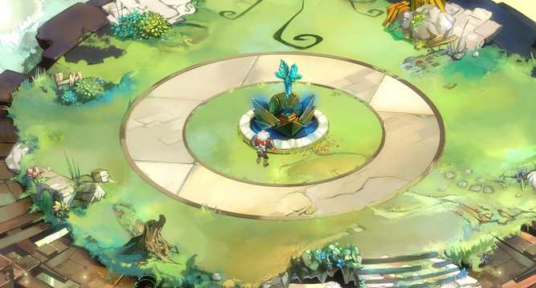

It was very easy to make enemies react to the player. It was also very easy when the level was entirely flat like a plane. So to make it more interesting, my levels have stairs, and the height changes. This way it makes for more intelligent AI as they have to be able to traverse levels of different height.

### Buddy View

I added a feature where you can see the game world from the eyes of Buddy the dinosaur. So as you are playing, you can at any time, enable a view that shows you the game world from your buddys eyes.

### Helping your AI

Buddy the dinosaur helps the player by fighting enemies he encounters, but the player must help the dinosaur too. The player can pick up spears and throw them at enemies.

The player can also collect health packs and feed them to the dinosaur to heal him

### Proper Levels

I really like the levels in the game. When using cubes or spheres, you cant see if objects are rotating correctly, or if states are changing properly so all characters are proper models with proper animations.

### Xbox Controller Compatability

Works with an xbox controller

### Pause Feature

Can pause the game too

### Randomization

Random enemy paths.

Random object placement (such as healthpacks)

Completely dynamic AI