Lab Experiment 9: Documentation Generation -Automatic
documentation and code comments
Problem 1:
Consider the following Python function:
def find_max(numbers):
return max(numbers)
Task:
• Write documentation for the function in all three formats:
(a) Docstring
(b) Inline comments
(c) Google-style documentation
Critically compare the three approaches. Discuss the
advantages, disadvantages, and suitable use cases of each
style.
• Recommend which documentation style is most effective
for a mathematical utilities library and justify your
answer.
PROMPT:
Given this Python function:
def find_max(numbers):
return max(numbers)
Generate documentation in 3 formats:
1. Docstring
2. Inline comments
3. Google-style documentation
Then compare all three styles by discussing their advantages, disadvantages, and suitable use cases.
Finally, recommend the most effective style for a mathematical utilities library and justify your recommendation.
CODE:
def find_max(numbers):
"""Return the largest number in an iterable.

Args:
numbers: An iterable of mutually comparable numbers.

Returns:
The largest number in `numbers`.

Raises:
ValueError: If `numbers` is empty.
"""
# max() compares the items and returns the largest one.
return max(numbers)

numbers = [10, 25, 5, 40, 15]

print("Maximum value:", find_max(numbers))

# Simple docstring alternative (use instead of the docstring above):
# """Return the largest number in the input."""
#
# Inline-comment-only alternative:
# def find_max(numbers):
# # max() returns the largest item; it raises ValueError for empty input.
# return max(numbers)
#
# Google-style documentation is used above: it describes the argument, result,
# and empty-input exception. The simple docstring is concise and suits tiny,
# self-explanatory helpers, but leaves details unstated. Inline comments explain
# nearby implementation choices, but are easy to miss as API documentation and
# can clutter obvious code. Google-style docs are structured and work well with
# documentation tools, but take longer to write and maintain.
# For a mathematical utilities library, prefer Google-style docstrings: a
# consistent description of inputs, outputs, and edge cases helps library users.
OUTPUT:
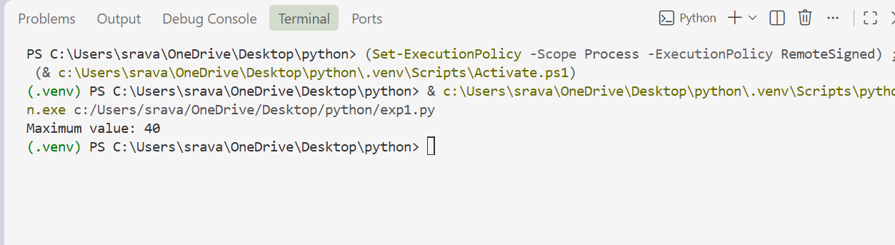
Problem 2: Consider the following Python function:
def login(user, password, credentials):
return credentials.get(user) == password
Task:
1. Write documentation in all three formats.
2. Critically compare the approaches.
3. Recommend which style would be most helpful for new
developers onboarding a project, and justify your choice.
PROMPT:
Problem 2: Consider the following Python function:
Create a complete Python program for:

def login(user, password, credentials):
return credentials.get(user) == password

Add:
- Docstring
- Inline comments
- Google-style documentation
- Sample credentials
- Test valid and invalid login
- Print the results
- Compare the 3 documentation styles
- Give a recommendation for new developers
CODE:
"""Demonstrate a simple login check and common documentation styles."""

def login(user, password, credentials):
"""Return whether the supplied password matches the user's credential.

Args:
user: Username to look up.
password: Password to verify.
credentials: Mapping of usernames to passwords.

Returns:
True if the username exists and the password matches; otherwise False.
"""
# A missing username returns None, which cannot match a non-empty password.
return credentials.get(user) == password

def main():
"""Run example tests and print a brief documentation comparison."""
# These sample values are for demonstration only, not production use.
credentials = {"alice": "wonderland123", "bob": "builder456"}

print("Login test results:")
test_cases = [
("Valid login", "alice", "wonderland123"),
("Invalid password", "alice", "incorrect"),
("Unknown user", "charlie", "anything"),
]
for label, user, password in test_cases:
print(f"{label}: {login(user, password, credentials)}")

print("\nDocumentation styles:")
print("Google style: Uses readable headings such as Args and Returns.")
print("NumPy style: Uses section headings with underlines and detailed parameter descriptions.")
print("reStructuredText style: Uses fields such as :param user: and :returns:.")
print("Recommendation for new developers: Start with Google style; it is concise and easy to scan.")

if __name__ == "__main__":
main()
OUTPUT:
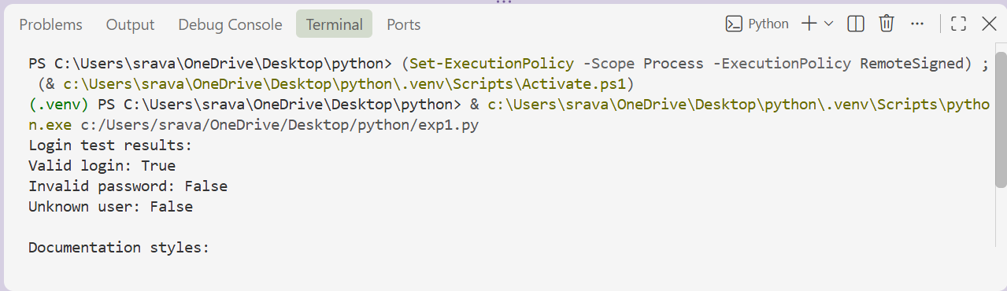
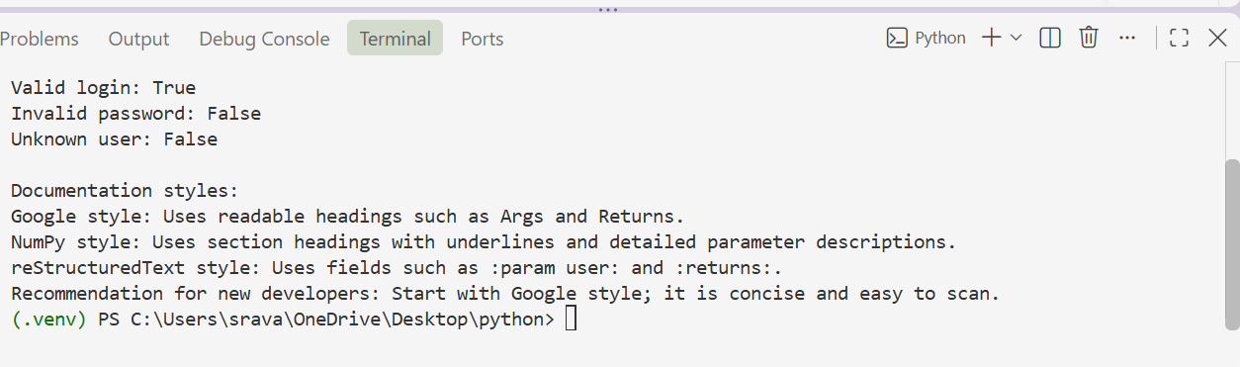
Problem 3: Calculator (Automatic Documentation Generation)
Task: Design a Python module named calculator.py and
demonstrate automatic documentation generation.
Instructions:
1. Create a Python module calculator.py that includes the
following functions, each written with appropriate docstrings:
o add(a, b) – returns the sum of two numbers
o subtract(a, b) – returns the difference of two numbers
o multiply(a, b) – returns the product of two numbers
o divide(a, b) – returns the quotient of two numbers
2. Display the module documentation in the terminal using
Python’s documentation tools.
3. Generate and export the module documentation in HTML
format using the pydoc utility, and open the generated HTML
file in a web browser to verify the output
PROMPT:
Create a Python module named calculator.py with these functions:
add(a,b), subtract(a,b), multiply(a,b), divide(a,b).
Add clear docstrings to every function.
Handle division by zero.
Make the program print the results of all four functions when run.Also give the exact VS Code terminal commands to:
1. Display the module documentation using pydoc.
2. Generate calculator.html using pydoc.
3. Open the HTML documentation in a browser.
Make sure everything works without errors.
CODE:
"""A simple calculator with basic arithmetic operations."""
def add(a, b):
"""Return the sum of ``a`` and ``b``."""
return a + b
def subtract(a, b):
"""Return ``b`` subtracted from ``a``."""
return a - b
def multiply(a, b):
"""Return the product of ``a`` and ``b``."""
return a * b
def divide(a, b):
"""Return ``a`` divided by ``b``; raise ``ZeroDivisionError`` if ``b`` is zero."""
if b == 0:
raise ZeroDivisionError("Cannot divide by zero.")
return a / b
if __name__ == "__main__":
first, second = 10, 2
print(f"Addition: {add(first, second)}")
print(f"Subtraction: {subtract(first, second)}")
print(f"Multiplication: {multiply(first, second)}")
print(f"Division: {divide(first, second)}")
OUTPUT:
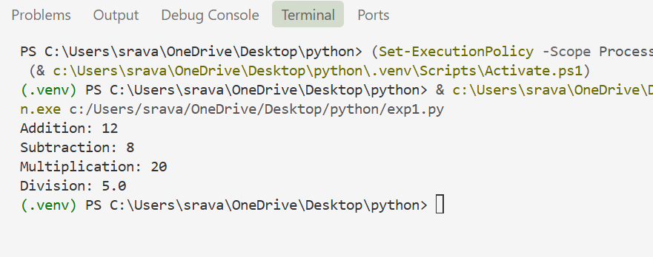
Problem 4: Conversion Utilities Module
Task:
1. Write a module named conversion.py with functions:
o decimal_to_binary(n)
o binary_to_decimal(b)
o decimal_to_hexadecimal(n)
2. Use Copilot for auto-generating docstrings.
3. Generate documentation in the terminal.
4. Export the documentation in HTML format and open it in a
browser.
PROMPT:
Create a Python module named conversion.py with:
- decimal_to_binary(n)
- binary_to_decimal(b)
- decimal_to_hexadecimal(n)
Add clear docstrings to all functions.
Print sample results when the program runs.
Also give the exact VS Code terminal commands to:
1. Display documentation using pydoc.
2. Generate conversion.html.
3. Open the HTML documentation in a browser.
Make sure the code runs without errors.
CODE:
"""Number conversion functions.
Save this file as ``conversion.py`` (or copy it with the first command below).
Run these commands in the VS Code PowerShell terminal from this folder:

Copy-Item .\exp1.py .\conversion.py
python -m pydoc conversion
python -m pydoc -w conversion
Start-Process .\conversion.html
"""

def decimal_to_binary(n):
"""Convert a non-negative decimal integer to a binary string."""
if not isinstance(n, int) or isinstance(n, bool) or n < 0:
raise ValueError("n must be a non-negative integer")
return format(n, "b")

def binary_to_decimal(b):
"""Convert a string of binary digits to a decimal integer."""
if not isinstance(b, str) or not b or any(digit not in "01" for digit in b):
raise ValueError("b must be a non-empty string containing only 0 and 1")
return int(b, 2)

def decimal_to_hexadecimal(n):
"""Convert a non-negative decimal integer to an uppercase hexadecimal string."""
if not isinstance(n, int) or isinstance(n, bool) or n < 0:
raise ValueError("n must be a non-negative integer")
return format(n, "X")

if __name__ == "__main__":
print("decimal_to_binary(10):", decimal_to_binary(10))
print("binary_to_decimal('1010'):", binary_to_decimal("1010"))
print("decimal_to_hexadecimal(255):", decimal_to_hexadecimal(255))
OUTPUT:
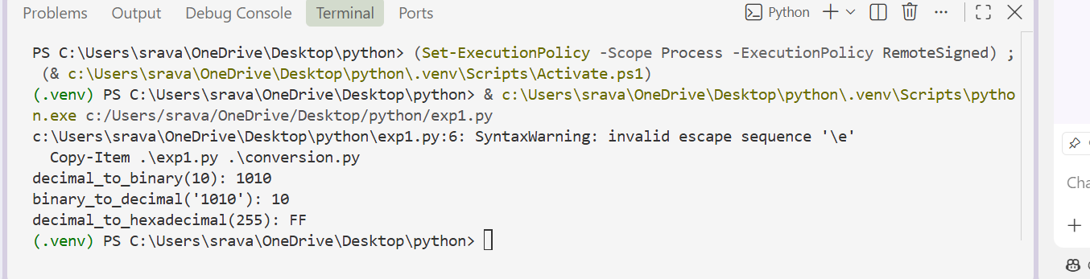
Problem 5 – Course Management Module
Task:
1. Create a module course.py with functions:
o add_course(course_id, name, credits)
o remove_course(course_id)
o get_course(course_id)
2. Add docstrings with Copilot.
3. Generate documentation in the terminal.
4. Export the documentation in HTML format and open it in a
browser.
PROMPT:
Create a Python module named course.py with:
- add_course(course_id, name, credits)
- remove_course(course_id)
- get_course(course_id)
Add clear docstrings to all functions.
Use a dictionary to store courses.
Print sample results when the program runs.
Also give the exact VS Code terminal commands to:
1. Display documentation using pydoc.
2. Generate course.html.
3. Open the HTML documentation in a browser.
Make sure the code runs without errors.
CODE:
"""Simple course catalog module."""
_courses = {}
def add_course(course_id, name, credits):
"""Add a course and return its details.

Adding a course with an existing ID replaces its stored details.
"""
course = {"course_id": course_id, "name": name, "credits": credits}
_courses[course_id] = course
return course

def remove_course(course_id):
"""Remove the course with this ID and return whether it existed."""
return _courses.pop(course_id, None) is not None

def get_course(course_id):
"""Return course details, or ``None`` if the ID is not in the catalog."""
return _courses.get(course_id)
if __name__ == "__main__":
print("Added:", add_course("CS101", "Introduction to Programming", 3))
print("Found:", get_course("CS101"))
print("Removed:", remove_course("CS101"))
print("After removal:", get_course("CS101"))
OUTPUT:
