Homework # 3: Alternative Keypoints Detection with LoG Pyramid

**Description:**

The objective of this homework is to reinforce the scale space response extrema concept in key points detection, and ask you to compute a LoG pyramid for scale space extrema detection, and compare that with the DoG pyramid based SIFT detection. An example is illustrated below, on the left is an image and its SIFT detection, with vl_sift() and peakStrenthThres=16, on the right is the LoG based detection:

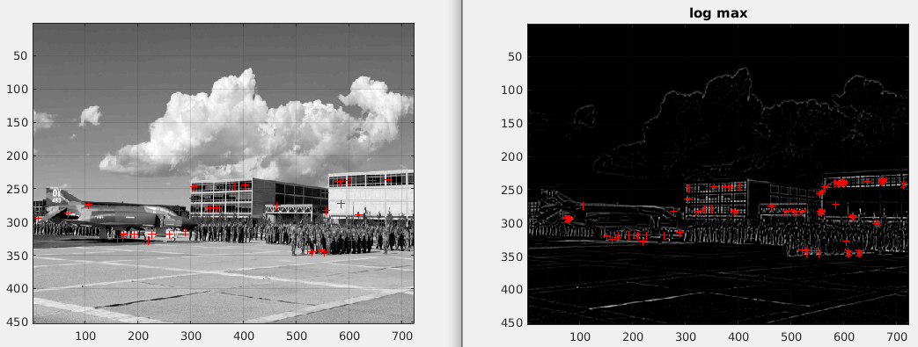

The LoG pyramid is computed for $σ=\{1.200 1.518 1.920 2.429 3.072 3.886 4.915\}$

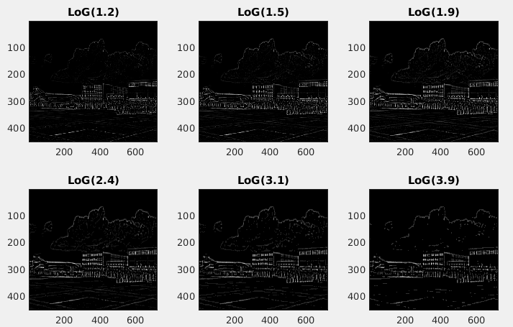

The scale space extrema detection is illustrated in the figure below:

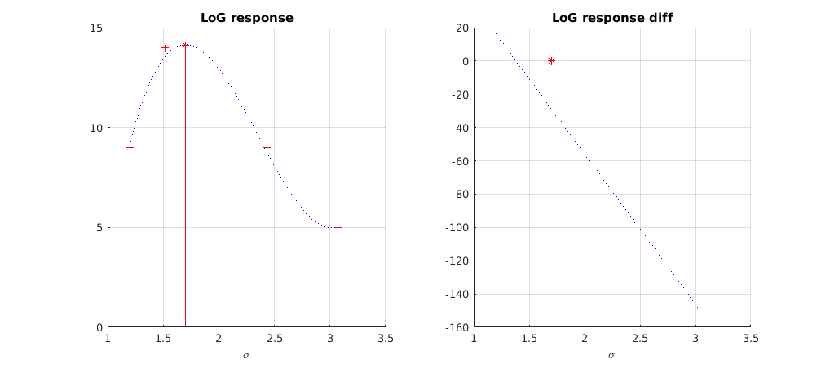

The LoG response is given as *=a3 + b2 + c +d,* the fitting can be done with polyfit(x, y, 3), and you can also compute its gradient. An extrema is detected by checking its gradient value.

Q1 [20 pts] Compute LoG Pyramid, show your code

|  |
| --- |
| function [log_pyramid]=getLoGPyramid(im, scales) |

Q2 [30 pts] Compute LoG response extrema,

|  |
| --- |
| function [x0, y_max]=getScaleResponseExtrema(x, y) |

Q3 [50 pts] Give the image level LoG key points detection and visualize and compare with SIFT detection.

|  |
| --- |
| function [x, y, scale]=getLoGKeyPoints(im, log_peak_thres) |

some additional example:

