* Intro
  + Features
  + Installation
  + Support
  + License
* Command
  + ClanManager
    - udpate_leagues
    - get_clan
    - get_league_infos
    - add_to_master_roster
    - remove_from_master_roster
    - get_master_roster
  + DBManager
    - update
    - beforeupdate
    - update_db
    - create_league
  + DiscordManager
    - myaccount
  + LineupManager
    - get_best_hitters
    - create_lineup
  + PlayerManager
    - add_player
    - delete_player
    - get_all
    - get_all_linked
    - get_player_stats
  + UpgradeManager
    - add_upgrade
    - get_upgrades
  + WarManager
    - claim_clan
    - post_hits
    - unclaim_clan
    - my_clan
    - on_war_attack
    - on_war_state_change
    - current_war_status
    - war_lineup
* Schemas
  + ER
  + UML
* Test
  + Unity
  + Integrity
* Exceptions
* utility.py
* Diagrams

Lambot

Hey Clasher, Lambot is the Discord bot made for you!

* It will help you out managing your clan, it will make your leader life easier!

Features

* Save your clan hit rates
* Keep a look on your master roster
* Manage all the competitions your clan is involved in
* Create the best lineup for each war

Installation

Install Lambot by following the next steps:

1. add the bot to your server clicking on the following link <https://discord.com/api/oauth2/authorize?client_id=727563602860703855&permissions=2148006976&scope=bot>
2. create a channel and link it to your clan by typing lb claimclan <clan_tag>
3. let your members to link their accounts to their Discord id by typing lb claim<account_tag>

Support

If you are having issues, please let us know.

* You can contact me at the following Discord ID: •Karot•#6042

License

The project is intellectual property of the developer Raffaele Scarano.

ClanManager

* udpate_leagues

perms: bot owner

it has autorun every 10 hours

[update_leagues|updateleagues|updateleague]

updates the league infos to dabatase

* get_clan

perms: any

[get_clan|getclan|clan] <clan_tag>

Returns clan infos

* get_league_infos

perms: any

[get_league_infos|getleagueinfos|gli|getleaguenames]

Returns league infos in order to update master roster properly

* add_to_master_roster

perms: leader

[add_to_master_roster|addmr|addtomr|mradd|addtomasterroster][league_name] [league_season] [league_division] [player_tags...]

Add player to league master roster You can provide multiple players too

* remove_from_master_roster

perms: leader

[remove_from_master_roster|removemr|removefrommr|mrremove|removefrommasterroster] [league_name] [league_season] [league_division] [player_tags...]

Remove player from league master roster You can provide multiple players too

* get_master_roster

perms: leader

[get_master_roster|getmasterroster|gmr][league_name][league_season][league_division]

Returns all linked accounts who played in clan Can be filtered to league

DBManager

* update

it has autorun every 6 minutes

updates the database

* beforeupdate

prevents the task from running before the database is connected

* update_db

perms: bot owner

updates the database

* create_league

perms: bot owner

creates a new league. It takes name, season, division, description

DiscordManager

* myaccount

perms: any

returns discord account infos

LineupManager

* get_best_hitters

perms: any

lb [get_best_hitters|gbh|get_hitrate|getbesthitters] [th] [clan_tag]

Returns the stats of the players in database.

Add th level to filter on th level and/or clan to filter on a clan NOTE: if channel is linked to a clan, clan filter will be applied

* create_lineup

perms: any

lb [create_lineup|createlineup] [league_name] [league_season] [league_division] [ths...]

Creates the best lineup possible based on who is in master roster and has the best performances.

Please provide the war breakdown from max th level to min required Ex: lb create_lineup 0 5 10 15

PlayerManager

* add_player

perms: any

Links a coc account to a discord user

lb [add_player|avatar|claim] <player_tag> [user]

If no user is given, default user is the command invoker

* delete_player

perms: any

Unlinks a coc account to a discord user

lb [delete_player|unclaim] <player_tag>

If no user is given, default user is the command invoker

* get_all

perms: bot owner

Returns all players in the database linked to their discord id

* get_all_linked

perms: any

Returns all coc accounts linked to a discord user

lb [get_all_linked|list|getme] [user] If no user is given, default user is the command invoker

* get_player_stats

perms: any

Returns player stats

lb [get_player_stats|getplayerstats|gps|mystats] [user] [clan_tag] If no user is given, default user is the command invoker

Type a clan tag to filter stats by a clan

UpgradeManager

* add_upgrade

perms: any

lb [add_upgrade|upgrade|setugrade|set_upgrade] <player_tag> <previous_th> <target_th> Adds an account upgrade to the database

* get_upgrades

perms: any

lb [get_upgrades|upgrades|getupgrades] Returns all upgrades currently ongoing

WarManager

* claim_clan

perms: any

Claim your war clan to a discord channel

lb claimclan <clan_tag> Clan attacks will be shown as they come

* post_hits

perms: leader

Turn on/off post hits feature

lb [post_hits|posthits] <arg>

Type lb posthits false to turn off post hits

Type lb posthits true to turn on post hits

* unclaim_clan

perms: any

lb [unclaim_clan|unclaimclan]

Unclaim your war clan from a discord channel

* my_clan

perms: any

lb [my_clan|myclan]

Returns clan linked to this discord channel

* on_war_attack

This method overwrites an event into the coc library.

It is called every time one attack happens, sends it to discord and saves the result onto the database

Only attacks from friendly wars between same level townhall are saved onto database.

* on_war_state_change

This method overwrites an event into the coc library.

It is called every time war state changes and it sends a message with the new state.

* current_war_status

perms: any

lb [get_status|status|getstatus|war]

Returns the current war status

* war_lineup

perms: any

lb [war_lineup|attacks|warlineup|goa|getourattacks]

Returns the lineup of the current war.

Schemas

* ER

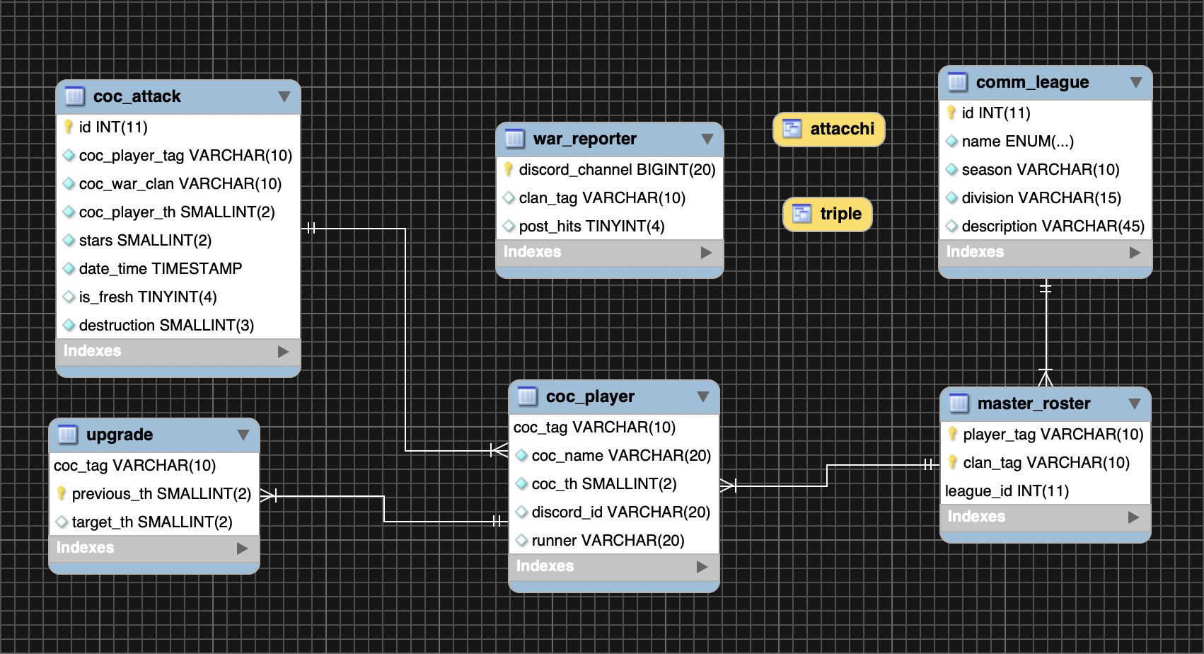

* UML

Gli schemi sono disponibili in una cartella [Google Drive](https://drive.google.com/drive/folders/1lwi5dVD3xSXReaPr1u70FEZof4jv6ljV?usp=sharing)

Test

* Unity

|  |  |  |  |
| --- | --- | --- | --- |
| Class | Method | Expected | Test |
| PlayerService | createPlayerTest | to format | Passed |
| WarService | getFirstChannelIDByTag | to find | Passed |
| WarService | getFirstChannelIDByTag | to not find | Passed |
| WarService | getAllChannelsIDByTagPostTrue | to find | Passed |

* Integrity
  + ClanManager

|  |  |  |  |
| --- | --- | --- | --- |
| Method | Command | Expected | Test |
| udpate_leagues | lb udpate_leagues | to pass | Passed |
| get_clan | lb get_clan | to pass | Passed |
| get_league_infos | lb get_league_infos | to pass | Passed |
| add_to_master_roster | lb addmr ndl 9 lightweigth #single_tag | to pass | Passed |
| add_to_master_roster | lb addmr ndl 9 lightweigth #multiple_tags | to pass | Passed |
| add_to_master_roster | lb addmr ndl 10 lightweigth #multiple_tags | to not pass (wrong league infos) | Passed |
| remove_from_master_roster | lb removemr ndl 9 lightweigth #single_tag | to pass | Passed |
| remove_from_to_master_roster | lb removemr ndl 10 lightweigth #multiple_tags | to not pass (wrong league infos) | Passed |
| remove_from_master_roster | lb removemr ndl 9 lightweigth #multiple_tags | to pass | Passed |
| get_master_roster | lb gmr ndl 9 lightweight | to pass | Passed |
| get_master_roster | lb gmr ndl 10 lightweight | to not pass (wrong league infos) | Passed |
| get_master_roster | lb gmr | to pass | Passed |

* + DBManager

|  |  |  |  |
| --- | --- | --- | --- |
| Method | Command | Expected | Test |
| update_db | lb udpate_db | to pass | Passed |
| create_league | lb_createleague wcl sko blizzard | to pass | Passed |
| create_league | lb create_league ndl 9 lightweight | to pass | Passed |

* + DiscordManager

|  |  |  |  |
| --- | --- | --- | --- |
| Method | Command | Expected | Result |
| myaccount | lb myaccount | to pass | Passed |

* + LineupManager

|  |  |  |  |
| --- | --- | --- | --- |
| Method | Command | Excpected | Test |
| get_best_hitters | lb gbh | to pass | Passed |
| get_best_hitters | lb gbh 12 | to pass | Passed |
| get_best_hitters | lb gbh 12 #clantag | to pass | Passed |
| get_best_hitters | lb gbh #clantag | to pass | Passed |
| get_best_hitters | lb gbh #wrong_clantag | to not pass | Passed |
| create_lineup | lb create_lineup ndl 9 lightweight 5 10 5 10 | to pass | Passed |
| create_lineup | lb create_lineup ndl 9 lightweight 5 10 2 | to not pass (wrong format) | Passed |
| create_lineup | lb create_lineup ndl 10 lightweight 5 10 5 | to not pass (wrong league infos) | Passed |
| create_lineup | lb create_lineup ndl 9 lightweight 5 10 5 35 | to not pass (wrong format) | Passed |

* + PlayerManager

|  |  |  |  |
| --- | --- | --- | --- |
| Method | Command | Expected | Test |
| add_player | lb claim #accounttag | to pass | Passed |
| add_player | lb claim #wrongaccounttag | to not pass | Passed |
| add_player | lb claim #accounttag @discordtag | to pass | Passed |
| delete_player | lb unclaim #accounttag | to pass | Passed |
| delete_player | lb unclaim #wrongaccounttag | to not pass | Passed |
| get_all | lb getall | to pass | Passed |
| get_all_linked | lb getme | to pass | Passed |
| get_all_linked | lb getme @discordid | to pass | Passed |
| get_player_stats | lb gps | to pass | Passed |
| get_player_stats | lb gps @discordid | to pass | Passed |

* + UpgradeManager

|  |  |  |  |
| --- | --- | --- | --- |
| Method | Command | Expected | Test |
| add_upgrade | lb upgrade #accounttag 12 13 | to pass | Passed |
| add_upgrade | lb upgrade #accounttag 13 12 | to not pass | Passed |
| get_upgrades | lb getupgrades | to pass | Passed |

* + WarManager

|  |  |  |  |
| --- | --- | --- | --- |
| Method | Command | Expected | Test |
| claim_clan | lb claimclan #clantag | to pass | Passed |
| claim_clan | lb claimclan #clantag | to not pass (channel already linked) | Passed |
| post_hits | lb posthits false | to pass | Passed |
| post_hits | lb posthits true | to pass | Passed |
| post_hits | lb posthits true | to not pass (channel not linked) | Passed |
| unclaim_clan | lb unclaimclan | to not pass (channel not linked) | Passed |
| unclaim_clan | lb unclaimclan | to pass (channel linked) | Passed |
| my_clan | lb myclan | to pass (channel linked) | Passed |
| my_clan | lb myclan | to not pass (channel not linked) | Passed |
| current_war_status | lb status | to pass (channel linked) | Passed |
| current_war_status | lb status | to not pass (channel not linked) | Passed |
| war_lineup | lb warlineup | to pass (channel linked) | Passed |
| war_lineup | lb warlineup | to not pass (channel not linked) | Passed |

Exceptions

Any exceptions not checked in the code, is handled by Discord error handler and shown as a result of the command sent.

utility.py

This file contains emojis, images and townhall level database.

It is used in graphic functions in order to retrieve the right image/emoji for the command requested.

Diagrams

* The very first action to be made is to link every single discord ID to their own coc accounts. The next chart explains how the process works and what happens after the player sends the right command.

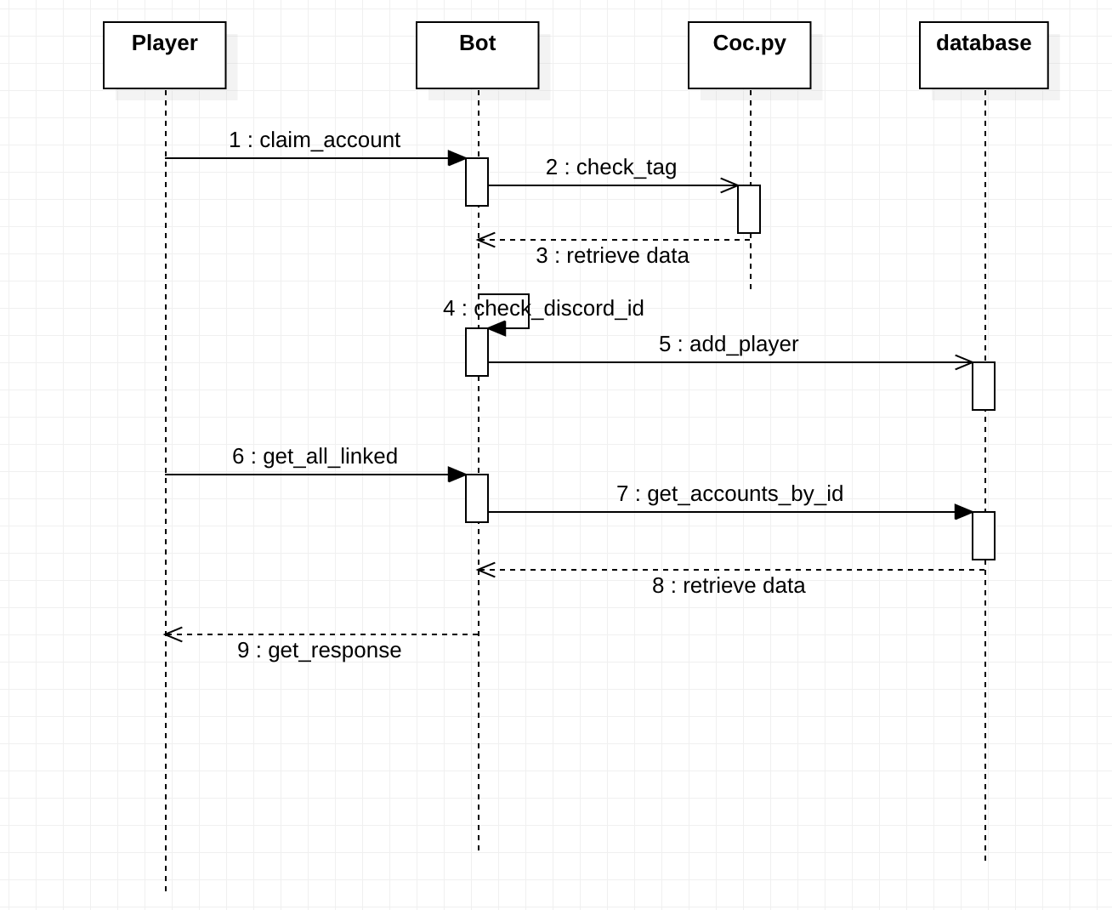

* Most complex feature is to auto create lineup based on members of a clan and their performance in passed events.

