Jenkins Master- Slave Setup —

Project Report
Name: Aashman Singh Verma
Enrollment No. LNCCBTC11101
Class Roll No. 02
Date: 2025-11-09
OS: Windows 11
Docker: Desktop
Agent: Windows inbound (WebSocket)

1. Objective
Configure a distributed Jenkins environment where the controller (master) manages build jobs executed on a connected agent (slave). Demonstrate a job that runs on the agent.

2. Tools & Versions
- Jenkins LTS (controller in Docker)
- Docker Desktop on Windows 11
- OpenJDK (Temurin) 17 on Windows (for agent)
- PowerShell

3. Implementation Steps
1) Start Jenkins controller via Docker Compose (ports 8080/50000, persistent volume).
2) Unlock Jenkins, install suggested plugins, create admin user.
3) Create node 'agent1' (Permanent Agent; inbound/JNLP; label 'agent1').
4) Download agent.jar from Jenkins and run it with the provided secret using WebSocket.
5) Create a pipeline job labeled 'agent1' and run it to verify execution on the agent.

4. Configuration Artifacts
See repository files: docker-compose.yml, Jenkinsfile, and this report.

5. Screenshots

5.1 Jenkins Dashboard (after setup)

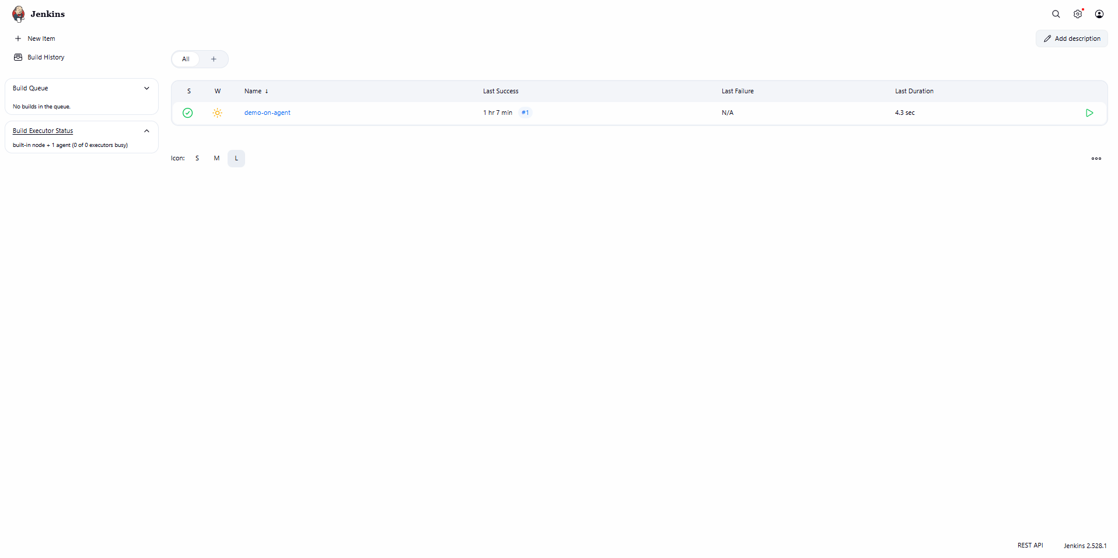

5.2 PowerShell: docker ps showing jenkins-master

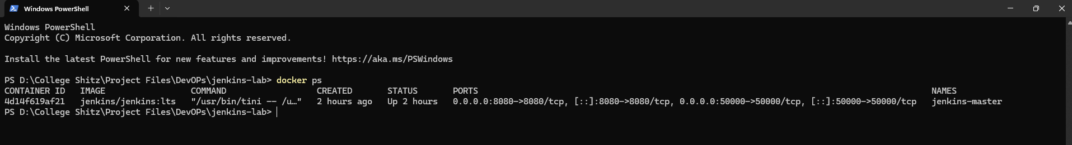

5.3 Nodes page showing agent1 Online

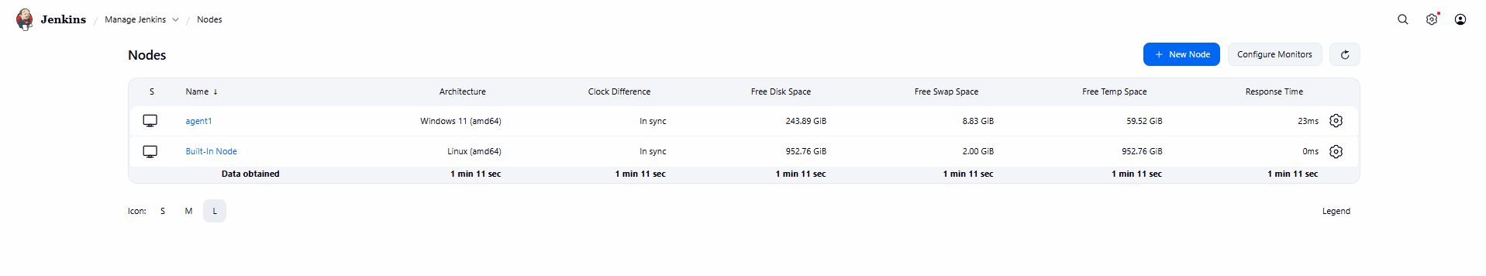
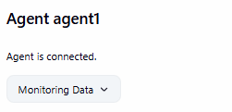

5.4 PowerShell: agent.jar output showing 'WebSocket connection open / Connected'

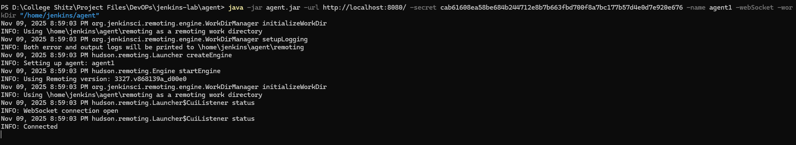

5.5 Console Output of 'demo-on-agent' pipeline job
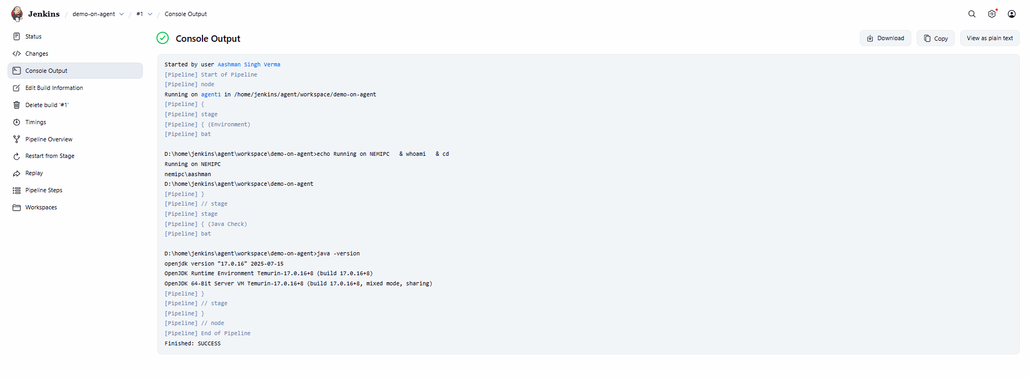

6. Observations
The agent connects over WebSocket reliably. Pipeline jobs labeled 'agent1' execute on the agent. Console output confirms environment details and Java version.

7. Conclusion
A functional distributed Jenkins setup (controller + agent) was implemented and validated via a running pipeline job on the agent.

8. Appendix: Commands
Start controller:
docker compose up -d
Initial admin password:
docker exec -it jenkins-master cat /var/jenkins_home/secrets/initialAdminPassword
Run agent on Windows:
curl.exe -sLo agent.jar http://localhost:8080/jnlpJars/agent.jar
java -jar .\agent.jar -url http://localhost:8080/ -secret <SECRET> -name agent1 -webSocket -workDir C:\jenkins-agent

