Sum of two number

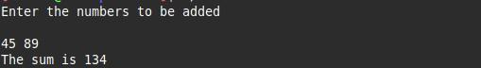

ques 2 function

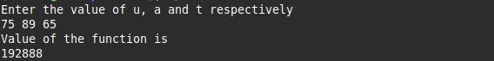

ques 3 average

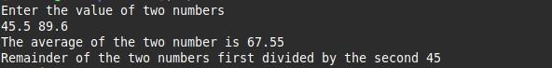

ques 4 ternary operator



temp conversion

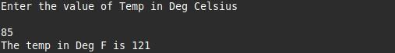

swap

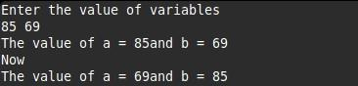

swapcool

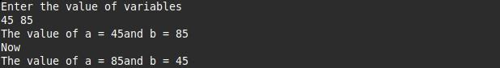

sorry wala

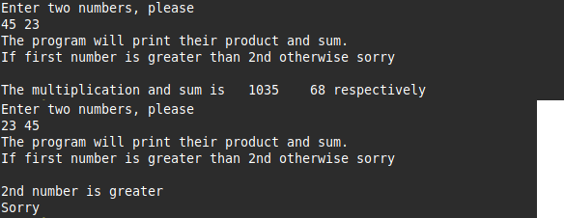

greatest among 4 number



check date

