================Experiment 1 ==============================================
1.) Linear Search
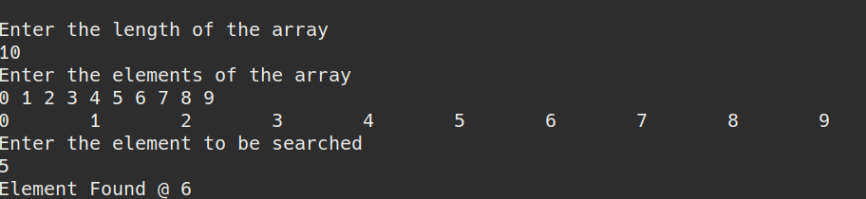
2.) Binary Search
