Array.c

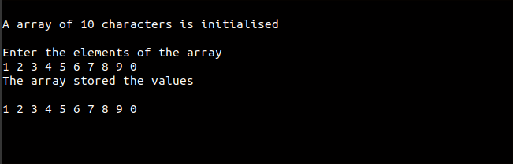

Linear_search.c

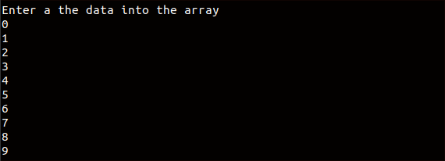

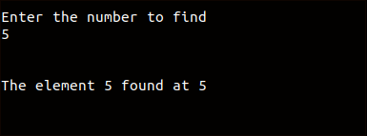

Matix_manipulation.c

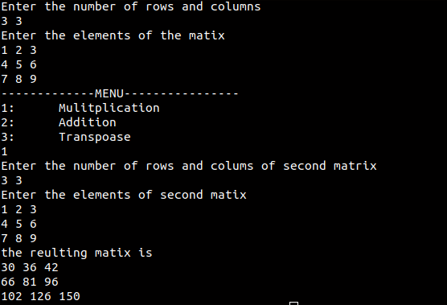

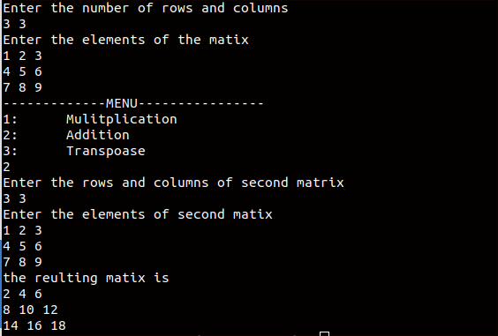

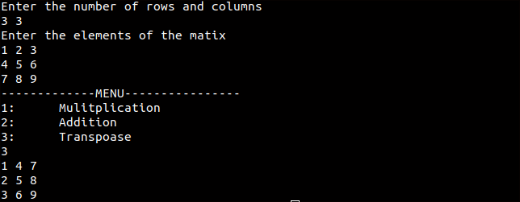

Binary_search.c

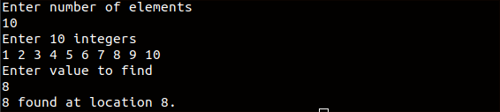

Reverse.c

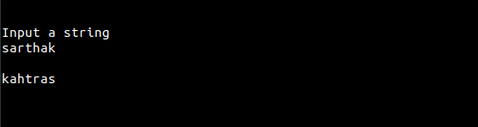

Pointer.c

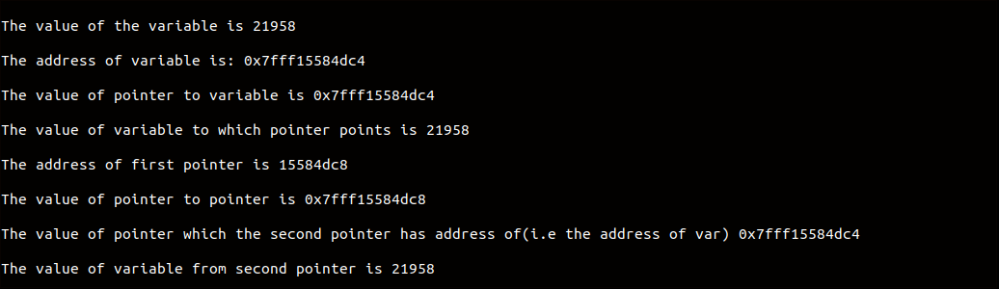

Malloc.c

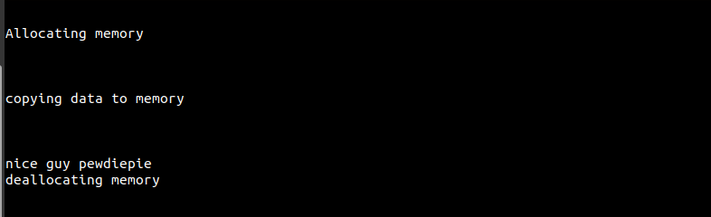

Function.c

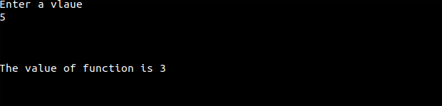

Cat.c

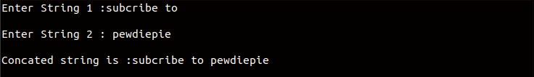

Union_and_struct.c

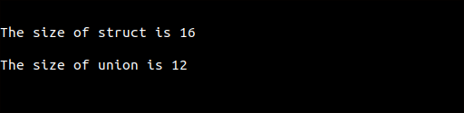

Stringlen.c

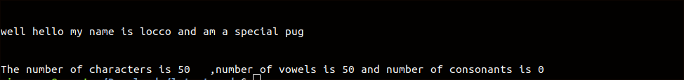

Vovwel.c

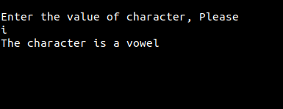

Week.c

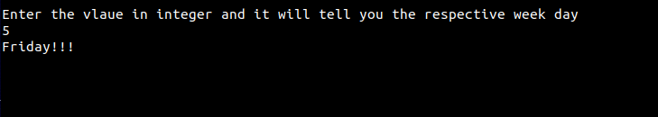

Dimensional.c

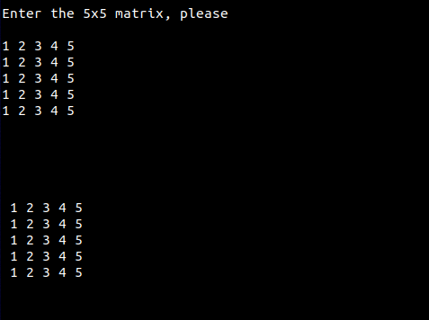

Sum_natual.c

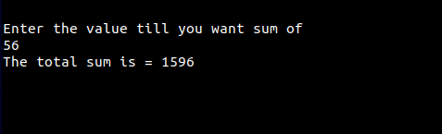

Table.c

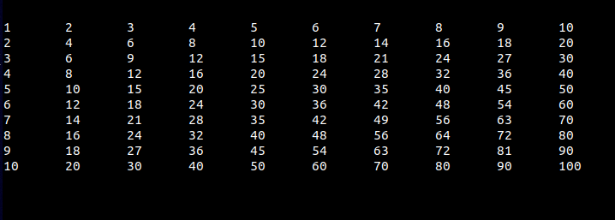

Palindrome.c

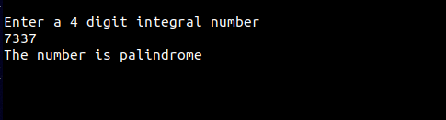

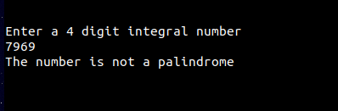

Pascal.c

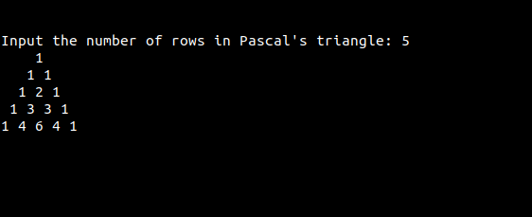

Folyd.c

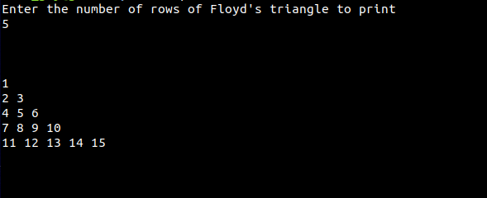

Sum_of_multiple_5.c

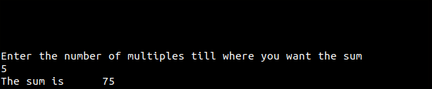

Sum_of_multiple_7.c

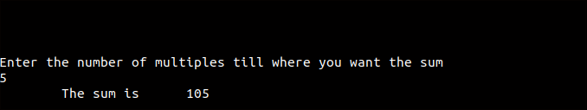

Star_triangle.c

