Vovwel.c

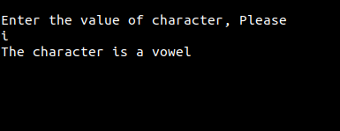

Week.c

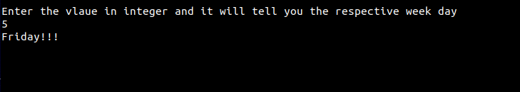

Dimensional.c

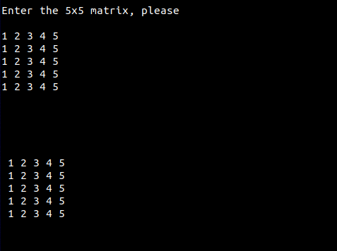

Sum_natual.c

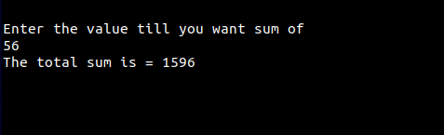

Table.c

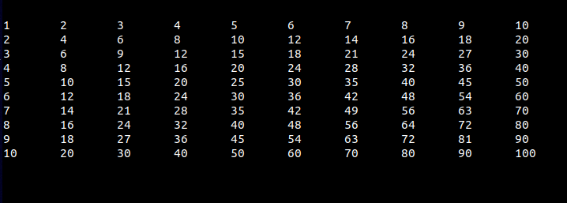

Palindrome.c

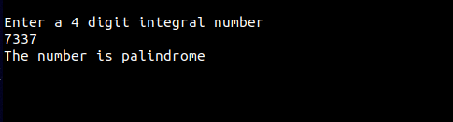

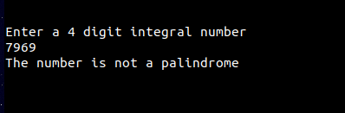

Pascal.c

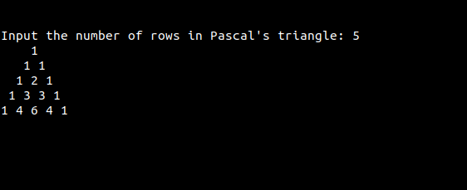

Folyd.c

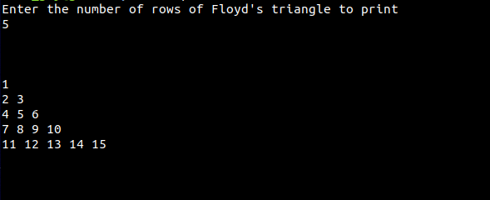

Sum_of_multiple_5.c

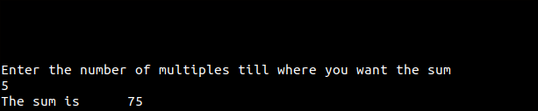

Sum_of_multiple_7.c

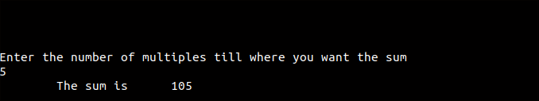

Star_triangle.c

