**DEVELOPMENT OF E-CHURCH MANAGEMENT INFORMATION SYSTEM FOR STO. NIÑO DE MOLINO PARISH CHURCH**

Undergraduate Capstone Project Submitted to the Faculty of the

Cavite State University – Bacoor City Campus Bacoor,

Cavite

In partial fulfillment of the requirements for the degree of Bachelor

of Science in Information Technology

Casares, Joaquin Carlos O.

Salalila, Lawrence Jake F.

Yusingco, Joshua A.

**December 2024**

**INTRODUCTION**

The Sto. Niño De Molino Parish Church, plays an essential role in the lives of its Catholic Parishioners. As the number of people attending on this church, the church expands, managing its activities becomes more difficult. Traditional methods for handling these schedules, transactions, and communication have become more inefficient, especially with the increasing demand for the better services. These issues often lead to delays, errors and missed opportunities between the church and its community,

To address these problems, a Web-based solution is proposed to modernize and streamline the church's operations. The Development of a Web-Based E-Church Management Information System for Sto Niño De Molino Parish Church aims to provide an effective and accessible platform for managing various church activities. The system is designed to simplify the tasks like scheduling events, tracking donations and improving the communication between the church and its parishioners.

With the features like real-time event updates, secure transaction management, prayer requests, and a communication platform, this project seeks to limit the usage of traditional methods while enhancing accessibility and usability. By integrating modern technology with the church operations, the Sto. Niño De Molino Parish Church can serve its growing community more effectively and focus on its mission.

**PROJECT CONTEXT**

The Sto. Niño De Molino Parish Church is a church for Catholics, as the number of people who attend continues to increase, the role of the church in its activities is also increasing. The traditional way of managing the schedule, managing transactions, and communicating with the church for its other activities is very difficult to do nowadays especially as the number of people who attend this church is increasing and this can also cause delays in events, errors in recording transactions, communication and so on. So, it would be better if they had a website that would help them to operate their activities such as managing a proper event schedule, managing and securing transactions, having proper communication, and so on.

In our digital era web-based is the solution to the challenges. Churches like Sto. Niño De Molino Parish Church wants to improve their services for their parishioners. The Development of Web-Based E-Church Management Information System for Sto. Niño De Molino Parish Church aims to modernize their operations more efficiently and accessible for all clients and parishioners.

The system is designed with a user-friendly interface to handle the data information and services of the church. Its feature is managing the event schedule which is time by time the system will update the parishioners, handling transactions like tracking record of donations and financial, prayer requesting, and also it will serve as a communication platform between church and parishioners.

The use of this web-based system will limit the traditional methods of the church, it will enhance the accessibility of the church in any activity and the church will be able to focus more on their mission. By balancing technology and traditional church operations, the church will be more prepared to meet the increasing number of people participating in their church.

**OBJECTIVES OF THE STUDY**

The general objectives of Development of Web-Based E-Church Management Information System for Sto. Niño De Molino Parish Church will develop a user-friendly website for modernized operation and good service to parishioners.

Specific objectives:

1. Develop user-friendly design.
2. Implementing a communication platform to ensure timely and effective updates to parishioners.
3. Members can send their prayer requests.
4. Develop a recording system for donation, financial transactions.
5. Tracks and manages church events, sacraments, schedules.

**PURPOSE AND DESCRIPTION**

The main purpose of this project is to design an effective, efficient user-friendly web-based management system adapted to Sto. Niño De Molino Parish Church. The goal of this system is to improve and enhance communication with parishioners, track efficiently of the events, schedules, financial records etc. This system aims to help the church on its mission to serve the community at ease, and accessibility to use for users.

**TIME AND PLACE OF THE STUDY**

Timeframe: the estimated development of this project will take approximately 3-6 months, divided into phases such as research gathering, system design, development, testing, and deployment.

Place: The project will be developed remotely, with periodic meetings and collaboration with church leaders and administrators at the Sto. Niño de Molino Parish Church Bacoor, Cavite.

**SCOPE AND LIMITATION OF THE STUDY**

Developing a web-based system for the church and parishioners of Sto. Niño De Molino Parish Church. The study will cover the following features: managing event schedule, tracking donations and financial records, managing sacramentals, announcing activities, prayer requesting, and effective communication between church and parishioners. The study will be conducted data collection and testing on church and parishioners

This study is limited only to church staff and parishioners of Sto. Niño De Molino Parish Church for 3-6 months. The system requires a stable internet connection and it is not available to other churches because it needs to meet the unique process of Sto. Niño De Molino Parish Church.

**CONCEPTUAL FRAMEWORK**

**INPUT PROCESS OUTPUT**



Figure 1: Shows the schematic diagram of the conceptual framework. The input is the developer’s skills and requirements. The research process includes the waterfall model phases of developing the system. Finally the output is the Development of Web-Based E-Church Management Information System for Sto. Niño De Molino Parish Church

**DIAGRAM METHODOLOGY**

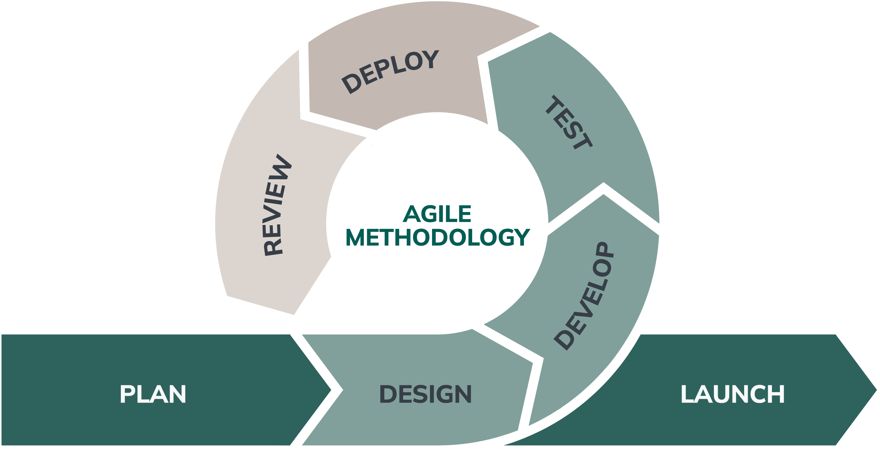

**Plan:** In the planning stage, the project is divided into smaller workable tasks like event scheduling, financial tracking, and managing prayer requests. A backlog is developed listing and prioritizing these tasks and features that will guide the development process. In order to ensure alignment with actual needs, the development team works closely with the church staff and parishioners to gather and understand the requirements fully.

**Design:** We develop the blueprint of our system, which includes the user interface and data structure. We make sure that the security of donations and financial transactions is well-protected.

**Develop:** We develop the system based on the system design specifications, using programming tools and frameworks that we already know. This phase focuses on developing all planned features, such as user-friendly interfaces, event scheduling, and secure transaction management.

**Testing:** We test the system to make sure that all requirements are aligned with the client's expectations and perform alpha testing to identify any possible issues or errors.

**Deploy:** After successful testing. We make sure that the church staff have easy access to the system, and we provide guidance on how to use it.

**Review:** Once a sprint or phase is completed, a retrospective analysis is conducted to evaluate its outcomes and identify areas for improvement. The backlog is updated to reflect changes in priorities or requirements based on the performance of previous sprints and stakeholder input. This ensures continuous improvement and alignment with the project's goals.

**Launch:** In the final phase, the system is officially launched on the production server, making it accessible to all users., and the development team continues to monitor the system for any post-launch issues to be addressed promptly. The users also have a feedback loop for sharing their experiences and suggestions for continued refinement and evolution of the system for the betterment of its users.