Stellar Modelling Final Project

PHYS 375  
Metallicity Group

Report By  
Eric Dong  
20616365  
3B Physics and Astronomy   
April 18, 2019

**Section 1: Code and Algorithm discussion**

We chose to write our code in Python due to it being the coding language that all members of the group were familiar with. Python also allows us to easily tabulate our data with the library Matplotlib as well as useful numerical tools in the numpy library.

To solve the stellar equations, we used the adaptive step size Runge Kutta Fehlberg method (RKF45). The adaptive method solves the equation in a much shorter time due to the algorithm adjusting the step size while solving the equations. This method allows us to use one calculation to solve for all the k-values. Using the Butcher tableau shown below, if k1, k2, k3 ,k4, k5, and k6 which are the columns left of the vertical line, are found then finding the fourth order and fifth order step solutions can also be found by multiplying the k-values and the coefficients.

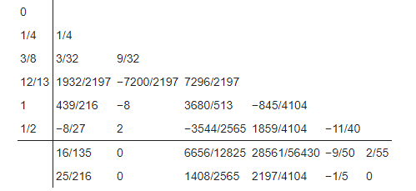

The adaptive step size Runge Kutta Fehlberg also known as RK45 method works by using two functions to solve the equation, in our case the RK4 and RK5 method. With the O(h5) and O(h4) given by the first and second row below the horizontal line of the Butcher tableau we can calculate the error in out step size. The adaptive method can change the step size using this error and user defined tolerances. If the error was greater than the tolerance the step size is halved, and the step is rejected. If the error is less than the tolerance, the step size was doubled, and the step was rejected. If the error was roughly equal to the tolerance, we keep the step size and accept the step. This greatly cuts down the run time since we don’t need to solve the RK4 method using small step sizes when the solutions to the differential equations don’t change much.

The bisection method for root finding was also used to find the root of the following equation.



This algorithm allows us to find a value of ρc where f(ρc) = 0 by using two values of ρc that gives f(ρc ) > 0 and f(ρc ) < 0 and a low precision.

Each member of the group generated a set of ten stars with varying metallicities with these stars we were able to generate a main sequence for each varying metallicity value. It was difficult to generate many stars since the run time for the code to produce one star varied from 30 minute to 4 hours. Thus, the main sequence produced only shows 10 stars with the metallicity equal to that of the solar metallicity.

**Section 2: The Main Sequence**

The HR diagram of 10 stars produced from the code graphed on log scale.

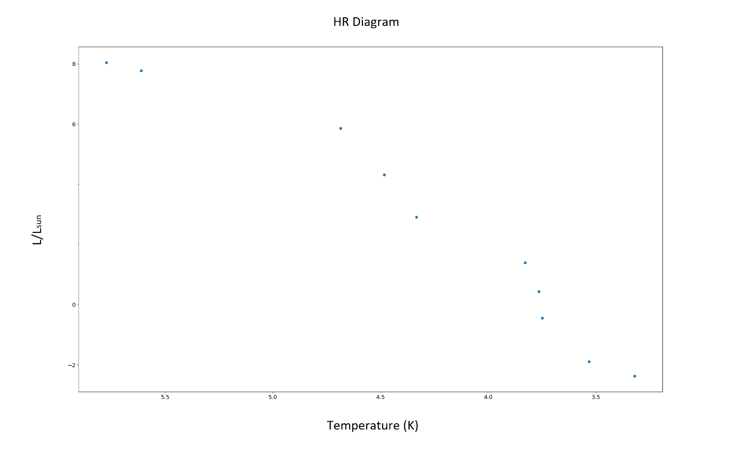We can see that the HR diagram produced has a shape that is roughly similar to what we see for the HR diagram in other literature. We can see that an increase in surface temperature leads to an increase in luminosity.

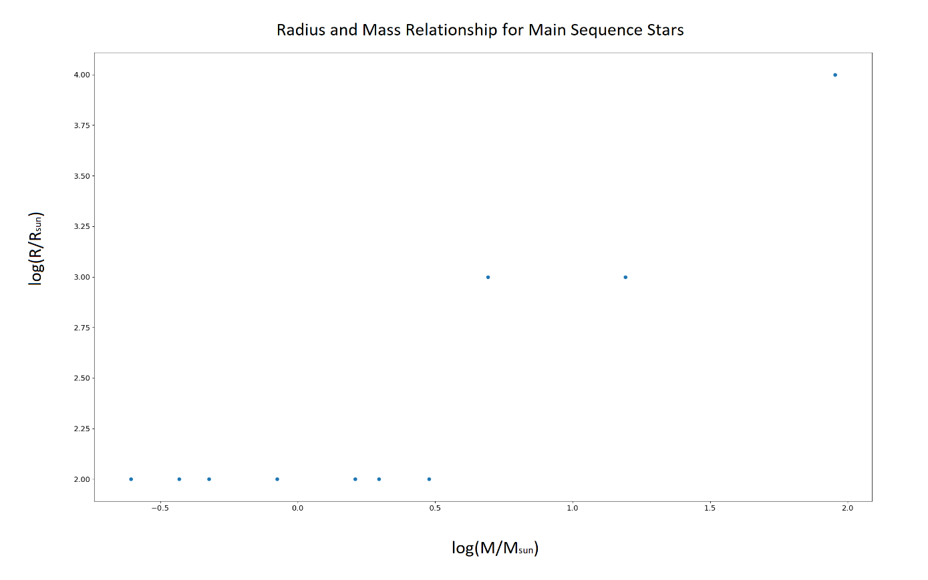

From the radius and mass relationship graph, we can see that there is a plateau in the region below 0.5 log(M/Msun) where the radius plateaus. I think in this region the mass is not great enough  
We see that after the 0.5 M/Msun the radius and mass relationship looks to be linear.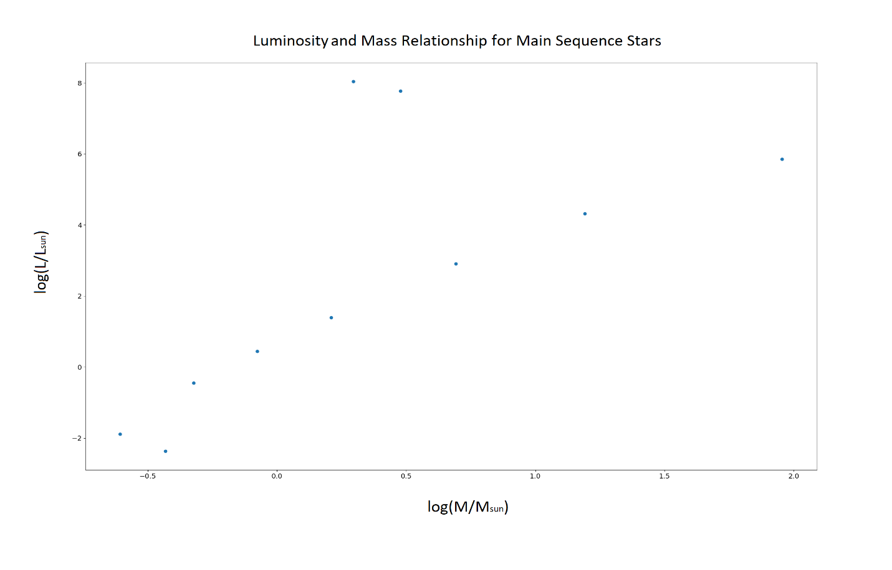   
  
The luminosity seems to follow a general linear trend where as the mass grows the luminosity of stars grows as well.

These two graphs from literature show the radius and mass relation as well as the luminosity relation. In the radius mass relation graph, we see the similar plateau around 0.5 solar masses just like the graph we produced. We also see the transition to a linear trend past the 0.5 solar mass range.  
  
From the luminosity relation graph we see a similar linear trend just like the graph I produced.

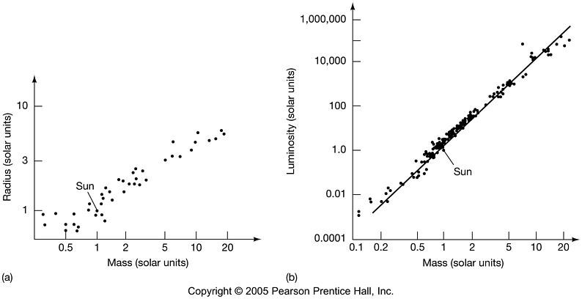

**Section 3:**

Two stars were analyzed for this section one of mass 7.35e29kg or 0.37Msun and one of mass 1.5e31 or 7.54Msun. Their properties are detailed below.

|  |  |  |
| --- | --- | --- |
| **Properties** | **Star 1** | **Star 2** |
| Mass of star (kg) | 7.347e+29 | 1.503e+31 |
| Temperature of star (K) | 2087 | 5285 |
| Luminosity of star (W) | 1.642e+24 | 1.138e+30 |
| Radius of star (km) | 343390000 | 1955730000 |

The properties of these two stars were plotted against r/R* below.

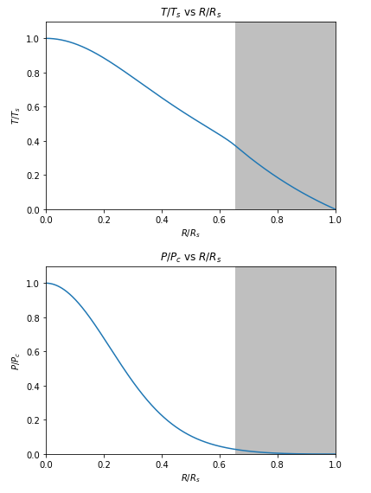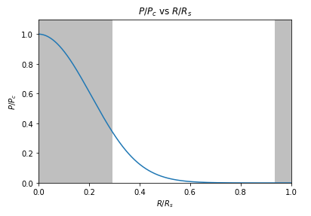

Pressure and Radius relation of 0.37Msun star Pressure and Radius relation of 7.54Msun star

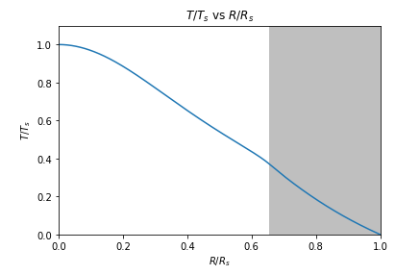 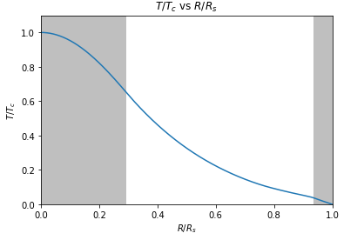

Temperature and Radius relation of 0.37Msun star Temperature and Radius relation of 7.54Msun star

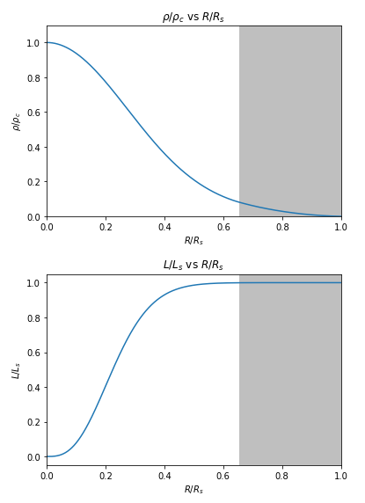 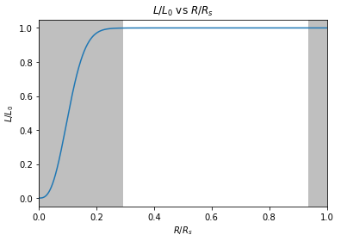

Luminosity and Radius relation of 0.37Msun star Luminosity and Radius relation of 7.54Msun star

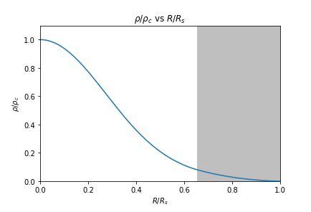 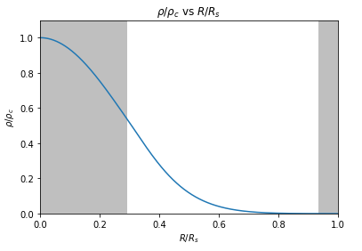

Density and Radius relation of 0.37Msun star Density and Radius relation of 7.54Msun star

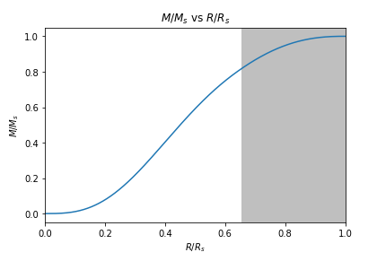 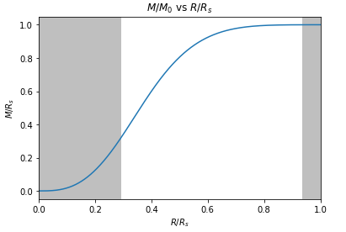

Mass and Radius relation of 0.37Msun star Mass and Radius relation of 7.54Msun star

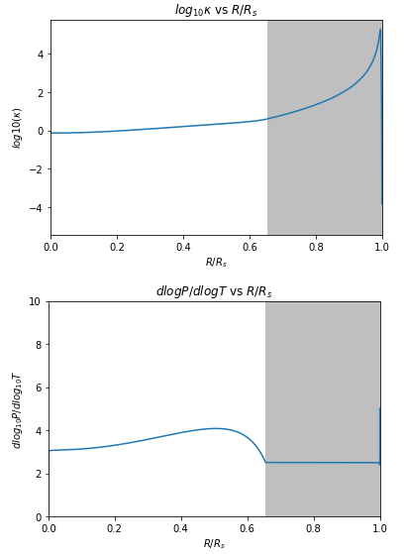 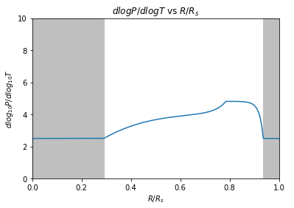

Convective Stability and Radius relation of 0.37Msun star Convective Stability and Radius relation of 7.54Msun star

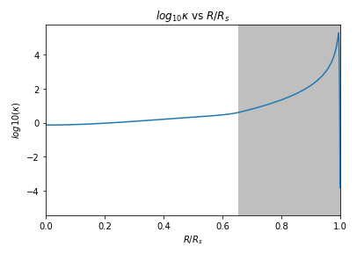 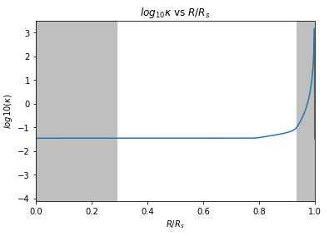

Opacity and Radius relation of 0.37Msun star Opacity and Radius relation of 7.54Msun star

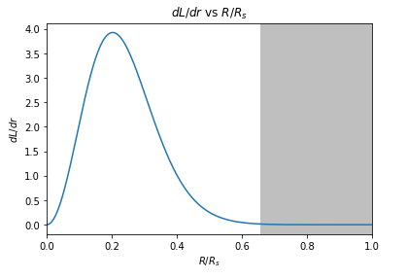 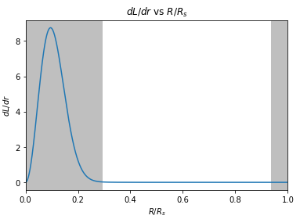

Partial Luminosity and Radius relation of 0.37Msun star Partial Luminosity and Radius relation of 7.54Msun star

The convection zones are shown by the gray area of the plots. For the 0.37Msun star the convection zone only occurs near the surface of the star with the rest of the star being radiative. We see that the 7.54Msun star has a convection zone at the center of the star up to around 0.3 R/Rs as well as a convective region at the surface. The convective region in the core of the larger star can be explained by its higher core temperature causing the CNO cycle to dominate the PP chain due to the PP chain being less temperature dependant than the CNO cycle. This high temperature gradient in the core forms a convection zone. This convection zone in the core does not occur in the smaller star since the core temperature of this star is not great enough to cause the CNO cycle to dominate.

As mentioned before, the higher mass star had a higher core temperature due to higher pressures in the core. This allows the CNO cycle to dominate the PP chain in the high mass star due the CNO cycle having a later dependence on temperature than the PP chain T19.9 for the CNO cycle compared to T4 in the PP chain. The lower mass star has too low of a temperature to really allow the CNO cycle to kick in thus, it is dominated by the PP chain.

The free free scattering opacity has a T-3.5 relationship where at highter temperatures the free free opacity becomes neglible. The electron scattering opacity remains constant throughout the star since it does not depend on the temperature of the star. With these properties, in the smaller star, the free free scatter opacity is able to dominate over the electron scattering opacity since the temperature of the star is not high enough to minize the free free opacity. In the more massive star there is higher temperatures which descreases the free free scattering opacity letting the electron scattering dominate the star.

**References**

Brau, J. (2015, January 19). Measuring the Stars. Retrieved March 16, 2019, from <https://pages.uoregon.edu/jimbrau/astr122-2015/Notes/Chapter17.html>

Physics and Astronomy Department. (2019, March). “Physic 375 Final Project”. University of Waterloo. Waterloo, Ontario. 2017. Retrieved from class website.