ISL Reader: A Two-Megabyte Vision Transformer, a Super-Resolution GAN Front End and an Integrated Interface for Indian Sign Language, Evaluated on Unseen Recording Sessions
Yalamanchi Kushal (CB.SC.U4CSE23766) · Nethi Kushala Kumar (CB.SC.U4CSE23735) · Dhruseek Rishi Menon (CB.SC.U4CSE23716)
Department of Computer Science and Engineering, Amrita School of Computing, Amrita Vishwa Vidyapeetham, Coimbatore, India
Faculty guide: Dr. T. Bagyammal · Course 23CSE473 Neural Networks and Deep Learning, Group 03
Abstract
Published word-level recognisers for Indian Sign Language (ISL) report accuracies above 94 %, mostly on random splits in which takes from the same recording session fall on both sides of the train–test boundary. ISL Reader is a recognition application built around ISL-ViT-Tiny, a factorised video Vision Transformer that reads left-hand, right-hand and face crops together with hand landmarks. We tested it only on recording sessions withheld from training. On the 472 held-out clips of its 50 deployed words, the shipped 4-bit model (3.89 M parameters, 1.97 MiB) scores 85.9 % top-1 and 96.4 % top-5, averaged over three seeds. Under the same recipe, a 50-word pixel-only model scored 98.5 % on a random split and 70.1 % (mean of two seeds) when whole recording sessions were held out. A camera worn on the head may send low-resolution video, so we put a super-resolution generative adversarial network (GAN) in front of the hand detector. We built three versions of it and compared each with bicubic upscaling and with the same generator trained without the adversarial loss. On 180p video a learned upscaler raised top-1 from 61.0 % to between 75.4 % and 76.0 %, whether or not it was trained adversarially. Against their non-adversarial controls the GANs passed our pre-registered test in 2 of 9 comparisons, both at 240p. This held even for a version trained against a differentiable copy of the hand-landmark detector. A seven-screen web interface connects the models to a camera, uploaded files or built-in clips, answers only above a confidence threshold, and logs corrections. Browser tests found no console errors, and the interface gave the same answer as the offline evaluation on all 8 clips checked. Pixel-only checkpoints scored at chance on a second corpus, so these results apply to studio video like INCLUDE's.
Keywords: Indian Sign Language · Vision Transformer · super-resolution · generative adversarial network · signer-independent evaluation · quantisation-aware training · user interface

1 Introduction
Indian Sign Language is the first language of a large deaf community, and few hearing people read it. A wearable assistant that watches a signer and shows each word to a hearing listener could remove part of that barrier. This project builds the recognition half of such a device and, for this review, the application around it. Given a short clip of one sign, the system names the word, reports its confidence, and lets the user confirm, correct or reject the answer. The intended hardware is a pair of smart glasses, which limits the classifier to about 2 MB.
Three properties of the problem make it hard. ISL is largely two-handed, and handshape, motion and location jointly define a word, so one handshape can mean different things at the forehead and at the chest. Labelled data is scarce: INCLUDE [16], the main public word-level corpus, has 4,257 usable clips of 262 words, about 15 per word, whereas vision transformers usually train on orders of magnitude more. And a head-worn camera sees the signer through a small sensor and a compressed stream, so its video will often be smaller than the 1080p studio footage the model learned from.
The way results are usually measured adds a fourth problem. INCLUDE was recorded as consecutive takes of each word, by one person in one room per session. A random split puts near-identical takes in both training and test data, and a model can score well by recognising the session instead of the sign. A deployed device meets only people and rooms it has never seen, so we test on whole recording sessions held out from training.
Earlier reviews produced the classifier and its evaluation protocol. Review 3 asked for the models to be integrated with a user interface and for their results to be compared, and this paper reports the complete system. Its contributions are four:
- A tested application. A seven-screen web interface runs any trained classifier checkpoint behind either upscaling front end. On every clip we checked, it returned the same answer as the offline evaluation.
- A compact classifier evaluated on unseen sessions. A 3.89 M-parameter factorised transformer, compressed by quantisation-aware training into a 1.97 MiB file, scores 85.9 % top-1 on held-out sessions. We compare it with pixel-only, 32-bit and post-training-quantised variants.
- A controlled GAN versus no-GAN study. Three super-resolution GANs, the third trained against a hand-landmark loss, are each compared on degraded test video with bicubic upscaling and with a generator trained without the adversarial loss, using paired tests and a decision rule fixed before the runs.
- A diagnosis of the remaining error. Swapping clean and degraded inputs shows that, after super-resolution, most of the lost accuracy comes from the hand landmarks rather than the pixels, and that adjusting the detector does not win it back.

2 Related work

2.1 Transformers for sign recognition
Vision transformers [19] have spread quickly into sign recognition. Ashfaq et al. [3] add an enhanced feed-forward head to a ViT and report 99.44–99.90 % on four static hand-gesture datasets. Shawon et al. [8] compare VideoMAE, ViViT and TimeSformer on word-level corpora and reach 96.9 % on BdSLW60 with held-out users, with models far larger than a wearable allows. Abdi and Barzegar Touchahi [5] found that a small ViT lost 2.1 points in murky water where ResNet-18 lost 12.1. That result suggests attention may tolerate corrupted input better than convolution, which is the situation our low-resolution front end deals with. Rubaiyeat et al. [4] apply a transformer to anatomically anchored landmarks. Our classifier follows the factorised encoder of ViViT [21] and initialises its spatial stage from DeiT-Tiny [20].

2.2 Compact recognisers for edge devices
TinyMSLR [1] fuses ConvNeXt-Tiny and Swin features and distils from two teachers, reaching 99.01 % on 20 classes with under 2.7 M parameters and 24 ms per sample on a CPU. Venkatappa et al. [2] quantise a landmark transformer for 33 Kannada signs to 1,097.77 KB and run it in 16.2 ms on a phone at 94.19 %. Their model is close to our size budget. It uses landmarks alone, however, and quantises after training, whereas we keep the image crops and quantise during training.

2.3 Indian Sign Language and evaluation practice
Nedungadi et al. [6] built a CNN–ViT conversational agent for ISL e-governance at 97.5 %. Kaliyaperumal et al. [7] recognise two-handed dynamic ISL words with a convolutional transformer. Damdoo et al. released the sentence-level ISH-NEWS corpus [9] and, in a survey, named data scarcity and evaluation practice as open problems [10]. None of these works reports signer- or session-disjoint results. More recent corpora come with a signer split: Isharah [11] defines signer-independent benchmarks, and TSL-ONE-S [12] reports signer-independent top-1 of 79.69 % (I3D) and 80.83 % (SPOTER) on 184 Thai glosses, the closest comparison to our setting that we found. INCLUDE has no signer labels, so we reconstruct its sessions ourselves (Section 3.3).

2.4 Super-resolution GANs
A generative adversarial network [27] trains a generator against a discriminator that learns to tell generated data from real data. SRGAN [28] used this for single-image super-resolution, pairing the adversarial loss with a perceptual loss on VGG features [33, 34]. ESRGAN [29] refined the architecture and brought the relativistic discriminator [32] to the task. Real-ESRGAN [30] trains on a randomised second-order degradation pipeline so that it handles real rather than synthetic low-resolution images, uses a U-Net discriminator [31] with spectral normalisation [35], and offers the compact VGG-style generator we adopt. All of these optimise for images that look real to a person. Whether that helps a downstream recogniser depends on what the recogniser relies on, and Section 4.4 returns to this question with a loss computed by a differentiable stand-in for the hand-landmark detector, built in the manner of heatmap pose estimators [36, 37].

3 Methodology

3.1 System overview
Fig. 1 traces a sign through the system using frames from a held-out test clip, and Fig. 2 shows the deployed application. The browser records or loads a clip and posts it to a Python server. The server decodes 32 frames and upscales them if the video is below 720p. MediaPipe Holistic [23] then locates the hands, face and body; the server cuts three crops per frame, extracts 21 joints per hand, and passes 16 frames of this to the classifier. The classifier scores six views of the clip, and the server returns the five most likely words with their probabilities and a record of how each crop was obtained. The browser shows an answer only when the top probability passes a threshold; below it, the user picks from the shortlist.
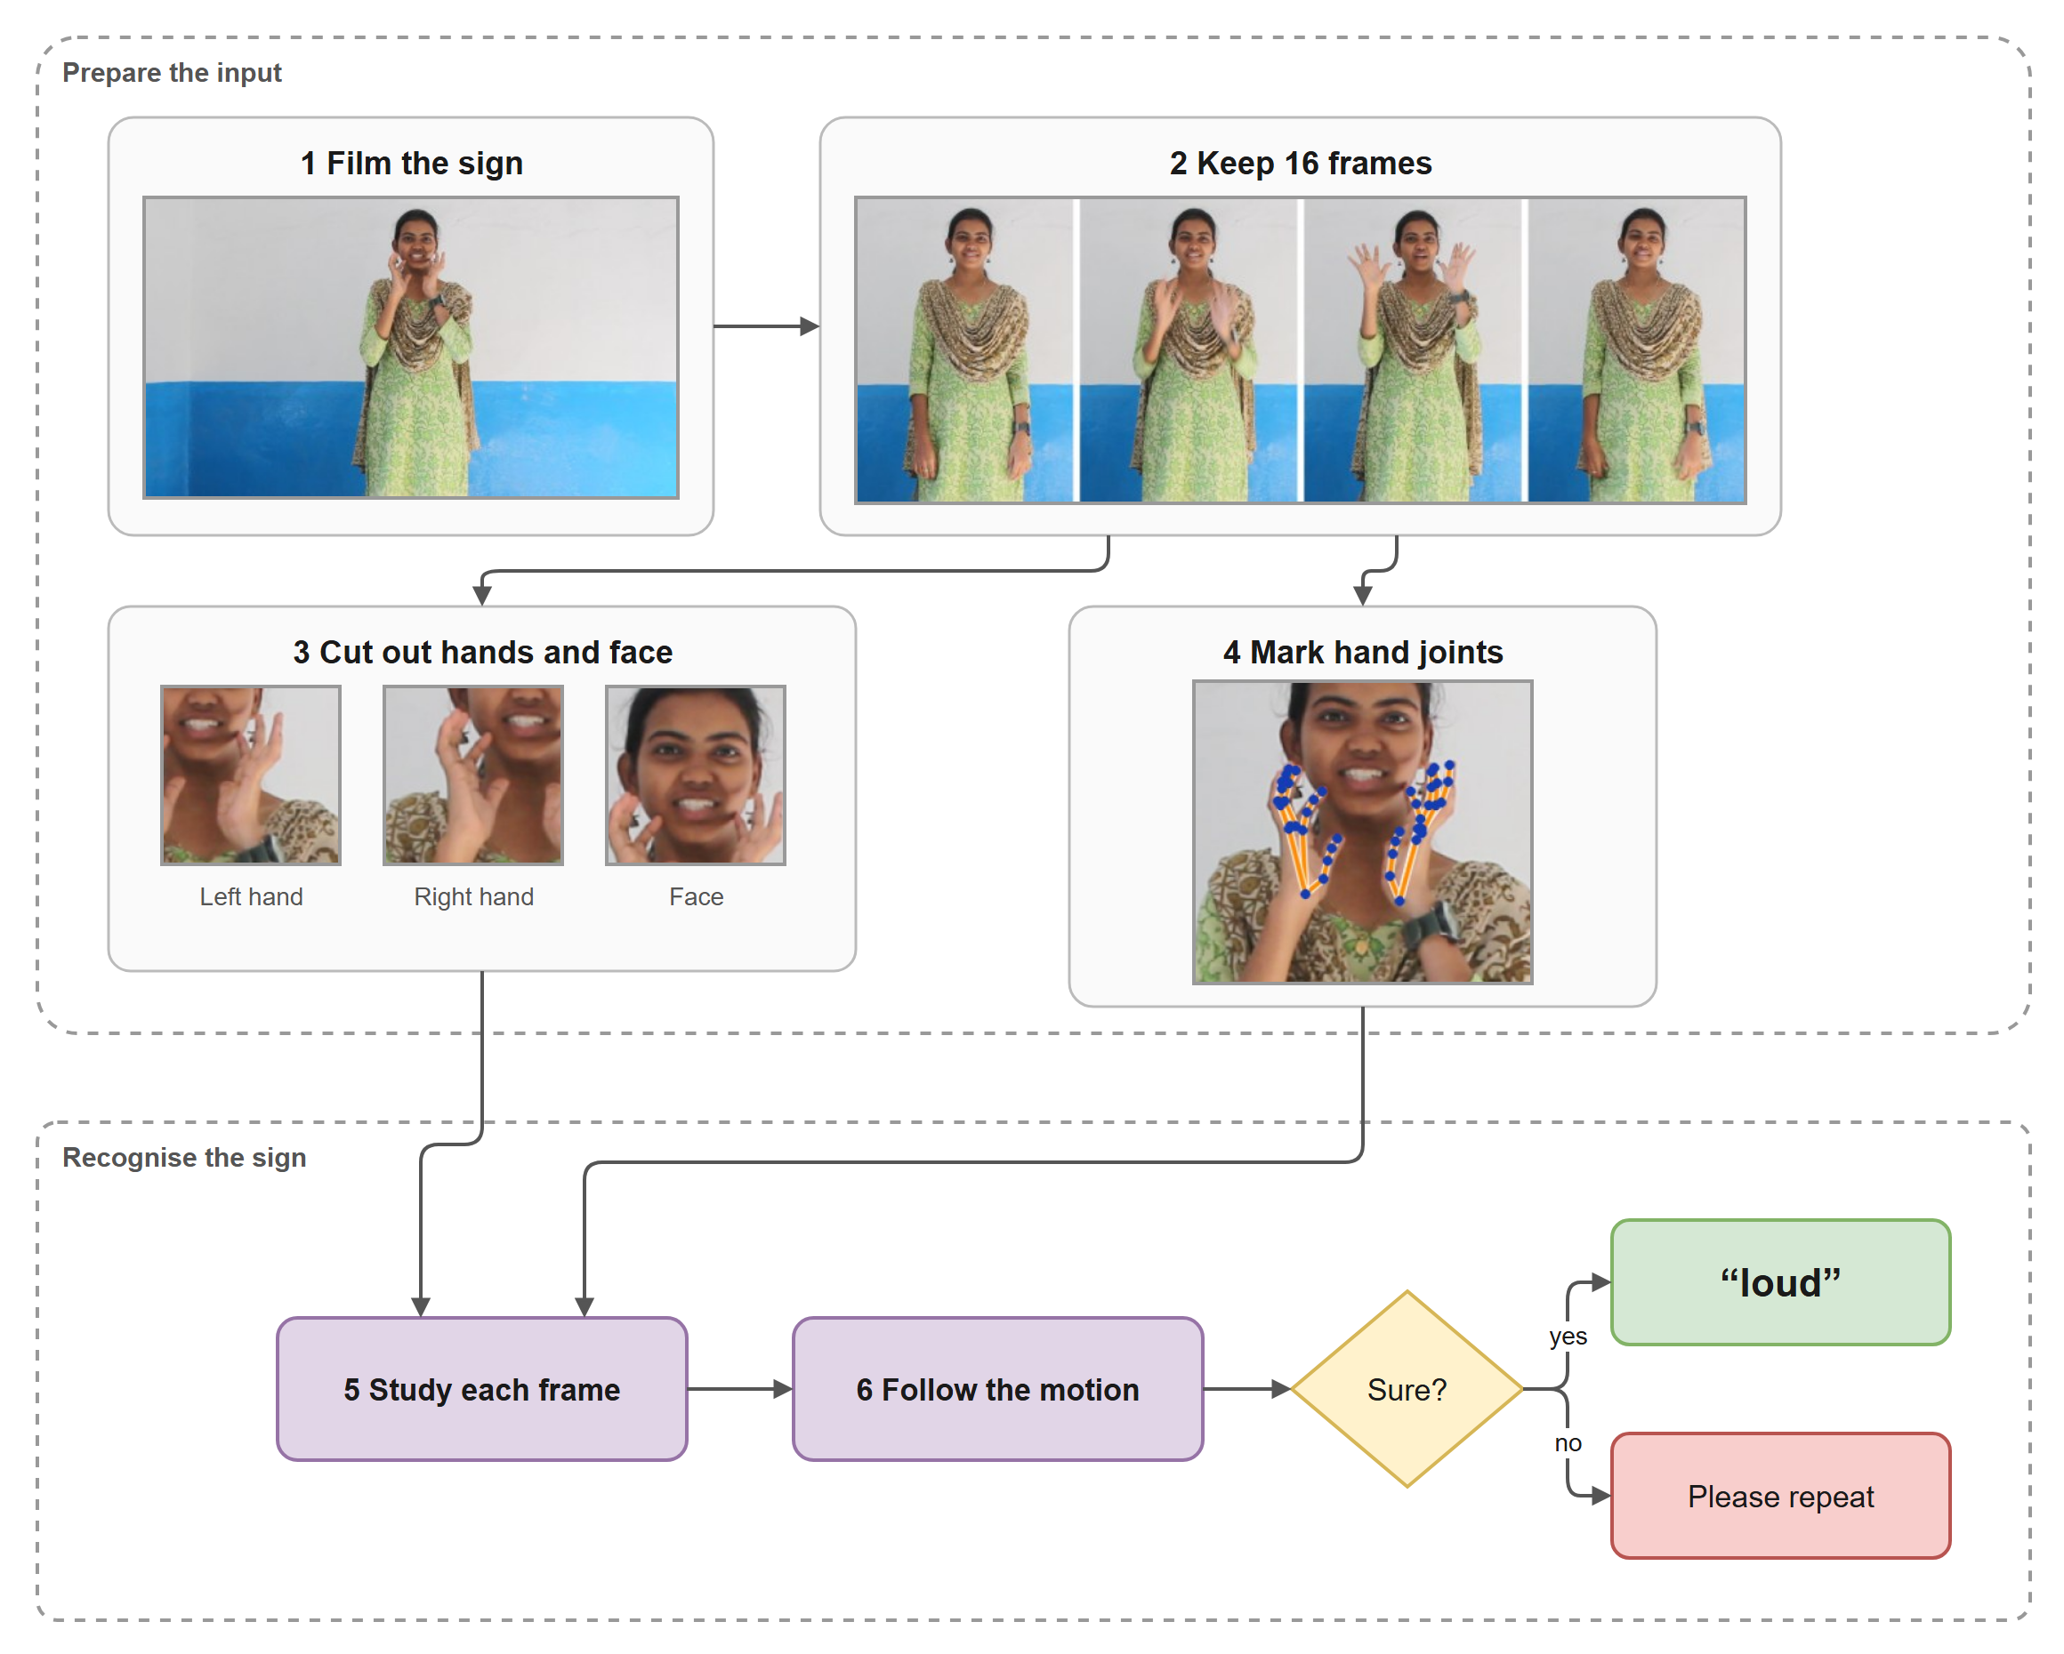
Fig. 1 How ISL Reader reads a sign. Frames, crops and detected hand joints are real data from a held-out test clip of the word "loud".
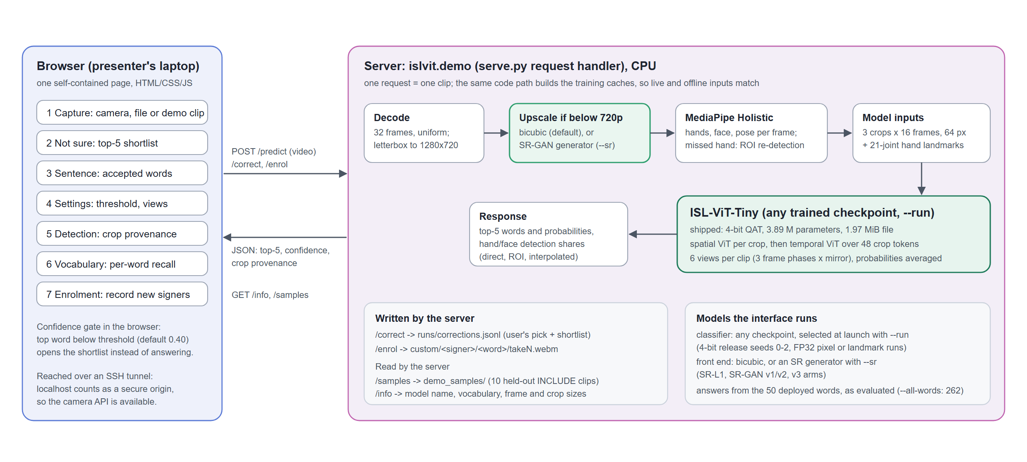
Fig. 2 Architecture of the integrated application. The classifier checkpoint and the upscaling front end are chosen when the server starts.

3.2 Dataset
Table 1 lists the data. INCLUDE [16] provides the labelled clips, recorded at 1920 × 1080 and 25 frames per second in one studio and released under CC-BY-4.0. We train on all 262 words and restrict the output to the 50 deployed words at test time. Training on only the 50 words would not help, because each word has a fixed number of clips and a smaller vocabulary simply discards the rest. iSign [18] supplies unlabelled clips for self-supervised pretraining (18,000 extracted, 17,896 kept after a hand-detection filter). CISLR [17], recorded with other signers and cameras at 300 × 300 pixels, serves as a cross-corpus test.
Table 1 Data used in this work.
Item | Value
INCLUDE clips used | 4,257 clips, 262 words, 15 categories; 1920 × 1080, 25 fps
Recording sessions | 13, reconstructed from camera clip numbers
Training split | 2,845 clips from training sessions
Test split | 1,010 clips from held-out sessions; 472 of them belong to the 50 deployed words
Excluded | 402 held-out-session clips of words with fewer than six training clips
Validation sessions (GAN development only) | 888 clips from training sessions, kept out of the version 3 generator's training
Unlabelled pretraining | 18,000 iSign clips extracted, 17,896 used
Cross-corpus test | CISLR, 609 clips, 300 × 300 pixels

3.3 Evaluation protocol
INCLUDE files are named after the camera's running clip counter. Consecutive numbers are consecutive takes, and large jumps separate sessions. Clustering the counter values of all 4,257 clips gives 13 session blocks, and whole blocks are held out for testing (Fig. 3); the split builder asserts that no counter value appears on both sides. Every result in this paper uses the same 472-clip, 50-word test set. Because the sessions are inferred, the protocol approximates signer independence but cannot guarantee it.
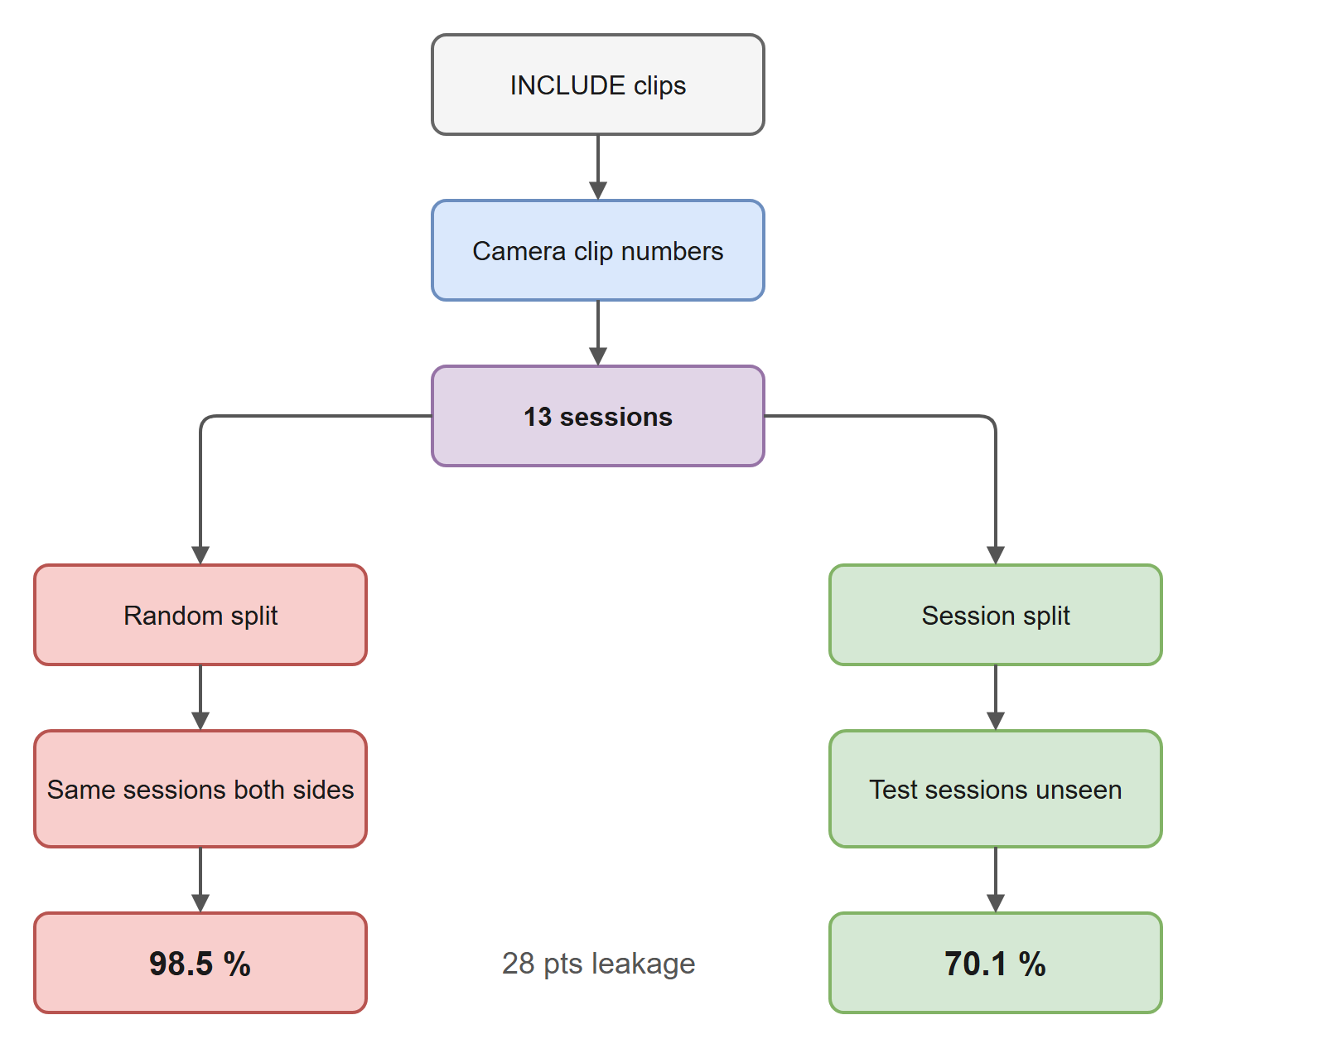
Fig. 3 Building the evaluation split from camera clip numbers. Under the same recipe, a 50-word model scores 98.5 % on a random split and 70.1 % on unseen sessions.
We report top-1 and top-5 accuracy, and balanced accuracy where per-word counts differ. Each figure is the mean of three independently trained seeds. We never quote the best seed, since choosing it would be selection on the test set. Two models or front ends are compared on identical clips with McNemar's exact test [26], pooling the discordant clips of the three seeds. One rule was fixed before the super-resolution runs began: a change counts as an improvement only if the mean rises, all three seeds move the same way and the pooled p-value is below 0.05. The mirror-image rule marks a change as harmful, and anything else is reported as no reliable difference.

3.4 Input pipeline and hand landmarks
Each clip is sampled uniformly to 32 frames and letterboxed to 1280 × 720, and MediaPipe Holistic finds the hands, face and body pose in each frame. If a hand is missed, a second pass runs MediaPipe's hand model on a forearm-sized region around the pose estimate, upscaled to 256 pixels. If that also fails, the nearest real box is reused and flagged as interpolated. Crops are stored at 128 pixels and resized to 64 for the model. MediaPipe's detectors carry state from one video to the next; processing the same clip twice changed hand presence on 3–6 % of frames. We therefore rebuild the detectors for every video, and repeated runs now agree exactly.
The detector's 21 joints per hand also go to the model (Fig. 4). Handshape is the joints' positions relative to the wrist, divided by the hand's extent, so it does not change with where the hand is or how far it is from the camera. Location is the wrist relative to the midpoint of the shoulders, in shoulder widths, and body pose uses the nose, shoulders, elbows and wrists from the same frame. A two-layer network adds these features to the matching crop token. Its last layer is initialised at zero, so training starts from exactly the pixel-only model it extends.
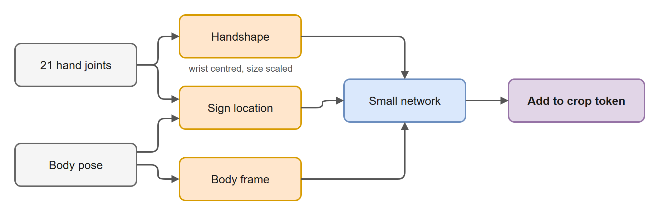
Fig. 4 Hand-landmark features. Joints are centred on the wrist and scaled by hand size before a small network adds them to the crop token.

3.5 Classifier architecture
ISL-ViT-Tiny (Fig. 5, Table 2) is a factorised video transformer. Its spatial stage, a four-block ViT, encodes one 64 × 64 crop at a time as 16 patches plus a class token, sharing weights across all 48 crops of a clip (16 frames × 3 streams). Each crop's class token then receives a stream embedding, a frame embedding, the position and size of its crop box, a learned flag for interpolated boxes, and the landmark features. Cropping throws away where the hand was, and location distinguishes words in ISL; the box geometry restores that information. A second four-block transformer attends over the 48 crop tokens and a class token, and a linear layer produces the word scores. Joint attention over every patch would need a sequence of 816 tokens. The factorised model instead attends over 17 tokens within each crop and then 49 across the clip.
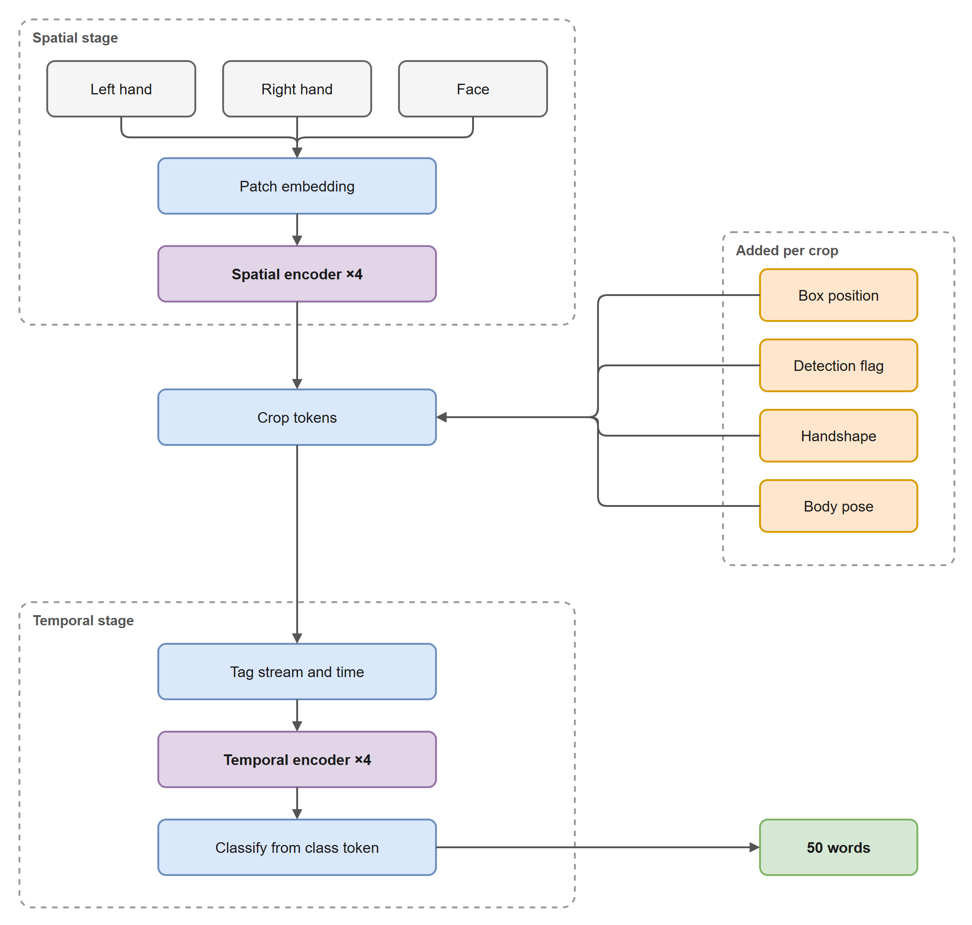
Fig. 5 ISL-ViT-Tiny. The spatial stage runs once per crop with shared weights; the orange inputs are added to every crop token before the temporal stage.
Table 2 Architecture of the deployed classifier.
Component | Setting
Input per clip | 16 frames × 3 crops × 64 × 64 RGB, box geometry, detection flags, hand landmarks
Patches per crop | 16 × 16 pixels, 16 patches + class token
Spatial stage | 4 blocks, width 192, 3 heads, MLP 768, shared across 48 crops
Temporal stage | 4 blocks, width 192, 3 heads, over 48 crop tokens + class token
Output | Linear 192 → 262, restricted to the 50 deployed words at test time
Parameters | 3,894,214 (91 k of them for the landmark features)

3.6 Training and compression
Training runs in two phases (Fig. 6). First, both transformer stages are pretrained on 17,896 of 18,000 extracted unlabelled iSign clips by masked image modelling in the style of SimMIM [22], reconstructing 75 % of the patches from the rest. Hands in iSign are small in the frame and blur when cropped, so during fine-tuning each INCLUDE crop is degraded to a random lower resolution and back (resolution jitter 0.5) to match. The full model then trains on the 2,845 training clips for a fixed 1,000 epochs with AdamW: learning rate 5 × 10⁻⁴ with 10 warm-up epochs and cosine decay, the encoder's rate scaled by 0.1, batch 64 and weight decay 0.05. Regularisation consists of label smoothing 0.1, mixup (α = 0.2, probability 0.5), stochastic depth 0.1, stream dropout 0.15, colour jitter 0.4, greyscale 0.15, horizontal flips that swap the two hand streams, gradient clipping at 1.0 and an exponential moving average of the weights. We keep the final epoch; no checkpoint is selected by test accuracy.
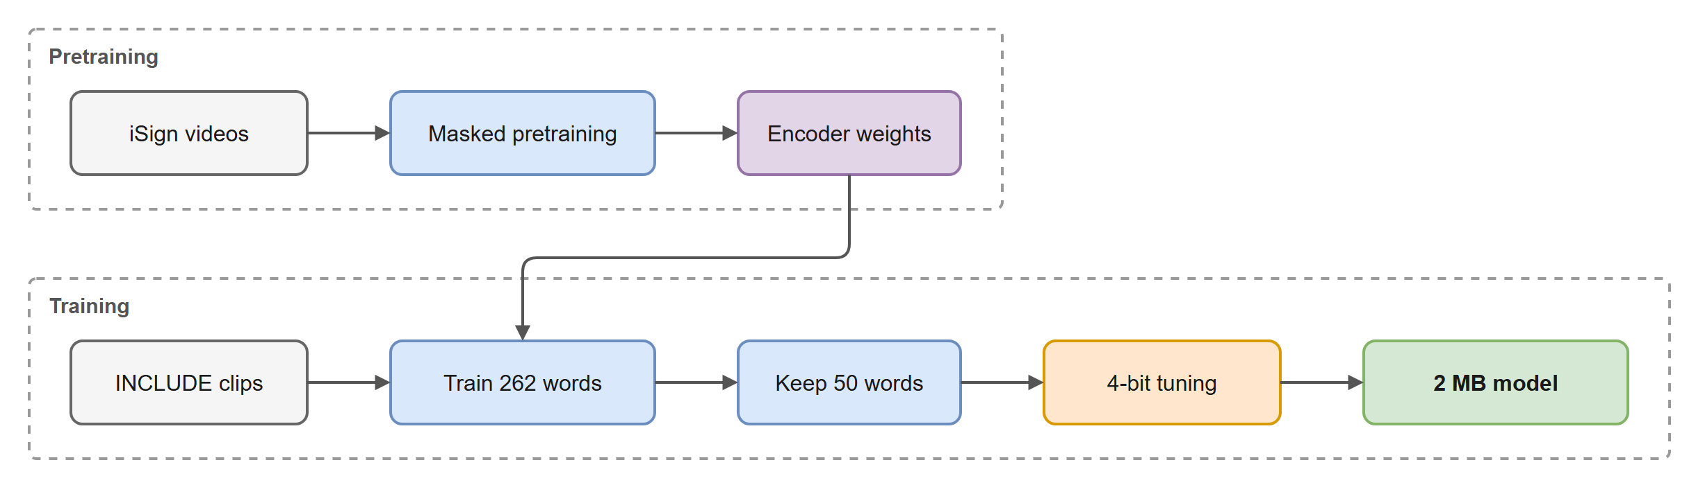
Fig. 6 Training pipeline, from unlabelled pretraining to the 2 MB deployed model.
In 32-bit floating point the model takes 14.9 MB. We store the weight matrices at 4 bits in groups of 128, each group with a 16-bit scale, and keep embeddings and small tensors at 16 bits. Rounding after training cost 3.1 points on average. We therefore fine-tune for a fixed 300 epochs with the rounding inside the forward pass and a straight-through estimator [25] in the backward pass, following Jacob et al. [24] (Fig. 7). The training loop and the exporter share one function that selects the tensors and one that rounds them, and reloading the saved file reproduces every weight bit for bit. The shipped file is 2,069,700 bytes.
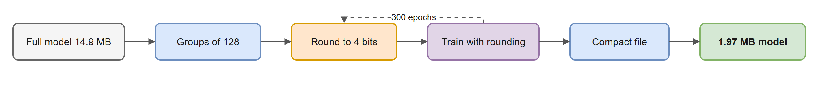
Fig. 7 Quantisation-aware training. The dashed loop runs for 300 epochs.

3.7 Super-resolution GAN front end
Every clip reaches the hand detector through a single function that resizes video below 720p up to the 720p working height. That resize used bicubic interpolation. When the server starts with a generator file, the GAN replaces this resize and nothing else. Video at 720p or above never passes through the generator, so results on the original 1080p data cannot change; we confirmed that crops extracted from clean clips with and without the generator are byte-identical. Fig. 8 shows the networks and losses.
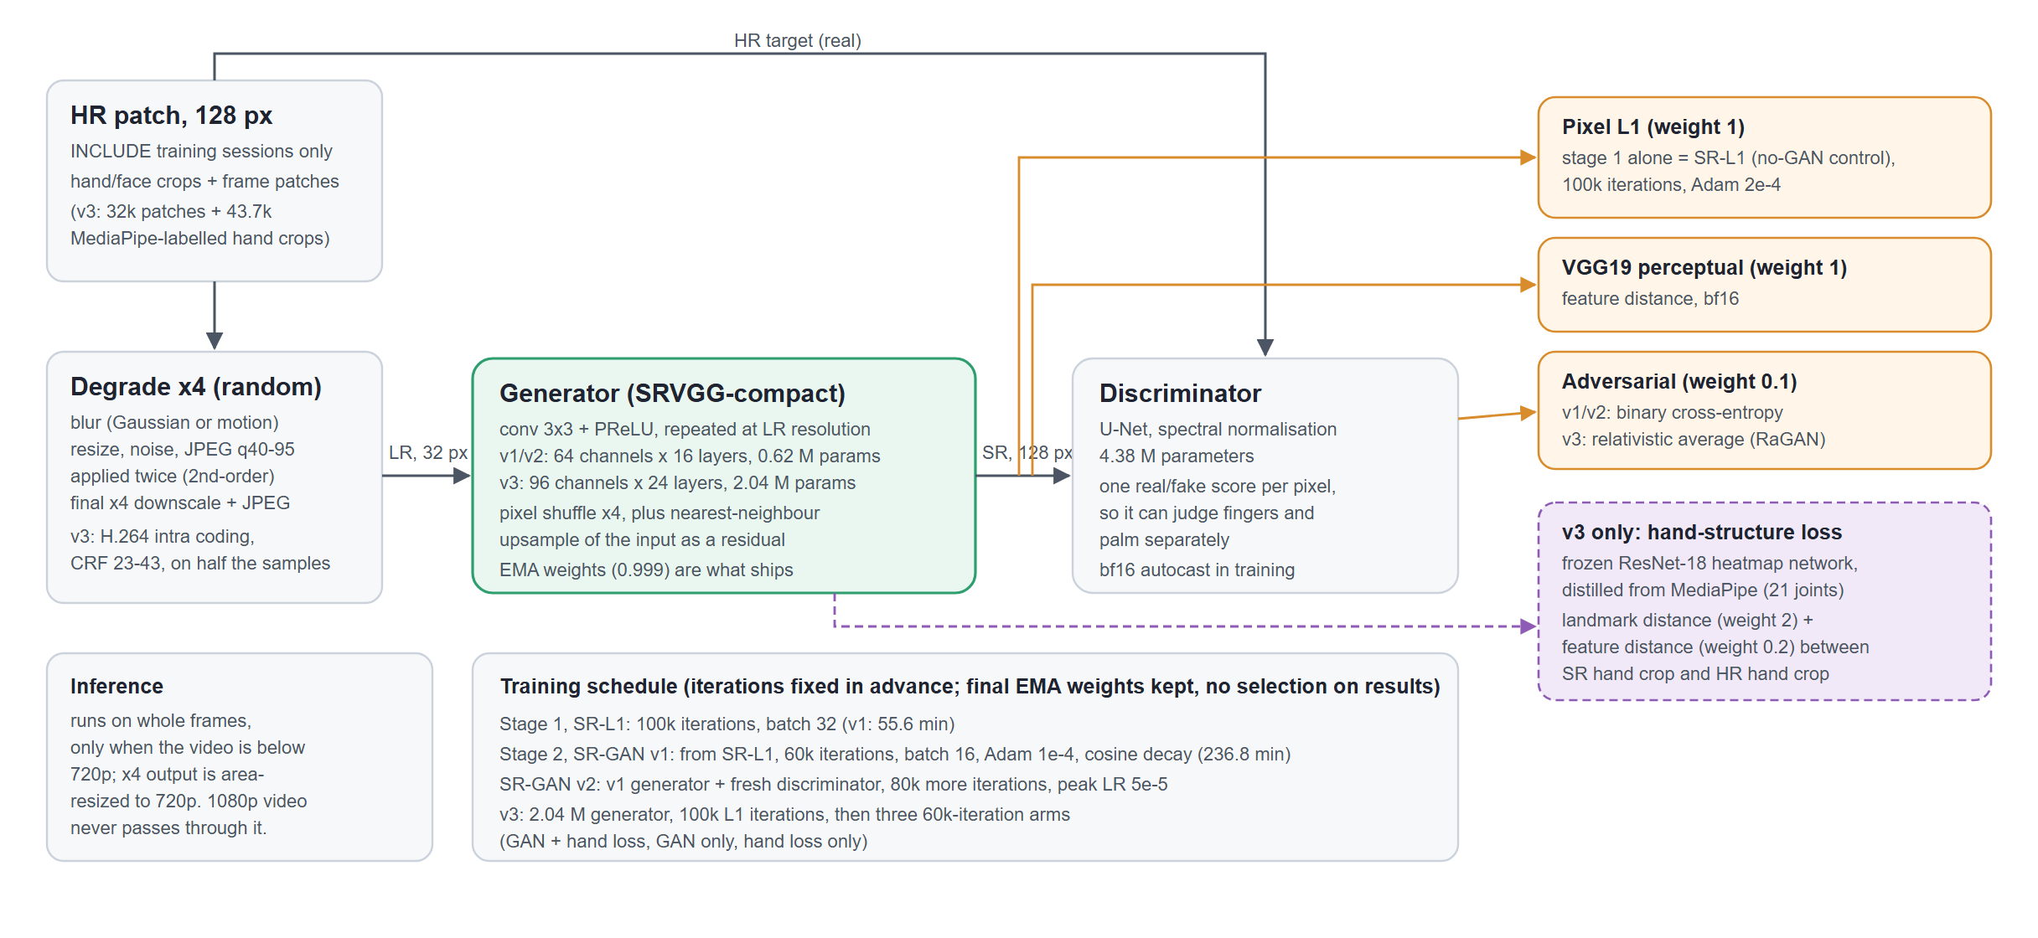
Fig. 8 The super-resolution GAN: training data and degradation, generator, discriminator, losses and schedule.
Networks. The generator is Real-ESRGAN's compact VGG-style network [30]. It applies 3 × 3 convolutions with PReLU activations at the low resolution, a ×4 pixel shuffle, and adds a nearest-neighbour upsample of the input as a residual, so an untrained network falls back to plain upscaling. The discriminator is a U-Net with spectral normalisation (4.38 M parameters) that scores realism for every pixel; it can penalise an implausible fingertip without penalising the palm beside it.
Training data and losses. Training patches of 128 pixels come only from INCLUDE training sessions, half from detected hand and face crops and half from whole frames, and a check rejects any clip from the test sessions. Each patch is degraded at random by blur, resizing, noise and JPEG compression, applied twice, and then downscaled by four. The generator first trains on a pixel L1 loss alone for a fixed 100,000 iterations. The resulting network, SR-L1, is the no-GAN control: it shows what learned upscaling achieves without the adversarial loss. A GAN then continues from that network with the L1 loss, a VGG19 perceptual loss and an adversarial loss weighted 0.1. Every run uses a fixed iteration count and keeps the final exponential-moving-average weights.
Three versions. We built three GANs in sequence, each in response to the previous result (Table 3). Version 1 is the planned design, trained for 60,000 adversarial iterations; the planned 100,000 were cut before the run because a float32 step took too long. Its discriminator ended the run clearly ahead of the generator, so version 2 restarted the discriminator and trained the same generator for 80,000 more iterations at half the learning rate. This tested whether version 1 was simply undertrained. Version 3 followed the diagnosis in Section 4.4, which placed most of the remaining error in the hand landmarks. MediaPipe is not differentiable, so we trained a stand-in: a ResNet-18 [36] whose features are expanded by three transposed convolutions into 21 heatmaps and read out by soft-argmax [37]. It learned from 43,682 hand crops from training sessions whose MediaPipe landmarks we could verify belonged to the crop. On 2,466 crops from the validation sessions its mean landmark error is 0.0215 of the crop width, with 91.4 % of points within 0.05. For comparison, MediaPipe re-run on the same crops differs from its own stored labels by 0.041. Version 3 keeps this network frozen and penalises the distance between its landmark readings of the generated and original crops (weight 2) and between their features (weight 0.2). It also uses a larger generator, a relativistic adversarial loss and H.264 intra-frame compression in half of the degradations. Three arms were trained from one 100,000-iteration L1 network: the full version 3, the same without the hand losses, and the hand losses without the adversarial loss. The last of these, which we call v3 without the GAN, is version 3's no-GAN control. We chose between the arms on 200 clips from the 888 validation-session clips, without touching the test set.
Table 3 The three GAN versions and their no-GAN controls.
Property | SR-GAN v1 | SR-GAN v2 | SR-GAN v3
Generator | 64 channels × 16 layers, 621,424 parameters | same as v1 | 96 channels × 24 layers, 2,039,568 parameters
Starts from | SR-L1 | v1, new discriminator | v3 L1 network
Adversarial loss | binary cross-entropy | binary cross-entropy | relativistic
Other losses | L1, VGG19 | L1, VGG19 | L1, VGG19, hand landmarks, hand features
Degradation | blur, resize, noise, JPEG | same as v1 | same + H.264 on half the samples
Adversarial iterations | 60,000 | 140,000 in total | 60,000
No-GAN control | SR-L1 | SR-L1 | v3 without the GAN
Why it was built | planned design | test whether v1 was undertrained | target the landmark error

Study design. The 472 test clips were degraded inside the frame reader, before detection, to three levels: 360p at JPEG quality 60, 240p at quality 50 and 180p at quality 40. Each level went through each front end, and the three released 4-bit models and their 32-bit originals were scored without retraining. In a second arm, the 32-bit models were fine-tuned for 150 epochs on 360p training video passed through bicubic, SR-GAN v1 or SR-GAN v2, to see whether a GAN still helps once the classifier has adapted to low-resolution input. We also compared hand detection with the clean video. That comparison counts hands detected in degraded video but absent from the clean video, which is where a GAN that invents hands would show up.

3.8 User interface and integration
The interface is a single self-contained web page served by the recognition server (Fig. 2), with seven screens. Capture records three seconds from the camera, accepts a dropped or chosen video, or plays one of ten built-in clips, and shows the answer inside a ring whose clarity follows the model's confidence. Not sure lists the five candidates when the top word falls below the threshold, and the user's pick is written to a corrections log as a labelled example. Sentence collects accepted words. Settings sets the threshold and the number of views. Detection shows, for each clip, how many hand and face crops came from real detections, from the second-pass search or from interpolation. Vocabulary shows per-word recall on the test sessions, and Enrolment records three takes per word from new signers into a folder the training pipeline reads.
Three integration details bear on the comparisons in this paper. First, the server loads any trained checkpoint and either upscaling front end, chosen at start-up. Second, it restricts answers to the 50 deployed words exactly as the evaluation does: the six views' probabilities are averaged over all 262 words, the other 212 are set to zero, and the highest remaining word is the answer. Without this step the application would answer from all 262 words, which for the same models gives 72.0 % instead of 85.9 %. Third, the presenter reaches the server through an SSH tunnel, which also makes the page a secure origin, a condition browsers impose before they allow camera access.
The ten demonstration clips are held-out test clips transcoded to 720p H.264, and the model reads exactly these files. Nine are words that all three released models classify correctly, each confirmed against the running server at 66–97 % confidence. The tenth, "wide", is a look-alike word the model is unsure of (top probability 7.3 %) while still keeping the right word in its shortlist, so the demonstration also exercises the Not-sure path. The clips illustrate the interface and say nothing about accuracy.

3.9 Testing the interface with the models
Testing ran at three levels. Automated browser tests, with Playwright driving Chromium, opened all seven screens at 1366 and 1920 pixels wide and recorded console errors, layout measurements and the timing of screen transitions. End-to-end tests posted held-out clips to the live server through the interface and checked the answer, confidence and detection breakdown on screen. A consistency test called the server's classification code on held-out test clips and compared each answer with the offline evaluation's result for the same clip and model.

4 Results and discussion

4.1 Leakage in the standard split
Under one recipe (50 words, 16 frames, 2,000 epochs, iSign initialisation, pixel crops only), a model scored 98.5 % on a random split (one seed, 200 clips) and 69.9 and 70.3 % on whole held-out sessions (two seeds, 472 clips; mean 70.1 %) (Fig. 9). Both come from the project's earlier controlled runs. The 28-point gap is what the model gains from having already seen the same person, room and take, and it is why every other result here uses held-out sessions. The 262-word model masked to the 50 deployed words reaches 75.6 % on those 472 clips; it is a different model, trained for a different vocabulary and number of epochs, so it is not part of this comparison.
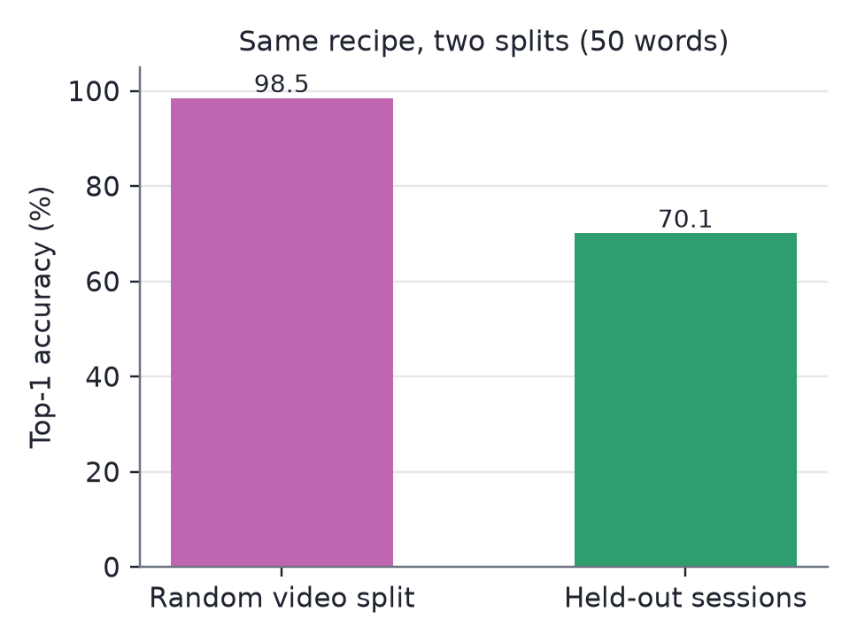
Fig. 9 Same recipe, two splits (50 words, pixel crops only).

4.2 Classifier variants
Table 4 and Fig. 10 compare the model variants on the same 472 clips. Adding hand landmarks to the pixel-only model raised top-1 from 73.7 % to 86.5 %. On identical clips, the landmark model corrected 76, 83 and 88 clips that the pixel-only model got wrong (one count per seed) and broke 18, 21 and 26 (McNemar p ≤ 5 × 10⁻⁹ for each seed). Rounding the landmark model to 4 bits after training cost 3.1 points; quantisation-aware training recovered all but 0.6 of them, at about a seventh of the file size. The shipped model is 10.9 points above the project's accuracy target of 75 %, within its size target of about 2 MB.
Table 4 Classifier variants on the 472 held-out clips of the 50 deployed words, six-view averaging. Means of three seeds, individual seeds in brackets.
Model | File size | Top-1 (%) | Top-5 (%)
Pixel-only, 32-bit | 14.55 MB | 73.7 (75.0 / 73.7 / 72.2) | 93.5
+ landmarks, 32-bit | 14.9 MB | 86.5 (87.3 / 86.9 / 85.4) | 96.5
+ landmarks, 4-bit after training | ≈ 2 MB | 83.4 (83.1 / 85.2 / 82.0) | —
+ landmarks, 4-bit quantisation-aware (shipped) | 1.97 MiB | 85.9 (84.5 / 87.5 / 85.8) | 96.4
Shipped model, answering from all 262 words | 1.97 MiB | 72.0 (69.7 / 75.8 / 70.3) | 92.7

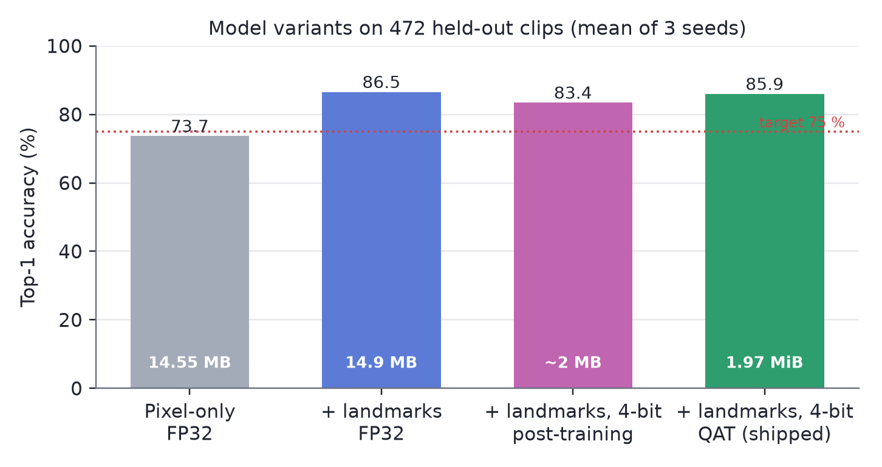
Fig. 10 Top-1 accuracy of the classifier variants. The dotted line marks the 75 % target.
Two comparisons put these numbers in context. The nearest like-for-like result we found, signer-independent recognition of 184 Thai signs [12], is 79.69–80.83 %. That suggests accuracy on unseen people sits in the high 70s to mid 80s, not above 95 %. The top-5 figure of 96.4 % matters for the interface: when the model is unsure, the right word is usually among the five candidates on the Not-sure screen. For an earlier pixel-only ensemble, a threshold of 0.4 answered 75.2 % of clips, and 88.7 % of those answers were correct. We have not re-measured that curve for the landmark model, and the Settings screen labels it as an older measurement.

4.3 GAN versus no GAN
Fig. 11 and Table 5 give the main comparison. A learned upscaler beat bicubic at every degraded level on the frozen 4-bit models. SR-GAN v2, for instance, gained 1.9 points at 360p, 6.4 at 240p and 14.5 at 180p, which closes 40–64 % of the gap to clean video. After fine-tuning, the GANs still beat bicubic by 5.2–5.7 points at 240p and 12.5–13.3 at 180p; at 360p the 1.1–1.3-point gains did not pass the rule. The frozen 32-bit models gained nothing from any upscaler at 360p and gained 5–18 points at 240p and 180p. Clean 1080p video never reaches the generator, and its result stayed at 85.9 %.
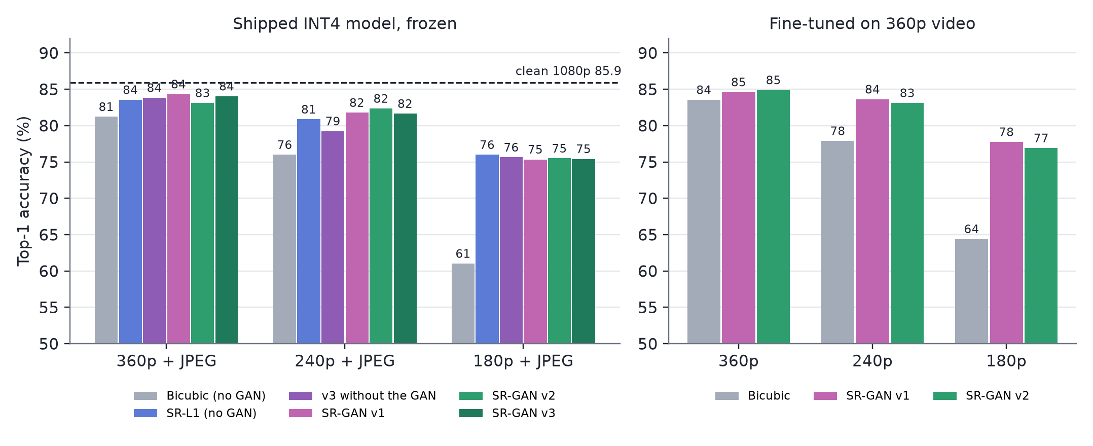
Fig. 11 Top-1 accuracy on degraded test video. Left: the shipped 4-bit models, unchanged. Right: 32-bit models fine-tuned on 360p video through each front end.
Table 5 Paired comparisons on the 472 test clips, frozen 4-bit models. Δ is the change in mean top-1 over three seeds; clips gained and lost are pooled over seeds; the verdict applies the pre-registered rule.
Input | Comparison | Δ (points) | gained / lost | p | Verdict
360p | SR-L1 vs bicubic (no GAN) | +2.3 | 66 / 33 | 0.0012 | helps
360p | SR-GAN v2 vs bicubic | +1.9 | 73 / 46 | 0.017 | helps
360p | SR-GAN v1 vs SR-L1 | +0.8 | 35 / 24 | 0.19 | none
360p | SR-GAN v2 vs SR-L1 | −0.4 | 28 / 34 | 0.53 | none
360p | SR-GAN v3 vs v3 without the GAN | +0.2 | 33 / 30 | 0.80 | none
360p | SR-GAN v3 vs SR-L1 | +0.5 | 30 / 23 | 0.41 | none
240p | SR-L1 vs bicubic (no GAN) | +4.9 | 125 / 56 | 3 × 10⁻⁷ | helps
240p | SR-GAN v2 vs bicubic | +6.4 | 142 / 52 | 8 × 10⁻¹¹ | helps
240p | SR-GAN v1 vs SR-L1 | +0.9 | 43 / 30 | 0.16 | none
240p | SR-GAN v2 vs SR-L1 | +1.5 | 49 / 28 | 0.022 | helps
240p | SR-GAN v3 vs v3 without the GAN | +2.4 | 68 / 34 | 0.001 | helps
240p | SR-GAN v3 vs SR-L1 | +0.8 | 52 / 41 | 0.30 | none
180p | SR-L1 vs bicubic (no GAN) | +15.0 | 269 / 57 | 4 × 10⁻³⁴ | helps
180p | SR-GAN v2 vs bicubic | +14.5 | 265 / 60 | 7 × 10⁻³² | helps
180p | SR-GAN v1 vs SR-L1 | −0.6 | 56 / 65 | 0.47 | none
180p | SR-GAN v2 vs SR-L1 | −0.5 | 56 / 63 | 0.58 | none
180p | SR-GAN v3 vs v3 without the GAN | −0.2 | 59 / 62 | 0.86 | none
180p | SR-GAN v3 vs SR-L1 | −0.6 | 53 / 61 | 0.51 | none

The adversarial loss contributed little of this. Against their own no-GAN controls the three GANs passed the rule in 2 of 9 comparisons, both at 240p: SR-GAN v2 beat SR-L1 by 1.5 points, and SR-GAN v3 beat v3 without the GAN by 2.4. The second result is weaker than it looks, because v3 without the GAN was the worst learned upscaler at 240p and SR-GAN v3 did not beat SR-L1 there. Training longer did not help either. Version 2, with 140,000 adversarial iterations in all, was no better than version 1 at any level and 1.2 points worse at 360p (p = 0.021), so undertraining does not explain why version 1 matched SR-L1.
The adversarial loss did change the images. On held-out patches at 180p, SR-GAN v2 doubled the sharpness of SR-L1 (variance of the Laplacian 32 against 16; originals 73) and lowered PSNR from 31.83 to 31.09 dB, the usual trade-off between perceived quality and distortion. In version 3 the discriminator had a second effect. Trained with the hand losses but no discriminator, the generator covered its output in a fine regular dot pattern, which the hand-landmark loss does not penalise; with the discriminator present the pattern did not appear. Neither effect on the images turned into accuracy.
Detection shows where the accuracy came from. At 180p with bicubic, MediaPipe found the left hand in 51.0 % of frames, the right hand in 53.8 % and the face in 33.5 %. With SR-GAN v2 the figures were 68.6 %, 71.9 % and 99.9 %, and SR-GAN v3 found the hands in 77.6 % and 76.9 % of frames. The share of hands present in clean video but missed fell from 39.3 % with bicubic to 22.1 % with v2 and 15.5 % with v3. Hands detected in degraded video but absent from the clean video rose from 1.9 % to 2.6 % with v2 and 3.1 % with v3, so the GANs did not gain accuracy by inventing hands, although they invented a few. On CISLR, which is natively 300 pixels, no upscaler changed left-hand detection (25.0 % with bicubic, 24.3–25.9 % with SR-L1, v1 and v2; version 3 was not run on CISLR); Section 4.5 explains why.

4.4 Where the remaining loss comes from
To locate the error that super-resolution leaves, we kept one input clean and degraded the other (Fig. 12). At 180p with SR-GAN v2, clean pixels with degraded landmarks scored 78.2 %, and degraded pixels with clean landmarks scored 83.1 %. Of the 10.4 points still missing from the clean 85.9 %, about 7.7 are therefore on the landmark side and 2.8 on the pixel side, and the two roughly add up. With bicubic upscaling both sides lost heavily, 12.2 and 6.9 points, and together they cost more than their sum. Super-resolution repaired most of the pixel damage. What it left is mainly in where the detector places the 21 joints.
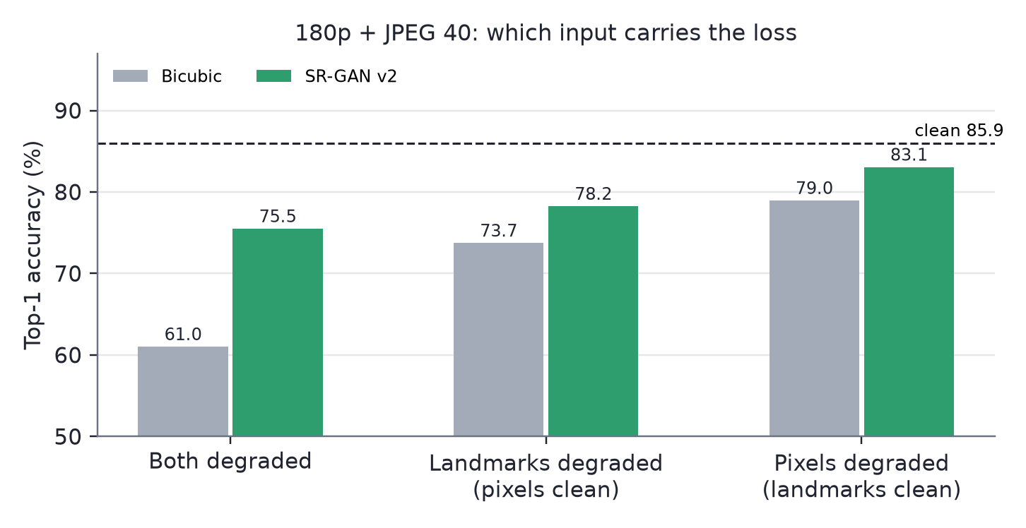
Fig. 12 180p, frozen 4-bit models: accuracy when only the landmarks, or only the pixels, come from degraded video.
Adjusting the detector does not recover this. We re-ran landmark extraction on the same super-resolved frames with lower confidence thresholds, a larger or multi-scale search region and gap filling. The share of hand frames found rose from 70.3 % to as much as 99.2 %, above the clean video's 89.7 %, yet accuracy moved by at most 0.8 points, because misplaced hands rose from 4.7 % to between 7.1 % and 14.1 %. Finding a hand is not the limit; placing its joints correctly is.
Version 3 was built to address this. On the validation sessions it behaved as designed at the detection level (Fig. 13). SR-GAN v3 found hands in 73.3 % of 180p frames against 63.3 % for v2, and v3 without the GAN had the lowest handshape error, 0.99 against 1.30 hundredths of the frame height. The test-set detection figures above agree. In accuracy, though, SR-GAN v3 was not reliably better than v2 or SR-L1 at any level, and v3 without the GAN was 3.1 points worse than v2 at 240p (p = 5 × 10⁻⁶). On the 32-bit models SR-GAN v3 was 1.7 points worse than v2 at 240p (p = 0.021). Better detection did not become better classification. One possible explanation, which we have not tested, is that the frozen classifier learned from MediaPipe's landmarks on clean video and reacts to the remaining detector errors in ways the proxy distance does not capture. Fine-tuning the classifier on version 3's output would test this.
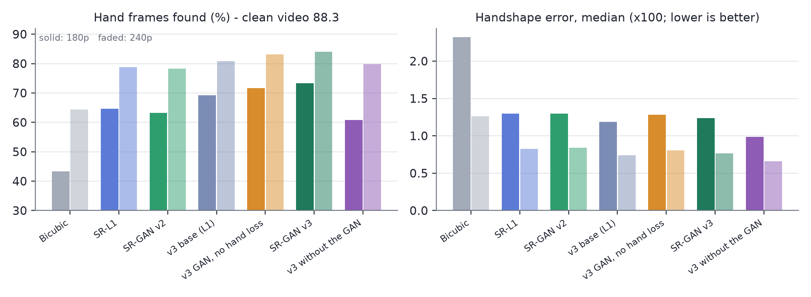
Fig. 13 Validation sessions, 200 clips, MediaPipe on the super-resolved video against the clean video. Solid bars 180p, faded 240p.

4.5 The second corpus
Pixel-only checkpoints that reached up to 42 % on INCLUDE's unseen sessions in earlier experiments scored 0.3–1.5 % on CISLR, which is chance level. Super-resolution cannot fix this, because CISLR's problem is not resolution. Its signers are framed tightly, with hands about 14 % of the frame width against 8.5 % in INCLUDE. MediaPipe's pose model expects a full upper body and reports a visible wrist in only 22 % (left) and 42 % (right) of CISLR frames; when it does find the wrist, the hand is found 79–85 % of the time. A hand detector run directly on the whole frame found a hand in 47 % of 318 sampled frames at confidence 0.3, against 40 % for the pose-led path. CISLR needs a different detection path, not a better upscaler.

4.6 Interface tests
Table 6 lists the interface tests. All seven screens rendered at both widths without browser console errors. Posted to the live server, the nine reliable demonstration clips were answered correctly with confidence 66–97 %, and the look-alike clip went to the Not-sure shortlist with the right word first. Four of the clips were also played through the Capture screen, with the same results (Figs. 14 and 15). The consistency test agreed with the offline evaluation on all 8 held-out clips checked, including the 2 the model gets wrong. On a desktop CPU, reading a clip with six views took 5–9 seconds. With the GAN front end switched on, a 180p copy of a demonstration clip was read correctly.
Table 6 Tests of the interface with the models.
Test | Method | Result
Screens render | Chromium, 7 screens × 1366 and 1920 px | No console errors
Live answers | All 10 demo clips posted to the live server; 4 also played through the Capture screen | 9/9 reliable clips correct (66–97 %); look-alike clip routed to Not sure
Same answers as the evaluation | Server classification vs offline result, same clips and model | 8 of 8 clips agree
Vocabulary restriction | 50-word answers vs all-262-word answers | Matches the evaluation's 85.9 % setting; 262 words would give 72.0 %
GAN front end in the interface | 180p copy of a demo clip, SR-GAN enabled | Read correctly
Latency | Desktop CPU, six views, end to end | 5–9 s per clip

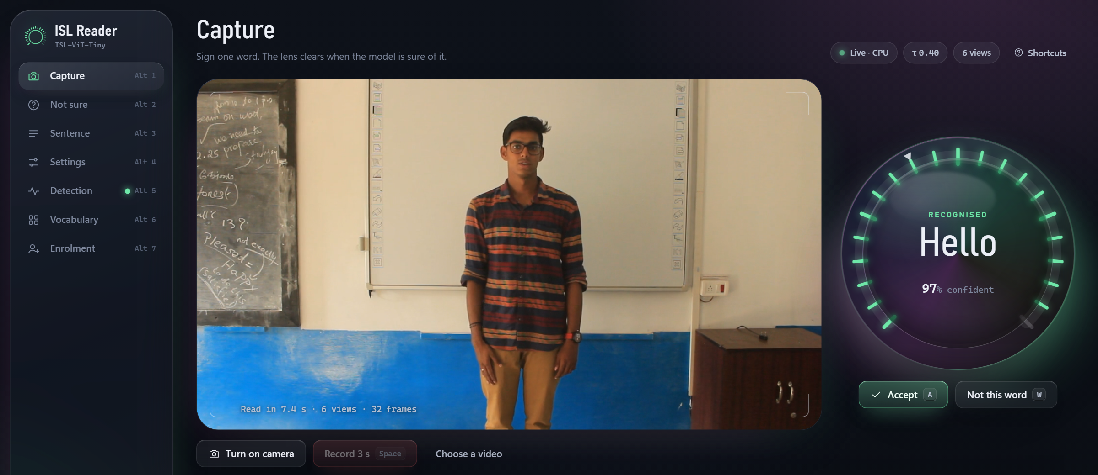
Fig. 14 Capture screen with the live model reading a held-out demonstration clip.

Fig. 15 Not-sure screen for the look-alike demonstration clip: the model's top probability is below the threshold, so the user picks from the shortlist.

4.7 Limitations
INCLUDE was recorded in one studio in one city, its sessions are inferred from camera counters rather than signer labels, and the classifier has not yet transferred to another corpus. The super-resolution study degrades studio video synthetically, by downscaling and a single JPEG pass; real phone or glasses video, with motion blur and inter-frame compression, may rank the front ends differently. Only version 1 of the GAN was pre-registered. Versions 2 and 3 were designed after earlier test results were known, although they were judged by the same rule and version 3's arms were chosen on validation sessions. The fine-tuned arm covers bicubic, v1 and v2 but not version 3, and two version 3 arms were evaluated on validation sessions only. With three seeds and a seed-to-seed spread of about two points, effects of a point or less cannot be settled either way. The confidence curve in the interface comes from an earlier model, latency was measured on a desktop CPU rather than wearable hardware, and the system recognises isolated words, not continuous signing.

5 Conclusion
On recording sessions it never saw, a 3.89 M-parameter factorised transformer recognises 50 ISL words at 85.9 % top-1 from a 1.97 MiB file, and the same recipe scores about 28 points higher when the split leaks sessions. In front of the hand detector, a learned upscaler recovers much of the accuracy lost on low-resolution video, up to 15 points at 180p on the shipped model. Whether that upscaler is trained as a GAN matters little for recognition. Across three versions, the adversarial loss sharpened the images, suppressed an artifact the hand-landmark loss introduced and helped version 3 find more hands, but it passed our test against a no-GAN control only twice in nine comparisons. After super-resolution, the remaining error lies mostly in where the detector places the hand joints, and neither detector tuning nor a landmark-aware generator has closed it. The interface ties the models together and gives the same answers as the offline evaluation. The next steps follow from these results: fine-tune the classifier on version 3's output, re-measure the confidence curve for the shipped model, build a detection path for tightly framed video such as CISLR, and test new signers recorded through the Enrolment screen on wearable hardware.

References
1. Lamaakal I, Yahyati C, Maleh Y, El Makkaoui K, et al. (2026) An explainable hybrid CNN–transformer model for sign language recognition on edge devices using adaptive fusion and knowledge distillation. Sci Rep 16:7143. https://doi.org/10.1038/s41598-026-38478-8
2. Venkatappa U, N. K. S., N. K. S., Bhat PP, Srinivas P (2026) Dynamic Kannada sign language recognition on resource constrained devices. Sci Rep 16:11186. https://doi.org/10.1038/s41598-026-40181-7
3. Ashfaq U, Wang Q, Merabet B, Zhang J (2026) SignViT: an enhanced vision transformer framework for attention-based sign language hand gesture recognition. Biomed Signal Process Control 112(Part B):108602. https://doi.org/10.1016/j.bspc.2025.108602
4. Rubaiyeat HA, Youssouf N, Hasan MK, et al. (2026) Transformer-based word level Bangla sign language recognition using relative quantization encoding. Sci Rep 16:25259. https://doi.org/10.1038/s41598-026-53835-3
5. Abdi A, Barzegar Touchahi F (2026) Underwater sign language recognition using convolutional and transformer models: a comparative study in clear and murky conditions. Signal Image Video Process 20:297. https://doi.org/10.1007/s11760-026-05314-5
6. Nedungadi P, et al. (2025) Vision transformer-powered conversational agent for real-time Indian Sign Language e-governance accessibility. Sci Rep 15:33055. https://doi.org/10.1038/s41598-025-12667-3
7. Govindharajalu Kaliyaperumal V, et al. (2025) A deep neural network framework for dynamic two-handed Indian Sign Language recognition in hearing and speech-impaired communities. Sensors 25(12):3652. https://doi.org/10.3390/s25123652
8. Shawon JAB, et al. (2026) A comparative analysis of video vision transformers on word-level sign language datasets. PLOS One 21(2):e0341909. https://doi.org/10.1371/journal.pone.0341909
9. Damdoo R, et al. (2026) End-to-end sentence-level Indian sign language translation with ISH-NEWS dataset and transformer model. Sci Rep. https://doi.org/10.1038/s41598-026-60893-0
10. Damdoo R, et al. (2025) An integrative survey on Indian sign language recognition and translation. IET Image Process 19(1):e70000. https://doi.org/10.1049/ipr2.70000
11. Alyami S, et al. (2026) Isharah: a large-scale multi-scene dataset for continuous sign language recognition. IEEE Trans Multimedia 28:5050–5058. https://doi.org/10.1109/TMM.2026.3664959
12. Chalotonpised J, et al. (2026) TSL-ONE-S: a real-world Thai Sign Language dataset with deep learning benchmarks. IEEE Access 14:37845–37870. https://doi.org/10.1109/ACCESS.2026.3670970
13. Arib SH, et al. (2025) SignFormer-GCN: continuous sign language translation using spatio-temporal graph convolutional networks. PLOS One 20(2):e0316298. https://doi.org/10.1371/journal.pone.0316298
14. Said Y, et al. (2025) Adaptive transformer-based deep learning framework for continuous sign language recognition and translation. Mathematics 13(6):909. https://doi.org/10.3390/math13060909
15. López-Nava IH, et al. (2026) A comprehensive dataset of static and dynamic signs for the Mexican Sign Language alphabet. Data Brief 66:112887. https://doi.org/10.1016/j.dib.2026.112887
16. Sridhar A, Ganesan RG, Kumar P, Khapra M (2020) INCLUDE: a large scale dataset for Indian Sign Language recognition. In: Proceedings of the 28th ACM International Conference on Multimedia, pp 1366–1375. https://doi.org/10.1145/3394171.3413528
17. Joshi A, et al. (2022) CISLR: Corpus for Indian Sign Language recognition. In: Proceedings of the 2022 Conference on Empirical Methods in Natural Language Processing
18. Joshi A, Mohanty R, Kanakanti M, Mangla A, Choudhary S, Barbate M, Modi A (2024) iSign: a benchmark for Indian Sign Language processing. In: Findings of the Association for Computational Linguistics: ACL 2024
19. Dosovitskiy A, et al. (2021) An image is worth 16x16 words: transformers for image recognition at scale. In: International Conference on Learning Representations
20. Touvron H, Cord M, Douze M, Massa F, Sablayrolles A, Jégou H (2021) Training data-efficient image transformers and distillation through attention. In: Proceedings of the 38th International Conference on Machine Learning, PMLR 139, pp 10347–10357
21. Arnab A, Dehghani M, Heigold G, Sun C, Lučić M, Schmid C (2021) ViViT: a video vision transformer. In: Proceedings of the IEEE/CVF International Conference on Computer Vision, pp 6836–6846
22. Xie Z, Zhang Z, Cao Y, Lin Y, Bao J, Yao Z, Dai Q, Hu H (2022) SimMIM: a simple framework for masked image modeling. In: Proceedings of the IEEE/CVF Conference on Computer Vision and Pattern Recognition, pp 9653–9663
23. Lugaresi C, et al. (2019) MediaPipe: a framework for building perception pipelines. arXiv:1906.08172
24. Jacob B, Kligys S, Chen B, Zhu M, Tang M, Howard A, Adam H, Kalenichenko D (2018) Quantization and training of neural networks for efficient integer-arithmetic-only inference. In: Proceedings of the IEEE Conference on Computer Vision and Pattern Recognition, pp 2704–2713
25. Bengio Y, Léonard N, Courville A (2013) Estimating or propagating gradients through stochastic neurons for conditional computation. arXiv:1308.3432
26. McNemar Q (1947) Note on the sampling error of the difference between correlated proportions or percentages. Psychometrika 12(2):153–157
27. Goodfellow I, Pouget-Abadie J, Mirza M, Xu B, Warde-Farley D, Ozair S, Courville A, Bengio Y (2014) Generative adversarial nets. In: Advances in Neural Information Processing Systems 27, pp 2672–2680
28. Ledig C, Theis L, Huszár F, et al. (2017) Photo-realistic single image super-resolution using a generative adversarial network. In: Proceedings of the IEEE Conference on Computer Vision and Pattern Recognition, pp 4681–4690
29. Wang X, Yu K, Wu S, Gu J, Liu Y, Dong C, Qiao Y, Loy CC (2018) ESRGAN: enhanced super-resolution generative adversarial networks. In: Computer Vision – ECCV 2018 Workshops
30. Wang X, Xie L, Dong C, Shan Y (2021) Real-ESRGAN: training real-world blind super-resolution with pure synthetic data. In: Proceedings of the IEEE/CVF International Conference on Computer Vision Workshops, pp 1905–1914
31. Schönfeld E, Schiele B, Khoreva A (2020) A U-Net based discriminator for generative adversarial networks. In: Proceedings of the IEEE/CVF Conference on Computer Vision and Pattern Recognition, pp 8207–8216
32. Jolicoeur-Martineau A (2019) The relativistic discriminator: a key element missing from standard GAN. In: International Conference on Learning Representations
33. Johnson J, Alahi A, Fei-Fei L (2016) Perceptual losses for real-time style transfer and super-resolution. In: Computer Vision – ECCV 2016, pp 694–711
34. Simonyan K, Zisserman A (2015) Very deep convolutional networks for large-scale image recognition. In: International Conference on Learning Representations
35. Miyato T, Kataoka T, Koyama M, Yoshida Y (2018) Spectral normalization for generative adversarial networks. In: International Conference on Learning Representations
36. He K, Zhang X, Ren S, Sun J (2016) Deep residual learning for image recognition. In: Proceedings of the IEEE Conference on Computer Vision and Pattern Recognition, pp 770–778
37. Sun X, Xiao B, Wei F, Liang S, Wei Y (2018) Integral human pose regression. In: Computer Vision – ECCV 2018, pp 529–545

