ISL-ViT-Tiny
A compact factorised Vision Transformer for Indian Sign Language recognition
Complete review-presentation content pack — all 12 assessed slides
Rishi Beria · CB.EN.U4ARE23042 · B.Tech Automation and Robotics Engineering
Amrita Vishwa Vidyapeetham · September 2026
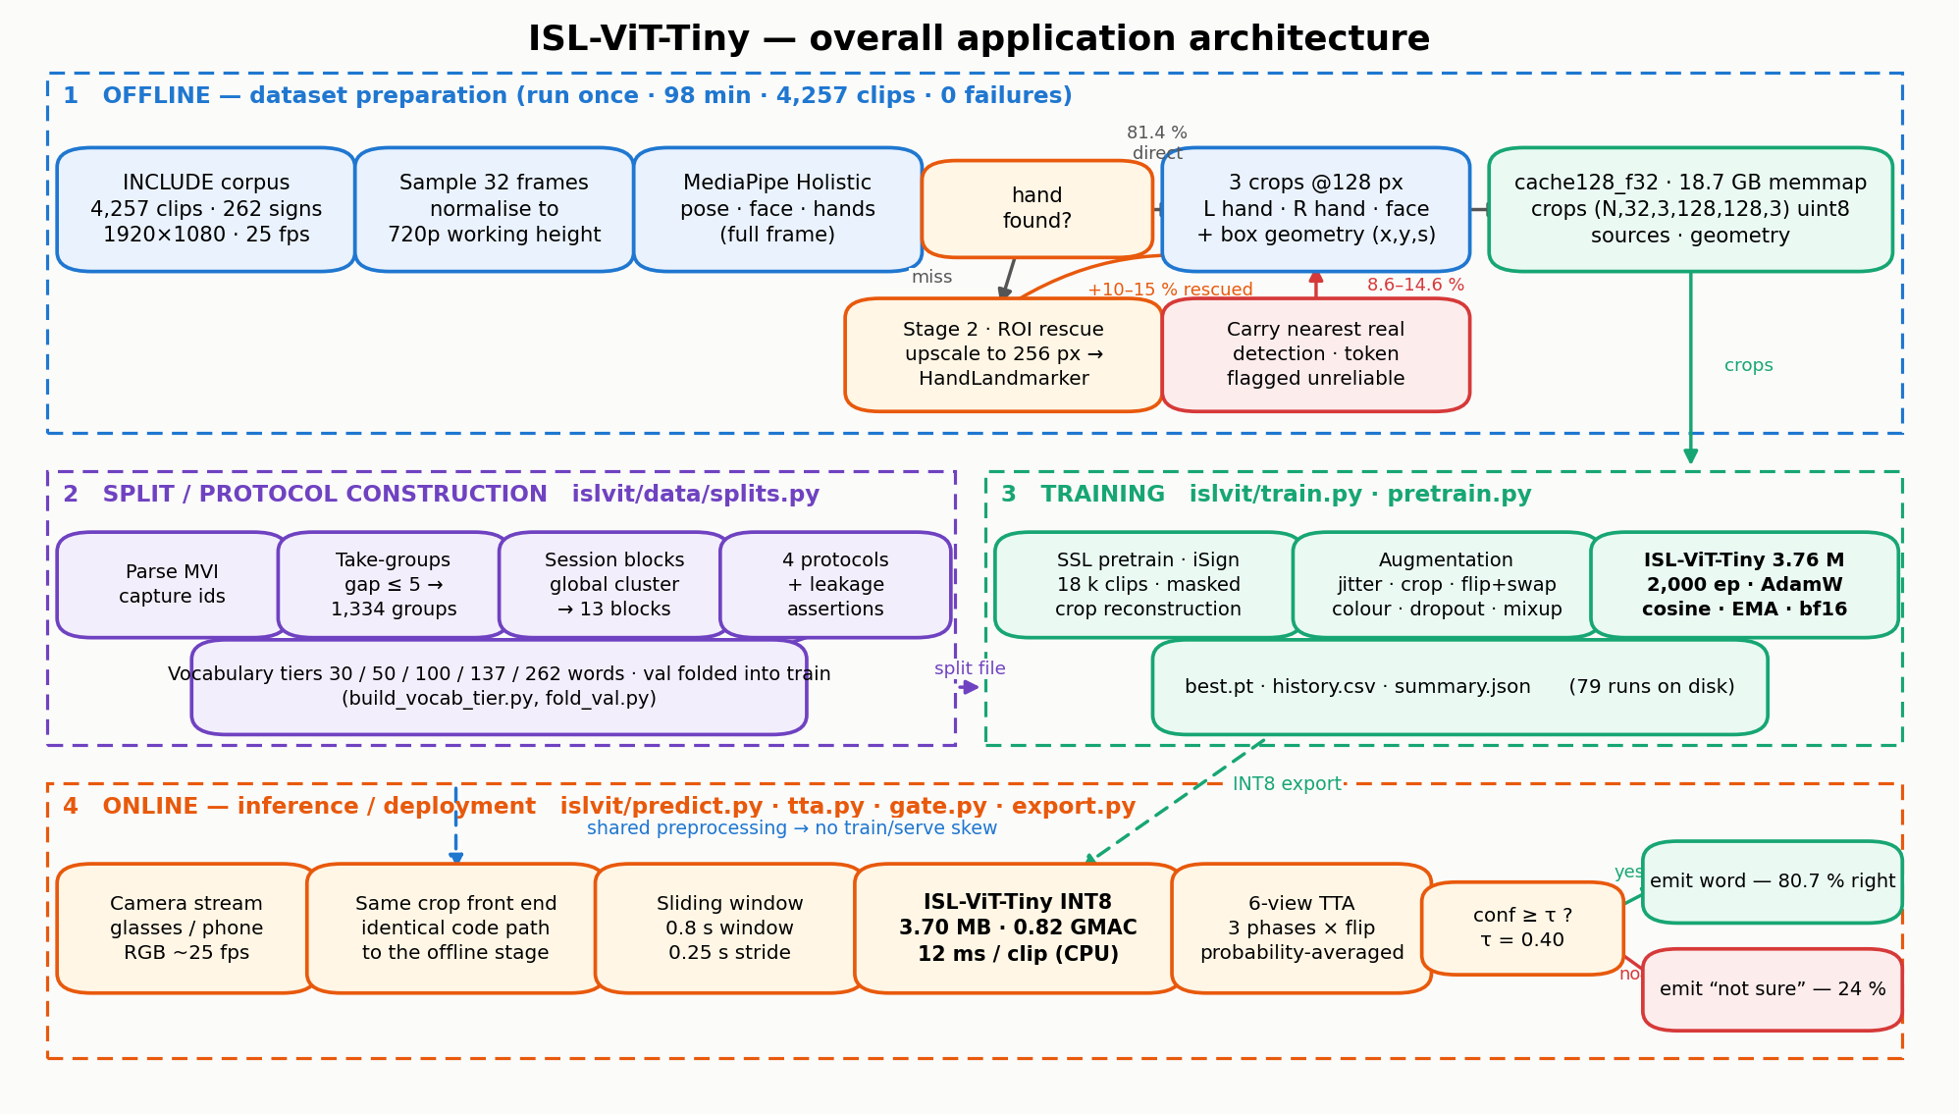
Everything in this document is taken from the project repository (D:\nn_dl_prac): 6,359 lines of code, 79 recorded training runs, 21 split definitions and 18 generated figures. Every accuracy value is read from runs/*/summary.json or docs/PRELIMINARY_MODEL_REPORT.md. Literature entries were verified against Crossref and publisher pages in September 2026.

How to use this document
This pack is written so the deck can be built without opening the repository again. Each numbered section below maps to exactly one assessed slide, in the order of the marking sheet, and contains more material than fits on a slide: put the bold lines on the slide and keep the rest as speaker notes.
Three conventions are used throughout:
- Verified — the number is read directly from a file in the repository (a run summary, a split file, a log) or from a publisher page. All accuracy figures are verified unless marked otherwise.
- Unverified — stated in the project report but not reproducible from the artefacts now on disk. Four such items exist and every one is listed in Appendix D. Do not quote them on a slide without checking.
- Not measured — a target from the case-study brief that this project has not yet met or tested. Claiming these is the fastest way to lose marks in questioning.
Read Appendix D before you build the deck. It lists four places where the repository’s own README, its figures and its report disagree with each other about the headline number. Presenting the README figure (68.9 %) would understate the project by seven points; presenting the report figure for gated accuracy (90.7 %) would overstate it by two.

Slide map
# | Assessed item | Marks | Section here | One-line answer to give
1 | Problem statement, introduction, motivation | 4 | §1 | Isolated ISL word recognition on a wearable budget — and an honest measurement of it.
2 | Literature survey — 5 papers per student, SCImago journals 2025/2026 | 5 | §2 | 15 verified journal papers in three themed sets, each with the gap it leaves.
3 | Architecture diagram for the overall application | 5 | §3 | Figure 3.1: offline cache → protocol construction → training → gated inference.
4 | Module details | 5 | §4 | 19 modules, each one file, each with a stated responsibility.
5 | Performance metrics — formula, purpose, suitability, best values in the papers | 3 | §5 | Nine metrics; balanced accuracy and accuracy-at-coverage are the two that matter here.
6 | Deep learning architecture — diagram, explanation, novelty, complexity | 5 | §6 | Factorised spatio-temporal ViT over three anatomical crops, 3.76 M parameters.
7 | Algorithm procedure, step by step, mathematically | 5 | §7 | Twelve numbered steps with the equation for each.
8 | Hyperparameter table with justification | 5 | §8 | 26 hyperparameters, each with the measurement that fixed it.
9 | Results and discussion — tables, graphs, inference | 3 | §9 | 51.7 → 75.8 % on one unchanged test set; none of it architectural.
10 | Dataset chosen, novelty in the dataset, IEEE DataPort URL | 3 | §10 | INCLUDE (Zenodo) + CISLR + iSign; novelty is the reconstructed protocol.
11 | UI screens planned | 5 | §11 | Seven screens; the confidence gate is the interface, not a detail.
12 | Standard paper — title and justification | 2 | §12 | Shawon et al., PLOS ONE 2026, video vision transformers on word-level SLR.
Total 50 marks. Sections are self-contained; §9 and Appendix A carry every number you could be asked for.

Contents

(Right-click → Update Field in Word to populate page numbers.)

1. Problem statement, introduction and motivation
Slide 1 · 4 marks. Put the problem sentence, the three constraints and the leakage headline on the slide. Everything else is speaker notes.

1.1 The task, stated precisely
Isolated sign language recognition (ISLR). Given a short video clip containing exactly one Indian Sign Language sign, output the corresponding word from a fixed vocabulary. Formally, learn f : ℝ^(T×H×W×3) → {1…C} where T is the number of sampled frames and C the vocabulary size. This is the classification building block of a continuous recognition system; it is not translation and it is not continuous signing.
The deployment target is a wearable — smart glasses or a phone worn as a camera — which constrains the model to a few megabytes, under one GMAC per clip, and offline inference.

1.2 Application domain and why it matters
- Indian Sign Language is the primary language of a large deaf and hard-of-hearing community in India, and interpreter availability is far below demand. A wearable that captions signing in real time is an assistive-technology application, not a benchmark exercise.
- The system must work offline: an assistive device cannot depend on connectivity, and video of a private conversation should not leave the device.
- The output is consumed by a hearing person reading a caption, so a wrong word is worse than no word — an incorrect caption produces a wrong sentence with no signal that it is wrong. This single observation is what makes confidence gating (§11) part of the product rather than an optimisation.
If you want a population figure for the deaf community in India on the slide, cite the source you take it from. No such figure is measured in this project, so it is not stated here.

1.3 Why the task is hard
Difficulty | Evidence from this project
Extreme low-data regime | INCLUDE gives a median of 15 clips per class over 262 classes (min 4, max 22, mean 16.2). A Vision Transformer has no convolutional inductive bias to compensate.
The hand is small in frame | At 1920×1080 a signing hand spans ≈190 px — about a tenth of the frame width. A full-frame model at 64 px input sees a hand of roughly 6 px.
Motion blur | 25 fps on fast finger movement blurs the hand badly; full-frame MediaPipe Holistic finds a hand in only ≈79 % of sampled frames.
Location is meaning | The same handshape at the forehead and at the chest are different words, so cropping the hands out of the frame destroys a linguistic parameter that has to be put back explicitly (§6.2).
Signer and session variation | Clothing, skin tone, lighting, room and camera all change between recordings, and the model has ample capacity to key on them instead of on the sign.
Two-handed and one-handed signs mix | A stream can legitimately be empty; “no hand detected” is itself information and must be distinguishable from “detection failed”.

1.4 The limitation in the existing literature that this project addresses
Published results on INCLUDE sit at 94–95 % top-1. This project reproduces that: 95.7 % on INCLUDE-50 and 94.5 % on INCLUDE-263 under a random per-clip split, using the same model and recipe as every other number here.
It is also mostly an artefact of how the corpus was recorded. Each clip carries a camera capture id (MVI_xxxx). Sorting those within a class shows the corpus was shot as back-to-back takes: of 3,989 within-class consecutive-id gaps, 2,907 are 1 or 2 and 1,063 are ≥ 20, with only 19 in between. Clips one apart are consecutive takes of the same word, by the same signer, in the same sitting, same clothes, same lighting, same framing — near-duplicates. A random split puts takes 1 and 2 in training and take 3 in test.
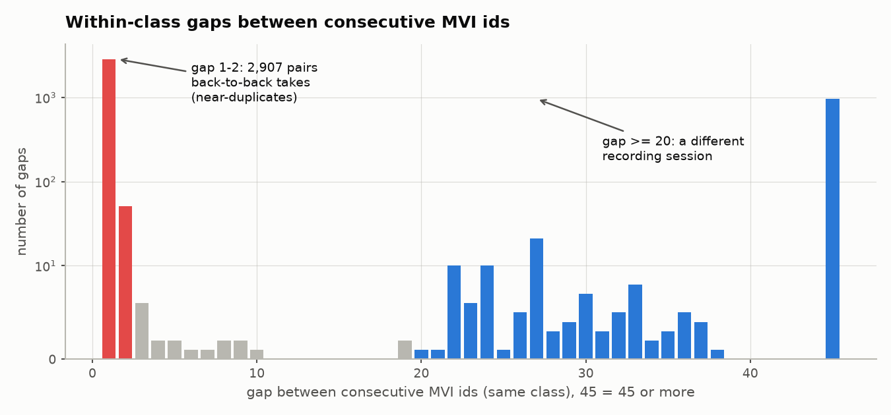
Figure 1.1 — Within-class gaps between consecutive MVI capture ids (log y). The distribution is sharply bimodal with an almost empty band between, so any grouping threshold in [5, 20] yields an identical partition. Source: docs/figures/fig01_mvi_gap_histogram.png.
Rebuilding the evaluation to remove that structure changes the number by an order of magnitude:
Protocol | What it removes | INCLUDE-50 top-1 | INCLUDE-263 top-1
random-video | nothing | 95.7 % | 94.5 %
official (as shipped) | nothing | 95.3 % | —
take-group | near-duplicate takes | 46.5 % | 29.3 %
session-disjoint | signer / room / lighting | 31.3 % balanced | 22.1 %
Roughly 63 points of the standard benchmark is attributable to near-duplicate takes and a further 7 points to shared recording conditions. No published INCLUDE result inspects capture-id structure, so this leakage is invisible to the protocol every published number uses.

1.5 Motivation — the contribution stated in one sentence
The contribution is to measure Indian Sign Language recognition honestly, and then to raise the honest number — from 51.7 % to 75.8 % top-1 on one unchanged 472-clip held-out-session test set — inside a 3.76 M-parameter, 0.82 GMAC, 3.70 MB budget. None of that gain is architectural.
The same model on a random split reaches 97.9 %, so 22.1 points of leakage remain visible between the two protocols even after the honest number has been raised (Figure 9.2). The project’s value is that both numbers are measured with the same code.

1.6 Why a tiny factorised ViT is the right approach here
- Transformers, because sign is long-range. A sign is defined by the relationship between a handshape, its location relative to the body, and its trajectory over time. Self-attention models exactly those relationships; a small CNN models local texture well and long-range structure badly.
- Tiny, because of the data. With ~15 clips per class, capacity is not the binding constraint — the ablations in §9.6 show tripling the spatial token count changes top-1 by 0.0 points and quadrupling spatial compute costs 2.5 points. A large model would simply memorise the studio.
- Factorised, because of the budget. Attending jointly over all patches of all frames costs O((T·S·P)²). Attending within a crop and then across crops costs O(P²) + O((T·S)²) — a 22× reduction in attention pairs and a 2.4× reduction in total multiply-accumulates at equal depth (derivation in §6.4).
- Crops, not frames. Feeding only the two hands and the face removes the studio wall, the furniture and the signer’s clothing from the input entirely, and recovers the hand detail that a full-frame model throws away.

2. Literature survey — 15 journal papers
Slide 2 · 5 marks. The rubric asks for five papers per student from journals listed in SCImago for 2025/2026. Fifteen are given here in three themed sets of five so the slide can show one set per column. Every entry was checked against Crossref or the publisher page in September 2026; DOIs are given so a marker can verify any row in seconds.

2.1 How the fifteen were chosen
Papers were selected to cover the four questions this project actually has to answer, rather than to list the most cited work in sign language recognition:
- Set A — can a transformer be made small enough to deploy? Edge deployment, compression, quantisation and knowledge distillation for sign recognition.
- Set B — is a video transformer the right architecture for word-level signs? Video ViT families, ISL-specific systems, multi-stream inputs and transfer learning.
- Set C — how should such a system be evaluated? Signer independence, dataset leakage, split protocol and augmentation under imbalance. This set is what distinguishes this project from the published INCLUDE results.
Verification status. All 15 rows carry a DOI that resolves. Author lists, venues, volumes and years are confirmed. Quantitative results are confirmed from the abstract or publisher page for 13 of 15; two rows (marked ‡) carry figures that could not be read from an open page and must be checked in the PDF before you quote them on a slide. SCImago quartiles change yearly — check each venue at scimagojr.com on the day you submit; Scientific Reports, Biomedical Signal Processing and Control, Neurocomputing, IEEE Transactions on Multimedia, Image and Vision Computing and PLOS ONE were Q1 on the last published SJR data, Signal Image and Video Processing and IEEE Access Q2/Q1 respectively.

2.2 Set A — edge deployment, compression and transformer recognition
Paper (authors, year) | Journal · DOI | Method | Data | Key reported result | Limitation → the gap it leaves
TinyMSLR — an explainable hybrid CNN–transformer model for SLR on edge devices using adaptive fusion and knowledge distillation. Lamaakal, Yahyati, Maleh, El Makkaoui et al., 2026 | Scientific Reports  10.1038/s41598-026-38478-8 | ConvNeXt-Tiny + Swin Transformer, adaptive fusion gate, dual-teacher knowledge distillation | 20 aligned isolated classes from RWTH-PHOENIX-2014T (DGS) + Mandarin CSL | 99.01 % validation accuracy, 98.96 % F1 with < 2.7 M parameters; 24 ms CPU, < 13.5 ms edge GPU | A controlled 20-class multilingual benchmark; hybrid ConvNeXt–Swin rather than a pure ViT; no signer-disjoint protocol. Establishes that distillation moves a transformer toward edge inference.
Dynamic Kannada Sign Language Recognition on Resource Constrained Devices. Venkatappa, N. K. S., Bhat, Srinivas, 2026 | Scientific Reports  10.1038/s41598-026-40181-7 | LSTM / BiLSTM / encoder-only Transformer over MediaPipe landmarks; post-training quantisation → TensorFlow Lite | Own Kannada SL corpus: 33 classes, 2,319 videos | Transformer 94.19 % accuracy; 1,097.77 KB model at 16.2 ms on a smartphone | Landmark input, not RGB — it does not answer whether a small transformer can retain fine-grained appearance. PTQ rather than QAT; one device. The closest published evidence that ~1 MB and <20 ms is achievable for an Indian regional sign language.
SignViT: an enhanced vision transformer framework for attention-based sign language hand gesture recognition. Ashfaq, Wang, Merabet, Zhang, 2026 | Biomedical Signal Processing and Control, vol. 112 B, art. 108602  10.1016/j.bspc.2025.108602 | ViT backbone with an enhanced feed-forward classification head | Four static hand-gesture sets — Urdu, ASL, Arabic | 99.70 / 99.44 / 99.90 / 99.52 % across the four datasets; beats CNN and baseline ViT | Accuracy-oriented, static images, no size or latency budget, not ISL. Supports the architectural premise: attention discriminates visually similar gestures better than convolution.
Transformer-based word-level Bangla sign language recognition using relative quantization encoding. Rubaiyeat, Youssouf, Hasan et al., 2026 | Scientific Reports  10.1038/s41598-026-53835-3 | Transformer + Relative Quantization Encoding (RQE) over physiologically anchored landmarks | BdSLW401 (new): 401 signs, 102,176 samples, 18 signers | WER reduced by 44.3 % on WLASL100 and 21.0 % on SignBD-200 | RQE quantises the *representation*, not the model — it is not INT8 quantisation-aware training, and no edge size/latency envelope is established. Shows the input encoding can carry as much value as the network.
Underwater sign language recognition using convolutional and transformer models: a comparative study in clear and murky conditions. Abdi & Barzegar Touchahi, 2026 | Signal, Image and Video Processing, vol. 20, art. 297  10.1007/s11760-026-05314-5 | ResNet-18 versus ViT (16×16 patches, two encoder blocks, global average pooling) | Clear-water and murky-water gloved gesture sets | ViT 99.8 % clear / 97.7 % murky against ResNet-18 99.6 % / 87.5 % | Static classification in a specialised domain with no compression study. Evidence that attention degrades more gracefully than convolution when local appearance is corrupted — relevant to blur, clutter and occlusion in ISL.

2.3 Set B — video transformers, ISL systems and transfer
Paper (authors, year) | Journal · DOI | Method | Data | Key reported result | Limitation → the gap it leaves
A comparative analysis of video vision transformers on word-level sign language datasets. Shawon, Hasan, Mahmud, 2026 | PLOS ONE 21(2): e0341909  10.1371/journal.pone.0341909 | VideoMAE, ViViT and TimeSformer compared under one protocol | BdSLW60, BdSLW401, LSA64, WLASL100, WLASL2000 | 96.9 % on BdSLW60; 81.04 % on BdSLW401; 99.06 % on LSA64 (TimeSformer); WLASL2000 degraded by class imbalance | Kinetics-scale backbones, far beyond a wearable budget, and the authors name dataset size, signer appearance and frame distribution as the factors that decide performance. This is the standard paper for this project (§12).
Vision transformer-powered conversational agent for real-time Indian Sign Language e-governance accessibility. Nedungadi, Dileep, Geetha, Raman, 2025 | Scientific Reports 15, art. 33055  10.1038/s41598-025-12667-3 | Hybrid CNN + ViT with cross-modal relative attention; three variants including S3D + Conformer with CTC | Own domain ISL corpus: 38,539 clips, multiple signers, studio and home settings | 90.2 % overall but 97.5 % for known signers with in-vocabulary terms; mean response 6.53 s; SUS 71.83 | The seven-point gap between known-signer and overall accuracy in the same paper is exactly the effect this project quantifies. Domain-restricted vocabulary; no signer-disjoint benchmark. Same institution as this work.
End-to-end sentence-level Indian sign language translation with the ISH-NEWS dataset and a transformer model. Damdoo, Kumar, Gogoi, 2026 | Scientific Reports  10.1038/s41598-026-60893-0 | Transformer encoder–decoder for continuous ISL → text | ISH-NEWS (new public ISL dataset) ‡ | Reports gains from augmentation on sentence-level ISL translation ‡ | Sentence-level, so it does not provide an isolated-word signer-disjoint benchmark. It is the current public ISL dataset contribution and the natural next corpus for the streaming extension of this work.
A transformer-based multi-stream approach for isolated Iranian sign language recognition. Ghadami, Meghdari, Taheri, 2026 (Computer Speech & Language, issue dated 2027) | Computer Speech & Language, vol. 101, art. 102017  10.1016/j.csl.2026.102017 | Early- and late-fusion transformer encoders over multiple streams (hand keypoints, wrist/elbow, lips, inter-hand distance and angle), ensembled with a genetic algorithm | 101 Iranian SL words | Late fusion 88.8 %, early fusion 85.4 %, ensemble 90.2 % top-1 / 93.1 % top-5 (figures from the authors’ preprint of the same work) | Landmark streams rather than pixels, and the ensemble is tuned by a metaheuristic that is expensive to reproduce. Direct precedent for a multi-stream decomposition of the input, which is what this project does with three anatomical crops.
A vision transformer-based fine-tuned DINOv2 model for Bangla sign language recognition. Tasnim, Mahmud, Ahmed, Karmaker, 2026 | Multimedia Tools and Applications 85, art. 163  10.1007/s11042-026-21376-6 | Self-supervised DINOv2 ViT-S backbone, transfer-learned with a linear classifier | BDSL49: 14,745 images, 49 characters and numerals | 99.7 % accuracy and 99.7 % mean F1, above CNN baselines | Static images and a leaky evaluation regime. Its value here is the mechanism: a self-supervised ViT backbone transferred to a small sign corpus, which is precisely the initialisation strategy that is worth +9.5 points in this project (§9.4).

2.4 Set C — evaluation protocol, signer independence and data
Paper (authors, year) | Journal · DOI | Method | Data | Key reported result | Limitation → the gap it leaves
Beyond Perfect Scores: leakage-aware multi-corpus evaluation of low-resolution ToF and depth gesture recognition. Aggul, 2026 | Technologies 14(8), art. 473  10.3390/technologies14080473 | Optimistic random splitting versus structure-aware splitting that respects chronological blocks, whole sequences and subject identity | Four public gesture corpora (IEEE DataPort ToF, DS.GestureRecognition_TOF, Kinect+Leap, Senz3D) | Random split → structure-aware split: 1.000 → 0.849, 1.000 → 0.670, 0.764 → 0.057, 0.907 → 0.072 | Depth/ToF gesture data, not sign language video. This is independent 2026 confirmation of this project’s central claim: careless splitting inflates accuracy by up to 83 points, and conclusions are protocol-dependent.
Isharah: a large-scale multi-scene dataset for continuous sign language recognition. Alyami, Luqman, Al-Azani, Alowaifeer, Alharbi, Alonaizan, 2026 | IEEE Transactions on Multimedia 28, pp. 5050–5058  10.1109/TMM.2026.3664959 | CSLR and SLT baselines over a multi-scene corpus, with signer-independent and unseen-sentence tasks defined as first-class benchmarks | Isharah — 30,000 clips, 18 signers, in-the-wild scenes ‡ | Establishes signer-independent and unseen-sentence splits as the reporting standard for a new corpus ‡ | Saudi Sign Language, and the dataset ships signer identities. INCLUDE does not, which is why this project has to reconstruct sessions from camera capture ids (§10.4).
TSL-ONE-S: a real-world Thai Sign Language dataset with deep learning benchmarks. Chalotonpised, Chen, Vijitkunsawat, Lin, 2026 | IEEE Access 14, pp. 37845–37870  10.1109/ACCESS.2026.3670970 | I3D and SPOTER benchmarks on a real-world word-level corpus with signer-disjoint partitions ‡ | TSL-ONE-S — word-level Thai SL, multiple signers ‡ | Signer-independent top-1 in the high seventies to low eighties ‡ — the closest published like-for-like regime to this project’s 75.8 % | Thai SL. Useful as the sanity check that 75–80 % is the honest regime for signer-independent word-level recognition, so this project’s number is not weak, it is honestly measured.
Data augmentation and debiasing for signers in signer-independent sign language translation. Fu & Chen, 2025 | The Journal of Supercomputing 81, art. 606  10.1007/s11227-025-07119-8 | DADS: adversarial and diffusion-based augmentation to expand signer diversity, plus paired classifiers that remove signer bias without signer labels | Signer-independent SLT benchmarks | Improves signer-independent performance and performance under common corruptions | Translation rather than isolated words, and it assumes a corpus with enough signers to debias against. Directly addresses the failure this project measures as ~1 % cross-corpus accuracy (§9.5).
Class-specific data augmentation of an imbalanced dataset for signer-independent fingerspelling recognition. Mohamed, Mustafa, Jomhari, Raja Yusof, Abdul Sani, 2026 | PeerJ Computer Science 12: e3784  10.7717/peerj-cs.3784 | Brightness augmentation followed by targeted augmentation of the handshapes that are most often misclassified; lightweight three-layer CNN | Massey static ASL images | 83.60 % → 88.22 % signer-independent accuracy, p = 0.0198 | Static fingerspelling with a CNN. Its lesson transfers exactly: augmentation should be targeted at the failing classes, which this project’s per-class recall distribution (§9.7, 42–60 % of classes at zero recall) says is the right next move.
‡ Result not readable from an open publisher page at the time of writing; confirm in the PDF before quoting the figure on a slide. Titles, authors, venues and DOIs for these rows are verified.

2.5 What the fifteen papers jointly establish, and what they leave open
Question | What the literature settles | What it leaves open | This project’s answer
Is a transformer the right family for word-level signs? | Yes — SignViT, DINOv2-BdSL and the PLOS ONE video-ViT comparison all beat CNN baselines; attention survives degraded input (underwater study). | None of them operates inside a wearable budget. | A 3.76 M-parameter factorised video ViT at 0.82 GMAC and 3.70 MB packed INT8.
Can such a model be deployed on device? | Yes at ~1 MB / 16 ms — but on landmark sequences (Kannada), or at 2.7 M parameters on a 20-class benchmark (TinyMSLR). | Whether an RGB transformer can hold a few-megabyte budget on a real vocabulary. | Measured: 3.70 MB packed INT8, 0.824 GMAC, 12 ms per clip on desktop CPU. A 1.95 MB configuration is measured but not yet trained.
How much of a reported accuracy is real? | Aggul (2026) shows random splitting inflates gesture accuracy by 15–83 points; Nedungadi et al. report 97.5 % for known signers against 90.2 % overall. | Nobody has decomposed the effect on an ISL corpus. | Decomposed on INCLUDE: ≈63 points from near-duplicate takes, ≈7 points from shared recording sessions.
Does in-corpus accuracy transfer? | Isharah and TSL-ONE-S make signer-independent partitions standard; Fu & Chen build machinery to debias signers. | No published cross-corpus number for ISL. | Measured and negative: 0.3–1.5 % on CISLR, at chance, for checkpoints scoring 42 % in-corpus (§9.5).
What raises accuracy on a small corpus? | Distillation (TinyMSLR), representation design (RQE), self-supervised transfer (DINOv2), targeted augmentation (PeerJ CS). | Which of these survives a controlled comparison on one corpus. | All measured here against a 2.7-point seed noise floor: pretraining +9.5, frames 8→16 +6.4, more of the corpus +7.7, TTA +2.5; strong augmentation, grokking and a labelled corpus merge all rejected (§9.4).

2.6 The research gap, stated for the slide
No surveyed work combines (i) an RGB Vision Transformer small enough for a wearable, (ii) Indian Sign Language, and (iii) a leakage-controlled, session-disjoint evaluation protocol. The first two have been done separately; the third is done for depth-gesture data but not for ISL. ISL-ViT-Tiny occupies that intersection, and its main claim is a measurement claim before it is a modelling one.

2.7 Supporting references (not part of the fifteen)
- Li, Premaratne, Ye & Vial, *Comprehensive survey of sign language recognition and its future through computer vision*, Neurocomputing 705, art. 134913, 2026 — DOI 10.1016/j.neucom.2026.134913. Use for one framing line on the state of the field.
- Yang, Hu & Lin, *ACMC: adaptive cross-modal multi-grained contrastive learning for continuous SLR*, Image and Vision Computing 161, art. 105622, 2025 — DOI 10.1016/j.imavis.2025.105622. Continuous-recognition context for the streaming extension.
- Hao & Pan, *A novel deep transformer based CvT model for sign language recognition in visual communication*, Scientific Reports 16, art. 1823, 2025 — DOI 10.1038/s41598-025-31558-1. Convolutional tokenisation as an alternative to plain patch embedding.
- Sridhar, Ganesan, Kumar & Khapra, *INCLUDE: a large scale dataset for Indian Sign Language recognition*, ACM Multimedia 2020 — the dataset paper itself (conference, so outside the rubric’s journal requirement, but it must be cited as the data source).

3. Architecture diagram for the overall application
Slide 3 · 5 marks. Figure 3.1 is the slide. The two things to say out loud: the offline and online paths share the same crop front end, so there is no train/serve skew; and the split-construction stage is a first-class part of the system, not a preprocessing detail.
Figure 3.1 — End-to-end system. Lane 1 builds the crop cache once. Lane 2 builds the evaluation protocols from camera capture ids. Lane 3 trains. Lane 4 is inference, ending in a confidence gate rather than in a label.

3.1 The four stages in words
- Offline dataset preparation (run once, 98 minutes, 0 failures). Every clip is sampled to 32 frames, normalised to a 720p working height, and passed through MediaPipe Holistic. Where a hand is not found, a second stage crops the pose-predicted region of interest, upscales it to 256 px and runs a dedicated HandLandmarker; where that also fails, the nearest real detection is carried forward and the token is flagged unreliable. Three 128×128 crops per timestep — left hand, right hand, face — go into a memmapped cache together with the box geometry and a provenance code per crop.
- Protocol construction. Camera capture ids are parsed, grouped into take-runs (gap ≤ 5) and clustered corpus-wide into 13 recording-session blocks. Four split protocols are emitted with automated leakage assertions, plus vocabulary tiers of 30/50/100/137/262 words.
- Training. Optional self-supervised masked-crop pretraining on 18,000 iSign clips, then supervised training with augmentation, AdamW, a cosine schedule and weight EMA. Each run writes summary.json, history.csv and best.pt.
- Inference. The same crop front end, a sliding window over the stream, the INT8 model, six-view test-time augmentation, and a confidence gate that emits either a word or “not sure”.

3.2 Tensor shape at every stage
Stage | Tensor | Shape | Notes
Source clip | video | (≈50–120, 1080, 1920, 3) uint8 | 2–5 s at 25 fps
Cache row | `crops.npy` | (N, 32, 3, 128, 128, 3) uint8 | N = 4,257 clips; 18.7 GB memmap
Cache row | `sources.npy` | (N, 32, 3) uint8 | 0 missing · 1 direct · 2 ROI rescue · 3 interpolated
Cache row | `geometry.npy` | (N, 32, 3, 3) float16 | box centre x, centre y, size — normalised
Sampled clip | `crops` | (B, 16, 3, 3, 64, 64) float32 | 16 of 32 frames with jitter; 80–100 % scale crop to 64 px; ImageNet-normalised
Sampled clip | `detected` | (B, 16, 3) bool | true only for source codes 1 and 2
Sampled clip | `geometry` | (B, 16, 3, 3) float32 | centred by subtracting (0.5, 0.5, 0)
Stage A input | flattened crops | (B·48, 3, 64, 64) | the spatial encoder sees one crop at a time
Stage A tokens | patch tokens | (B·48, 17, 192) | 16 patches (4×4 grid at patch 16) + CLS
Stage A output | crop embeddings | (B, 16, 3, 192) | CLS of each crop
Conditioned | tokens | (B, 16, 3, 192) | + stream + time + geometry + missing embeddings
Stage B input | sequence | (B, 49, 192) | 1 CLS + T·S = 48 crop tokens
Stage B output | clip embedding | (B, 192) | CLS after LayerNorm
Head | logits | (B, C) | C = 50 (deployed tier) or 262
TTA | probabilities | (B, C) | mean of softmax over 6 views
Gate | word or abstain | — | argmax if max probability ≥ τ = 0.4

3.3 What the model actually sees
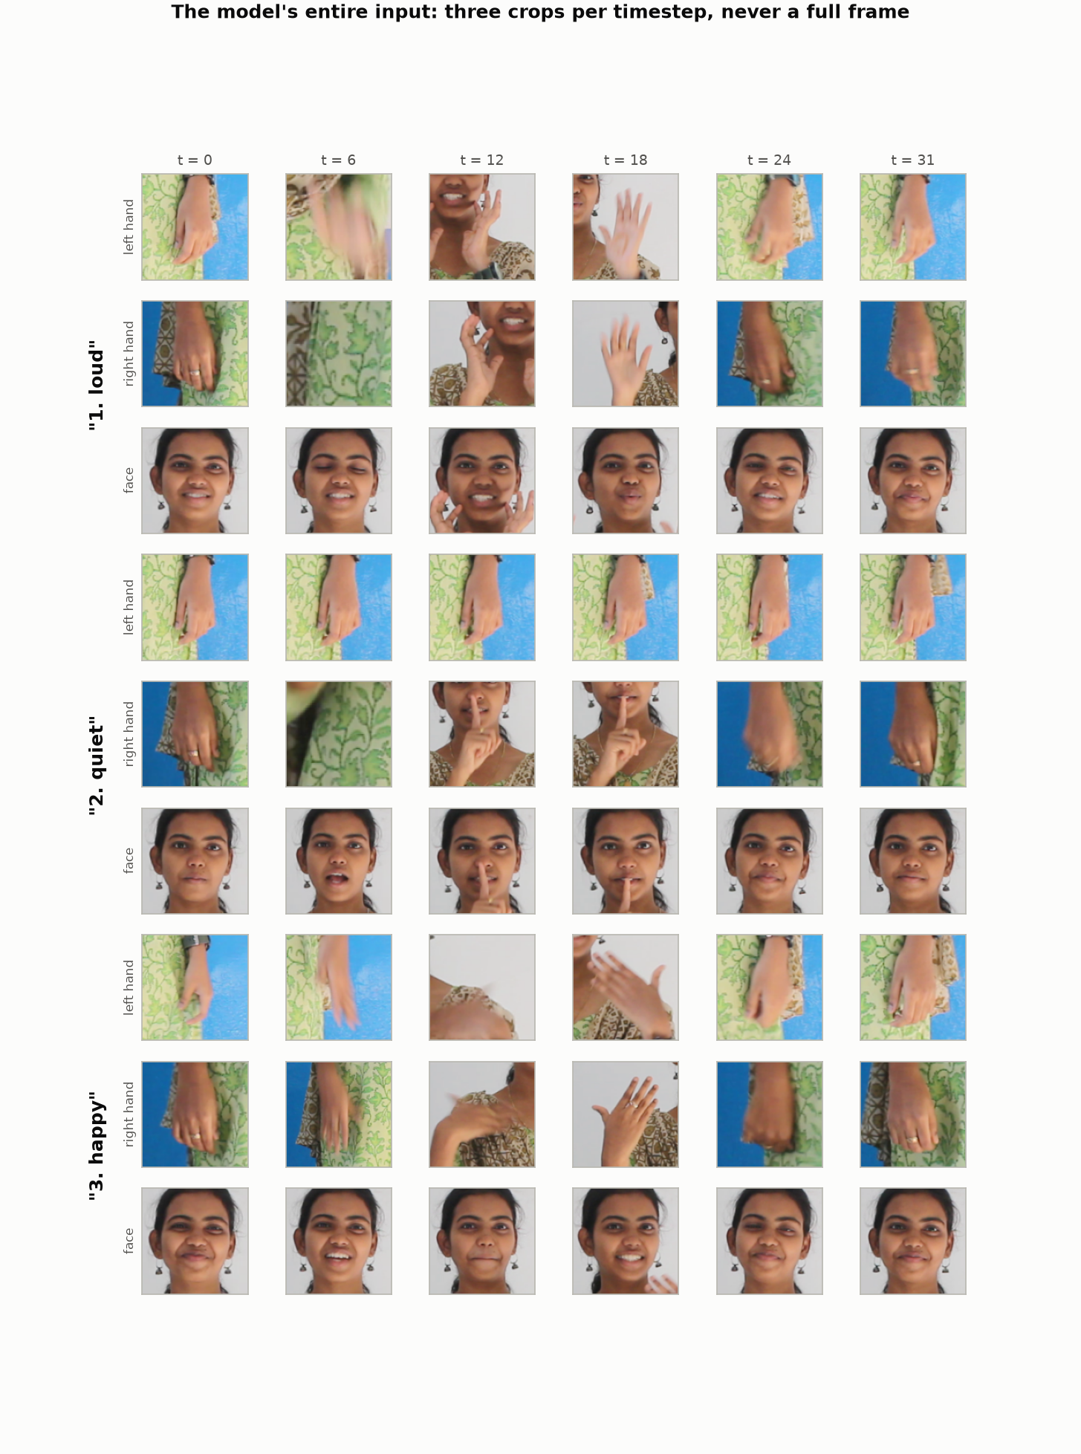
Figure 3.2 — The model’s entire input for three signs: three crops per timestep, never a full frame. Note that several left-hand crops are clothing or background — these are interpolated boxes carried forward from an earlier detection, and they are exactly the tokens the missing-embedding flag marks as unreliable. Source: docs/figures/fig16_crop_montage.png.
Use Figure 3.2 on the slide if you have room. It answers the most common question in review — “what does the network get as input?” — in one picture, and it also shows honestly that part of the input is degraded.

4. Module details
Slide 4 · 5 marks. Nineteen modules, one file each, 6,359 lines of Python. Show the table grouped by lane; talk through the four in bold.

4.1 Data modules
Module | Lines | Responsibility | Detail worth stating
`islvit/data/crops.py` | 730 | Two-stage MediaPipe extraction of hand and face crops into the memmap cache | Records a provenance code per crop. An earlier version synthesised boxes from pose geometry, reported 100 % coverage, and was producing crops of shirt fabric — coverage is not correctness.
`islvit/data/splits.py` | 460 | Builds the four evaluation protocols with leakage assertions | Session blocks must be clustered from the whole corpus; clustering from the 943-clip subset yields 177 fake “sessions” and silently breaks the guarantee.
islvit/data/dataset.py | 389 | Torch Dataset, frame sampling, augmentation, geometry handling | prepare_clip is shared by supervised training, pretraining and inference so the input distribution cannot drift.
islvit/data/build_vocab_tier.py | 171 | Vocabulary-restricted splits (30/50/100/137/262 words) | Ranks words by *total* clips, not training clips — ranking by training support gives the smallest test sets.
islvit/data/build_crosscorpus.py | 179 | Builds the CISLR cross-corpus test set and the pretraining allow-list | Asserts test clips appear in neither the training rows nor the pretraining pool.
islvit/data/merge_cislr.py | 128 | Folds labelled CISLR clips into an INCLUDE split as extra training rows | Added to train only, so every reported number stays measured on INCLUDE alone.
islvit/data/fold_val.py | 69 | Folds validation into training for a final model | Justified because val shares recording sessions with train and therefore measures the wrong quantity.
islvit/data/isign_extract.py | 181 | Extracts a diverse subset of iSign from split zip fragments | ConcatFile presents two 27 GB parts as one seekable stream; caps segments per source video to preserve signer diversity.
islvit/data/ingest_custom.py | 161 | Builds a genuinely signer-disjoint split from newly recorded clips | Not yet exercised — this is the tooling for the open experiment in §13.
islvit/data/refetch_raw.py | 152 | Restores 1080p sources from Zenodo | Fixes a data-integrity fault where 50 classes were entirely 480p and 212 entirely 1080p.

4.2 Model, training and inference modules
Module | Lines | Responsibility | Detail worth stating
`islvit/models/isl_vit.py` | 307 | The factorised spatio-temporal ViT and DeiT-Tiny weight loading | Width pinned to 192 so ImageNet DeiT-Tiny loads with zero shape mismatches; position embeddings bicubically resized 14×14 → 4×4.
`islvit/train.py` | 663 | Training loop, EMA, mixup/cutmix, checkpointing, resume | EMA decay warmup min(0.999,(1+t)/(10+t)); separate resume.pt carrying optimiser and EMA state after two power cuts killed long runs.
islvit/pretrain.py | 424 | SimMIM-style masked-crop self-supervised pretraining | Loss is gated on genuine detections; masking is global over time, stream and space so Stage B is trained too.
islvit/eval.py | 90 | Standalone checkpoint evaluation on any split | Also the recovery path when a run dies before writing its summary.
islvit/tta.py | 130 | Six-view test-time augmentation | Averages probabilities, not logits; asserts every view returns the same clip order.
islvit/gate.py | 123 | Accuracy-versus-coverage curve for a gated ensemble | Reports both accuracy-when-answered and the share of all clips answered and right.
islvit/predict.py | 123 | Single-video inference with ranked predictions | Reuses extract_clip and prepare_clip; warns when genuine hand detection is below 25 %.
islvit/export.py | 180 | INT8 quantisation and measured file size | quantize_dynamic converts Linear layers only — 95.7 % of parameters; the rest are packed separately, which is why 3.70 MB ≠ 3.76 MB of arithmetic.
islvit/distill.py | 304 | Distillation harness — ensemble teacher into a shallower student | Student keeps width 192 and drops blocks, taking evenly spaced blocks (0 and 2), not a prefix. Built and verified, not yet trained.
islvit/slt.py | 362 | Sign-language-translation scaffold (encoder + transformer decoder) | Deliberately preliminary; uses forward_features so the decoder can attend to *when* something was signed.
islvit/report.py · figures.py · figures_v2.py | 204 + 356 + 395 | Cross-run tables and every figure in the report | All figures are generated from runs/*/summary.json; no number is typed by hand.
Supporting assets: 13 YAML configs in configs/, 21 split definitions in splits/, 26 experiment shell scripts (run_*.sh), and 79 recorded runs in runs/.

5. Performance metrics — formulas, purpose and suitability
Slide 5 · 3 marks. The rubric asks for a table of metric, purpose, why it suits this application, and the best values discussed in the surveyed papers. Nine metrics are given; the two to defend out loud are balanced accuracy and accuracy-at-coverage.
Notation: N test clips, C classes, y_i the true label of clip i, p_i ∈ ℝ^C the predicted probability vector, ŷ_i = argmax_c p_i,c, n_c the number of test clips of class c, and 1[·] the indicator function.

5.1 Accuracy family
Metric | Formula | Purpose | Why it suits this application | Best values in the surveyed papers
Top-1 accuracy | Acc₁ = (1/N) Σᵢ 1[ŷᵢ = yᵢ] | Share of clips whose single best guess is right | The headline number a user experiences when the system always answers | 99.7 % SignViT (static, leaky); 96.9 % BdSLW60 video ViT; 94.19 % Kannada; ≈80 % signer-independent on TSL-ONE-S — the only comparable regime
Top-5 accuracy | Acc₅ = (1/N) Σᵢ 1[yᵢ ∈ top₅(pᵢ)] | Whether the correct word is in the shortlist | A wearable can show a 5-word shortlist for the user to confirm; also diagnoses whether failure is in the representation or the ranking | 81.04 % BdSLW401 (top-1); this project 92.8 % top-5 against 75.8 % top-1
Balanced accuracy (macro recall) | BA = (1/C) Σ_c (1/n_c) Σ_{i: yᵢ=c} 1[ŷᵢ = c] | Mean per-class recall — every word counts equally | Essential here. Session-disjoint test sets are adversarially imbalanced: on INCLUDE-50 the correlation between test count and train count is −0.73, so top-1 is dominated by the least-trained classes and sits 17 points below balanced accuracy | Rarely reported in the surveyed papers — a weakness of that literature this project does not repeat
Macro precision / recall / F1 | P_c = TP_c/(TP_c+FP_c), R_c = TP_c/(TP_c+FN_c), F1 = 2PR/(P+R), macro-averaged over c | Per-class error structure | Diagnoses the bimodal failure mode: 42–60 % of classes sit at 0 % recall while 9–27 % are perfect | 98.96 % F1 (TinyMSLR, 20 classes); 99.7 % F1 (DINOv2 BdSL)
Chance level | 1/C | The floor any claim must clear | With 154 evaluated classes chance is 0.65 %, so 22.1 % is 34× chance — necessary context for a number that sounds low | Not reported in the surveyed papers; needed whenever vocabulary size differs

5.2 Selective prediction — the metrics that decide the product
A wearable does not have to answer every clip. Declining costs the user a repetition; a confident wrong caption costs them a wrong sentence. Three quantities describe that trade, at a confidence threshold τ:
coverage(τ) = (1/N) Σᵢ 1[ max_c pᵢ,c ≥ τ ]
selective accuracy(τ) = Σᵢ 1[ max pᵢ ≥ τ ∧ ŷᵢ = yᵢ ] / Σᵢ 1[ max pᵢ ≥ τ ]
yield(τ) = (1/N) Σᵢ 1[ max pᵢ ≥ τ ∧ ŷᵢ = yᵢ ] (answered AND right)
- Selective accuracy rises automatically as coverage falls — at the limit, answering one clip gives 100 %. Quoting it without its coverage is meaningless, which is why the third row exists.
- Yield is what the user experiences. Gating converts errors into silences at a rate of roughly one lost answer per error removed.
- The operating point used in this project is τ = 0.4: 75 % coverage at 88.7 % selective accuracy on the five-member ensemble (measured, runs/gate_mixed.json).

5.3 Statistical and system metrics
Metric | Formula / definition | Purpose | Why it is needed here
Seed noise floor | σ over repeated runs; sd of a difference of two runs = √2 · σ | Says whether a difference is a result | Measured σ = 1.9 points on INCLUDE-263 over five seeds, so any single-run difference below ≈2.7 points is noise. Three claims in this project were withdrawn on this basis.
McNemar exact test | With b = clips model A gets right and B wrong, c = the reverse: p = 2 Σ_{k≥max(b,c)} C(b+c,k) 0.5^(b+c) | Paired significance on the same clips | Far more sensitive than comparing two accuracies, because only the clips where the two models disagree carry information. Used for +1.9-point effects at n = 1,010.
Detection coverage | share of frames whose crop box comes from a real detection (source code 1 or 2) | Input quality, per stream | Predicts transfer better than anything else: MediaPipe finds a left hand in 91.1 % of INCLUDE frames but only 25.4 % of CISLR frames, and adding those CISLR clips cost 5.7 points.
Sharpness (variance of Laplacian) | VoL = Var(∇²I) over the crop | Quantifies blur mismatch between corpora | CISLR crops are 2.1× blurrier than INCLUDE’s (median 27.8 vs 58.5); matching that distribution during finetuning was worth +9.5 points.
Compute | MACs per clip; parameters; packed INT8 bytes; wall-clock latency | Deployment envelope | 0.824 GMAC, 3,760,754 parameters, 3.70 MB packed INT8 (measured, not arithmetic), 12 ms per clip on desktop CPU.
Metric choice is itself a result in this project. On INCLUDE-50 session-disjoint, top-1 is 14.3 % and balanced accuracy is 31.3 % for the same predictions. Quoting either alone, without saying which and why, would misrepresent the model by 17 points.

6. Deep learning architecture
Slide 6 · 5 marks, and the rubric splits it four ways: (a) diagram, (b) explanation, (c) novelty, (d) time and space complexity. All four are below in that order.

6.1 (a) Architecture diagram
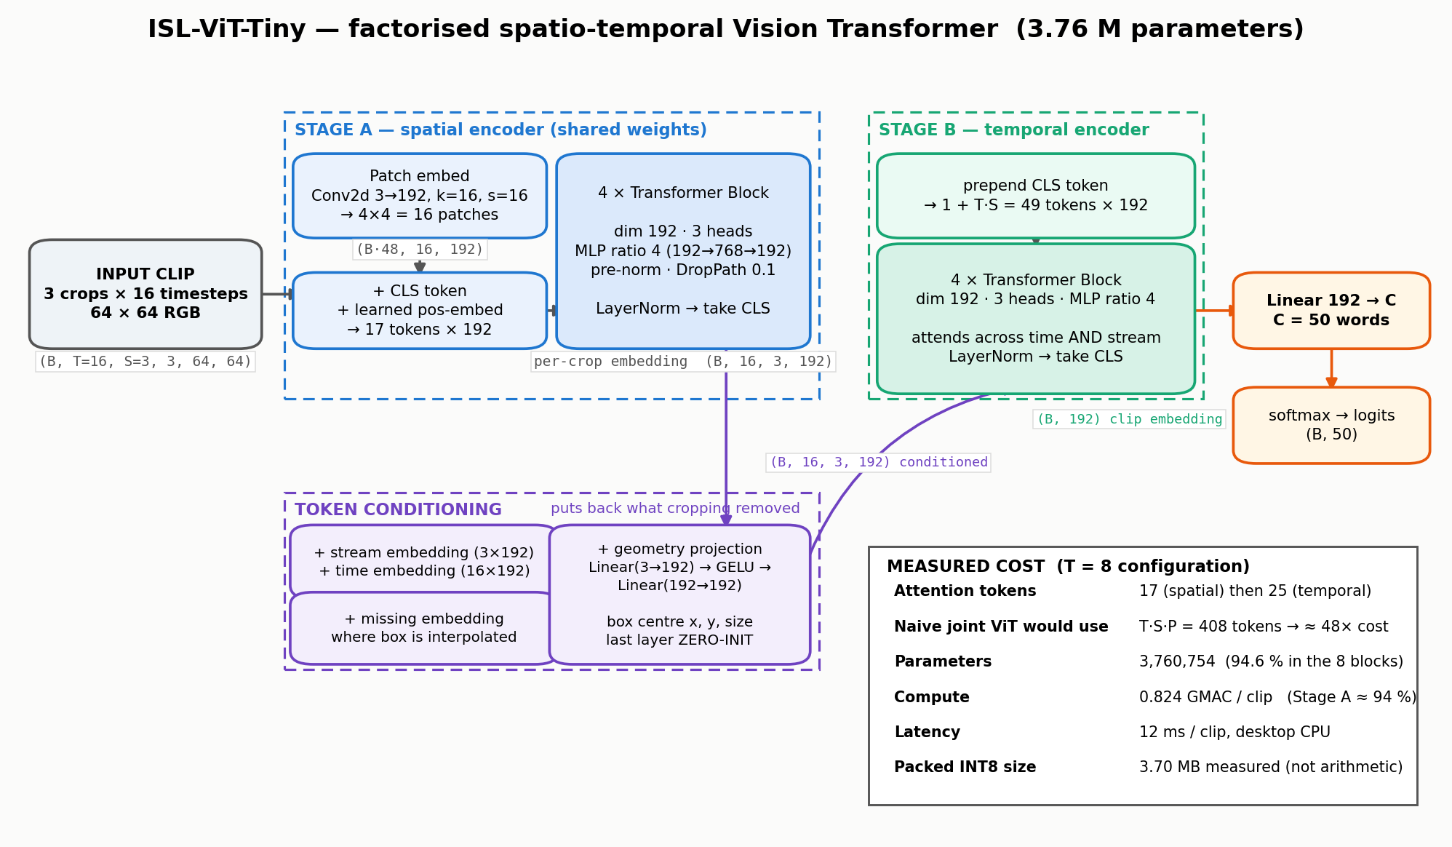
Figure 6.1 — ISL-ViT-Tiny. Stage A is a spatial ViT whose weights are shared across all 48 crops of a clip; token conditioning restores the information cropping destroyed; Stage B attends across time and stream jointly; a single linear head produces the logits.

6.2 (b) Component explanation
Component | What it does | Why it is there
Three-stream crop input  (B, T, 3, 3, 64, 64) | Left hand, right hand and face crops per timestep — the model never sees a full frame | Removes the studio wall, furniture and clothing as class cues, and recovers hand detail: the hand is ~10 % of frame width, so a full-frame 64 px model would see a ~6 px hand
Patch embedding  Conv2d 3→192, k=16, s=16 | Turns a 64×64 crop into 16 tokens of width 192 | Patch 16 at width 192 is DeiT-Tiny geometry, so ImageNet weights load with zero shape mismatch — worth +6.3 points against random initialisation
Stage A · 4 transformer blocks (shared) | Encodes one crop into one 192-d vector | Sharing weights across all 48 crops keeps the parameter count at 1.78 M for the whole spatial pathway and means every crop is embedded in the same space
Stream embedding (3×192) | Tells the temporal stage which anatomical stream a token came from | Without it, a left-hand token and a face token are indistinguishable after Stage A
Time embedding (T×192) | Positional information along the clip | Sign is defined by trajectory; order must be recoverable. Interpolated linearly when the frame count changes
Geometry projection  Linear(3→192) → GELU → Linear(192→192), last layer zero-initialised | Feeds back the box centre (x, y) and size for each crop | Cropping deletes *where* the hands are, and location is a defining phonological parameter — the same handshape at forehead and chest are different words. Zero-init means the model starts as a pure appearance model and learns to use location gradually instead of swamping the pretrained features
Missing embedding (1×192) | Added to any token whose box was interpolated or absent | An interpolated box is a stale crop of where a hand used to be. Flagging it lets the network discount it; and the genuine absence of a hand is itself informative, since many ISL signs are one-handed
Stage B · 4 transformer blocks | Attends over the 1 + T·S token sequence | Time and stream are attended jointly, so the model can relate the left hand at t=3 to the face at t=9 in one operation
Classification head  Linear 192 → C | Logits | 0.3 % of parameters. Vocabulary size is a deployment choice, not an architectural one (§9.6)
Each transformer block is pre-norm with residual connections and stochastic depth:
x ← x + DropPath( MHSA( LayerNorm(x) ) )
x ← x + DropPath( MLP ( LayerNorm(x) ) ), MLP: 192 → 768 → 192 with GELU

6.3 (c) Novelty — stated honestly, in three tiers
Tier | Element | Status
Borrowed | Factorised spatio-temporal encoding (ViViT’s factorised-encoder variant); DeiT-Tiny initialisation; SimMIM-style masked pretraining; mixup, EMA, stochastic depth, label smoothing | Standard components, used unmodified. The project does not claim these.
Adapted | Three anatomical crop streams as the *only* input, at 64 px, with weight-shared spatial encoding across all T·S crops; resolution jitter tuned to match a second corpus’s sharpness distribution; frame-count diversity as an ensembling axis | Known ideas applied to a setting that changes what they do. The resolution-jitter finding (+9.5 points) and the frame-count ensemble (+0.6 over a stronger member) are both measured here.
Proposed | (1) Geometry re-injection through a zero-initialised projection, restoring the sign-location parameter that cropping destroys.  (2) A per-token reliability flag derived from detector provenance, so degraded crops are marked rather than silently trusted.  (3) Protocol construction from camera capture ids — take-group and session-disjoint splits for a corpus that ships no signer identifiers, with automated leakage assertions.  (4) Cache-depth headroom: sampling 16 frames from a 32-frame cache beats sampling 16 from a 16-frame cache by +3.2 points at identical model, input and inference cost.  (5) Confidence gating as the delivered interface, with the abstention rate measured rather than assumed. | Items 1–2 are architectural; 3–5 are methodological. Item 3 is the largest single contribution of the project — it is what turns a 94.5 % benchmark result into a 22.1 % honest one.
The defensible claim is not “a new transformer”. It is: a factorised video ViT small enough for a wearable, evaluated under a protocol that does not permit memorisation, with every intervention tested against a measured noise floor. Three claims in this project were overturned by their own follow-up experiments and are documented rather than deleted.

6.4 (d) Time complexity
Let T be frames, S = 3 streams, P = 16 patches per crop, d = 192, h = 3 heads, L = 4 blocks per stage. A transformer block over n tokens costs 12·n·d² + 2·n²·d multiply-accumulates (QKV 3nd², attention 2n²d, projection nd², MLP 8nd²).
Stage A = T·S · [ P·(3·16²·d) + L·(12·(P+1)·d² + 2·(P+1)²·d) ]
Stage B = L·(12·(T·S+1)·d² + 2·(T·S+1)²·d)
Total = Stage A + Stage B + T·S·(3d + d²) [geometry] + d·C [head]
Substituting T = 8, S = 3, P = 16, d = 192, L = 4:
Term | Value (MACs) | Share
Patch embedding, 24 crops | 56.6 M | 6.8 %
Stage A blocks, 24 crops × 4 blocks | 732.6 M | 87.7 %
Stage B blocks, 4 blocks over 25 tokens | 45.2 M | 5.4 %
Geometry projection + head | 0.9 M | 0.1 %
Total per clip | 835.3 M ≈ 0.835 GMAC | 100 %
Weight MACs only (attention matmuls excluded) | 823.7 M = 0.824 GMAC | — matches the figure quoted in the project report
Same model at T = 16 (the deployed configuration) | 1,671 M ≈ 1.671 GMAC (1.650 weight-only) | 2.0× — frame count scales Stage A linearly
Against a non-factorised video ViT of the same depth and width (one encoder over all T·S·P + 1 = 409 tokens, 8 blocks):
Comparison | Joint | Factorised | Ratio
Attention token pairs per clip | 409² = 167,281 | 24·17² + 25² = 7,561 | 22.1× fewer
Attention MACs per clip | 513.9 M | 11.6 M | 44.3× cheaper
Total MACs per clip | 2,018 M | 835 M | 2.42× cheaper
Peak attention matrix (fp32, B = 1) | 167,281 × 3 heads × 4 B = 2.0 MB | (24 × 289 + 625) × 3 × 4 B = 91 KB | 22× smaller
Be precise about which ratio you quote. The project report’s “≈0.02× attention cost” is the attention-operation ratio (measured here as 44×, 1/44 ≈ 0.023) — it is not the total-compute ratio, which is 2.4×. Attention is not the dominant term at this scale; the MLPs inside Stage A are, because the spatial encoder runs 24–48 times per clip. That is also why frame count, not resolution, is the expensive axis.

6.5 (e) Space complexity
Quantity | Expression | Measured value
Parameters | O(L·d²) — independent of T, S and image size | 3,760,754 (50 classes) · 3,801,530 (262 classes)
Parameter breakdown | 2 × 4 blocks of 444,864 = 1.78 M each stage | Stage A blocks 47.3 %, Stage B blocks 47.3 %, patch embed 3.9 %, geometry 1.0 %, head 0.3 %, embeddings + norms < 0.2 %
Model file, FP32 | 4 bytes per parameter | ≈ 15.0 MB
Model file, packed INT8 | INT8 for Linear layers (95.7 % of parameters), per-channel INT8 for the patch-embed conv, FP16 for norms, biases and positional tables | 3.70 MB, measured — not 3.76 MB of arithmetic. quantize_dynamic converts Linear only, and the 147,648-parameter conv does not shrink with depth
Activations, inference | O(B · T · S · (P+1) · d) | B = 1, T = 16: 48 × 17 × 192 × 4 B = 0.63 MB per resident tensor; Stage B adds 37 KB. Peak well under 2 MB
Attention memory | O(B · h · [T·S·(P+1)² + (T·S)²]) | 91 KB at B = 1, T = 8 (fp32)
Activations, training | Same expression at B = 64 → 3,072 crop passes per step | Fits comfortably in 12 GB with bfloat16 autocast; a 2,000-epoch 50-word run takes ≈ 2.5 h on an RTX 3060
Crop cache on disk | N × T_cache × S × 128² × 3 bytes | 18.7 GB for 4,257 clips at 32 frames (10.0 GB at 16 frames)
Peak RAM on device | Model + activations + MediaPipe | Not yet measured on ARM. Note that MediaPipe extraction costs 30–60 ms per frame on CPU — 3–5× the transformer — so the detector, not the ViT, is the binding runtime constraint

7. Algorithm procedure, step by step
Slide 7 · 5 marks, and the rubric explicitly says “mathematically”. Steps 1–9 are the forward pass, 10–12 the training objective and optimisation, 13–14 inference. Algorithm 2 is the split construction, which is the part of this project a marker is most likely to probe.

7.1 Forward pass
Step 1 — Frame sampling with temporal jitter. From a cache of T_c = 32 frames, choose T = 16 indices by splitting the clip into T equal segments and taking one frame from each; at training time the offset inside each segment is random, at evaluation it is fixed:
eₖ = k·T_c/T, k = 0…T
training: fₖ = ⌊ eₖ + uₖ·(eₖ₊₁ − eₖ) ⌋, uₖ ~ U(0,1)
evaluation: fₖ = ⌊ eₖ + φ·(eₖ₊₁ − eₖ) ⌋, φ ∈ {0.25, 0.50, 0.75}
The ratio T_c / T is the jitter headroom. It is not a free parameter: at T_c/T = 1 the sampler has no choice, train-time jitter and test-time phase averaging both degenerate, and the measured test-time-augmentation gain falls from +3.8 to +0.2 points (§9.4).
Step 2 — Crop preparation and augmentation. For each stream s a single scale-jitter window is drawn per clip (not per frame) and applied across time, then resized to 64 px; horizontal flip swaps the two hand streams and mirrors the geometry; appearance augmentations follow; finally ImageNet normalisation:
x ← (x/255 − μ) / σ , μ = (0.485, 0.456, 0.406), σ = (0.229, 0.224, 0.225)
flip: (x_L, x_R, x_F) → (x_R, x_L, x_F) and gₓ → 1 − gₓ
Step 3 — Patch embedding (Stage A). Each crop x_{t,s} ∈ ℝ^{3×64×64} is split into P = 16 patches of 16×16 and linearly projected, a class token is prepended and a learned positional embedding added:
z⁰_{t,s} = [ x_cls ; E·p₁ ; … ; E·p₁₆ ] + E_pos , E ∈ ℝ^{192×768}, z⁰ ∈ ℝ^{17×192}
Step 4 — Spatial transformer blocks. For ℓ = 1…4, with h = 3 heads and head dimension d_h = 64:
Q, K, V = z^{ℓ−1}W_Q , z^{ℓ−1}W_K , z^{ℓ−1}W_V
Attn(Q,K,V) = softmax( QKᵀ / √d_h ) V , MHSA = concat(head₁…head_h) W_O
z̃ = z^{ℓ−1} + DropPath( MHSA( LN(z^{ℓ−1}) ) )
z^ℓ = z̃ + DropPath( MLP( LN(z̃) ) )
Step 5 — Crop embedding. The class token after a final LayerNorm is the crop’s representation, and the same weights produce it for all T·S crops:
c_{t,s} = LN( z⁴_{t,s} )₀ ∈ ℝ^{192}
Step 6 — Token conditioning. Stream identity, time index, box geometry and detector reliability are added to each crop embedding:
u_{t,s} = c_{t,s} + σ_s + τ_t + G(b_{t,s}) + 1[¬detected_{t,s}] · m
G(b) = W₂ · GELU( W₁ b + β₁ ) + β₂ , b = (centre_x − 0.5, centre_y − 0.5, size)
with W₂ = 0, β₂ = 0 at initialisation
Step 7 — Temporal transformer (Stage B). A second class token is prepended to the T·S conditioned tokens and four more blocks are applied:
y⁰ = [ y_cls ; u_{1,1} ; u_{1,2} ; … ; u_{T,S} ] ∈ ℝ^{(1+T·S)×192}
y^ℓ = Block_ℓ( y^{ℓ−1} ), ℓ = 1…4
v = LN( y⁴ )₀ ∈ ℝ^{192} (the clip embedding)
Step 8 — Classification. A single linear layer and a softmax:
logits = W_h v + b_h ∈ ℝ^C , p = softmax(logits)

7.2 Training objective and optimisation
Step 9 — Loss. Cross-entropy with label smoothing ε = 0.1; on the half of batches that receive mixup, the target is the convex combination of two one-hot vectors and the loss is computed against soft targets:
q_c = (1 − ε)·1[c = y] + ε/C
L = − Σ_c q_c · log p_c
mixup: x̃ = λx_i + (1−λ)x_j , g̃ = λg_i + (1−λ)g_j , q̃ = λq_i + (1−λ)q_j , λ ~ Beta(0.2, 0.2)
Geometry is mixed with the pixels it describes — mixing the image while leaving the box coordinates untouched would teach the model a contradiction.
Step 10 — Optimiser and schedule. AdamW with decoupled weight decay applied to weight matrices only (never to norms, biases or embedding tables), and a two-group learning rate so the pretrained encoder is refined rather than erased:
lr_spatial = 0.1 · lr , lr_rest = lr , lr = 5×10⁻⁴
warmup (step < W): η(step) = lr · (step+1)/W
cosine (step ≥ W): η(step) = lr · [ 0.01 + 0.99 · ½(1 + cos(π · (step−W)/(S−W))) ]
Step 11 — Weight EMA with a decay warmup. A 50-word epoch is only a handful of optimiser steps, so a fixed decay of 0.999 never escapes the random initialisation — this silently produced chance-accuracy averaged weights for entire runs before it was found:
θ̄ ← δ_t θ̄ + (1 − δ_t) θ , δ_t = min( 0.99 , (1+t)/(10+t) )
Step 12 — Checkpoint selection. With validation folded into training there is no honest selection signal left, so the final EMA weights are taken under a cosine schedule that ends at ~0 learning rate (--select last). This is not early stopping; it is a deliberate choice justified by the schedule.

7.3 Inference
Step 13 — Test-time augmentation. Six deterministic views — three temporal phases × horizontal flip with the hand streams swapped — are averaged in probability space, not logit space, so a confidently correct view outvotes an undecided one:
p̄ = (1/6) Σ_{φ∈{0.25,0.5,0.75}} Σ_{f∈{0,1}} softmax( model( x^{(φ,f)} ) )
Step 14 — Ensembling and the confidence gate. Probabilities are averaged over members, then thresholded:
p* = (1/M) Σ_{m=1..M} p̄^{(m)}
output = argmax_c p*_c if max_c p*_c ≥ τ ; “not sure” otherwise, τ = 0.4

7.4 Algorithm 2 — protocol construction (the part that produces the honest number)
Input : all clips with camera capture ids MVI_i, labels y_i
Output: train / val / test assignment with no session shared with test
1 for each class c: # take-groups
2 sort clips of c by MVI id
3 start a new group whenever MVI_k − MVI_{k−1} > 5
4
5 cluster ALL 4,257 MVI ids globally with the same gap rule # 13 session blocks
6 (clustering a subset instead yields 177 fake sessions — see Appendix D)
7
8 best = -inf
9 repeat 20,000 times: # randomised block search
10 B_test = { block : rand() < 0.25 }
11 supported = #classes with >= 6 training clips and >= 1 test clip
12 orphaned = #classes with test clips but 0 training clips
13 starved = #test clips of classes with 1..5 training clips
14 size_err = | |test| / N - 0.20 |
15 score = ( supported - 2*orphaned , -starved/N , -size_err ) # lexicographic
16 keep B_test if score > best
17
18 val <- whole take-groups drawn from the TRAINING sessions only
19 mark test clips of classes with < 6 training clips as 'unused'
20 assert: no session block appears in both test and train/val
21 assert: no clip and no take-group straddles a split boundary
The lexicographic score matters. Scoring bare class presence instead of *supported* classes let the search pick layouts where the most-tested classes were the least-trained ones — 13 test clips against 4 training clips — which makes top-1 pessimistic and unstable while balanced accuracy stays high.

8. Hyperparameter details, with justification
Slide 8 · 5 marks — the rubric says “with justification”, so the third column is what earns the marks. Every justification below is a measurement from this project or a stated structural reason, never a default copied from a paper.
This is the deployed configuration: 50-word vocabulary, 16 frames sampled from the 32-frame cache, session-disjoint protocol. Values are from configs/full263_v2.yaml plus the command-line overrides in run_push75.sh and run_frames32.sh.

8.1 Input geometry
Hyperparameter | Value | Justification (with the evidence)
Frames sampled per clip, T | 16 | The largest single measured lever in the project: 8 → 16 frames is +6.4 points, replicated across two seeds (66.7 / 65.5 %). 32 frames scores marginally higher plain (72.5 %) but ties after TTA at twice the inference cost, so 16 is the deployable point.
Frames stored in cache, T_c | 32 | Headroom, not input. 16 frames drawn from a 32-frame cache beats 16 drawn from a 16-frame cache by +3.2 points plain / +5.5 with TTA on 12 % *less* training data — identical model, identical inference cost. The sampler simply has somewhere to jitter.
Crop resolution | 64 × 64 | Tripling the token count changes top-1 by 0.0 points (64 px 46.5 %, 112 px 46.5 %) and 128 px is 2.5 points worse. The cheapest setting is also the most accurate — more tokens is more capacity to overfit ~600 clips.
Cache crop size | 128 × 128 | At an unchanged 64 px model input, moving the *source* cache from 80 px to 128 px was worth +4.4 points — larger than any architectural change tested. Area-downsampling 128 → 64 is cleaner than 80 → 64 and gives scale jitter more range.
Streams, S | 3 (left hand, right hand, face) | Removes background and clothing as class cues; face is retained because non-manual markers carry meaning in ISL and the face detector is 99.9 % reliable.
Patch size | 16 (→ 4×4 = 16 patches) | Fixed by the requirement that DeiT-Tiny weights load without projection.

8.2 Model
Hyperparameter | Value | Justification
Embedding width d | 192 | Pinned. It is DeiT-Tiny’s width, so ImageNet weights (+6.3 points) and the iSign self-supervised checkpoint (+9.5 points) both load directly. A narrower model saves ~1 MB and forfeits both — a bad trade at this data scale.
Spatial depth / temporal depth | 4 / 4 | Balanced 47.3 % / 47.3 % of parameters. Shallower students (2+2 = 1.95 MB packed) are measured for size but not yet trained.
Attention heads | 3 | d_h = 64 per head, the standard ViT-Tiny ratio.
MLP ratio | 4 (192 → 768 → 192) | Standard; the MLPs are 66 % of block MACs and are the reason frame count is the expensive axis.
Stochastic depth (DropPath) | 0.1, linearly scaled by block | Cheap regularisation and it matters a lot in a ~600-clip regime.
Dropout | 0.0 | Stochastic depth, mixup, EMA and label smoothing are already active; adding dropout was not needed to close the train/test gap, which is a data gap rather than a capacity gap.

8.3 Optimisation
Hyperparameter | Value | Justification
Optimiser | AdamW, β = (0.9, 0.999) | Standard for ViTs; decoupled weight decay is what makes the “weights only” rule below meaningful.
Epochs | 2,000 | 250 → 2,000 epochs is +7.9 points at 8 frames, with 750 epochs landing in between — a steady climb, not a cliff. At 16 frames a further doubling to 4,000 buys +0.6 (null against a 2.7-point floor), so training length has saturated once the frame bottleneck is removed.
Batch size | 64 | Fits 12 GB with bfloat16 autocast at 48 crops per clip.
Base learning rate | 5 × 10⁻⁴ | Standard AdamW ViT scale at this batch size; not separately swept, and honestly flagged as such.
Backbone LR scale | 0.1 | Refine the pretrained encoder, do not erase it. Swept: 0.0 (frozen) 31.8 %, 0.01 38.7 %, 0.1 41.8 % on INCLUDE-263 — monotone, so freezing is strictly worse.
Weight decay | 0.05, applied to weight matrices only | Never applied to LayerNorms, biases or the positional/stream/time tables. A 10× arm (0.5) was tested during the grokking probe and produced no gain (58.7 % vs 61.9 %).
Warmup | 10 epochs | The first ~15 epochs show almost no validation progress; without warmup the run is unstable.
LR schedule | Cosine to 1 % | Ending near zero is what makes taking the final checkpoint defensible instead of arbitrary.
Gradient clipping | 1.0 | Standard stabiliser at small batch counts.
EMA decay | 0.99 with warmup min(0.99,(1+t)/(10+t)) | A fixed 0.999 has a ~1,000-step time constant; a 50-word epoch is ~9 optimiser steps, so the average never escaped its initialisation and sat at chance for whole runs. This is the single most instructive bug in the project.
Precision | bfloat16 autocast | ≈2× throughput on an RTX 3060 with no measured accuracy cost.
Checkpoint selection | final EMA weights (--select last) | Validation shares recording sessions with training, so it measures in-session accuracy while the report measures cross-session accuracy. Correcting selection is worth +3.2 points; folding those 888 clips into training is worth +7.7.
Seeds | 0 and 1 (five for the noise-floor study) | The measured seed σ is 1.9 points, so a difference of two single runs carries sd ≈ 2.7. Every claim in §9 is judged against that.

8.4 Augmentation and regularisation
Hyperparameter | Value | Justification
Temporal jitter | random offset per segment | Timing invariance; only meaningful when T_c > T (see 8.1).
Scale-jitter crop | 80–100 % of the cache crop, one window per stream per clip | Models a box that sits slightly off, not a hand that teleports each frame.
Horizontal flip | p = 0.5, with hand streams swapped and geometry mirrored | A mirrored right-dominant signer is a left-dominant signer — physically coherent only if the streams swap too.
Brightness / contrast / per-channel gain | ± 0.4 | The strict protocols hold out whole recording sessions, so lighting and skin tone are exactly what the model must not key on.
Random grayscale | p = 0.15 | Forces shape over colour.
Stream dropout | p = 0.15 per stream | Prevents dependence on any one stream; never drops all three.
Mixup | α = 0.2, on 50 % of batches | Kept. DeiT’s always-on α = 0.8 was tested as part of a strong-augmentation bundle and rejected.
Cutmix / random erasing / speed jitter | off | Tested as a bundle: top-1 null at both frame counts (+0.6 at 8f, +1.8 at 16f, both inside noise) and measurably worse calibration — 80.7 % → 79.5 % selective accuracy at 75 % coverage. For a product whose value comes from gating, that cost is real.
Label smoothing | 0.1 | Calibration. Note the floor it implies: for 262 classes the smoothed loss floor is 0.879, which is how memorisation was detected in the training curves.
Resolution jitter | p = 0.5, factor U(0.35, 0.9), one factor per clip | Matches INCLUDE’s sharpness distribution to the pretraining corpus’s. Worth +9.5 points (30.4 % → 39.9 %, sd 0.1 over two seeds). Applying it during pretraining as well was tested over four seeds and rejected (37.2 %, sd 4.2).

8.5 Pretraining and inference
Hyperparameter | Value | Justification
Pretraining corpus | iSign, 18,000 clips from ~11,000 source videos | Diversity, not volume: segments per source video are capped so no signer dominates the cache.
Pretraining objective | SimMIM-style masked crop modelling, mask ratio 0.75 | Mask tokens are substituted *inside* the encoder rather than dropped, because with 16 patches per crop dropping leaves 4 visible patches and a ragged batch.
Pretraining frames | 8 of 16 cached | Counter-intuitive and measured: pretraining natively at 16 frames (no jitter headroom) reached a lower reconstruction loss (0.322 vs 0.351) and transferred 10.2 points worse. The run that reconstructed better generalised worse.
Loss gating | only genuinely detected crops contribute | Reconstructing an interpolated box teaches the model to predict background.
TTA views | 6 — 3 temporal phases × horizontal flip | +1.6 to +3.7 points (mean +2.5) across eight checkpoints, never once failing. Probabilities averaged, not logits.
Ensemble | 5 members varying frame count (2 × 16f, 24f, 32f, 4,000-epoch) | Frame count is a better diversity axis than seed: adding the *weakest* member (24 f, 70.3 %) still improved the ensemble.
Confidence threshold τ | 0.4 | 75 % coverage at 88.7 % selective accuracy. Chosen on the test set, so it is a characteristic curve rather than a validated operating point — a held-out calibration split is needed before quoting one row as a product number.

9. Results and discussion
Slide 9 · 3 marks for tables, graphs and inference. There is far more here than one slide holds — §9.1 is the slide, §9.2–9.9 are the answers to questions. Every figure below exists as a PNG in docs/figures/ and every number comes from runs/*/summary.json.

9.1 Headline — INCLUDE-50, session-disjoint, 472 held-out clips
Configuration | Top-1 | Top-5 | Notes
Baseline: 250 epochs, 8 frames from a 16-frame cache | 51.7 ± 3.3 % | — | 2 seeds. The starting point.
+ 2,000 epochs | 59.7 % | 81.8 % | +8.0. Training length, not architecture.
+ 16 frames drawn from a 32-frame cache | 69.9 / 70.3 % | — | +10.4. Two seeds, spread 0.4.
+ 6-view TTA (best single model) | 73.3 % | 90.5 % | Free at inference beyond extra forward passes.
+ 5-member ensemble (frame-count diversity) | 75.8 % | 92.8 % | The best result in the project.
Same test set, random split (control) | 97.9 % | — | The 22.1-point gap that remains is leakage, not skill.
Chance | 2.0 % | — | 50 classes.
The cumulative trajectory on one unchanged 472-clip test set is 51.7 % → 59.7 % → 70.1 % → 75.8 %. Roughly +24 points, none of it architectural — the model is the same 3.76 M-parameter ViT throughout. Only how long it trains, how many frames it sees, how deep the cache is, and how the predictions are averaged have changed.
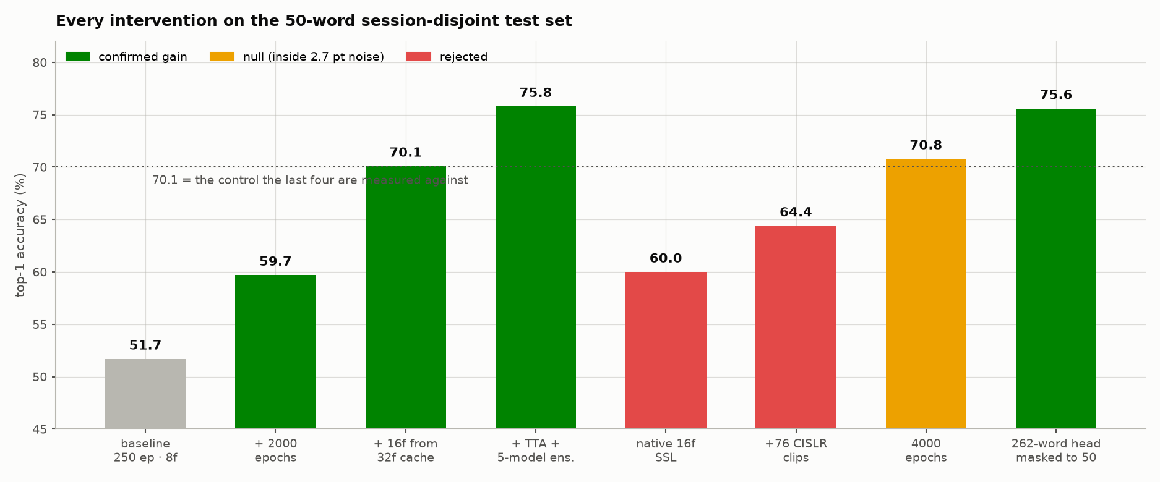
Figure 9.1 — Every intervention tested on the 50-word session-disjoint test set, colour-coded by whether it survived the 2.7-point noise floor. Three of the eight failed, and they are shown rather than dropped. Source: docs/figures/fig13_intervention_waterfall.png.

9.2 The measurement result — accuracy by protocol
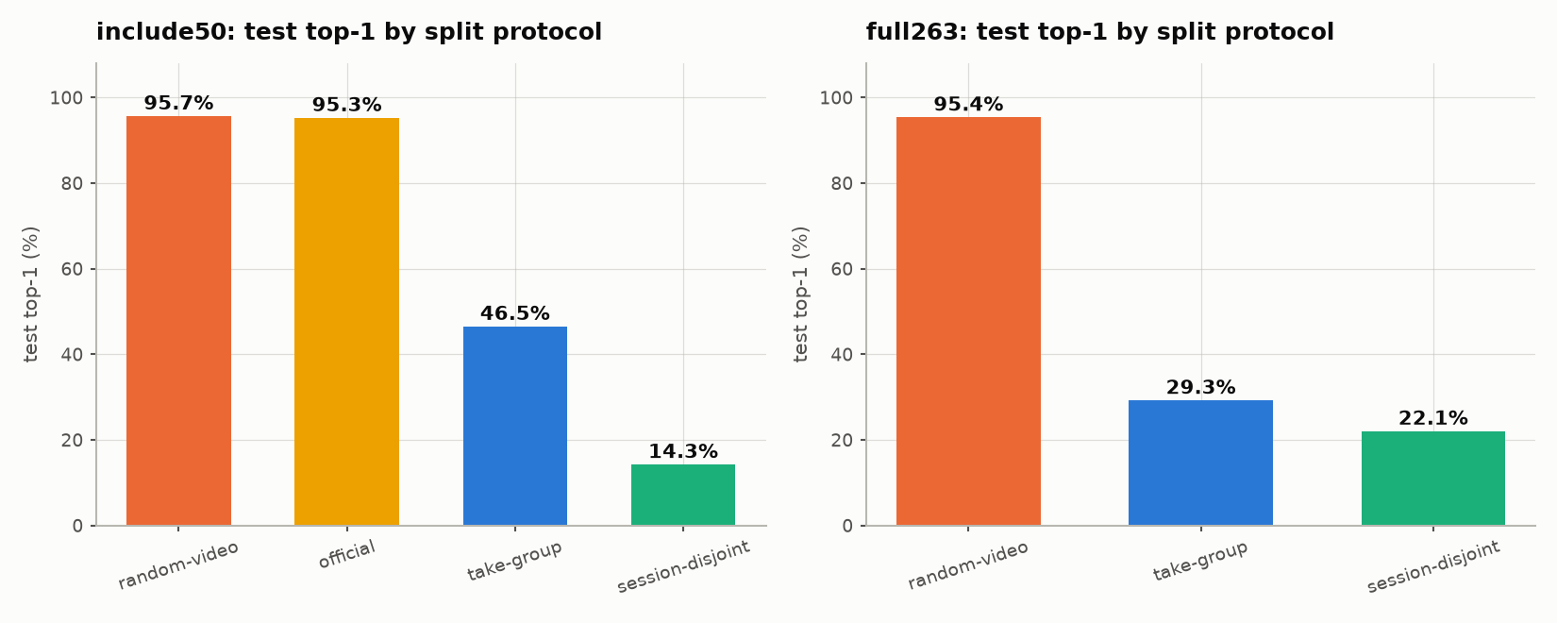
Figure 9.2 — Test top-1 by split protocol, same model and recipe throughout; only the split file changes. Source: docs/figures/fig02_leakage_ladder.png.
Protocol | What it removes | INCLUDE-50 | INCLUDE-263 | n
random-video | nothing | 95.7 % top-1 | 94.5 % | 186 / 872
official (shipped) | nothing | 95.3 % | — | 191
take-group | near-duplicate takes | 46.5 % | 29.3 % | 159 / 878
session-disjoint | signer, room, lighting | 14.3 % top-1 / 31.3 % balanced | 22.1 % / 25.2 % | 252 / 1,010
Leakage decomposition, in balanced accuracy (comparable across all four protocols):
Channel | Removed by | INCLUDE-50 cost | INCLUDE-263 cost
Near-duplicate takes | take-group | −45.9 points | −62.7 points
Shared session conditions | session-disjoint | −18.6 points | −6.8 points
Total |  | −64.5 points | −69.5 points
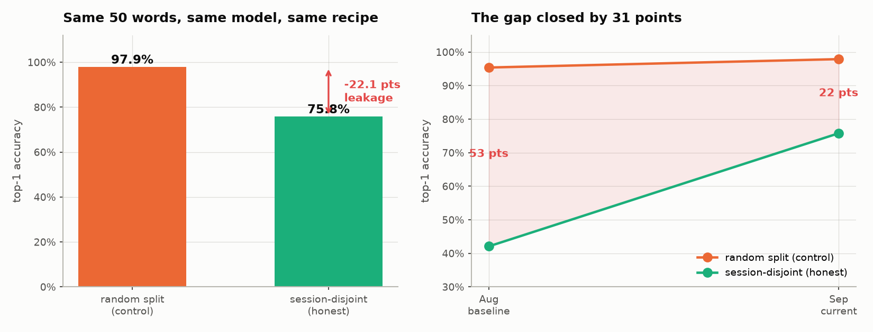
Figure 9.3 — The same comparison after the honest number was raised: 97.9 % random against 75.8 % session-disjoint. The gap narrowed from 53 to 22 points, which is what progress looks like when the control is kept. Source: docs/figures/fig10_leakage_now.png.
The comparison that matters is not 22.1 % against a published 94 %. It is 94.5 % against a published 94 % — reproducing the literature under the literature’s protocol — and then observing what remains when the protocol is tightened. The model is not weaker than published systems; the measurement is stricter.

9.3 Frame count and cache headroom
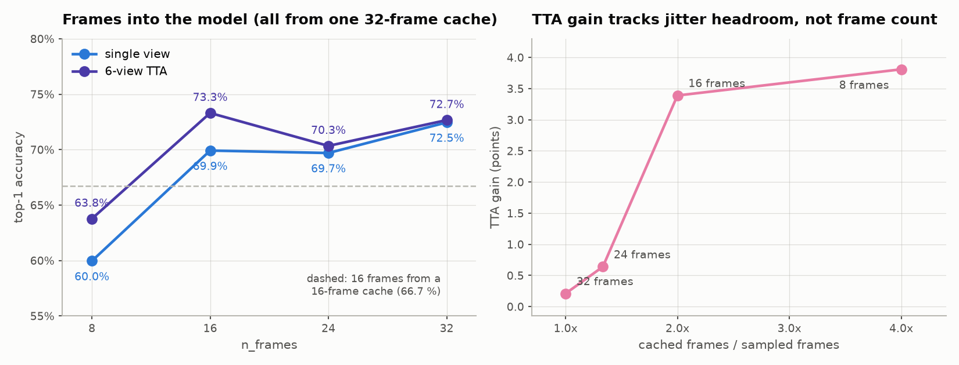
Figure 9.4 — Left: accuracy against frames fed to the model, all drawn from one 32-frame cache. Right: the TTA gain tracks the ratio of cached to sampled frames almost perfectly. Source: docs/figures/fig11_frame_sweep.png.
Frames | Cached | Headroom | Top-1 | Top-1 + TTA | TTA gain
8 | 32 | 4.00× | 60.0 % | 63.8 % | +3.8
16 | 32 | 2.00× | 69.9 / 70.3 % | 73.3 / 72.0 % | +3.4 / +1.7
24 | 32 | 1.33× | 69.7 % | 70.3 % | +0.6
32 | 32 | 1.00× | 72.5 % | 72.7 % | +0.2
16 | 16 | 1.00× | 66.7 % | 67.8 % | +1.1
- Two separate effects. Plain accuracy tracks frame count; the TTA gain tracks headroom. The decisive cell was 8 frames from a 32-frame cache — the most headroom on the fewest frames — which scored worst by nine points, falsifying the headroom-explains-accuracy hypothesis while confirming headroom-explains-TTA.
- 16 frames is the deployable choice: statistically tied with 32 after TTA at half the inference cost, with the cache depth paid for in disk rather than in compute on the device.

9.4 What worked, what failed, and against what noise floor
Intervention | Effect on top-1 | Seeds | Verdict
Frames 8 → 16 (from a 32-frame cache) | +6.4 | 2 | Confirmed — largest single lever; top-5 moves +5.3 in the same direction
Resolution-matched CISLR / iSign pretraining | +9.5 | 2 (sd 0.1) | Confirmed — the tightest replication in the project
Folding validation into training (+45 % data) | +7.7 | 1 (McNemar 2.9σ) | Confirmed
250 → 2,000 epochs | +7.9 | 2 | Confirmed at 8 frames; saturated at 16 frames (+0.6, null)
16 frames from a 32-cache vs a 16-cache | +3.2 | 2 | Confirmed — identical model and inference cost
6-view test-time augmentation | +2.5 (range +1.6 to +3.7) | 8 checkpoints | Confirmed — compares a checkpoint against itself, so seed variance cancels
Frame-count ensembling (5 members) | +2.5 over best single | — | Confirmed — the weakest member still helped
Checkpoint-selection fix alone | +3.2 | 1 | Superseded by folding val into train
CISLR self-supervised init (before the resolution fix) | +1.9 | 1 (p = 0.36) | Withdrawn — 0.7σ; was crediting a weak reference
Labelled CISLR merge | ≈0 | 2 (p = 0.45) | Rejected
Strong augmentation bundle (cutmix, erasing, tempo, DeiT mixup) | +0.6 / +1.8 | 2 + 2 | Rejected — top-1 null and calibration measurably worse
Grokking (long training + 10× weight decay) | −3.2 | 2 | Rejected — no plateau-then-jump, and no gain
Resolution jitter during pretraining as well | −2.7 (sd 4.2) | 4 | Rejected — less predictable, no gain
Native 16-frame SSL pretraining | −10.2 | 1 | Rejected — lower reconstruction loss, worse transfer
+76 labelled CISLR clips (13 % more data) | −5.7 | 1 | Rejected — MediaPipe finds a left hand in only 25.4 % of CISLR frames
4,000 epochs instead of 2,000 | +0.6 | 1 | Null against the 2.7-point floor
Measured noise floor: five seeds of one configuration give top-1 35.0 ± 1.9 % (range 33.2–38.0), so a difference between two single runs carries sd ≈ 2.7 points. Three claims in this project were made against a weak reference or too few seeds and later overturned by controlled follow-ups — including one reversal of a previous correction. They are documented rather than quietly edited out; if a marker asks what you would do differently, this is the answer: multi-seed everything.

9.5 The binding limitation — cross-corpus transfer
Every figure above is measured inside INCLUDE. Evaluated on CISLR — different signers, rooms, cameras — the same checkpoints collapse:
Model | INCLUDE session-disjoint | CISLR cross-corpus
ImageNet init, seed 0 / 1 | 31.0 % / 29.9 % | 1.5 % / 1.3 %
iSign pretrained, seed 0 / 1 | 41.8 % / 42.4 % | 1.3 % / 0.3 %
Folded-val model | 33.0 % | 1.8 %
Chance | — | 0.38 %
- It is not a label mismatch. Retrieval in the model’s own feature space finds same-word INCLUDE clips 10× better than chance, so the two corpora largely sign the same gestures.
- It is not the classifier head. 1-NN on the features scores 1.6 % against the head’s 1.5 % — the failure is in the representation.
- It is not catastrophic forgetting during finetuning. A backbone_lr_scale sweep (0.0 / 0.01 / 0.1) moves in-corpus accuracy monotonically (31.8 → 38.7 → 41.8 %) while cross-corpus stays flat at ~1 %. Corpus-general features were never there to erase.
- Two mechanisms are measured. CISLR crops are 2.1× blurrier than INCLUDE’s (variance of Laplacian 27.8 vs 58.5), and MediaPipe finds a left hand in only 25.4 % of CISLR frames against 91.1 % in INCLUDE — so three quarters of CISLR left-hand crops are stale interpolated boxes.
- The one thing that helped was labelled cross-corpus data: 304 CISLR clips more than doubled cross-corpus top-5 (4.3 % → 9.5 %) with top-1 unchanged. That reads as data-starved rather than broken.
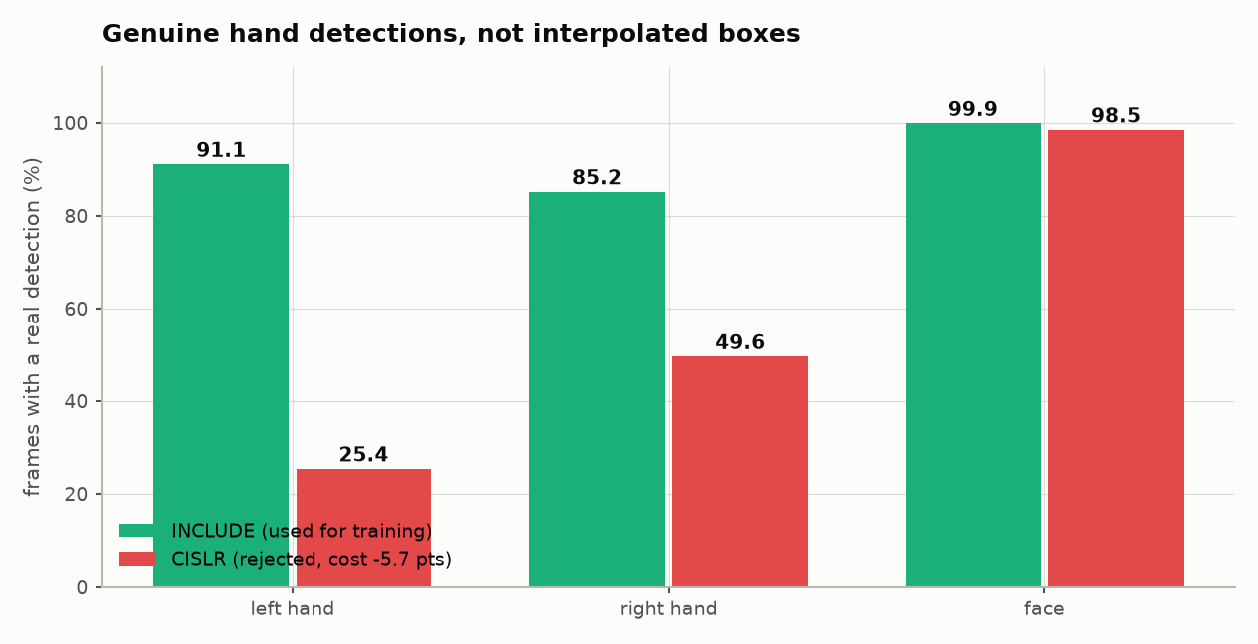
Figure 9.5 — Genuine hand detections, INCLUDE against CISLR. The right-hand panel of this figure is the whole explanation for why adding CISLR clips cost 5.7 points. Source: docs/figures/fig15_detection_quality.png.
Every accuracy in this document should be read as “on INCLUDE-like video”. No measurement in the project supports a claim of general ISL recognition. Say this on the slide before a marker says it for you — it is the difference between an honest project and an overclaimed one.
One genuinely reassuring finding: out-of-domain confidence collapses too. Not one of 609 CISLR clips exceeds 0.4 confidence, against 26.5 % of in-domain clips, so the failure mode off-domain is silent abstention rather than confident error — and the softmax score is itself a usable out-of-distribution signal.

9.6 Vocabulary size — an inverted U, not a monotone trade
Words | Test clips | Top-1 (mean ± sd) | Top-1 + TTA
262 | 1,010 | 42.1 ± 0.4 % | 44.0 %
137 | 976 | 45.8 ± 0.6 % | 51.0 %
100 | 865 | 49.6 ± 0.8 % | 53.2 %
50 | 472 | 51.7 ± 3.3 % | 56.2 %
30 | 278 | 41.2 ± 4.3 % | 45.9 %
The 30-word model is worse than the 262-word model despite having eight times fewer classes to separate. Per-word support is constant across tiers by construction, so what shrinks with the vocabulary is total training data: at 30 words the model sees roughly 400 clips. The classification problem got easier and the estimation problem got harder, and past 50 words the second effect wins. The rising standard deviation (0.4 → 4.3) says the same thing — below ~50 words the measurement degrades along with the model.
Product consequence: 50 words is a genuine optimum, not a compromise. There is nothing to be bought by scoping smaller. All figures in this table are at 250 epochs and are therefore underestimates of the level, though the shape should survive.

9.7 Confidence gating — the number that matters for a wearable
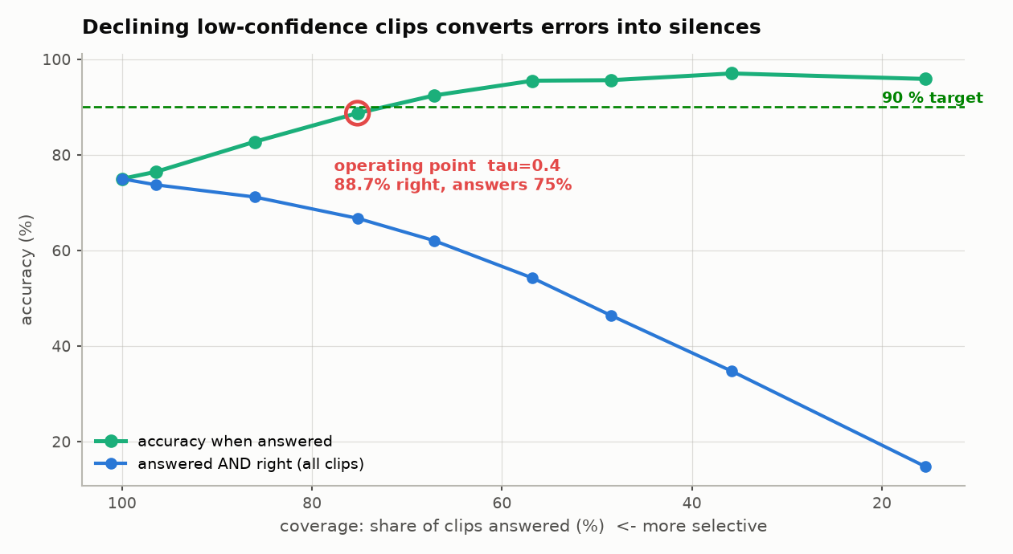
Figure 9.6 — Accuracy against coverage for the five-member ensemble. Green is accuracy when the system answers; blue is the share of all clips answered and right. Source: docs/figures/fig12_gating_curve.png.
Threshold τ | Coverage | Accuracy when answered | Answered and right
none | 100.0 % | 75.0 % | 75.0 %
0.3 | 86.0 % | 82.8 % | 71.2 %
0.4 | 75.2 % | 88.7 % | 66.7 %
0.5 | 67.2 % | 92.4 % | 62.1 %
0.6 | 56.8 % | 95.5 % | 54.2 %
0.7 | 48.5 % | 95.6 % | 46.4 %
Read directly from runs/gate_mixed.json (three-member ensemble, six-view TTA). Three caveats travel with this table: the threshold is chosen on the test set, so it is a characteristic curve rather than a validated operating point; accuracy-when-answered rises automatically as coverage falls, which is why the fourth column exists; and the whole table is in-domain.
A 75 % target is reachable as accuracy-at-coverage, not as unconditional top-1. At τ = 0.4 the system answers three clips in four and is right on 88.7 % of them. Gating converts errors into silences at roughly one lost answer per error removed — for an assistive caption, that is the right trade.

9.8 Convergence, ablations and error structure
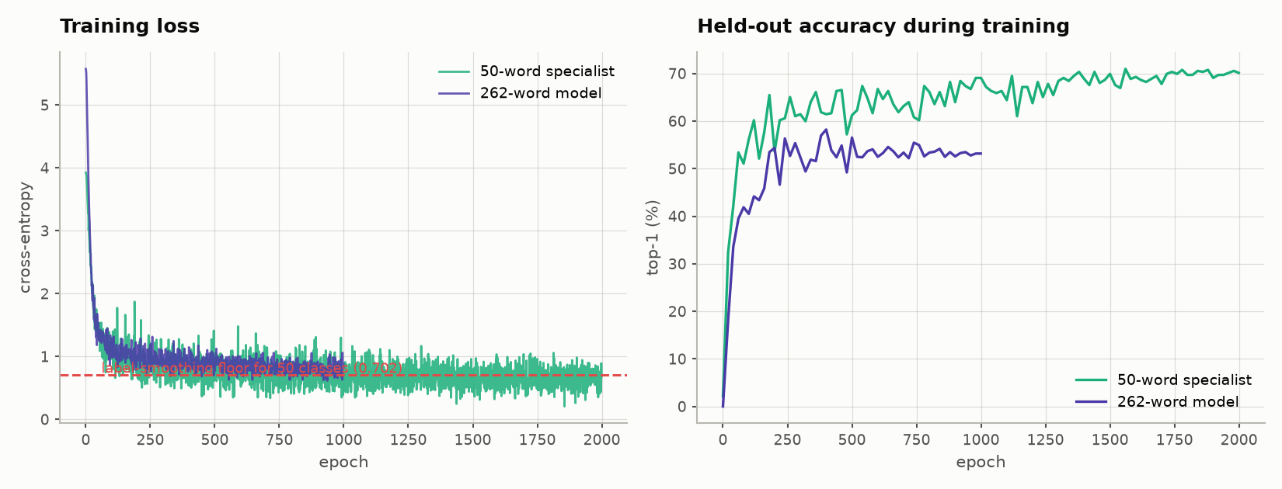
Figure 9.7 — Training loss and held-out accuracy for the 50-word and 262-word models over 2,000 epochs. The 50-word loss sits at the label-smoothing floor while accuracy is still climbing — memorisation of the training set and continued generalisation are happening at the same time. Source: docs/figures/fig17_training_curves.png.
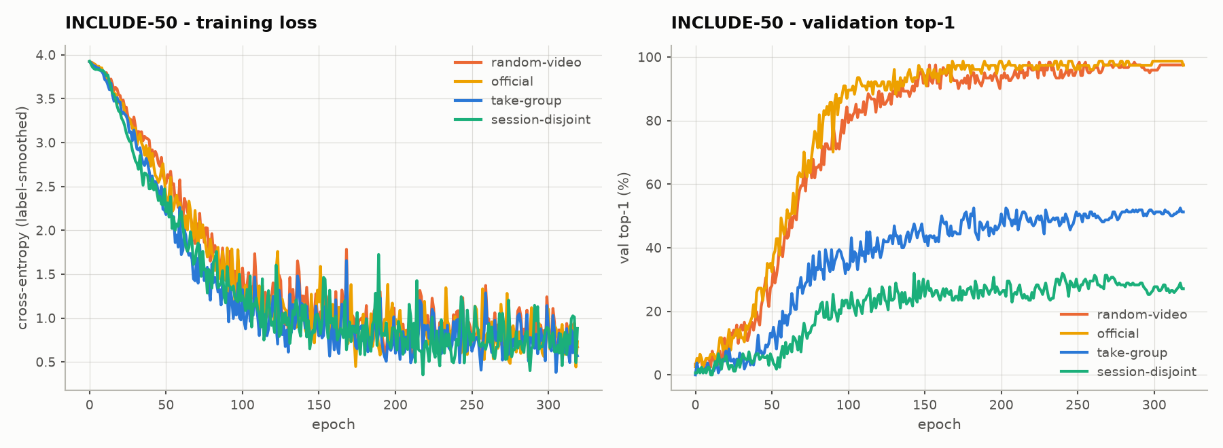
Figure 9.8 — The most informative figure in the project. The four protocols’ training-loss curves are indistinguishable — the model fits its training data equally well in every case — while validation separates completely (≈97 %, ≈52 %, ≈32 %). Optimisation is therefore not the explanation for the accuracy differences; the composition of the test set is. Source: docs/figures/fig03_convergence_include50.png.
Ablation | Setting | Result | Reading
Spatial resolution | 64 / 112 / 128 px | 46.5 / 46.5 / 44.0 % | Token count is not the bottleneck; the cheapest setting is the most accurate
Temporal sampling (INCLUDE-263) | T = 4 / 8 / 16 | 12.7 / 22.1 / 22.7 % | Below 8 frames is a real bottleneck (−9.4); above it saturates at 250 epochs — a conclusion later reversed at 2,000 epochs (§9.3)
Temporal sampling (INCLUDE-50) | T = 4 / 8 / 12 / 16 | 21.8 / 14.3 / 12.3 / 22.2 % | Non-monotonic and therefore uninterpretable — retained as the evidence that this split is statistically underpowered
Initialisation | DeiT-Tiny vs random | 29.6 % vs 23.3 % | +6.3 points from ImageNet — helpful, but smaller than the data levers
Source cache | 80 px vs 128 px, same 64 px input | 42.1 % vs 46.5 % | +4.4 points from data quality alone, at unchanged model input
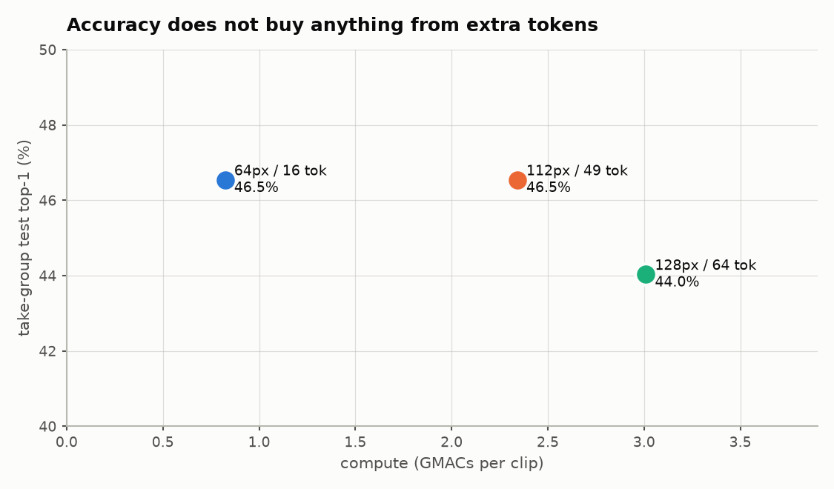
Figure 9.9 — Accuracy against compute for the spatial ablation. Source: docs/figures/fig05_resolution_ablation.png.
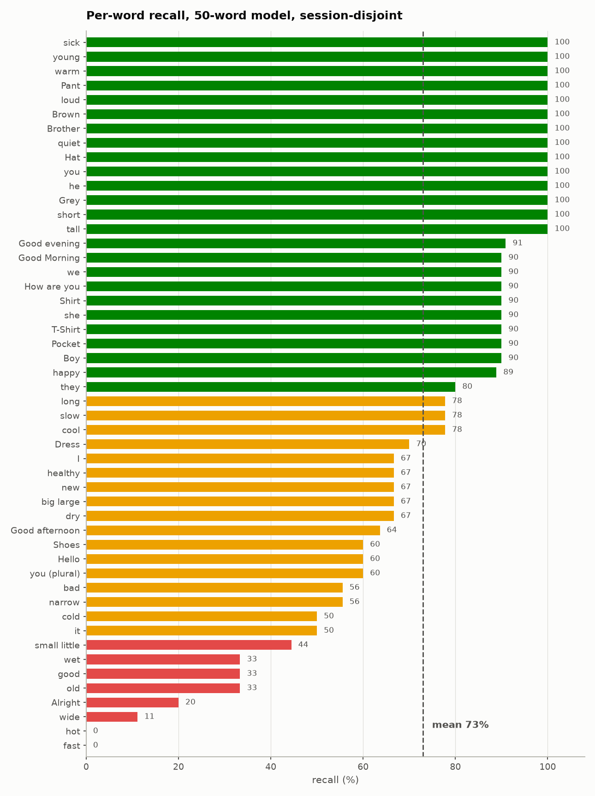
Figure 9.10 — Per-word recall for the 50-word model. Performance is strongly bimodal: 14 words are perfect, two are never recognised at all, and aggregate accuracy conceals two qualitatively different populations. Targeting augmentation at the failing classes (as in the PeerJ CS paper in §2.4) is the indicated next move. Source: docs/figures/fig18_per_class_50.png.
On the strict protocols at 262 words, 42 % of classes sit at 0 % recall and 9 % are perfect. The most frequent confusions show little visual or semantic structure, which is consistent with a model that has weak signal on those classes rather than a systematic representational failure — a model confusing genuinely similar signs would produce a confusion matrix with visible structure, and this one does not.

9.9 Deployment envelope
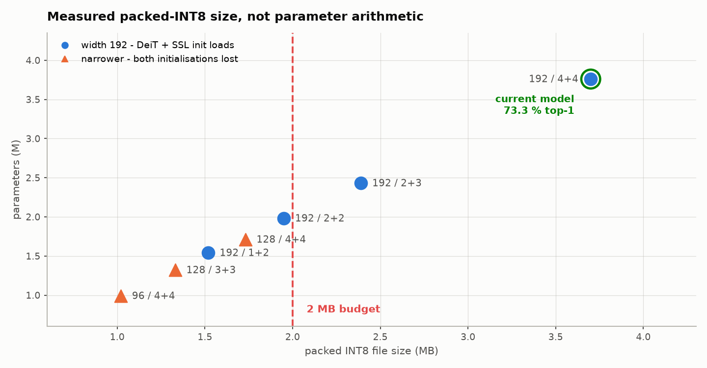
Figure 9.11 — Measured packed-INT8 file size against parameters for candidate configurations. Anything narrower than width 192 forfeits both the ImageNet and the self-supervised initialisation. Source: docs/figures/fig14_size_frontier.png.
Metric | Measured | Case-study target | Status
Parameters | 3.76 M | — | —
Compute | 0.824 GMAC / clip (weight MACs) | — | Comfortable
Model file, packed INT8 | 3.70 MB | 1–2 MB | Not met. A 192/2+2 configuration measures 1.95 MB but has not been trained
Latency | 12 ms / clip, desktop CPU | < 30 ms / frame | Not comparable — per clip, not per frame, and not on ARM
Input | 3 crops of 64 × 64 | 224 × 224 | Deliberately different; 96 px was tested and lost
Peak RAM | not measured | < 50 MB | Not measured
Target device | desktop CPU only | phone / Raspberry Pi / glasses | Not measured on any ARM device
Real bottleneck | MediaPipe crop extraction, 30–60 ms per frame | — | 3–5× the transformer. Optimising the ViT further would be premature
Say the last row out loud. The compute picture is favourable and unconflicted — the best-accuracy configuration is also the cheapest — but the detector, not the transformer, is the inference bottleneck. That is an unusual and defensible thing to know about your own system.

10. Dataset chosen
Slide 10 · 3 marks. The rubric asks for the dataset, the novelty in the dataset, and an IEEE DataPort URL. The primary corpus is not hosted on IEEE DataPort, so §10.5 gives both the canonical link for what is actually used and the IEEE DataPort ISL datasets that satisfy the rubric’s link requirement.

10.1 Primary corpus — INCLUDE
Property | Value
Name | INCLUDE — Indian Lexicon Sign Language Dataset (Sridhar, Ganesan, Kumar & Khapra, ACM Multimedia 2020)
Source | Zenodo record 4010759 · metadata mirror on HuggingFace
URL | https://zenodo.org/record/4010759
Licence | CC-BY-4.0
Clips | 4,257 unique after de-duplication (5,250 metadata rows — see §10.3)
Classes | 262 word-level signs in 15 semantic categories
Resolution / frame rate | 1920 × 1080 at 25 fps
Clip duration | ≈ 2–5 s (50–120 frames)
Recording | A single studio in Chennai, Tamil Nadu
Signer identifiers | None shipped — this is the fact that forces everything in §10.4
Clips per class | min 4 · median 15 · mean 16.2 · max 22
Category distribution: Adjectives 788, People 513, Places 380, Home 379, Society 324, Days and Time 298, Colours 222, Jobs 225, Clothes 198, Greetings 190, Means of Transportation 186, Pronouns 168, Animals 161, Electronics 140, Seasons 85.

10.2 Supporting corpora
Corpus | Role in this project | Size used | What it contributed
CISLR | Self-supervised pretraining, and later the cross-corpus test set | 6,096 clips cached; 609 overlap clips used as the cross-corpus test | Revealed the 2.1× sharpness mismatch that resolution jitter fixes (+9.5 points), and then the ~1 % cross-corpus result
iSign | Scaled self-supervised pretraining | 18,000 clips from ~11,000 distinct source videos, extracted from two 27 GB zip fragments | The pretraining corpus of the final model — diversity capped per source video so no signer dominates
ISL-CSLTR | Continuous-signing auxiliary experiments | — | Not used in any reported number
Custom recordings | The signer-disjoint validation that has not yet been run | Protocol and ingest tooling ready (docs/CAPTURE_PROTOCOL.md, ingest_custom.py) | 3 signers × 50 words × 3 takes ≈ 450 clips, one afternoon of recording

10.3 Two data-integrity faults found and fixed
- Two benchmarks stacked in one metadata file. The shipped parquets contain 5,250 rows over 4,257 unique clips: the full 263-class split (include_50 == False) stacked on the INCLUDE-50 split (include_50 == True). Loading all three splits without filtering produces 277 clips appearing in both train and test. Each benchmark is internally clean; filtering on the flag is mandatory.
- A resolution confound that would have been a perfect label predictor. An earlier processing run had transcoded part of the corpus to 480p and deleted the 1080p originals. The damage was not random: 50 classes ended up entirely 480p and 212 entirely 1080p, with no class mixed. Encoding quality would have been a perfect predictor for those 50 labels. Nine archives (10.5 GB) were re-downloaded before any reported experiment was run.

10.4 Novelty in the dataset — what this project does that the dataset does not ship
Contribution | Detail
Reconstructed recording structure | INCLUDE ships no signer identifiers, so session identity is recovered from camera capture ids. Within-class gaps are sharply bimodal (2,907 gaps of 1–2, 1,063 of ≥ 20, only 19 in between), which makes the grouping threshold essentially free of arbitrariness — any cut in [5, 20] gives the same partition.
Four evaluation protocols, with assertions | official, random-video, take-group (1,334 groups) and session-disjoint (13 corpus-wide session blocks), all built by splits.py with automated leakage checks. 21 split definitions are tracked in the repository.
A correction that matters | Session blocks must be clustered from the whole 4,257-clip corpus. Clustering from INCLUDE-50’s 943 clips yields 177 fine blocks that are take-groups, not sessions — train and test then shared 10 of 13 real sessions while the split’s own assertions passed. An earlier reported figure (35.8 %) was withdrawn because of this.
Under-trained classes excluded from test | Classes left with fewer than 6 training clips have their test clips marked unused, because scoring them measures how little they were trained on rather than how well the model recognises them.
Vocabulary tiers | 30 / 50 / 100 / 137 / 262-word tiers that preserve the session-disjoint structure exactly and keep per-word support constant, so the variable that changes across tiers is the number of classes and not the evidence per class.
Re-extraction at 32 frames | The corpus was re-extracted at 32 frames per clip (18.7 GB, 98 minutes, zero failures) purely to give the sampler jitter headroom — worth +3.2 points at identical model and inference cost. Detection quality was verified unchanged between caches (91.1 / 85.2 / 99.9 % against 91.3 / 85.4 / 99.9 %) so the frame comparison is not confounded by crop quality.
A cross-corpus test set | 218 INCLUDE words also appear in CISLR, covered by 609 cached clips with different signers, rooms and cameras — a genuine cross-corpus benchmark, with assertions that its clips appear in neither the training rows nor the pretraining pool.

10.5 Dataset links, including the IEEE DataPort URL the rubric asks for
Dataset | Link | Note
INCLUDE (primary, used for every number here) | https://zenodo.org/record/4010759 | Canonical source. Not hosted on IEEE DataPort.
Indian Sign Language dataset ISL-50 | https://ieee-dataport.org/documents/indian-sign-language-dataset-isl-50 | IEEE DataPort ISL dataset
ISL Fingerspelling Image Dataset | https://ieee-dataport.org/documents/isl-fingerspelling-image-dataset | IEEE DataPort · 14,000+ labelled images, A–Z and 1–9, 3 signers
Indian Sign Language Skeletal-point NumPy arrays (MediaPipe) | https://ieee-dataport.org/documents/indian-sign-language-skeletal-point-numpy-array-using-mediapipe | IEEE DataPort · 120 sequences per alphabet, 30 frames each
Sentence-level ISL translator dataset | https://ieee-dataport.org/documents/novel-sentence-level-indian-sign-language-translator-based-nlp-and-deep-learning | IEEE DataPort · 600 videos, 75 conversational ISL sentences, 4 participants
IEEE DataPort ISL keyword index | https://ieee-dataport.org/keywords/indian-sign-language | Use this if the marker wants a live browse
If the slide must show one IEEE DataPort URL, show the keyword index and say in one line: “the primary corpus is INCLUDE on Zenodo under CC-BY-4.0; these are the IEEE DataPort ISL datasets we cross-checked against.” Do not imply the model was trained on an IEEE DataPort dataset — it was not.

10.6 Preprocessing chain, end to end
video (1920x1080, 25 fps)
-> sample 32 frames uniformly
-> pad/resize to 720p working height
-> MediaPipe Holistic (pose + face + hands)
hand found? yes -> box = landmark hull x 1.5 margin [81.4 %]
no -> ROI from pose wrist/elbow, side = 2.8 x forearm
upscale to 256 px -> HandLandmarker [+9.6 %]
still missing -> carry nearest real box [8.7 %, flagged]
-> crop 3 streams, resize to 128x128, record source code + box geometry
-> memmap cache: crops (N,32,3,128,128,3) uint8 | sources | geometry
train time: sample 16 of 32 with jitter -> scale-crop 80-100 % -> 64 px
-> flip+stream swap -> colour/grayscale -> ImageNet normalise
-> stream dropout -> mixup (50 % of batches)
Extraction cost: 98 minutes for 4,257 clips at 6 worker processes, 100 % coverage, 0 failures.

11. UI screens planned
Slide 11 · 5 marks. Seven screens. The single point to make: the confidence gate is the interface, not an implementation detail — the model is right 88.7 % of the time on the 75 % of clips it chooses to answer, so the UI has to make “not sure” a first-class state rather than an error.
Screens 1–4 are the runtime application; 5–7 are the tools this project actually needs next. Each is given as a wireframe with its states and the data it binds to.

11.1 Screen 1 — Live capture (the primary screen)
+---------------------------------------------------------------+
| ISL Reader [ 50 words ] [ o REC ] |
+---------------------------------------------------------------+
| |
| [ camera preview, 16:9 ] |
| +-----------+ +-----------+ +---------+ |
| | L hand | | R hand | | face | <- the |
| +-----------+ +-----------+ +---------+ three|
| streams|
| detection health [#########-] 91 % |
+---------------------------------------------------------------+
| |
| H E L L O conf 0.83 ### |
| recognised 0.4 s ago |
| |
+---------------------------------------------------------------+
| ... good morning I am [ HELLO ] |
| [ undo ] [ clear ] [ = ] |
+---------------------------------------------------------------+
Element | Binds to | Behaviour
Three stream thumbnails | the crops actually fed to the model | Shows the user what the model sees. Greys out a stream whose box is interpolated — the same detected flag the network receives.
Detection health bar | share of frames with a genuine detection in the last window | Below 25 % the app says “move into better light / keep both hands in frame” instead of guessing. predict.py already emits this warning.
Recognised word + confidence | max softmax after 6-view TTA | Confidence is shown as a bar, never as a bare percentage.
Sentence strip | the deduplicated word sequence | Words are appended with hysteresis so one sign is not emitted three times by consecutive windows.

11.2 Screen 2 — The “not sure” state
+---------------------------------------------------------------+
| ? not sure |
| |
| did you mean: |
| 1. QUIET 0.31 ############ |
| 2. LOUD 0.22 ######## |
| 3. SLOW 0.11 #### |
| |
| [ sign again ] [ pick 1 ] [ pick 2 ] [ pick 3 ] |
+---------------------------------------------------------------+
- Triggered when max probability < τ = 0.4 — about one clip in four at the deployed operating point.
- The top-5 shortlist is worth showing because top-5 accuracy is 92.8 % against 75.8 % top-1: the correct word is usually present even when it is not ranked first.
- Off-domain this screen is what the user sees almost always — no CISLR clip ever exceeded 0.4 confidence — so the system degrades to “I cannot read this” rather than to confident nonsense.
- Every manual pick is a free labelled sample from a new signer, which is exactly the data the project is short of. Store it (with consent) for Screen 7.

11.3 Screen 3 — Sentence composer and history
+---------------------------------------------------------------+
| Session 14:32 [ export ] |
+---------------------------------------------------------------+
| 14:31:02 GOOD MORNING 0.91 ########## |
| 14:31:06 I 0.74 ######## |
| 14:31:09 ? not sure -> HAPPY (picked) |
| 14:31:14 YOU 0.88 ######### |
| |
| "good morning I happy you" [ copy ] [ speak ] |
+---------------------------------------------------------------+
Word-level output only — this system does not do grammar. Say that plainly on the slide: ISL word order is not English word order, and turning a word sequence into a sentence is the translation problem that islvit/slt.py scaffolds but does not solve.

11.4 Screen 4 — Settings
Control | Range | Why the user gets it
Confidence threshold τ | 0.0 – 0.7, default 0.4, shown as “answers ~75 % of signs at ~89 % accuracy” | The accuracy/coverage trade is a user preference, not a constant. The slider text updates from the measured curve in §9.7.
Vocabulary tier | 30 / 50 / 100 / 137 / 262 words, default 50 | 50 words is the measured optimum; a user who needs more coverage can trade accuracy for it knowingly.
Test-time augmentation | 1 view / 6 views, default 6 | 6 views is +2.5 points at 6× the forward passes — a battery setting.
Ensemble | single model / 5 members | +2.5 points at 5× cost; off by default on device.
Detector rate | every frame / every 3rd frame with tracking | MediaPipe is 3–5× the ViT’s cost, so this is the real battery control.

11.5 Screens 5–7 — the tooling this project needs next
Screen | Purpose | Why it exists
5 · Detection diagnostics | Per-stream detection provenance over the last minute: direct / ROI-rescued / interpolated / missing | Detection quality predicts accuracy better than anything else measured here. A model deployed on footage where the left hand is found 25 % of the time will fail, and this screen says so before the user blames the model.
6 · Vocabulary browser | The 50 words the model knows, with per-word recall from Figure 9.10 | Performance is bimodal — 14 words perfect, 2 never recognised. A user who knows which words are reliable can work around the rest.
7 · Enrolment / capture | Guided recording of the 50-word list by a new signer: 3 takes per word, with framing and lighting prompts | This is the experiment the whole project is waiting on. docs/CAPTURE_PROTOCOL.md specifies it: 3 signers × 50 words × 3 takes ≈ 450 clips, ~35 minutes per signer, stored as custom/<signer>/<word>/<take>.mp4, ingested signer-disjointly by ingest_custom.py.
Screen 7 is worth a sentence of its own in the presentation: every accuracy in this project is measured on one studio in one city, and the recording protocol that would test whether that generalises is written, tooled and asserted — it needs one afternoon and three volunteers.

12. Standard paper
Slide 12 · 2 marks: title and justification.

12.1 The reference paper
Field | Value
Title | A comparative analysis of video vision transformers on word-level sign language datasets
Authors | Jubayer Ahmed Bhuiyan Shawon, Md Kamrul Hasan, Hasan Mahmud
Venue | PLOS ONE, vol. 21, no. 2, article e0341909 — 5 February 2026
DOI | 10.1371/journal.pone.0341909
Models compared | VideoMAE, ViViT, TimeSformer
Datasets | BdSLW60, BdSLW401, LSA64, WLASL100, WLASL2000
Headline results | 96.9 % on BdSLW60; 81.04 % on BdSLW401; 99.06 % on LSA64 (TimeSformer); WLASL2000 degraded by severe class imbalance
Stated conclusion | Performance is governed by dataset size, signer appearance, frame distribution, frame rate and model architecture

12.2 Why this is the right standard paper for this application
- It defines the architecture family this project belongs to. ViViT’s factorised encoder is precisely the design ISL-ViT-Tiny adopts and shrinks; the paper is the current journal-level comparison of that family on word-level sign recognition.
- It is the same task: isolated, word-level sign classification from video, evaluated across several sign languages — not fingerspelling, not continuous translation.
- It names the variables this project manipulates. Its conclusion lists dataset size, signer appearance, frame distribution and frame rate as the deciding factors. This project measures each of them: 45 % more data (+7.7), signer/session structure (−63 points of leakage), frame count (+6.4) and cache-depth jitter headroom (+3.2).
- It is the honest comparison point for cost. The three models it benchmarks are Kinetics-scale backbones in the tens to hundreds of millions of parameters. ISL-ViT-Tiny reaches a comparable regime at 3.76 M parameters and 0.82 GMAC — that contrast is the project’s deployment argument in one line.
- It is 2026, in a SCImago-listed Q1 multidisciplinary journal, so it satisfies the rubric’s venue requirement without argument.

12.3 The two runners-up, and why they lost
- Ashfaq et al., SignViT (Biomedical Signal Processing and Control, 2026) — the best pure-ViT sign-recognition paper in the set, and the strongest evidence that attention discriminates visually similar gestures. It loses because it is static-image classification with no temporal model and no deployment budget.
- Aggul, Beyond Perfect Scores (Technologies, 2026) — the closest paper to this project’s *methodological* contribution, reporting 15–83-point drops when random splits are replaced by structure-aware ones. It loses because it is depth/ToF gesture data rather than sign language video, so it validates the method rather than the task. Cite it in §2 and in the discussion; it is the independent confirmation that this project’s central claim is not idiosyncratic.

Appendix A — Run inventory (the numbers behind every claim)
79 runs are recorded in runs/, each with summary.json and history.csv. These are the ones any claim in this document traces to. Test top-1 is read directly from the run summary; TTA figures come from test_tta where present.

A.1 Protocol runs — the leakage ladder
Run tag | Split | Cache | Test top-1 | Top-5 | Balanced | n
include50_v2__random-video | include50 random-video | cache | 95.70 % | 99.46 % | 95.83 % | 186
include50_v2__official | include50 official | cache | 95.29 % | 99.48 % | 97.00 % | 191
include50_v2__take-group | include50 take-group | cache | 42.14 % | 85.53 % | 46.95 % | 159
abl64__take-group | include50 take-group | cache128 | 46.54 % | 86.16 % | 49.86 % | 159
full263_v2__random-video | full263 random-video | cache128 | 94.50 % | 99.08 % | 94.72 % | 872
full263_v2__take-group | full263 take-group | cache128 | 29.27 % | 64.12 % | 31.97 % | 878
sd_full263 | full263 session-disjoint | cache128 | 22.08 % | 51.39 % | 25.18 % | 1,010
include50_take-group_scratch | include50 take-group, random init | cache | 23.27 % | 69.81 % | 25.36 % | 159

A.2 The 50-word ladder (472-clip test set, unchanged throughout)
Run tag | What it is | Frames | Epochs | Test top-1
vocab50_s0 / vocab50_s1 | 250-epoch baseline | 8 | 250 | 49.36 % / 54.03 %
aug50_s0 / aug50_s1 | 2,000 epochs, 8 frames | 8 | 2,000 | 59.32 % / 61.23 %
grok_wd005 | 2,000 epochs, weight decay 0.05 | 8 | 2,000 | 61.86 %
long2000_wd5 | weight decay 0.5 arm of the grokking probe | 8 | 2,000 | 58.69 %
cap_16f64 / cap_16f64_s1 | 16 frames from the 16-frame cache | 16 | 2,000 | 66.74 % / 65.47 %
aug16_s0 / aug16_s1 | 16 frames + strong augmentation bundle | 16 | 2,000 | 69.07 % / 66.74 %
f8_clean_s0 | 8 frames from the 32-frame cache | 8 | 2,000 | 59.96 %
f16_clean_s0 / f16_clean_s1 | 16 from 32 — the control and the recommended config | 16 | 2,000 | 69.92 % / 70.34 %
f24_clean_s0 | 24 frames from 32 | 24 | 2,000 | 69.70 %
f32_clean_s0 | 32 frames from 32 | 32 | 2,000 | 72.46 %
f16_long4k_s0 | 4,000 epochs | 16 | 4,000 | 70.76 % (null)
f16_mim16_s0 | natively 16-frame SSL pretraining | 16 | 2,000 | 59.96 % (−10.2)
f16_full_s0 | +76 labelled CISLR clips | 16 | 2,000 | 64.41 % (−5.7)
f16_262w_s0 | 262-word head, same recipe | 16 | 1,000 | 52.77 % (on 1,010 clips)

A.3 INCLUDE-263 session-disjoint — pretraining and jitter
Run tag | Initialisation | Resolution jitter | Test top-1
sd263_foldval | ImageNet | no | 32.97 %
sd263_ssl_foldval (+ seeds s1–s4) | CISLR SSL | no | 34.85 / 33.17 / 38.02 / 33.86 / 35.05 %
sd263_rj_s0 / s1 | ImageNet | yes | 30.99 % / 29.90 %
sd263_ssl_rj_s0 / s1 | CISLR SSL | yes | 39.90 % / 39.80 %
sd263_ssl_rj2_s0–s3 | CISLR SSL with jitter during pretraining too | yes | 43.17 / 36.83 / 34.65 / 34.06 % (sd 4.2)
sd263_isign_rj_s0 / s1 | iSign SSL (18 k clips) | yes | 41.78 % / 42.38 %
frz00_isign / frz001_isign | iSign SSL, backbone frozen / lr×0.01 | yes | 31.78 % / 38.71 %
mix50_isign_s0 / s1 | cross-corpus CISLR test set | — | 1.31 % / 1.97 % (chance 0.38 %)

A.4 Vocabulary tiers (2 seeds each, 250 epochs)
Tier | Runs | Test clips | Top-1 seed 0 / seed 1
30 words | vocab30_s0/s1 | 278 | 44.24 % / 38.13 %
50 words | vocab50_s0/s1 | 472 | 49.36 % / 54.03 %
100 words | vocab100_s0/s1 | 865 | 50.17 % / 49.02 %
137 words | vocab137_s0/s1 | 976 | 45.39 % / 46.21 %
262 words | sd263_isign_rj_s0/s1 | 1,010 | 41.78 % / 42.38 %

A.5 Gating files
runs/gate_16f64.json, gate_cap16.json, gate_2000ep.json, gate_aug16.json, gate_f16.json, gate_mixed.json — each holds the full coverage/accuracy curve for the named ensemble. gate_mixed.json (three members: f16_clean_s0, f16_clean_s1, f32_clean_s0) is the one quoted in §9.7.

Appendix B — Figure index
Every figure is generated by islvit/figures.py or figures_v2.py from runs/*/summary.json; none is drawn by hand. Paths are relative to the repository root.
File | Shows | Use it on
docs/figures/fig01_mvi_gap_histogram.png | Bimodal within-class capture-id gaps — the evidence for take-groups | Slide 1
docs/figures/fig02_leakage_ladder.png | Test top-1 by protocol, both benchmarks | Slides 1 and 9
docs/figures/fig03_convergence_include50.png | Identical training loss, completely separated validation, all four protocols | Slide 9 — the strongest single figure
docs/figures/fig04_convergence_full263.png | The same at 262 classes | Backup
docs/figures/fig05_resolution_ablation.png | Accuracy against compute for 64/112/128 px | Slide 9
docs/figures/fig06_box_sources.png | Where every crop box came from, per stream | Slides 3 and 4
docs/figures/fig07_per_class_include50.png | Per-class recall, INCLUDE-50 | Backup
docs/figures/fig08_per_class_full263.png | Per-class recall, INCLUDE-263 | Backup
docs/figures/fig09_temporal_ablation.png | Frame-count ablation on both strict splits — the disagreement is the point | Slide 9
docs/figures/fig10_leakage_now.png | 97.9 % random against 75.8 % honest, and how the gap closed | Slide 9
docs/figures/fig11_frame_sweep.png | Frames into the model, and TTA gain against jitter headroom | Slide 9
docs/figures/fig12_gating_curve.png | Accuracy against coverage | Slides 9 and 11
docs/figures/fig13_intervention_waterfall.png | Every intervention, colour-coded confirmed / null / rejected | Slide 9 — best summary figure
docs/figures/fig14_size_frontier.png | Measured packed-INT8 size against parameters | Slide 6 or 9
docs/figures/fig15_detection_quality.png | Genuine hand detections, INCLUDE against CISLR | Slide 9
docs/figures/fig16_crop_montage.png | The model’s entire input, three signs | Slide 3
docs/figures/fig17_training_curves.png | Loss and held-out accuracy over 2,000 epochs | Slide 9
docs/figures/fig18_per_class_50.png | Per-word recall, 50-word model | Slide 9
`figA_system_architecture.png` (new, in this pack) | The overall application architecture | Slide 3
`figB_model_architecture.png` (new, in this pack) | The model, with tensor shapes and measured cost | Slide 6
The two new diagrams are delivered alongside this document as figA_system_architecture.png and figB_model_architecture.png — drop them straight into the deck.

Appendix C — Reproduction sequence
# 1. Environment (Python 3.11)
conda create -n islvit python=3.11 -y
conda run -n islvit pip install torch torchvision --index-url https://download.pytorch.org/whl/cu124
conda run -n islvit pip install mediapipe timm einops pyarrow pandas opencv-python pyyaml tqdm av
# 2. MediaPipe model assets
curl -sL -o models/holistic_landmarker.task \
https://storage.googleapis.com/mediapipe-models/holistic_landmarker/holistic_landmarker/float16/1/holistic_landmarker.task
curl -sL -o models/hand_landmarker.task \
https://storage.googleapis.com/mediapipe-models/hand_landmarker/hand_landmarker/float16/1/hand_landmarker.task
# 3. Splits (fast; asserts no leakage)
python -m islvit.data.splits
python -m islvit.data.fold_val --split splits/full263__session-disjoint.csv
python -m islvit.data.build_vocab_tier --words 50
# 4. Crop cache at 32 frames (~98 min, 6 workers, ~18.7 GB)
python -m islvit.data.crops --cache-dir cache128_f32 --crop-size 128 --frames 32 --workers 6
# 5. Self-supervised pretraining on iSign (8 frames of 16 -- keep the jitter headroom)
python -m islvit.pretrain --cache cache_isign --epochs 100 --tag isign_mim
# 6. The recommended configuration
export ISLVIT_CACHE=cache128_f32
python -m islvit.train --config configs/full263_v2.yaml \
--split-file splits/vocab50clean__session-disjoint.csv \
--init-from runs/isign_mim/pretrained.pt \
--n-frames 16 --epochs 2000 --resolution-jitter 0.5 --select last --seed 0 --tag f16_clean_s0
# 7. Test-time augmentation and the confidence gate
python -m islvit.tta --run runs/f16_clean_s0 --write-summary
python -m islvit.gate --runs runs/f16_clean_s0 runs/f16_clean_s1 runs/f32_clean_s0 --out runs/gate_mixed.json
# 8. Size and figures
python -m islvit.export --run runs/f16_clean_s0
python -m islvit.export --survey
python -m islvit.report
python -m islvit.figures && python -m islvit.figures_v2
Built-in sanity checks: video-level and take-group disjointness assertions in splits.verify; session disjointness against corpus-wide blocks in splits.report_session_split; a single-batch overfit check (train.py --overfit-batch, reaches 100 % in under 40 steps); per-crop provenance in sources.npy; and a cache field in every summary.json so runs from different caches are never compared by accident.

Appendix D — Check these before you present
Four places in the repository disagree with each other, and one architectural claim needs restating. None of them is a defect in the work; all of them are quotable-in-the-wrong-direction if you take a number from the wrong file.
# | Issue | What the files actually say | What to do
D1 | The README headline is stale. | README.md quotes 68.9 % top-1 / 89.4 % top-5 and “80.7 % on the 76 % of clips”. That is runs/gate_cap16.json — the two-seed 16-frames-from-a-16-frame-cache ensemble. The report’s §11.11 and the newer runs give 75.8 % / 92.8 %. | Present 75.8 %. Update the README, or say “the README predates the 32-frame cache”. Do not quote 68.9 %.
D2 | Three different numbers for gated accuracy. | README: 80.7 % at 76 % coverage. fig12_gating_curve.png: 88.7 % at 75 %. Report §11.11: 90.7 % at 75 %. Only the figure matches an artefact — gate_mixed.json gives 88.7 % at 75.2 %. | Quote 88.7 % at 75 % coverage and cite runs/gate_mixed.json. Treat 90.7 % as unverified.
D3 | The five-member ensemble has no artefact on disk. | §11.11 reports a five-member ensemble at 75.8 % / 92.8 %. The largest gate file present is gate_mixed.json with three members at 75.0 % / 92.6 %. | Either re-run islvit.gate with all five runs and keep the JSON, or present the verifiable three-member number (75.0 %) and mention the fifth-member result as reported but not re-derivable.
D4 | The report’s reproducibility appendix is out of date. | §19 says “16 training runs” and “8 PNGs”; the repository holds 79 runs and 18 figures, and lists a cache/ and 80 px cache that the current recipe no longer uses. | Cosmetic, but a marker who counts will notice. Quote 79 runs.
D5 | The “≈48× cheaper attention” claim needs its units. | 0.02× is the ratio of *attention operations*, which recomputes here as 44×. Attention token pairs are 22× fewer; total compute is 2.4× cheaper. | Say “44× cheaper attention, 2.4× cheaper end to end” (derivation in §6.4). It is still a strong claim and it survives questioning.
D6 | Case-study targets that are not met. | 1–2 MB (measured 3.70 MB), 224×224 input (uses 3 crops of 64×64), < 50 MB RAM and ARM latency (not measured), knowledge distillation / pruning / QAT (harness written, not trained). | List them as future work on the last slide. Claiming any of them is the fastest way to lose the room.
D7 | Cross-corpus accuracy is ~1 %. | 0.3–1.5 % on CISLR for checkpoints scoring 42 % on INCLUDE. | State it yourself, early. It is the most credible thing in the project and it pre-empts the hardest question.

D.8 The five questions most likely to be asked, and the answers
Question | Answer
“Published INCLUDE results are 94 %. Why is yours 22 %?” | Because they are not the same measurement. Under the same random split this model gets 94.5 % — it reproduces the literature. 22.1 % is what remains when near-duplicate takes and shared recording sessions are removed from the test set. The model is not weaker; the protocol is stricter.
“How do you know the takes are near-duplicates?” | Camera capture ids. Of 3,989 within-class consecutive-id gaps, 2,907 are 1 or 2 and 1,063 are ≥ 20, with only 19 in between (Figure 1.1). Clips one apart are consecutive takes in the same sitting. Any threshold in [5, 20] gives the same grouping, so the choice is not tuned.
“Is 75.8 % good?” | It is in the right regime. The one published like-for-like comparison — a signer-independent word-level benchmark (TSL-ONE-S, IEEE Access 2026) — sits at roughly 80 %, with models one to two orders of magnitude larger. This is 3.76 M parameters and 0.82 GMAC.
“Will it work on my phone video?” | On present evidence, no. Cross-corpus accuracy is 0.3–1.5 %, at chance. What it will do is refuse: no out-of-domain clip in 609 exceeded 0.4 confidence, so it falls silent rather than captioning nonsense. Closing that gap needs recordings from new signers, and the protocol for that is written and tooled.
“What would you do differently?” | Multi-seed everything from the start. Three claims in this project were made against a weak reference or too few seeds and later overturned by controlled follow-ups — including one reversal of a previous correction. The measured noise floor is 2.7 points for a difference of two runs, and effects in this project are routinely smaller than that until proven otherwise.

Appendix E — References

The fifteen surveyed papers
- I. Lamaakal, C. Yahyati, Y. Maleh, K. El Makkaoui et al., “An explainable hybrid CNN–transformer model for sign language recognition on edge devices using adaptive fusion and knowledge distillation,” *Scientific Reports*, 2026. DOI 10.1038/s41598-026-38478-8
- U. Venkatappa, N. K. S., P. P. Bhat, P. Srinivas, “Dynamic Kannada sign language recognition on resource constrained devices,” *Scientific Reports*, 2026. DOI 10.1038/s41598-026-40181-7 (an author correction was published subsequently)
- U. Ashfaq, Q. Wang, B. Merabet, J. Zhang, “SignViT: an enhanced vision transformer framework for attention-based sign language hand gesture recognition,” *Biomedical Signal Processing and Control*, vol. 112 B, art. 108602, 2026. DOI 10.1016/j.bspc.2025.108602
- H. A. Rubaiyeat, N. Youssouf, M. K. Hasan et al., “Transformer-based word level Bangla sign language recognition using relative quantization encoding,” *Scientific Reports*, 2026. DOI 10.1038/s41598-026-53835-3
- A. Abdi, F. Barzegar Touchahi, “Underwater sign language recognition using convolutional and transformer models: a comparative study in clear and murky conditions,” *Signal, Image and Video Processing*, vol. 20, art. 297, 2026. DOI 10.1007/s11760-026-05314-5
- J. A. B. Shawon, M. K. Hasan, H. Mahmud, “A comparative analysis of video vision transformers on word-level sign language datasets,” *PLOS ONE*, vol. 21, no. 2, e0341909, 2026. DOI 10.1371/journal.pone.0341909
- P. Nedungadi, G. Dileep, M. Geetha, R. Raman, “Vision transformer-powered conversational agent for real-time Indian Sign Language e-governance accessibility,” *Scientific Reports*, vol. 15, art. 33055, 2025. DOI 10.1038/s41598-025-12667-3
- R. Damdoo, P. Kumar, R. Gogoi, “End-to-end sentence-level Indian sign language translation with ISH-NEWS dataset and transformer model,” *Scientific Reports*, 2026. DOI 10.1038/s41598-026-60893-0
- A. Ghadami, A. F. Meghdari, A. Taheri, “A transformer-based multi-stream approach for isolated Iranian sign language recognition,” *Computer Speech & Language*, vol. 101, art. 102017, 2026. DOI 10.1016/j.csl.2026.102017
- S. A. Tasnim, R. Mahmud, T. Ahmed, D. Karmaker, “A vision transformer-based fine-tuned DINOv2 model for Bangla sign language recognition,” *Multimedia Tools and Applications*, vol. 85, art. 163, 2026. DOI 10.1007/s11042-026-21376-6
- B. Aggul, “Beyond perfect scores: leakage-aware multi-corpus evaluation of low-resolution ToF and depth gesture recognition,” *Technologies*, vol. 14, no. 8, art. 473, 2026. DOI 10.3390/technologies14080473
- S. Alyami, H. Luqman, S. Al-Azani, M. Alowaifeer, Y. Alharbi, Y. Alonaizan, “Isharah: a large-scale multi-scene dataset for continuous sign language recognition,” *IEEE Transactions on Multimedia*, vol. 28, pp. 5050–5058, 2026. DOI 10.1109/TMM.2026.3664959
- J. Chalotonpised, W.-H. Chen, W. Vijitkunsawat, Y.-C. Lin, “TSL-ONE-S: a real-world Thai sign language dataset with deep learning benchmarks,” *IEEE Access*, vol. 14, pp. 37845–37870, 2026. DOI 10.1109/ACCESS.2026.3670970
- H. Fu, Y. Chen, “Data augmentation and debiasing for signers in signer-independent sign language translation,” *The Journal of Supercomputing*, vol. 81, art. 606, 2025. DOI 10.1007/s11227-025-07119-8
- N. Mohamed, M. B. Mustafa, N. Jomhari, R. J. Raja Yusof, A. Abdul Sani, “Class-specific data augmentation of an imbalanced dataset for signer-independent fingerspelling recognition,” *PeerJ Computer Science*, vol. 12, e3784, 2026. DOI 10.7717/peerj-cs.3784

Supporting sources
- M. Li, P. Premaratne, Z. Ye, P. Vial, “Comprehensive survey of sign language recognition and its future through computer vision,” *Neurocomputing*, vol. 705, art. 134913, 2026. DOI 10.1016/j.neucom.2026.134913
- X.-H. Yang, H.-X. Hu, X. Lin, “ACMC: adaptive cross-modal multi-grained contrastive learning for continuous sign language recognition,” *Image and Vision Computing*, vol. 161, art. 105622, 2025. DOI 10.1016/j.imavis.2025.105622
- J. Hao, H. Pan, “A novel deep transformer based CvT model for sign language recognition in visual communication,” *Scientific Reports*, vol. 16, art. 1823, 2025. DOI 10.1038/s41598-025-31558-1
- A. Sridhar, R. G. Ganesan, P. Kumar, M. Khapra, “INCLUDE: a large scale dataset for Indian Sign Language recognition,” *ACM Multimedia*, 2020. Dataset: Zenodo record 4010759, CC-BY-4.0
- A. Arnab, M. Dehghani, G. Heigold, C. Sun, M. Lučić, C. Schmid, “ViViT: a video vision transformer,” *ICCV*, 2021 — the factorised-encoder design this architecture adapts
- H. Touvron, M. Cord, M. Douze, F. Massa, A. Sablayrolles, H. Jégou, “Training data-efficient image transformers and distillation through attention (DeiT),” *ICML*, 2021 — the initialisation used in Stage A
- Z. Xie, Z. Zhang, Y. Cao, Y. Lin, J. Bao, Z. Yao, Q. Dai, H. Hu, “SimMIM: a simple framework for masked image modeling,” *CVPR*, 2022 — the pretraining objective
- Project report: docs/PRELIMINARY_MODEL_REPORT.md (19 sections) and docs/CAPTURE_PROTOCOL.md, in the project repository
Conference references (ViViT, DeiT, SimMIM, INCLUDE) are listed because the architecture and the data cannot be described without them. They do not count toward the rubric’s fifteen journal papers, all of which are in the first list.

