# Laboratory Report #6

**Name:** Josh Ratificar **Date Completed:** 12-08-2023

**Laboratory Exercise Title:** Behavioral Modeling of Sequential Circuits

**Block Diagrams:**

**Figure 1.0** – *Hex_to_7_Seg_Decoder Block Diagram*

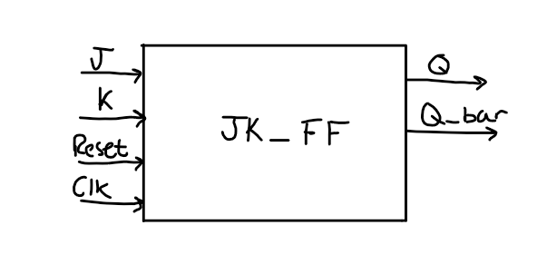

**Figure 2.0 –***Counter_4bit Block Diagram*

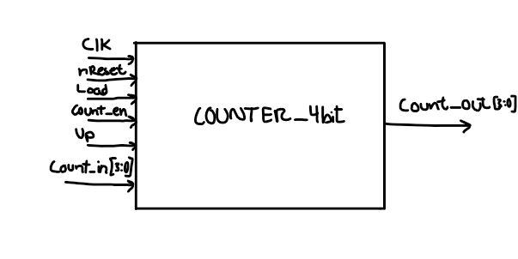

**Exercise 5A:**

**Figure 1.1** –*JK_FF.v Script*

/\**\*\*\*\*\*\*\*\*\*\*\*\*\*\*\*\*\*\*\*\*\*\*\*\*\*\*\*\*\*\*\*\*\*\*\**

*\*   FILE:               JK_FF.v*

*\*   AUTHOR:             Mohan Francis, Josh Ratificar*

*\*   Class:              Gr.3 CpE 3101L Introduction to HDL*

*\*   Group/Schedule      Friday, 7:30 AM to 10:30 AM*

*\*   Description:        JK_FF.v file*

*\*\*\*\*\*\*\*\*\*\*\*\*\*\*\*\*\*\*\*\*\*\*\*\*\*\*\*\*\*\*\*\*\*\*\**\*/

module JK_FF (

    input wire J,K,Reset, Clk,

    output reg Q, Q_bar

);

always @(negedge Clk, posedge Reset)

    begin

        if(Reset)

        begin

            Q <= 1'b0;

            Q_bar <= 1'b1;

        end

        case({J,K})

            2'b00:                          //*NO CHANGE*

                begin

                    Q <= Q;

                    Q_bar <= Q_bar;

                end

            2'b01:                          //*RESET*

                begin

                    Q <= 1'b0;

                    Q_bar <= 1'b1;

                end

            2'b10:                     //*SET*

                begin

                    Q <= 1'b1;

                    Q_bar <= 1'b0;

                end

            2'b11:                          //*TOGGLE*

                begin

                    Q <= ~Q;

                    Q_bar <= ~Q_bar;

                end

        endcase

    end

endmodule

**Figure 1.2** – *JK_FF.v Analysis and Elaboration Test Results*

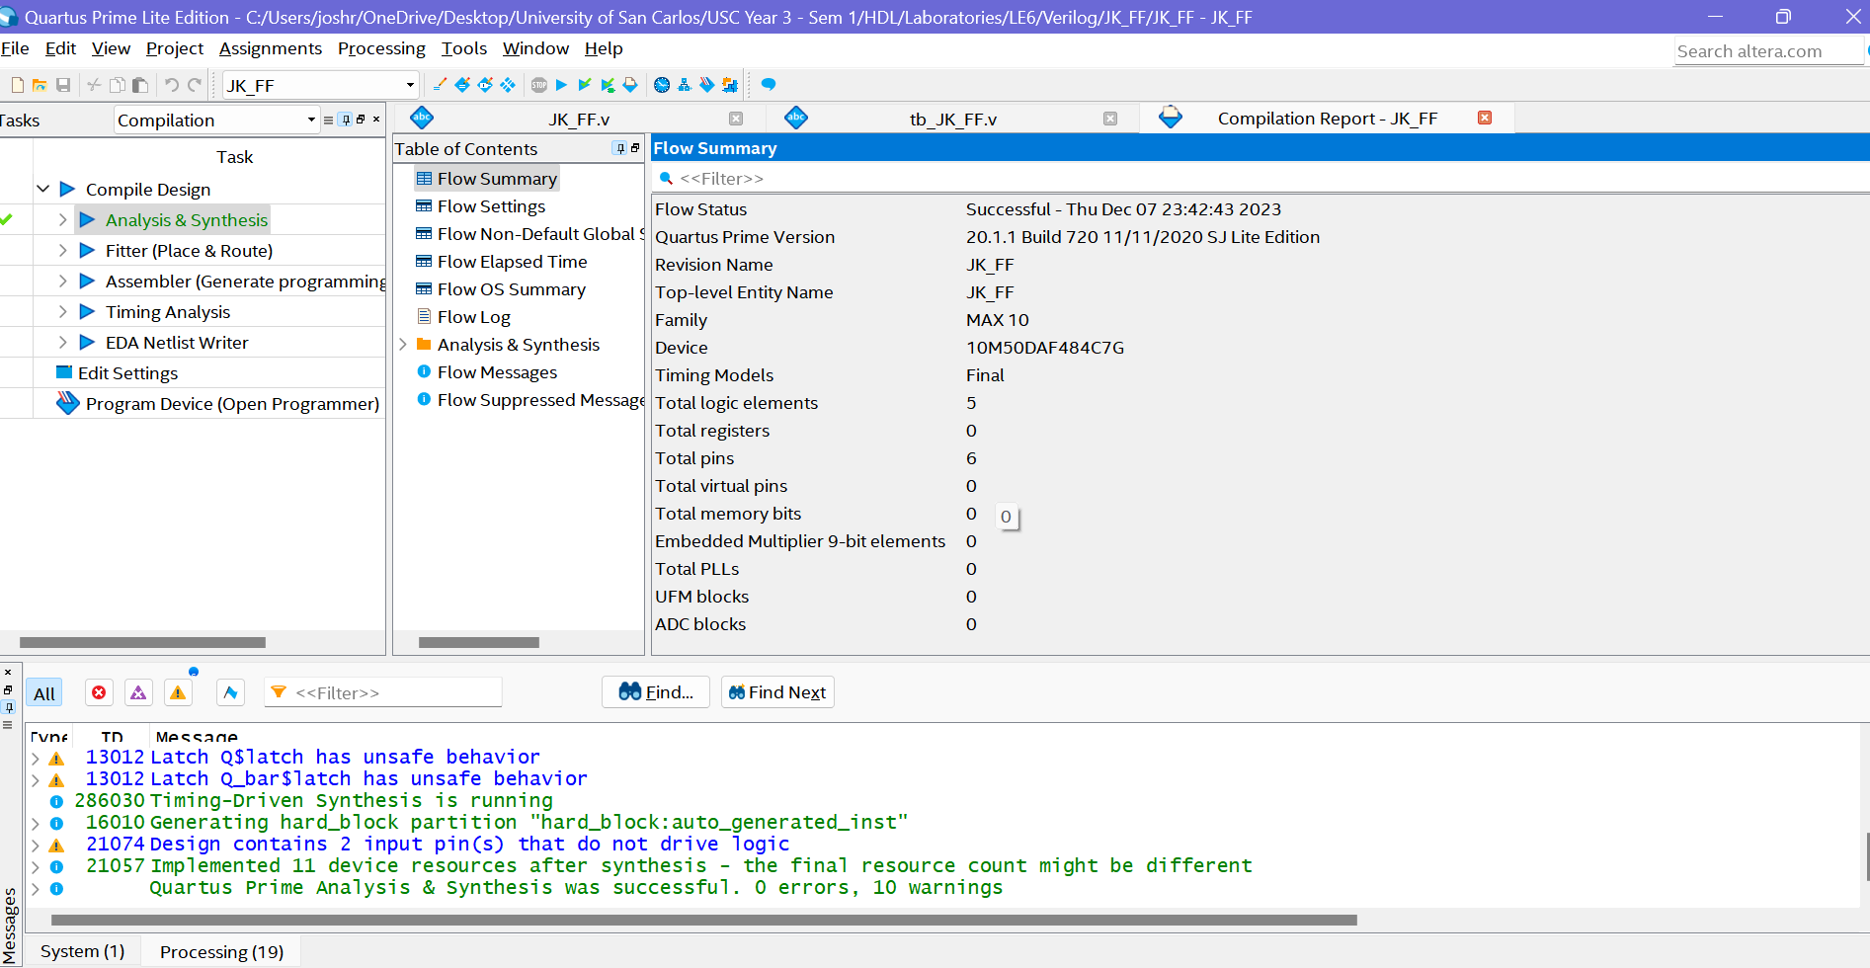

**Figure 1.3** – *JK_FF RTL View Output*

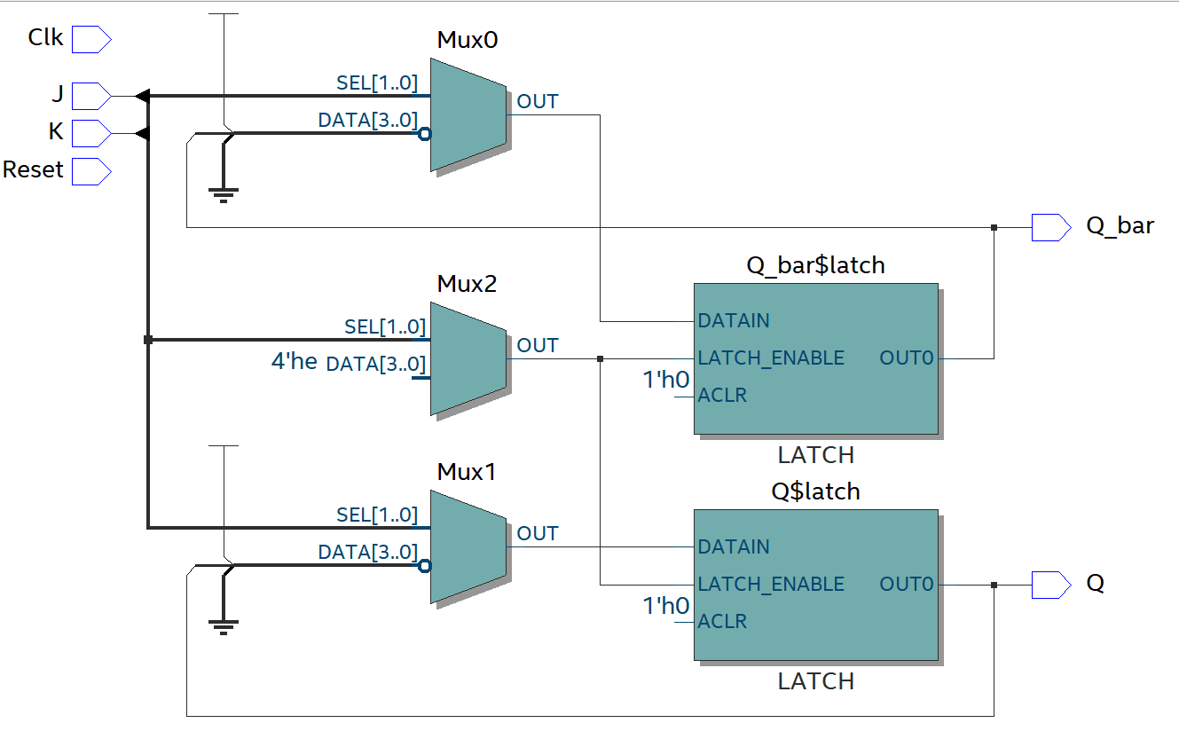

**Figure 1.4** – *tb_* *JK_FF.v Script for Testing Module*

/\**\*\*\*\*\*\*\*\*\*\*\*\*\*\*\*\*\*\*\*\*\*\*\*\*\*\*\*\*\*\*\*\*\*\*\**

*\*   FILE:                   tb_JK_FF.v*

*\*   AUTHOR:             Mohan Francis, Josh Ratificar*

*\*   Class:              Gr.3 CpE 3101L Introduction to HDL*

*\*   Group/Schedule      Friday, 7:30 AM to 10:30 AM*

*\*   Description:        Test Bench for JK_FF.v file*

*\*\*\*\*\*\*\*\*\*\*\*\*\*\*\*\*\*\*\*\*\*\*\*\*\*\*\*\*\*\*\*\*\*\*\**\*/

`timescale 1 ns / 1 ps

module tb_JK_FF();

    reg  J,K,Reset,Clk;

    wire Q,Q_bar;

    JK_FF UUT(

        .J(J),

        .K(K),

        .Reset(Reset),

        .Clk(Clk),

        .Q(Q),

        .Q_bar(Q_bar)

    );

    initial

        Clk = 1'b0;

    always

        #5 Clk = ~Clk;

    initial begin

        Reset = 1'b1;       #10

        Reset = 1'b0;

    end

    initial begin

        $display("Test Bench | JK FLIP FLOP...");

        J = 1'b0;   K = 1'b0; #5

        J = 1'b0;   K = 1'b1; #5

        J = 1'b1;   K = 1'b0; #5

        J = 1'b1;   K = 1'b1; #5

        J = 1'b0;   K = 1'b0; #5

        J = 1'b0;   K = 1'b1; #5

        J = 1'b1;   K = 1'b0; #5

        J = 1'b1;   K = 1'b1; #5

        J = 1'b1;   K = 1'b1; #5

        $stop;

    end

    initial begin

        $monitor("Time = %2d ns | J = %b | K = %b | CLK = %b | RESET = %b | Q = %b | Q_bar = %b", $time, J, K, Clk, Reset, Q, Q_bar);

    end

endmodule

**Figure 1.5** – *JK_FF RTL Simulation Output*

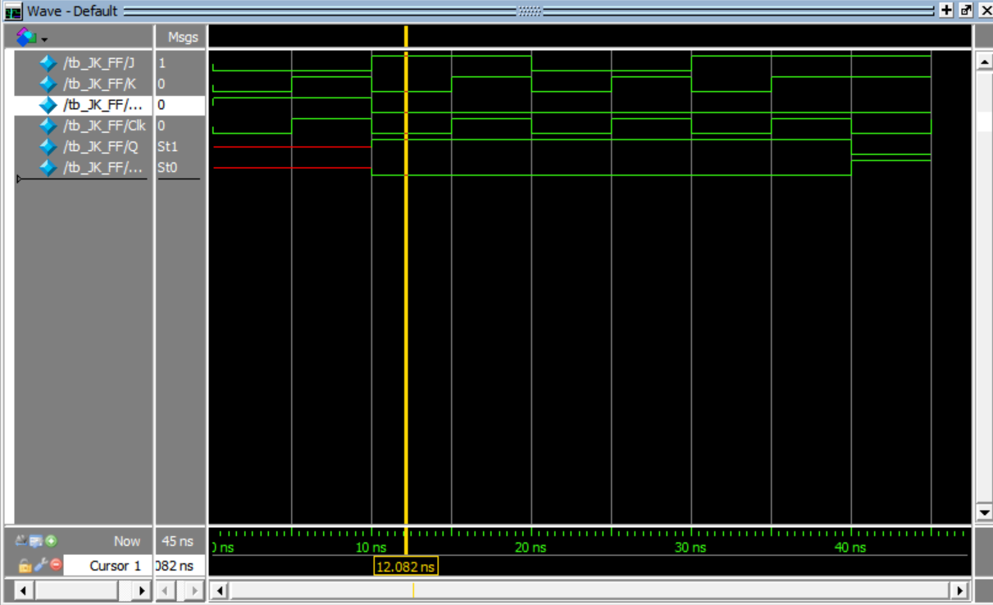

**Figure 1.6** – *JK_FF Test Bench Monitor Output (Annotations to* ***Figure 1.5****)*

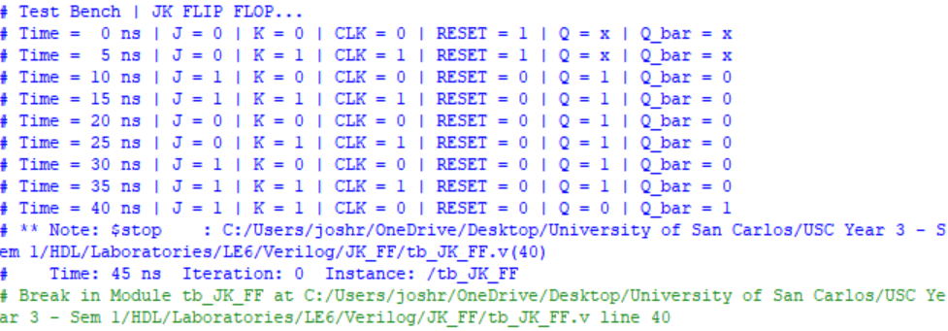

**Discussion of Results (Exercise 5A)**

It appears that the simulation is working as expected according to the JK Flip Flop’s behaviour as seen in **Figure 1.5**. The behaviour expected is that we can set, reset, no-change, and toggle. This can also be seen through **Figure 1.6** where we can see the asynchronous reset being called behaving as expected.

**Exercise 5B:**

**Figure 2.1** – *Counter_4bit.v Script*

/\**\*\*\*\*\*\*\*\*\*\*\*\*\*\*\*\*\*\*\*\*\*\*\*\*\*\*\*\*\*\*\*\*\*\*\**

*\*   FILE:                   Counter_4bit.v*

*\*   AUTHOR:             Mohan Francis, Josh Ratificar*

*\*   Class:              Gr.3 CpE 3101L Introduction to HDL*

*\*   Group/Schedule      Friday, 7:30 AM to 10:30 AM*

*\*   Description:        Counter_4bit.v file*

*\*\*\*\*\*\*\*\*\*\*\*\*\*\*\*\*\*\*\*\*\*\*\*\*\*\*\*\*\*\*\*\*\*\*\**\*/

//*Notes:*

//*nReset   |   Clk   |  Load  |  Count_en  |  Up  |   Counter Operation*

// *0    |    X    |    X   |      X     |  X   |    Reset to 0*

// *1    |    ®    |    1   |      X     |  X   |    Load inputs (parallel load)*

// *1    |    ®    |    0   |      0     |  X   |    No change*

// *1    |    ®    |    0   |      1     |  0   |    Count down*

// *1    |    ®    |    0   |      1     |  1   |    Count up*

module Counter_4bit(

    input Clk, nReset, Load, Count_en, Up,

    input [3:0] Count_in,

    output reg [3:0] Count_out

);

    always @(negedge Clk, negedge nReset)

        begin

            if(nReset == 0) // *Checking for Asynchronous Reset*

                Count_out <= 4'b0000;

            else if(Load == 1) // *Status of Load Pin*

                Count_out <= Count_in;

            else if(Count_en == 1) // *Counter Enable*

                begin

                    if(Up == 1) // *If up is high, then count up*

                        Count_out <= Count_out + 1;

                    else // *If up is low, then we should count down*

                        Count_out <= Count_out - 1;

                end

        end

endmodule

**Figure 2.2** – *Counter_4bit.v Analysis and Elaboration Test Results*

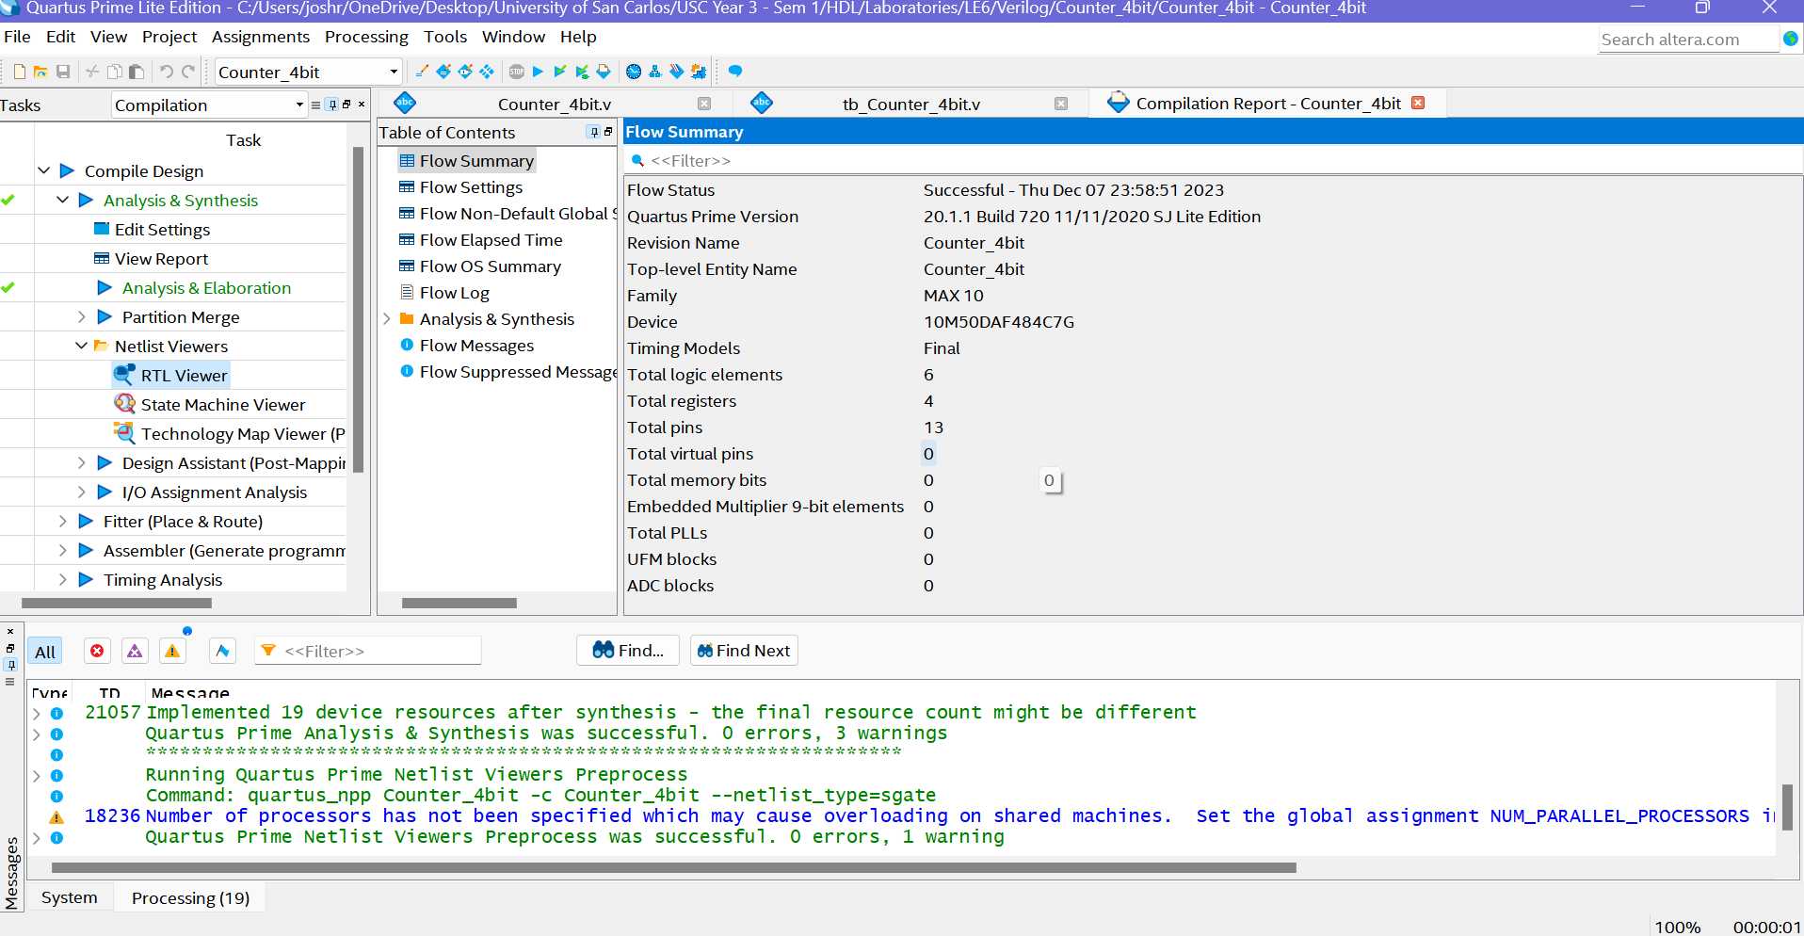

**Figure 2.3** – *Counter_4bit RTL View Output*

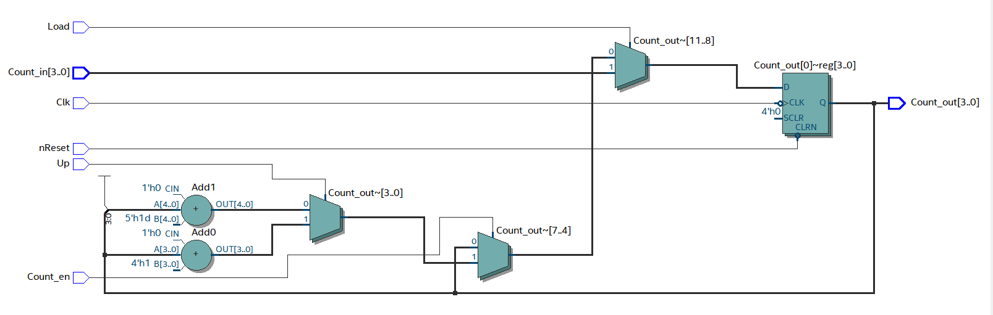

**Figure 2.4** – *tb_ Counter_4bit.v Script for Testing Module*

/\**\*\*\*\*\*\*\*\*\*\*\*\*\*\*\*\*\*\*\*\*\*\*\*\*\*\*\*\*\*\*\*\*\*\*\**

*\*   FILE:               tb_Counter_4bit.v*

*\*   AUTHOR:             Mohan Francis, Josh Ratificar*

*\*   Class:              Gr.3 CpE 3101L Introduction to HDL*

*\*   Group/Schedule      Friday, 7:30 AM to 10:30 AM*

*\*   Description:        Testbench for Counter_4bit.v file*

*\*\*\*\*\*\*\*\*\*\*\*\*\*\*\*\*\*\*\*\*\*\*\*\*\*\*\*\*\*\*\*\*\*\*\**\*/

`timescale 1 ns / 1 ps

module tb_Counter_4bit();

    reg Clk, nReset, Load, Count_en, Up;

    reg [3:0] Count_in;

    wire [3:0] Count_out;

    Counter_4bit UUT(

        .Clk(Clk),

        .nReset(nReset),

        .Load(Load),

        .Count_en(Count_en),

        .Up(Up),

        .Count_in(Count_in),

        .Count_out(Count_out)

    );

    // *Clock generation*

    always #5 Clk = ~Clk;

    // *Initial block for stimulus generation*

    initial begin

        $display("Test Bench | Counter_4bit...");

        $display("Initialize inputs...");

        Clk = 0; nReset = 1; Load = 0; Count_en = 0; Up = 0; Count_in = 4'b0000; #10

        $display("Loading Counter with 15d");

        Load = 1; #10

        Load = 0; #10

        Count_in = 4'b1111; #10; // *15*

        $display("Enabling Counting");

        Count_en = 1; #10

          $display("Countdown:");

        // *Counting down*

        #10 Up = 0; Load = 0; Count_en = 1;  // *14*

        Count_en = 1; #10; // *13*

        Count_en = 1; #10; // *12*

        Count_en = 1; #10; // *11*

        Count_en = 1; #10; // *10*

        Count_en = 1; #10; // *09*

        Count_en = 1; #10; // *08*

        Count_en = 1; #10; // *07*

        Count_en = 1; #10; // *06*

        Count_en = 1; #10; // *05*

        Count_en = 1; #10; // *04*

        Count_en = 1; #10; // *03*

        Count_en = 1; #10; // *02*

        Count_en = 1; #10; // *01*

        Count_en = 1; #10; // *00*

        // *Counting up*

        Up = 1; Count_en = 1; #10;  // *01*

        Count_en = 1; #10; // *02*

        Count_en = 1; #10; // *03*

        Count_en = 1; #10; // *04*

        Count_en = 1; #10; // *05*

        Count_en = 1; #10; // *06*

        Count_en = 1; #10; // *07*

        $display("Resetting");

        nReset = 0; #10;

        nReset = 1; #10;

        $stop;

    end

    initial begin

        $display("Test Bench | Counter_4bit...");

        $monitor("Time = %2d ns | Clk = %b | nReset = %b | Load = %b | Count_en = %b | Up = %b | Count_in = %b | Count_out = %d", $time, Clk, nReset, Load, Count_en, Up, Count_in, Count_out);

    end

endmodule

**Figure 2.5** – *tb_ Counter_4bit RTL Simulation Output*

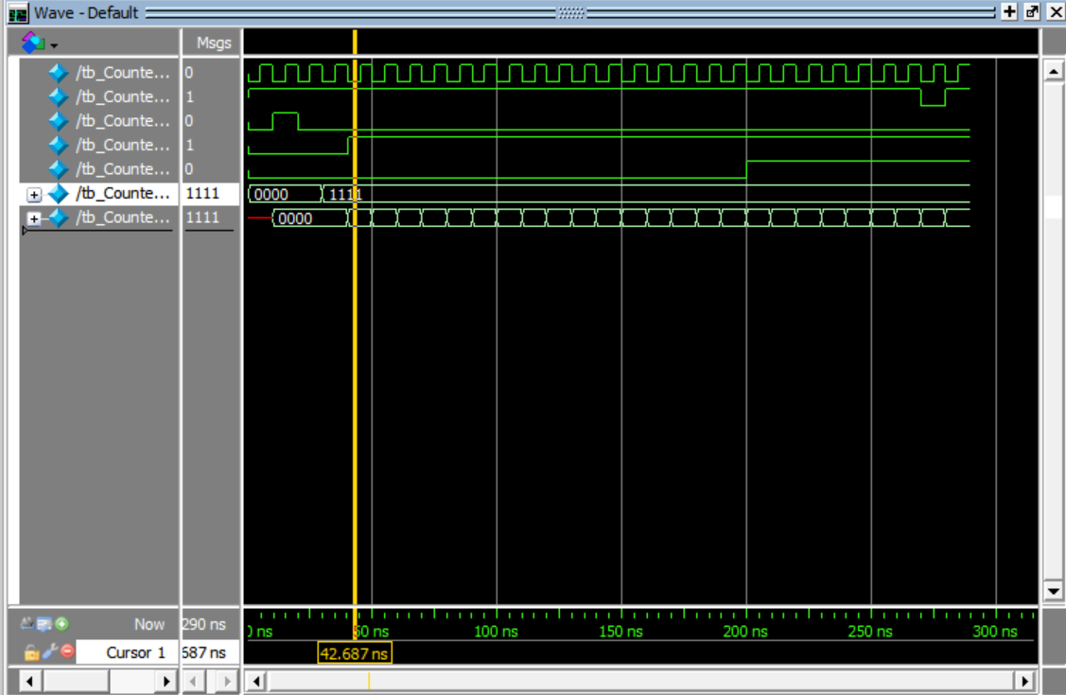

**Figure 2.6** – *tb_ Counter_4bit Test Bench Monitor Output (Annotations to* ***Figure 2.5****)*

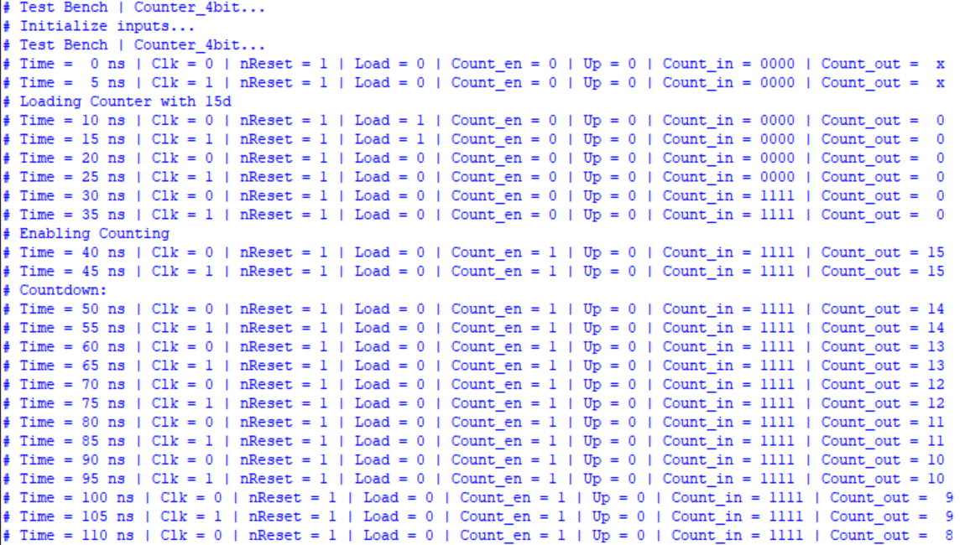

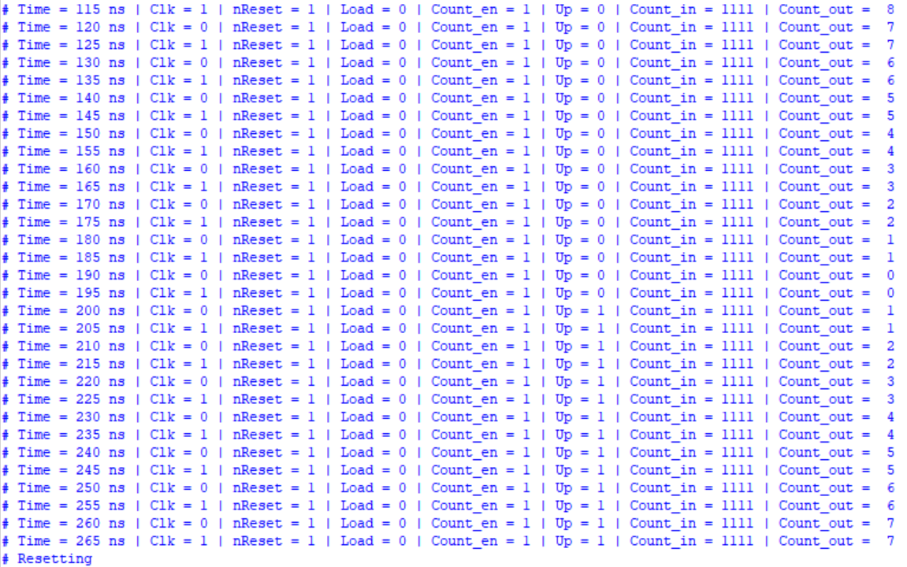

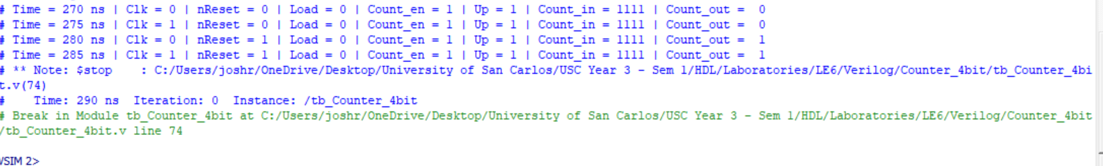

**Discussion of Results (Exercise 5B)**

The 4-bit counter operates as expected as observed in **Figure 2.5**. Through the test bench, we confirmed that the circuit can switch to countdown mode and as well count up mode. The asynchronous active low reset as well works as expected. There is no change when the clock is low which is also the behaviour that is desired. The **Figure 2.6** “$monitor” command really makes it easier to see that this behaviour is consistent.