AYUSH RAWAT MCA (1st Sem) B STD-ID 22391138

**PROBLEM STATEMENT 2:**

Prepare and verify an employee database file (EMPLOYEE) that contains at least 30 employee records under the following columns/fields:

EMP Id, EMP First_Name, EMP Last_Name, Location, Designation, Net Salary, Specialization, Project, Joining Month, Joining_Year.

**Sample Record:**

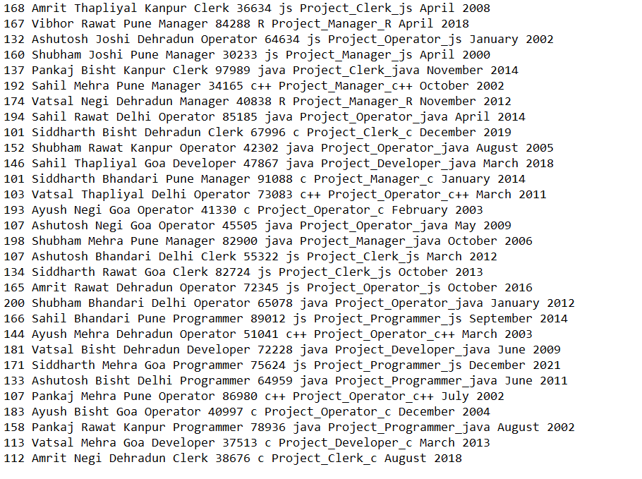

AYUSH RAWAT MCA (1st Sem) B STD-ID 22391138

**PROBLEM STATEMENT 2.1:**

Create and execute AWK script to display EMP Id, Name, location, and Designation of employees having designations as ‘Manager’.

**OBJECTIVE:**

To create and execute AWK script to display EMP Id, Name, location, and Designation of employees having designations as ‘Manager’.

**SHELL SCRIPT:**

BEGIN {

print "Following are the records (Employee Id, Name, location, and Designation) of employees having designations as ‘Manager’:\n"

print "Employee ID, Name, Location, Designation\n"

}

($5 == "Manager") {

print $1 ", " $2 " " $3 ", " $4 ", " $5

}

**Output:**

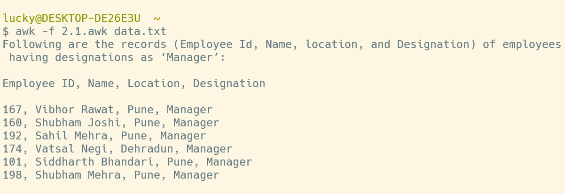

AYUSH RAWAT MCA (1st Sem) B STD-ID 22391138

**PROBLEM STATEMENT 2.2:**

Create and execute AWK script to display EMP Id, Name, specialization, and location of employees who are specialized in Java Programming and are working at Delhi or Pune locations.

**OBJECTIVE:**

To create and execute AWK script to display EMP Id, Name, specialization, and location of employees who are specialized in Java Programming and are working at Delhi or Pune locations.

**SHELL SCRIPT:**

BEGIN {

print "Following are the records (Employee_ID, Name, Specialization, Location) of employees who are specialized in Java Programming and are working at Delhi or Pune locations:\n"

print "Employee_ID, Name, Specialization, Location\n"

}

($7 == "java" && ($4 == "Delhi" || $4 == "Pune")) {

print $1 ", " $2 " " $3 ", " $7 ", " $4

}

**Output:**

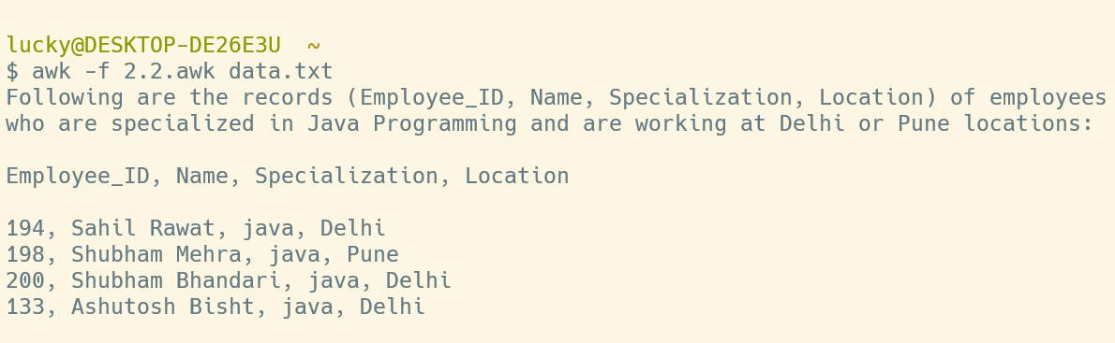

AYUSH RAWAT MCA (1st Sem) B STD-ID 22391138

**PROBLEM STATEMENT 2.3:**

Create and execute AWK script to display EMP Id, Name, location, Designation, and Joining Month, Joining_Year of all those employees who joined after Jan 2000 but before December 2005.

**OBJECTIVE:**

To create and execute AWK script to display EMP Id, Name, location, Designation, and Joining Month, Joining_Year of all those employees who joined after Jan 2000 but before December 2005.

**SHELL SCRIPT:**

BEGIN {

print "Following are the records (Employee Id, Name, location, Designation, Joining Month, Joining_Year) of all those employees who joined after Jan 2000 but before December 2005:\n"

print "Employee Id, Name, location, Designation, Joining Month, Joining_Year\n"

}

($10 >= 2000 && $10 <= 2005) {

run = 1

if (($9 == "January" && $10 == "2000") || ($9 == "December" && $10 == "2005")) {

run = 0

}

if (run == 1) {

print $1 ", " $2 " " $3 ", " $4 ", " $5 ", " $9 ", " $10

}

}

**Output:**

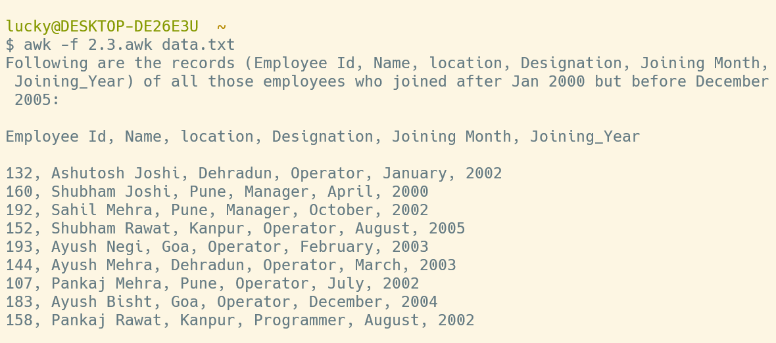

AYUSH RAWAT MCA (1st Sem) B STD-ID 22391138

**PROBLEM STATEMENT 2.4:**

Create and execute AWK script to display all fields of all those employees who joined the organization on the net salary in between 45000-65000, during the period Jan 2000 to December 2005.

**OBJECTIVE:**

Create and execute AWK script to display all fields of all those employees who joined the organization on the net salary in between 45000-65000, during the period Jan 2000 to December 2005.

**SHELL SCRIPT:**

BEGIN {

print "Following are the records of all those employees who joined after Jan 2000 but before December 2005:\n"

print "Employee ID, Employee First_Name, Employee Last_Name, Location, Designation, Net Salary, Specialization, Project, Joining Month, Joining_Year\n"

}

(($6 > 45000 && $6 < 65000) && ($10 >= 2000 && $10 <= 2005)) {

print $1 ", " $2 ", " $3 ", " $4 ", " $5 ", " $6 ", " $7 ", " $8 ", " $9 ", " $10

}

**Output:**

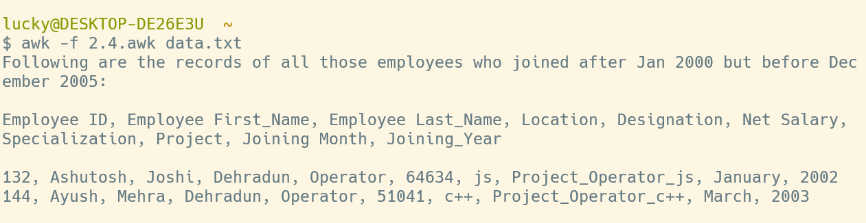

AYUSH RAWAT MCA (1st Sem) B STD-ID 22391138

**PROBLEM STATEMENT 2.5:**

Create and execute AWK script to display all fields of the employee getting the highest salary at the Delhi location.

**OBJECTIVE:**

To create and execute AWK script to display all fields of the employee getting the highest salary at the Delhi location.

**SHELL SCRIPT:**

BEGIN {

print "Following is the record of the employee getting the highest salary at the Delhi location:\n"

print "Employee_ID Employee_First_Name Employee_Last_Name Location Designation Net_Salary Specialization Project Joining_Month Joining_Year\n"

max = 0

max_row = 0

}

($4 == "Delhi") {

if ($6>max) {

max=$6

max_row = $0

}

}

END {

print max_row

}

**Output:**

