PROBLEM STATEMENT 1:

Write a jquery code to hide and show an element on button click.

DESCRIPTION:

The jQuery toggle() function is used to toggle between the hide() and show() methods. When called on an element that is currently hidden, it will show the element. When called on an element that is currently visible, it will hide the element.

HTML:

<!DOCTYPE html>

<html>

<head>

<title>Ayush_RAWAT MCA-B 26</title>

<script src="https://ajax.googleapis.com/ajax/libs/jquery/3.6.0/jquery.min.js"></script>

</head>

<body>

<button id="btnHideShow">Hide/Show</button>

<div id="myDiv">This is my div</div>

<script>

$(document).ready(function() {

$("#btnHideShow").click(function() {]

$("#myDiv").toggle();

});

});

</script>

</body>

</html>

OUTPUT:





PROBLEM STATEMENT 2:

Write a jquery code to change the size, background color of a paragraph when user clicks on it.

DESCRIPTION:

The jQuery css() function is used to get or set the value of a CSS property for a selected element. When called with a single argument, it returns the value of the specified CSS property. When called with two arguments, it sets the value of the specified CSS property to the specified value.

HTML:

<!DOCTYPE html>

<html>

<head>

<title>Ayush_RAWAT MCA-B 26</title>

<script src="https://ajax.googleapis.com/ajax/libs/jquery/3.6.0/jquery.min.js"></script>

</head>

<body>

<p id="myParagraph">This is my paragraph</p>

<script>

$(document).ready(function () {

$("#myParagraph").click(function () {

$(this).css({

"font-size": "3em",

"background-color": "yellow"});})});

</script>

</body>

</html>

OUTPUT:



PROBLEM STATEMENT 3:

Write a jquery code to display text which user enters into the text box dynamically.

DESCRIOPTION:

The jQuery keyup event is triggered when a key on the keyboard is released. This event can be used to bind an action to the release of a specific key, or to bind an action to the release of any key.

HTML:

<!DOCTYPE html>

<html>

<head>

<title>Ayush_RAWAT MCA-B 26</title>

<script src="https://ajax.googleapis.com/ajax/libs/jquery/3.6.0/jquery.min.js"></script>

</head>

<body>

<input type="text" id="myTextBox">

<div id="display"></div>

<script>

$(document).ready(function() {

$("#myTextBox").keyup(function() {

var text = $(this).val();

$("#display").text(text);});});

</script>

</body>

</html>

OUTPUT:



PROBLEM STATEMENT 4:

Write a jquery code to demonstrate fadeIn() with different parameters.

DESCRIPTION:

The jQuery fadeIn() function is used to fade in a hidden element. When called on an element that is currently hidden, it will gradually change the element's opacity from 0 to 1, making it visible. The fadeIn() function takes an optional duration parameter that specifies the length of the fade in effect in milliseconds. It also takes an optional easing parameter that specifies the type of easing to use for the transition.

HTML:

<!DOCTYPE html>

<html>

<head>

<title>Ayush_RAWAT MCA-B 26</title>

<script src="https://ajax.googleapis.com/ajax/libs/jquery/3.6.0/jquery.min.js"></script>

</head>

<body>

<button id="btnFadeIn">Fade In</button>

<div id="myDiv" hidden>This is my div</div>

<script>

$(document).ready(function() {

$("#btnFadeIn").click(function() {

$("#myDiv").fadeIn(500);});});

</script>

</body>

</html>

OUTPUT:





PROBLEM STATEMENT 5:

Write a jquery code to display the content of button in a textbox when user clicks on the button.

HTML:

<!DOCTYPE html>

<html>

<head>

<title>Ayush_RAWAT MCA-B 26</title>

<script src="https://ajax.googleapis.com/ajax/libs/jquery/3.6.0/jquery.min.js"></script>

</head>

<body>

<button id="myButton">Click me</button>

<input type="text" id="myTextBox">

<script>

$(document).ready(function () {

$("#myButton").click(function () {

var text = $(this).text();

$("#myTextBox").val(text);});});

</script>

</body>

</html>

OUTPUT:



PROBLEM STATEMENT 1:

Write a PHP script to display the Factorial of all the numbers from 1-10.

PHP CODE:

<?php

$num = 10;

$factorial = 1;

for ($y=1; $y<=$num; $y++){

for ($x=$y; $x>=1; $x--)

{

$factorial = $factorial * $x;

}

echo "<br/>"."Factorial of $y is $factorial";

$factorial=1;

}

?>

OUTPUT:

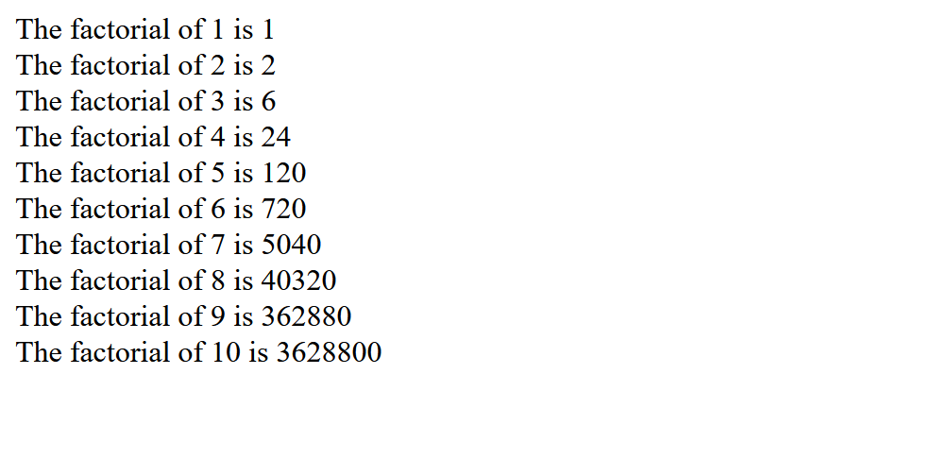

PROBLEM STATEMENT 2:

Write a PHP script to search a given digit in a number.

PHP CODE:

<?php

$num = 1029384756;

$s_num = 6;

$array = str_split($num);

echo "Given number $num" . "<br/>";

for ($x = 0; $x < sizeof($array); $x++) {

if ($array[$x] == $s_num) {

echo "$s_num is at " .($x+1). " position";

}

}

?>

OUTPUT:



PROBLEM STATEMENT 3:

Design an associative, array in PHP, with ‘Course’ as key and ‘Semester’ as value and perform following:

operations (using predefined functions):

i) Sort this array with respect to the key, in ascending order.

ii) Sort this array with respect to the value, in descending order.

PHP CODE:

<?php

$courses = array("MCA" => 2, "MBA" => 4, "B-Tech" => 5, "BCA" => 4, "BSC-IT" => 6);

ksort($courses);

echo "Sorted array with respect to the key, in ascending order:<br>";

foreach ($courses as $key => $value) {

echo "$key: $value<br>";

}

echo "<br>";

arsort($courses);

echo "Sorted array with respect to the value, in descending order:<br>";

foreach ($courses as $key => $value) {

echo "$key: $value<br>";

}

?>

OUTPUT:

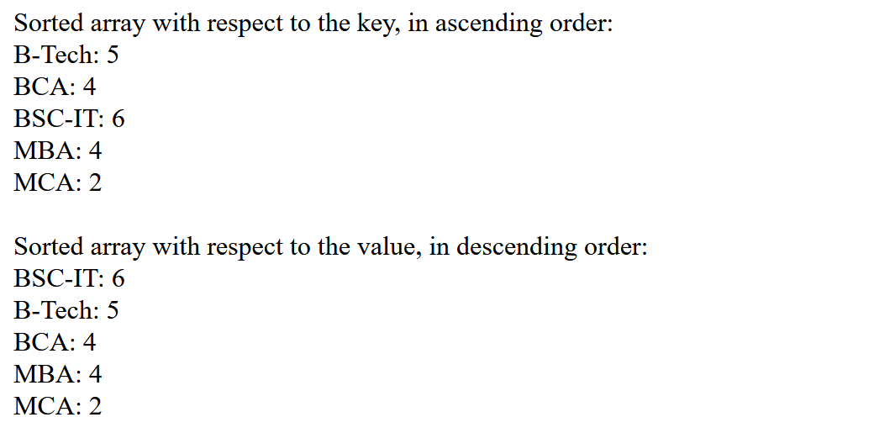

PROBLEM STATEMENT 4:  
Write a PHP script to sort strings using user defined functions.

PHP CODE:

<?php

$test = "Hello!! This is just a test.";

$arr = str_split($test);

echo "Initial array: </br>";

for ($i = 0; $i < sizeof($arr); $i++) {

echo "$arr[$i]";

}

echo "</br> </br>";

sort_string($arr);

function sort_string($arr)

{

$m = 0;

for ($i = 0; $i < sizeof($arr) - 1; $i++) {

$min_ind = $i;

for ($j = $i; $j < sizeof($arr); $j++) {

if ($arr[$j] < $arr[$min_ind]) {

$min_ind = $j;

}

}

$temp = $arr[$i];

$arr[$i] = $arr[$min_ind];

$arr[$min_ind] = $temp;

}

echo "Sorted array: </br> ";

for ($i = 0; $i < sizeof($arr); $i++) {

echo "$arr[$i]";

}

}

?>

OUTPUT:



PROBLEM STATEMENT 5:

Write a PHP script that will give the following Validations on an HTML form :

i) The name field should not be left blank.

ii) The name field should not contain numbers and special characters.

iii) Course can only be ‘MCA’, ‘BCA’ and ‘BTECH’.

iv) Email should contain ‘@’ and ‘.’ symbol.

PHP CODE:

<?php

if ($_SERVER["REQUEST_METHOD"] == "POST") {

$name = $_POST["name"];

$course = $_POST["course"];

$email = $_POST["email"];

$valid = true;

if (empty($name)) {

echo "Name field cannot be left blank.<br>";

$valid = false;

}

if (preg_match('/[^a-zA-Z\s]/', $name)) {

echo "Name field cannot contain numbers or special characters.<br>";

$valid = false;

}

if (!in_array($course, array("MCA", "BCA", "BTECH"))) {

echo "Course can only be 'MCA', 'BCA', or 'BTECH'.<br>";

$valid = false;

}

if (!preg_match('/@/', $email) || !preg_match('/\./', $email)) {

echo "Email must contain '@' and '.' symbols.<br>";

$valid = false;

}

if ($valid) {

echo "Form data is valid!";

}

}

?>

PROBLEM STATEMENT 6:

Write a PHP script to find the occurrence of ‘is’ in a string and replace it by ‘and’.

PHP CODE:

<?php

$string = "This is a test string. And this is the next sentence.";

echo "Text before replace: </br>" . $string;

echo "</br></br>Occurance of string \"is\" in given string is : ";

echo substr_count($string, "is");

echo "<br> </br>";

$new = str_replace("is", "and", $string);

echo "Text after replace: <br/>" . $new;

?>

OUTPUT:

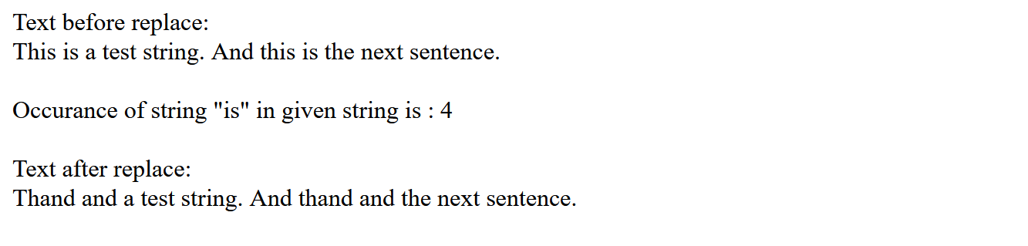

PROBLEM STATEMENT 7:

Write a PHP script that will create a Database ‘Hospital’ and perform following operations :

i) Create a table ‘Doctors’ and put all these details : Id, Name, Specialization, Date_of_joining, Total_experience, Age, Contact_number.

ii) Create table ‘Rooms’/’Wards’ and put all these details : Type, Total_no_of_beds, charges_per_day, number_of_pateints.

iii) Insert values in these 2 tables using forms.

The fields should be validated as :

i) No field should be left blank.

ii) Fields like age,no_of_beds, etc, should only contain numeric values.

iii) The no_of_beds should not exceed 20.

iv) The room should be either ‘general’, ‘ICU’ or ‘private’.

v) The specialization should be ‘physician’, ‘surgeon’, ‘dentist’, etc

vi) Show the details of all the doctors and rooms.

vii) Based on specialization, search the details of the doctors and display.

PHP CODE:

<!DOCTYPE html>

<html lang="en">

<head>

<title>Ayush_Rawat MCA-B 26</title>

</head>

<body>

<!-- Form to insert values into 'Doctors' table -->

<form method="post">

Name: <input type="text" name="Name"><br>

Specialization: <input type="text" name="Specialization"><br>

Date of joining: <input type="date" name="Date_of_joining"><br>

Total experience: <input type="number" name="Total_experience"><br>

Age: <input type="number" name="Age"><br>

Contact number: <input type="number" name="Contact_number"><br>

<input type="submit" name="submit" value="Submit">

</form>

<br><br><br>

<!-- Form to insert values into 'Rooms' table -->

<form method="post">

Type: <input type="text" name="Type"><br>

Total number of beds: <input type="number" name="Total_no_of_beds"><br>

Charges per day: <input type="number" name="charges_per_day"><br>

Number of patients: <input type="number" name="number_of_patients"><br>

<input type="submit" name="submit" value="Submit">

</form>

<br><br><br><br>

<?php

error_reporting(0);

// Connect to MySQL server

$conn = mysqli_connect('localhost:3306', 'root', '');

// Check connection

if (!$conn) {

die("Connection failed: " . mysqli_connect_error());

}

// Create database

$sql = "CREATE DATABASE Hospital";

if (mysqli_query($conn, $sql)) {

echo "Database created successfully\n";

} else {

echo "Error creating database: " . mysqli_error($conn);

}

// Select database

mysqli_select_db($conn, "Hospital");

// Create table "Doctors"

$sql = "CREATE TABLE Doctors (

Id INT(6) UNSIGNED AUTO_INCREMENT PRIMARY KEY,

Name VARCHAR(30) NOT NULL,

Specialization VARCHAR(30) NOT NULL,

Date_of_joining DATE NOT NULL,

Total_experience INT(6) UNSIGNED NOT NULL,

Age INT(3) UNSIGNED NOT NULL,

Contact_number INT(10) UNSIGNED NOT NULL

)";

if (mysqli_query($conn, $sql)) {

echo "Table Doctors created successfully\n";

} else {

echo "Error creating table: " . mysqli_error($conn);

}

// Create table "Rooms"

$sql = "CREATE TABLE Rooms (

Type VARCHAR(10) NOT NULL,

Total_no_of_beds INT(2) UNSIGNED NOT NULL,

charges_per_day INT(6) UNSIGNED NOT NULL,

number_of_patients INT(2) UNSIGNED NOT NULL

)";

if (mysqli_query($conn, $sql)) {

echo "Table Rooms created successfully\n";

} else {

echo "Error creating table: " . mysqli_error($conn);

}

// Validate form input

if (empty($_POST['Name']) || empty($_POST['Specialization']) || empty($_POST['Date_of_joining']) || empty($_POST['Total_experience']) || empty($_POST['Age']) || empty($_POST['Contact_number'])) {

echo "Error: No field should be left blank.";

}

if (!is_numeric($_POST['Age']) || !is_numeric($_POST['Total_experience']) || !is_numeric($_POST['Contact_number'])) {

echo "Error: Fields like Age, Total_experience, and Contact_number should only contain numeric values.";

}

if (!in_array($_POST['Specialization'], ['physician', 'surgeon', 'dentist'])) {

echo "Error: The specialization should be 'physician', 'surgeon', or 'dentist'.";

}

// Insert form data into table "Doctors"

$sql = "INSERT INTO Doctors (Name, Specialization, Date_of_joining, Total_experience, Age, Contact_number)

VALUES ('$Name', '$Specialization', '$Date_of_joining', '$Total_experience', '$Age', '$Contact_number')";

if (mysqli_query($conn, $sql)) {

echo "New record created successfully in Doctors Table.<br>";

} else {

echo "Error: " . $sql . "<br>" . mysqli_error($conn);

}

// Validate form input

if (empty($_POST['Type']) || empty($_POST['Total_no_of_beds']) || empty($_POST['charges_per_day']) || empty($_POST['number_of_patients'])) {

echo "Error: No field should be left blank.";

}

if (!is_numeric($_POST['Total_no_of_beds']) || !is_numeric($_POST['charges_per_day']) || !is_numeric($_POST['number_of_patients'])) {

echo "Error: Fields like Total_no_of_beds, charges_per_day, and number_of_patients should only contain numeric values.";

}

if ($_POST['Total_no_of_beds'] > 20) {

echo "Error: The no_of_beds should not exceed 20.";

}

if (!in_array($_POST['Type'], ['general', 'ICU', 'private'])) {

echo "Error: The room should be either 'general', 'ICU', or 'private'.";

}

// Insert form data into table "Rooms"

$sql = "INSERT INTO Rooms (Type, Total_no_of_beds, charges_per_day, number_of_patients)

VALUES ('$_POST[Type]', '$_POST[Total_no_of_beds]', '$_POST[charges_per_day]', '$_POST[number_of_patients]')";

if (mysqli_query($conn, $sql)) {

echo "New record created successfully";

} else {

echo "Error: " . $sql . "<br>" . mysqli_error($conn);

}

// Show details of all doctors

$sql = "SELECT * FROM Doctors";

$result = mysqli_query($conn, $sql);

if (mysqli_num_rows($result) > 0) {

// Output data of each row

while ($row = mysqli_fetch_assoc($result)) {

echo "Id: " . $row["Id"] . " - Name: " . $row["Name"] . " - Specialization: " . $row["Specialization"] . " - Date of joining: " . $row["Date_of_joining"] . " - Total experience: " . $row["Total_experience"] . " - Age: " . $row["Age"] . " - Contact number: " . $row["Contact_number"] . "<br>";

}

} else {

echo "0 results";

}

// Show details of all rooms

$sql = "SELECT * FROM Rooms";

$result = mysqli_query($conn, $sql);

if (mysqli_num_rows($result) > 0) {

// Output data of each row

while ($row = mysqli_fetch_array($result)) {

echo "Type: " . $row["Type"] . " - Total no of beds: " . $row["Total_no_of_beds"] . " - Charges per day: " . $row["chargescharges_per_day"] . " - Number of Patients: " . $row["number_of_patients"] . "<br>";

}

} else {

echo "0 results";

}

// Search for doctors based on specialization

$sql = "SELECT * FROM Doctors WHERE Specialization = '$_POST[Specialization]'";

$result = mysqli_query($conn, $sql);

if (mysqli_num_rows($result) > 0) {

// Output data of each row

while ($row = mysqli_fetch_array($result)) {

echo "Id: " . $row["Id"] . " - Name: " . $row["Name"] . " - Specialization: " . $row["Specialization"] . " - Date of joining: " . $row["Date_of_joining"] . " - Total experience: " . $row["Total_experience"] . " - Age: " . $row["Age"] . " - Contact number: " . $row["Contact_number"] . "<br>";

}

} else {

echo "0 results";

}

// Close connection

mysqli_close($conn);

?>

</body>

</html>

OUTPUT:

