ByteView Site Plan

Cyle Andrews

WDD 130

Overview

Purpose
The purpose of this site is to provide honest, experience-based reviews of programming languages. The site helps beginners and developers understand each language’s strengths, weaknesses, learning curve, and ideal use cases. It aims to guide users in choosing the best language for their goals, with practical insight and real coding examples.

Audience
This site is designed for new programmers choosing their first language, experienced developers exploring new tools, and students looking for reliable, hands-on perspectives. Anyone interested in software development can benefit from these practical reviews.

Branding

Website Logo


Style Guide

Color Palette
Primary | Secondary | Accent 1 | Accent 2
#726adc | #8dcecc | #fbfef9 | #2c363f

Typography

Heading Font: Roboto Slab

Paragraph Font: Open Sans

Navigation
Home Language Reviews Compare Languages

Content

Home Page
Welcome to ByteView!
Explore hands-on reviews and comparisons of today’s most popular programming languages. Whether you’re new to coding or expanding your skill set, ByteView offers practical insight into how each language performs in real projects.
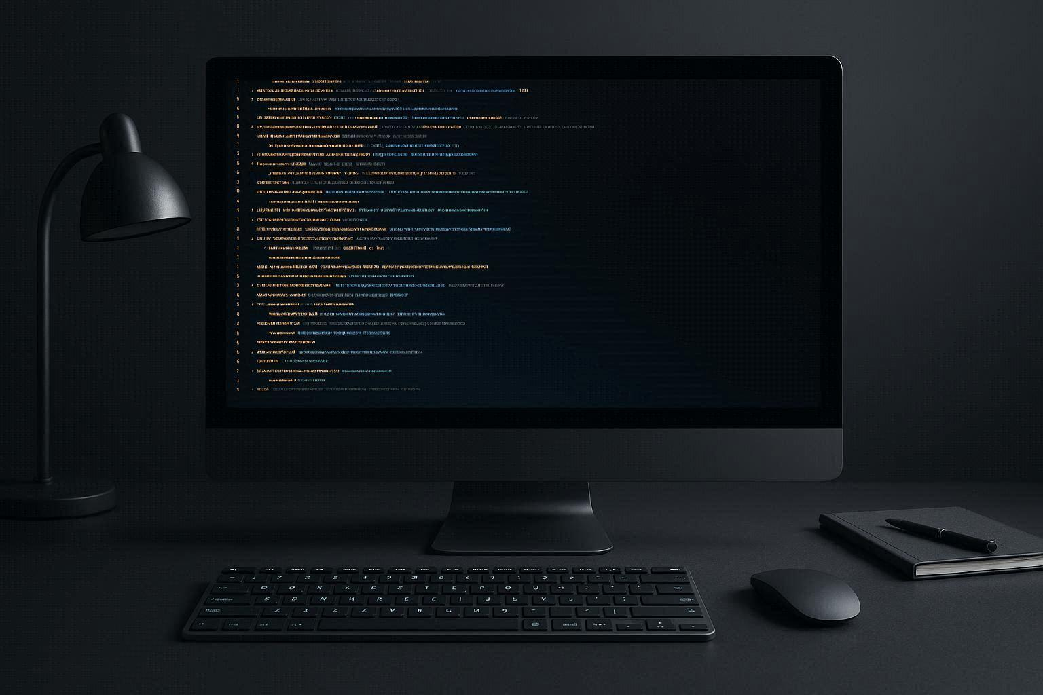

Language Reviews Page
Each review includes:
- Overview and background of the language
- Code syntax and readability examples
- Strengths, weaknesses, and use cases
- Learning curve and tool support
- Personal impressions and final rating
Example Languages:
- Python: Beginner-friendly and versatile
- C++: High performance with steep learning curve
- JavaScript: Core of modern web development


Compare Languages Page
Compare programming languages side by side for speed, readability, and project suitability.
Visual charts and summaries make it easy to see which language fits your needs.
Example Comparison: Python vs. JavaScript for beginner projects.
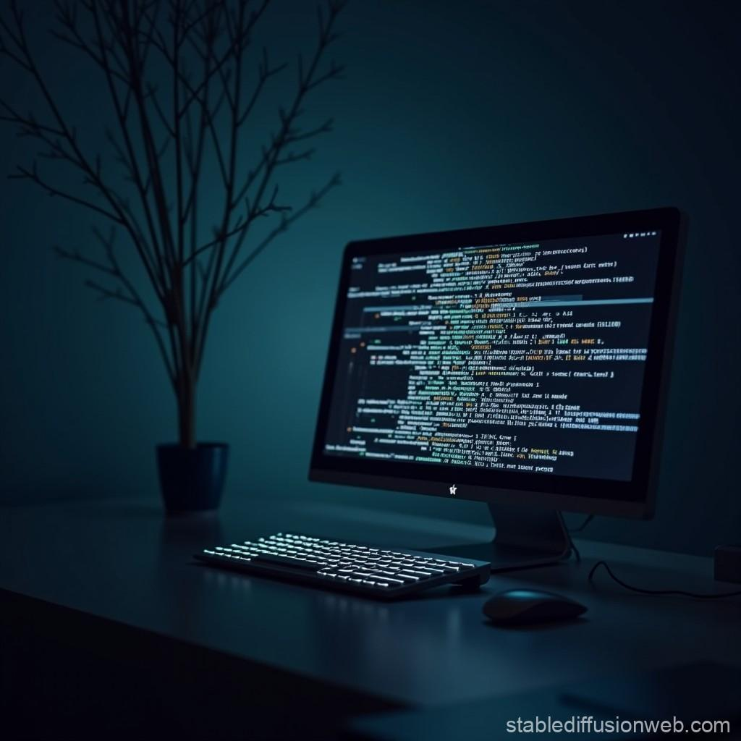

Wireframes

Home

BODY
#2c363f
IMAGE
Paragraph
Footer
Navigation
ByteView
Home

Wireframes

Language Reviews

BODY
#2c363f
IMAGE
Language 1 icon
Footer
Navigation
Language 1 Title
Paragraph
Paragraph
Paragraph
Language 2 icon
Language 2 Title
Paragraph
Paragraph
Paragraph
Language 3 icon
Language 3 Title
Paragraph
Paragraph
Paragraph
ByteView
Language Reviews

Wireframes

Compare Languages

BODY
#2c363f
IMAGE
ByteView
Language Comparison
Footer
Navigation
Language 1 Title
PROS
CONS
Language 2 Title
PROS
CONS
Language 3 Title
PROS
CONS
Language 4 Title
PROS
CONS
Beginner Languages
Compiled languages

