Muhammad Faiq Hakim Ulinnuha, Irena Vanessa Gunawan, Monika Evelin Johan
A Traceable Spatial Database Integrating Sentinel-1, MODIS and GPM IMERG at Sub-district Level for Community-based Hydrometeorological Disaster Mitigation in South Lebak, Indonesia
Abstract:
Community disaster organisations can access open satellite data but rarely have a database that turns these heterogeneous products into stored, comparable and traceable information. Following the Database System Development Life Cycle, this study designs and implements such a database for Gugus Mitigasi Lebak Selatan, a community mitigation group in Banten, Indonesia. Sentinel-1, MODIS and GPM IMERG observations are reduced by area-weighted zonal aggregation to one time series per sub-district, every value is linked to its source file through SHA-256 checksums and a lineage graph, and role-based access control and auditing are enforced inside the database. PostgreSQL with PostGIS was selected over MySQL 8.0 with a weighted score of 4.90 against 3.05. The schema of 43 tables and 22 views passed 1183 of 1185 automated tests (2 skipped), answered all core queries below 2 ms and was restored exactly from backup. GMLS approved the design with revisions, and 13 users completed 62 of 67 task attempts.
Keywords: spatial database, PostGIS, satellite remote sensing, data lineage, disaster mitigation
- Introduction
Disaster management increasingly depends on information systems that collect, integrate and disseminate data before, during and after hazardous events [1]. Recent platforms for large regions show that the value of such systems lies less in a single data source than in the integration of heterogeneous data into one consistent structure that different actors can use [2]. In Indonesia, where floods and landslides are triggered mainly by intense rainfall, hydrological studies at island scale and the evaluation of satellite precipitation have demonstrated that satellite products can fill gaps left by sparse rain gauge networks [3, 4].
Access to satellite data has also become considerably more open. The Copernicus Data Space Ecosystem provides Sentinel data through application programming interfaces and cloud processing [5]. Sentinel-1 synthetic aperture radar (SAR) observes the surface regardless of cloud cover and has been shown to be effective for flood detection [6]. MODIS offers a daily archive of more than two decades with continuity into VIIRS [7], and GPM IMERG supplies global precipitation estimates whose long-term behaviour has been evaluated over land [8]. The three missions are complementary: radar sees water through clouds, optical sensors describe vegetation and water indices on cloud-free days, and IMERG describes the rainfall that drives both.
Open availability does not, however, mean that the data are usable by a local organisation. The products differ in format (GeoTIFF, HDF5, NetCDF), spatial resolution (about 10 m to 0.1°) and temporal frequency (daily to 6–12 days). Without a database that stores them in a structured and comparable form, every analysis has to be repeated from raw files, and nobody can later verify from which file and processing step a reported value came. Studies that combine several sensors typically focus on the analysis of a single event, such as a drought or a flood [9, 10], while open pipelines for Sentinel-1 preprocessing or analysis-ready data concentrate on image processing rather than on persistent storage [11, 12].
This article reports the design and implementation of a hydrometeorological monitoring database for Gugus Mitigasi Lebak Selatan (GMLS), a community mitigation group in South Lebak, Banten. The contribution is a database design, tested on real data and real users, that (1) integrates Sentinel-1, MODIS and GPM IMERG into one time series per sub-district, (2) makes every value traceable to its source file and processing step, (3) supports early warning and the recording of disaster events, and (4) enforces role-based access control and auditing at the database level rather than only in the application. The system, named Orbit-U: The Monitor, is publicly accessible, and its source code is available for reproduction.
- Analysis (state) of the Problems
Integrated geospatial databases have been recommended to reduce duplication and to support local decision making, for example in land-use governance [13]. In the data engineering literature, lineage is treated as structured metadata that should be recorded by the pipeline itself rather than reconstructed afterwards [14]. Role-based access control has been implemented in PostgreSQL through GRANT and REVOKE statements for business information systems [15], and PostGIS has been shown to outperform general relational approaches for spatial storage and proximity queries [16, 17]. These studies address integration, lineage, security and spatial performance separately; none of them combines the three satellite missions into one traceable time series with access control enforced in the database for a community organisation.
Research involving GMLS has so far concerned earthquakes and tsunamis. Earthquake patterns in South Lebak for 2021–2025 were analysed and visualised from the official GMLS dataset [18], and a pre-disaster tsunami dashboard was designed for the village of Panggarangan [19]. Hydrometeorological hazards, which are frequent in the area, have not been addressed.
The current situation at GMLS was analysed through observation, an interview with the chairman of GMLS accompanied by a lecturer involved in earlier community projects, and the examination of GMLS documents and data. The data held by GMLS consist of a demographic assessment of 356 households in the tsunami-prone zone of Panggarangan collected by volunteers in January–June 2021, tables of families, residents, evacuation sites and 25 preparedness activities in 2023, official administrative boundaries and hazard zone maps, and a global earthquake catalogue. A village information application developed with university partners (MySQL, 11 tables) manages the hierarchy of administrative areas, houses with their tsunami-zone status, families and residents. Weather information reaches GMLS from the national meteorological agency through radar images that show areas with potential rain and flooding but are not specific to the locations of residents.
Four problems were therefore formulated: (P1) how to integrate the three satellite sources, with their different formats, resolutions and frequencies, into one structured unit of analysis; (P2) how to make every stored value traceable to its source and processing together with its quality; (P3) how to present the stored data as information that supports monitoring and the recording of disaster events; and (P4) how to secure the data through role-based access control and an audit trail. Demographic and evacuation data remain in the existing village application and are outside the scope of the new database.
- Material and Methods
  - Study area and data
The study area comprises ten sub-districts (kecamatan) of Lebak Regency: Banjarsari, Bayah, Cibeber, Cigemblong, Cihara, Cijaku, Cilograng, Malingping, Panggarangan and Wanasalam (Fig. 1). The boundaries were taken from the Indonesian subnational administrative boundaries dataset (COD-AB) [20]; the total area computed from the polygons is 1575.8 km², ranging from about 94.9 km² (Cilograng) to 400.8 km² (Cibeber). The selection of the ten sub-districts was confirmed by GMLS.
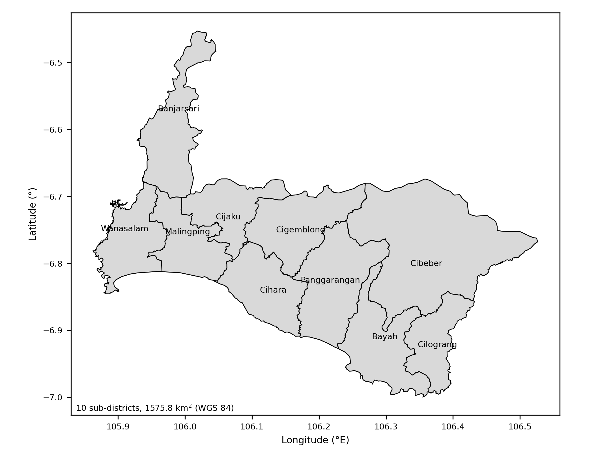
Fig. 1. Study area: ten sub-districts of South Lebak, Banten, Indonesia
Source: Own elaboration based on COD-AB boundaries [20]
The satellite products used are summarised in Table 1. Sentinel-1 SAR is sensitive to open water because smooth water surfaces return little backscatter [21, 22], and global flood mapping with a decade of radar data has confirmed its value at large scale [23]. MODIS daily observations provide surface water dynamics at 250 m [24], but optical pixels are frequently invalid under cloud cover [25]. Because the sources cannot be compared pixel by pixel, the sub-district was chosen as the common unit of analysis.
Table 1. Satellite data sources
Mission | Products | Resolution | Frequency | Provider
Sentinel-1 (S1A, S1C, S1D) | GRD IW, VV and VH polarisation | ≈10 m | 6–12 days per orbit | ESA, CDSE
MODIS Terra and Aqua | MCDWD flood; MOD09A1, MOD09GA (NDVI, NDWI) | 250–500 m | Daily; 8-day composite | NASA LANCE, LAADS DAAC
GPM IMERG | Daily Final, Late and Early runs | 0.1° | Daily | NASA GES DISC
Source: Own elaboration based on [6–8]
The three missions complement rather than duplicate one another. Sentinel-1 is an active radar that observes through cloud but revisits the area only every 6–12 days; MODIS observes daily but loses pixels under cloud; IMERG measures the rainfall that precedes flooding rather than the water itself. Their resolutions also span three orders of magnitude, from about 10 m to 0.1° (roughly 11 km), which is why the values are reduced to the sub-district before they are compared. The IMERG runs differ in latency: Early and Late are available within hours, whereas Final appears about 3.5 months later; a stored value is replaced only by a run that is not worse (Final over Late over Early), so warnings can use near-real-time rainfall while the archive converges to Final.
  - Development method
The Database System Development Life Cycle (DBSDLC) was followed: database planning (mission statement and eight mission objectives), system definition (system boundary and user views for five roles), requirements collection and analysis, conceptual, logical and physical database design, DBMS selection, application design with Unified Modeling Language use case, activity and sequence diagrams [26], prototyping, implementation, data loading and testing. Conceptual design identified entities, relationships, attributes, domains and keys, checked redundancy and validated the model against user transactions. Logical design identified strong and weak entities and multiplicities and normalised the relations to third normal form, with selected relations checked against Boyce–Codd and fourth normal form [27, 28]. Integrity rules were placed in the database as constraints and triggers, following the observation that constraints inferred from application code alone leave data unprotected [29, 30].
Requirements were collected through observation, the interview, document examination, a literature study and a requirements review questionnaire. The questionnaire, written in plain language for non-technical users, asked GMLS to assess six requirements (R1–R6), the recorded information, the system limits and the role assignment, and to approve or reject the design. A second questionnaire was used for a user trial with six task scenarios. Respondents were invited with an explanation of the purpose of the study, participation was voluntary and submission of the questionnaire was taken as consent; respondents are reported by role only, not by name.
  - Zonal aggregation
Each raster is converted to a Cloud-Optimised GeoTIFF per band and reduced to one value per sub-district. Because an IMERG cell of 0.1° covers only one to six cells per sub-district, taking the nearest cell would bias small sub-districts. The value of variable b for sub-district r on date t is therefore computed as the mean of valid cells weighted by the area of intersection between each cell and the sub-district polygon:
${x̄}_{r,b,t}=\frac{\sum_{c∈C_{r}}{A_{r,c}·x_{c}}}{\sum_{c∈C_{r}}{A_{r,c}}}$ (1)
where A_{r,c} is the planar area of the intersection of cell c with polygon r multiplied by the cosine of the cell latitude, an approximation of its area on the sphere, x_{c} is the cell value and C_{r} is the set of valid cells intersecting r. The fraction of the polygon covered by valid cells is stored with each value, so that a value computed from a small cloud-free part of a sub-district can be recognised.
  - DBMS selection and evaluation
DBMS selection followed four steps: establishing the terms of reference, short-listing, evaluating the products and recommending one. PostgreSQL 18.6 with PostGIS 3.6.2 and MySQL 8.0.40 Community were short-listed; MongoDB 7 was assessed only by features because it does not support foreign keys. Both relational candidates received an equivalent schema with the same types, keys, constraints and indexes, including spatial indexes, and the same deterministic synthetic data with default configurations: a grid of 28 synthetic sub-district polygons, ten of which form the area of interest so that spatial predicates also meet neighbouring areas, 76 720 observations, 1076 warnings and 150 events, the latter allowing Q4 to be measured although no verified official events exist yet. All tests ran on one machine (Intel Core i7-7700, 4 cores and 8 threads, 32 GB RAM, Windows 10), and the data directories of both systems were placed on the same 7200 rpm HDD with a 128 MB buffer and a flush to disk on every commit, so that storage-sensitive results are comparable. Five core queries (Q1–Q5) were each executed 30 times after 5 warm-up runs in three separate runs, and medians are reported. Security features (F1–F3), scalability (a monthly summary per sub-district over the whole table, Q6, at 1, 10 and 30 times the data volume, up to 2.3 million rows), concurrency and write throughput were tested in addition. Write tests were repeated in two sessions, and because PostgreSQL varied between sessions on the HDD, their results are reported as ranges. PostgreSQL was accessed through psycopg2, a C-based driver; MySQL was measured with the pure-Python PyMySQL for the core queries, and the scalability, concurrency and write tests were repeated with the C-based mysqlclient, so that the overhead of a Python driver does not penalise MySQL. The products were scored from 1 to 5 on seven weighted criteria. Performance criteria were scored by the ratio of the slower to the faster system, computed from the summed median times of the tests behind each criterion so that the test with the largest absolute delay dominates: 5 for the faster system or a difference within 10%, 4 for less than 2 times, 3 for 2–5 times, and 2 for more than 5 times or when a query had to be rewritten; feature criteria received 5 when the feature is native, 2 when it needs a workaround and 1 when it cannot be provided. Cost, ecosystem and familiarity was scored qualitatively. The weights were set by the authors from the problem formulation (P1–P4), not elicited from GMLS. The total score was calculated as:
$S=\sum_{i=1}^{7}{w_{i}·s_{i}}$ (2)
where w_{i} is the weight and s_{i} the score of criterion i. The six minimum evaluations of the design were requirements review, integrity, functional, security, query and backup/recovery testing. Integrity and functional behaviour were tested with automated black-box scenarios through the REST API [31], security with a GRANT matrix and API tests for every role, and recovery with dump-and-restore and process-kill scenarios.
- Results and Discussion
  - Architecture and implementation
The implemented architecture has four layers (Fig. 2). A Python extract–transform–load (ETL) layer, scheduled with an advisory lock so that only one instance runs a job, downloads products from the official providers, processes them through ordered tiers, writes rasters to the file system and values to the database under a dedicated ETL role. A FastAPI REST API connects under a separate application role and switches to the role of the requesting user for every transaction. A web client presents current conditions per sub-district, satellite images, warnings and disaster events. The production system runs in a Linux container (LXC) on a Proxmox VE host provided by The IO Foundation, with four virtual CPUs of an AMD Ryzen AI 9 HX 370 processor, 8 GB of memory and a 98 GB volume on an NVMe SSD, under Ubuntu 24.04 and PostgreSQL 18.6. The implemented schema contains 43 tables, 22 views, 528 columns, 226 constraints, 162 indexes, 29 triggers and 3 row-level security policies. It holds 12 master tables and 17 transaction tables with at least 100 records each, including 72 850 sub-district observations, 15 850 data products, 8142 lineage edges and 7958 processing jobs.
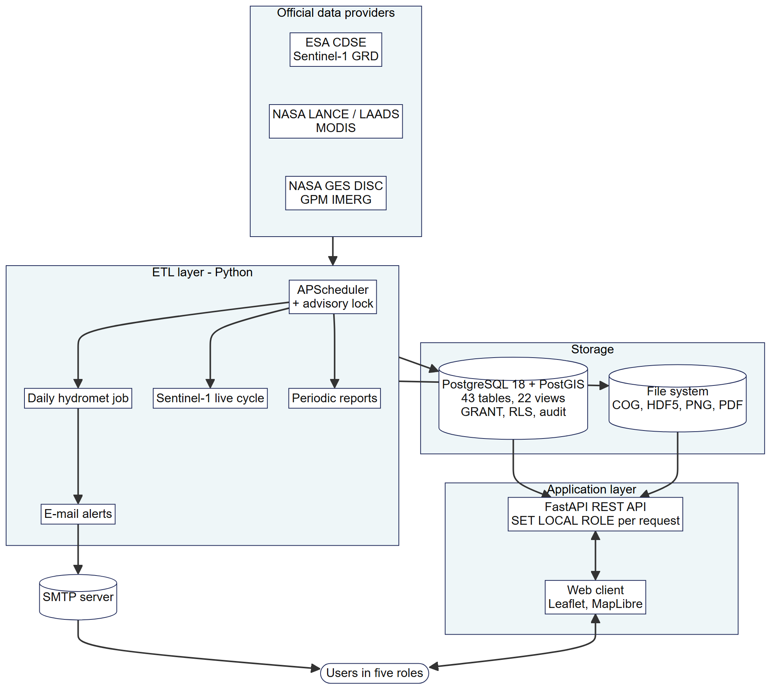
Fig. 2. System architecture of Orbit-U: The Monitor
Source: Own elaboration
Two properties of this architecture are not visible from the layers alone. First, the database stores only values and metadata, while the raster files stay in the file system; the database therefore remains small enough for a regular dump, and lost rasters can be regenerated from the providers. Second, the ETL and the API never share a role: the API cannot write observations, and the ETL cannot read user accounts, so an error or misuse in one layer does not reach the data of the other. The web client never connects to the database directly.
  - Integration and traceability (P1, P2)
The core of the design is the relation region_observations (Fig. 3), with the alternate key (region_id, band_id, obs_date). Eleven variables from three missions are stored as rows rather than columns: VV and VH backscatter, water percentage and water change from Sentinel-1; MODIS flood fraction, NDVI and NDWI; and 24-hour, 72-hour, 7-day and 30-day rainfall from IMERG. Adding a variable therefore requires a new row in spectral_bands, not a change of schema. Each band defines physical limits, and a trigger rejects values outside them, for example negative rainfall caused by a processing error.
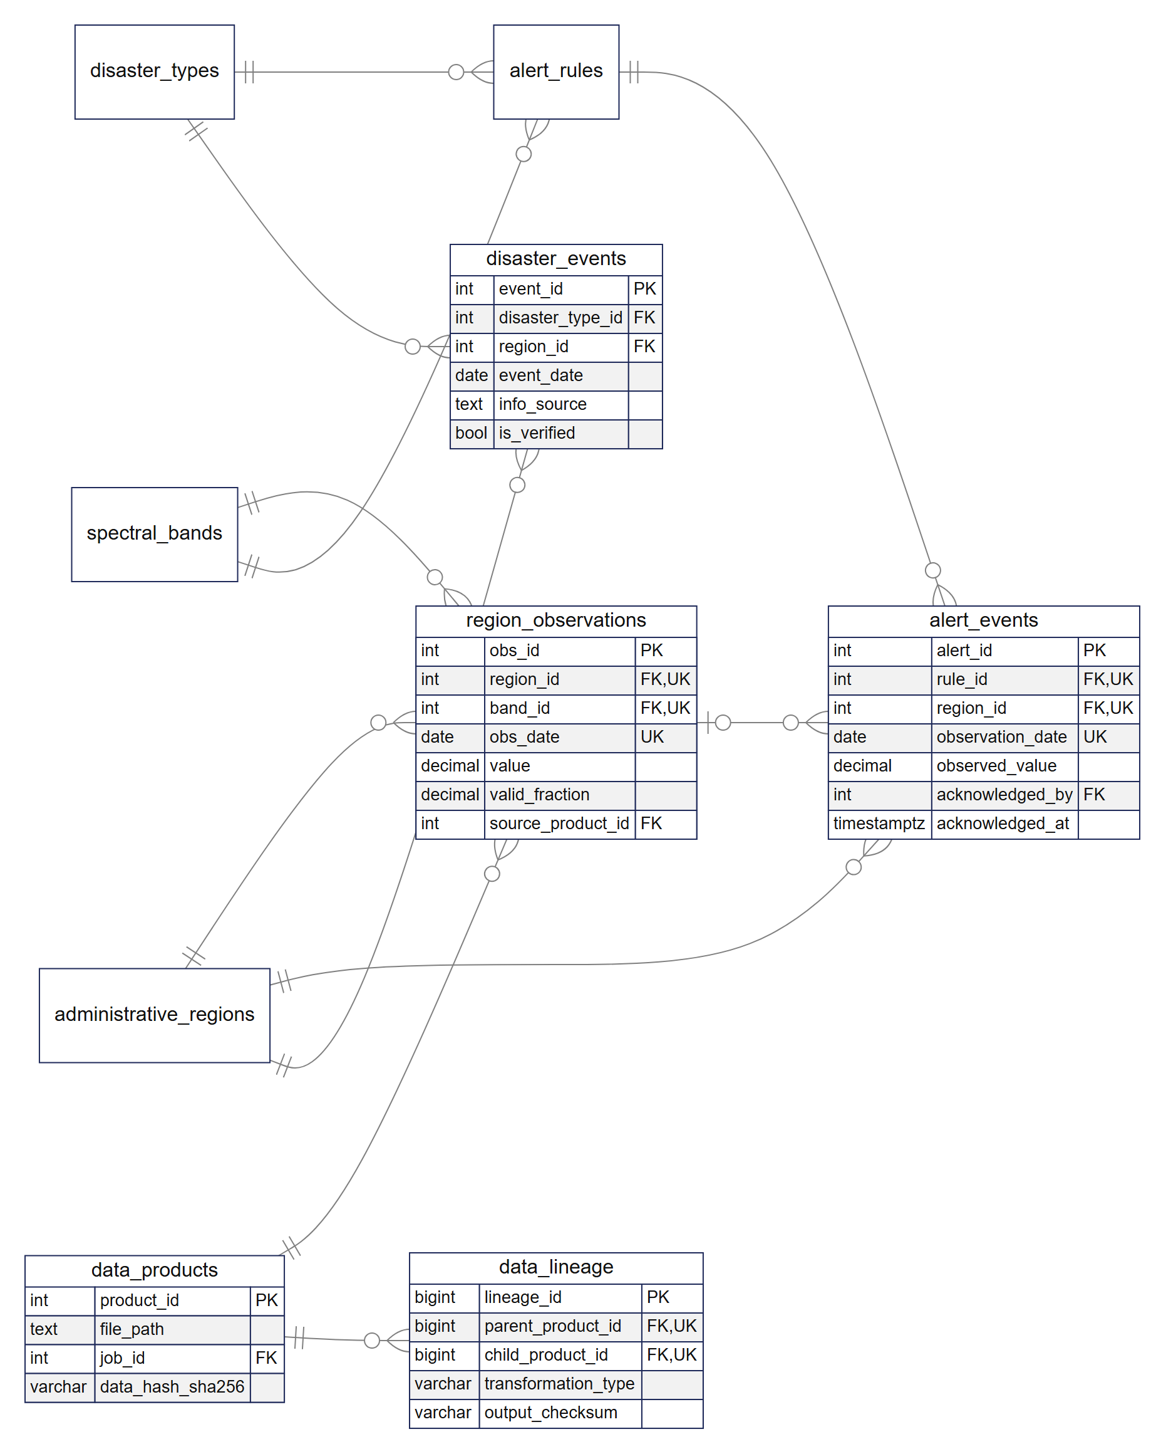
Fig. 3. Core relations for observations, lineage, warnings and events (crow's foot notation)
Source: Own elaboration
The relation was obtained by normalisation of an unnormalised observation record that repeated the name of the sub-district, its regency, the band, its unit and the satellite in every row. Moving the attributes of the area and of the band to their own relations removed the partial dependencies (2NF); making the regency a recursive reference to the area relation through parent_region_id and moving the satellite attributes to a source relation removed the transitive dependencies (3NF). Weak and dependent entities, such as warnings that cannot exist without their rule and sub-district, are identified by composite unique keys. In total the schema defines 43 primary keys, 80 foreign keys, 36 unique and 67 check constraints.
Physical design followed the observed access patterns. GiST indexes serve spatial predicates on boundaries, scene footprints and event locations; descending B-tree indexes serve the most recent values of a time series; a partial index covers only unacknowledged warnings; expression indexes support case-insensitive searches; and two B-tree indexes on the lineage edges allow traversal in both directions. Raster files are kept in the file system in ordered tiers from raw data to Cloud-Optimised GeoTIFF, while the database stores only their metadata, location and checksum. User views are implemented as database views whose time window depends on the active database role: visitors see 30 days of satellite images, volunteers 365 days and the other roles the full archive. Controlled redundancy was introduced only where a value is read repeatedly and its consistency can be maintained by a trigger or a scheduled job.
Because GMLS had no previous hydrometeorological database, no data conversion was required. Loading started from an empty database: the schema, security objects and reference data were applied in order, the COD-AB boundaries were loaded and the ten sub-districts of the study area flagged, and GPM, MODIS and Sentinel-1 data were backfilled. As of 24 October 2026, the database held 72 850 observations from 1 January 2024 to 22 October 2026 and 210 warnings generated from them. Large-scale flood hazard assessments have shown that such multi-year satellite records are needed before the behaviour of an area can be interpreted [32].
Traceability is provided by three relations. data_products records every file with its SHA-256 checksum, data_lineage records each transformation as an edge between a parent and a child product with input and output checksums, and processing_jobs stores the parameters of every stage. Any value can be followed through source_product_id and a recursive query to the raw file it came from, and quality metrics are compared with configurable thresholds. This corresponds to treating lineage as structured metadata recorded by the pipeline [14], and it answers the question that GMLS raised in the interview: where a number shown to residents comes from.
  - DBMS selection
Median execution times of the core queries are given in Table 2 and Fig. 4. PostgreSQL was faster in Q1–Q4, most clearly in the spatial intersection with geodesic area (Q3, 16 times) and the evaluation of warnings against events (Q4, 14 times). The equivalent Q3 even failed in MySQL with error 3516, because the geographic intersection produced a GeometryCollection, and had to be rewritten specifically for MySQL. MySQL was faster in the recursive lineage query Q5, although both completed below 1 ms. Row counts of every query were identical in both systems, and the intersection areas of Q3 agreed per sub-district within 0.1%. In the scalability test, the summary query Q6 over 2.3 million rows took 579 ms in PostgreSQL and 1666 ms in MySQL (2.9 times with mysqlclient), with the p95 of MySQL rising to 6.0 s; PostgreSQL was 11–35% faster under concurrent reads and 4.4–6.2 times faster for inserts. Both data directories resided on the same physical disk, and the row counts of the 2.3-million-row test were identical.
Table 2. Median execution time of core queries [ms]
Query | Content | PostgreSQL | MySQL | MySQL/PG
Q1 | Rainfall pivot per sub-district, one date | 0.45 | 0.87 | 1.9×
Q2 | 30-day trend, one sub-district and band | 0.31 | 0.68 | 2.2×
Q3 | Polygon intersection with geodesic area | 1.15 | 18.63 | 16×
Q4 | Warning evaluation: hits, misses, false alarms | 1.06 | 15.13 | 14×
Q5 | Six-level lineage (WITH RECURSIVE) | 0.65 | 0.45 | 0.7×
Source: Own elaboration
The ratio column should be read together with the absolute times. In Q1, Q2 and Q5 the difference is below 1 ms and is not noticeable to a user, so MySQL's advantage in Q5 is not decisive. The differences that matter are in Q3 and Q4, about 17 ms and 14 ms per execution, because these queries are repeated for every sub-district and warning in the daily job and grow with the archive, as the 2.3-million-row test shows.
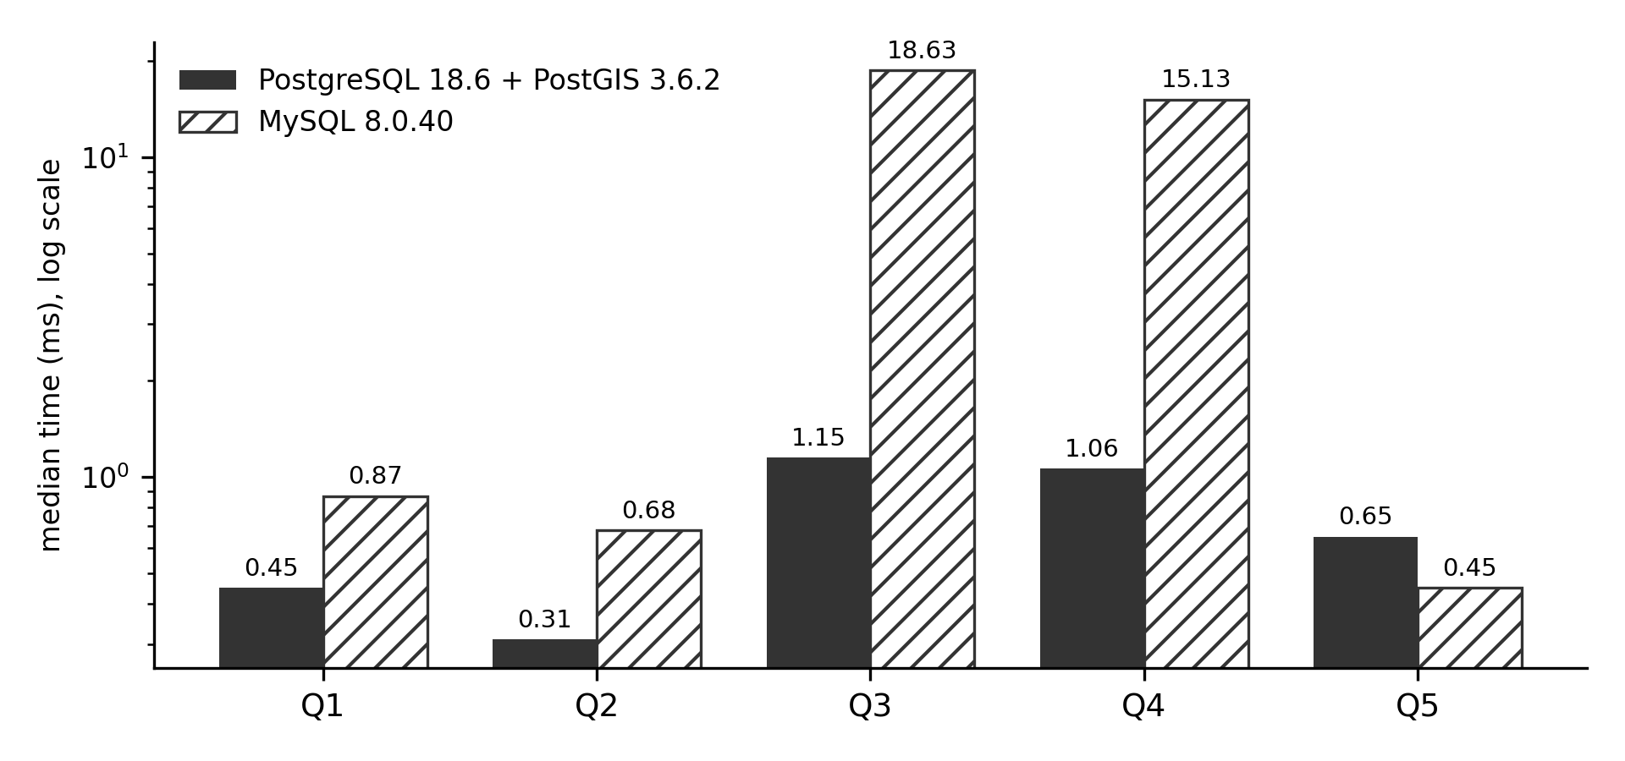
Fig. 4. Median execution time of core queries (logarithmic scale)
Source: Own elaboration
The decisive differences were functional rather than temporal (Table 3). PostgreSQL supports SET LOCAL ROLE, which narrows privileges for one transaction and reverts automatically, row-level security policies and a single audit trigger function that stores old and new rows as JSON. MySQL 8.0 switches roles only per session while the account privileges remain effective, has no row-level security and requires a trigger per table for auditing. MySQL scored higher only on cost, ecosystem and familiarity, because the existing village application uses MySQL. A first run with PostgreSQL on an SSD and MySQL on an HDD overstated the storage-sensitive differences: with the same PyMySQL client, the summary query Q6 shrank from 8.5 to 2.8 times and inserts from 8.2 to 4.4–6.2 times once both systems were placed on the same disk. The spatial query (17 to 16 times) and the security features did not change, and the warning evaluation Q4 even widened from 9 to 14 times, so the advantage of PostgreSQL in these queries does not stem from the storage medium. MySQL's analytics score therefore rose from 2 to 3 and its total from 2.90 to 3.05, still below 4.90, because the largest differences come from security and spatial queries, which do not depend on the storage medium. This agrees with earlier comparisons that favour PostGIS for spatial workloads [16, 17].
Table 3. Weighted scores of the DBMS selection
Criterion | Weight | PostgreSQL | MySQL | Basis
Role-based security and audit | 25% | 5 | 2 | F1–F3
Spatial queries | 20% | 5 | 2 | Q3 16×, rewritten (error 3516)
Analytics and scale | 15% | 5 | 3 | Q4 14×, Q6 2.9×; summed 2.9×
ETL writes | 10% | 5 | 3 | Insert 4.4–6.2×, upsert 1.3–2.2×; summed 3.2–5.0×
Concurrent reads | 10% | 5 | 4 | 11–35%
Relational and recursive integrity | 10% | 5 | 5 | Both support FK
Cost, ecosystem, familiarity | 10% | 4 | 5 | MySQL used locally
Total | 100% | 4.90 | 3.05
Source: Own elaboration
Following the problem formulation, role-based security and audit carry the largest weight because the database must protect warnings and user accounts (P4), followed by spatial queries, which are the basis of the zonal aggregation. Of the total difference of 1.85 points, role-based security contributes 0.75 and spatial queries 0.60, that is almost three quarters; integrity contributes nothing because both systems scored 5, and cost, ecosystem and familiarity is the only criterion in favour of MySQL, by 0.10.
  - Information, access control and audit (P3, P4)
Information is presented through 22 views, the REST API and the web client: current conditions for the sub-district in which the user is located, rainfall warnings based on the 50, 100 and 150 mm thresholds of the national meteorological agency sent by e-mail to subscribed users, an archive of disaster events with their source and verification status, and periodic reports. A warning is recorded once per rule, sub-district and day (a unique constraint), and a check constraint ensures that the person and the time of acknowledgement are always recorded together. Five application roles (visitor, volunteer, analyst, data engineer and administrator) are mapped to five PostgreSQL roles. The API role is NOINHERIT and has no privileges until it switches role, and no application role is a superuser or may bypass row-level security. Views restrict the time window visible to each role, and the audit trigger writes every change of important tables to audit_log. In the security tests, queries under an unauthorised role were rejected by the database even when the checks in the API were disabled, which extends the GRANT-based approach of [15] with per-transaction role switching and row-level security.
  - Evaluation
The results of the six minimum evaluations are summarised in Table 4. The automated test run comprised 1185 test cases, of which 1183 passed, none failed and 2 were skipped because they require the full boundary shapefile; an earlier run had revealed two failures, which were corrected before the final run. All five core queries finished below 2 ms, and the system reached 8204 queries per second with eight clients. Backup and recovery were tested on a copy of the production database with 44 tables (the 43 tables of the schema plus the PostGIS table spatial_ref_sys) and 146 541 rows: after restore, the MD5 hashes of all rows, sequences, constraints and 163 indexes (including the primary key of spatial_ref_sys) were identical, which corresponds to the role of log and dump structures in reliable recovery [33]. A backfill killed during processing resumed only the remaining dates without duplicates.
Table 4. Results of the six minimum evaluations
Evaluation | Evidence | Result
Requirements review | Questionnaire, three GMLS respondents | Approved (two with revisions)
Integrity | Schema, constraint, comment and audit tests | Passed
Functional | Black-box scenarios through the REST API | Passed
Security | 165 API cases, GRANT matrix of 390 cells | Passed
Query | Benchmark Q1–Q6, concurrency, writes, F1–F3 | All core queries < 2 ms
Backup/recovery | Dump and restore, process kill and resume | Passed; identical MD5
Source: Own elaboration
In the requirements review, all three GMLS respondents (the chairman and two volunteers) assessed R1 and R3–R6 as appropriate. For R2, notification of abnormal conditions, one respondent agreed, one asked for a change and one disagreed, because residents use mobile phones more than e-mail. GMLS approved the design, two respondents with revisions. Notification by SMS or messaging applications was not implemented because these services charge per message or subscription, which exceeded the budget of the study; the subscription and delivery tables do not depend on the channel, so the database can support such a channel without change. In the user trial, 13 respondents (three participants of a university community project working with GMLS and ten students outside engineering representing lay users) made 67 attempts at six scenarios, of which 62 (92.5%) succeeded with a mean ease rating of 4.36 out of 5. The remaining attempts concerned saving the e-mail subscription, which requires signing in first, and finding the event list; the application log showed no errors, and other respondents completed the same scenarios. Nine respondents judged the application ready for use and four ready with improvements, mainly larger fonts, plainer language and an in-application guide.
  - Limitations
The accuracy of warnings can be evaluated through a dedicated view that classifies hits, misses and false alarms, but at the time of writing no verified official hydrometeorological events were available for the study area, so this evaluation remains empty. IMERG is known to underestimate extreme daily rainfall [4], and the warnings inherit this limitation. Point-in-time recovery was not tested because WAL archiving was not enabled, and raster files are not backed up because they can be regenerated from the providers while the values per sub-district remain in the database. The benchmark used synthetic data, default configurations and an HDD on a single desktop machine; absolute write times on an SSD or on the production server would be lower, and tuned configurations could change the ratios, although not the missing features of MySQL 8.0 (per-transaction role switching and row-level security).
- Conclusion
A spatial relational database was designed and implemented with the DBSDLC for a community disaster mitigation group. Sentinel-1, MODIS and GPM IMERG observations were integrated into one time series per sub-district by area-weighted zonal aggregation, with eleven variables stored as rows so that new variables do not change the schema. Every value is traceable to its source file through checksums and a lineage graph, and role-based access control and auditing are enforced in the database itself. PostgreSQL with PostGIS was selected over MySQL 8.0 with a weighted score of 4.90 against 3.05, measured with both systems on the same disk. All six minimum evaluations were met, GMLS approved the design with revisions, and lay users completed 92.5% of task attempts.
The design shows that a community organisation without its own hydrometeorological data can obtain a traceable data source from open satellite missions when the database, rather than the application, carries integration, lineage and security. Future work should add notification through mobile messaging when funding is available, evaluate warning accuracy as verified events accumulate, allow residents to report events that remain unverified until reviewed by an analyst, and enable continuous WAL archiving for point-in-time recovery.
Funding
This research received no specific grant from any funding agency in the public, commercial, or not-for-profit sectors.
CRediT Author Contribution
M. F. H. U.: conceptualization, methodology, software, validation, formal analysis, investigation, data curation, writing – original draft preparation, visualization. I. V. G.: conceptualization, validation, supervision, writing – review and editing. M. E. J.: conceptualization, validation, supervision, writing – review and editing.
Declaration of Competing Interests
The authors declare that they have no known competing financial interests or personal relationships that could have appeared to influence the work reported in this paper.
Data Availability
The source code, DDL scripts, queries, configuration, data dictionary and instructions for reproduction are available at https://github.com/not-notyou-you/orbit_u_monitor, and the implemented system is accessible at https://orbit-u.hakimhakim.workers.dev/. Satellite data are publicly available from the Copernicus Data Space Ecosystem and NASA Earthdata. Demographic data of GMLS contain personal information of residents and are not shared; access may be requested from GMLS.
Use of Generative AI and AI-Assisted Technologies
During the preparation of this manuscript, the authors used Claude (Anthropic) to translate and condense text from the first author's undergraduate thesis into English, to assist in writing the scripts that render figures from the authors' own data, and to check the formatting of the references. All research design, data, analyses and conclusions are the authors' own. The authors reviewed and edited the content as needed and take full responsibility for the content of the publication.
Acknowledgements
The authors thank the chairman and volunteers of Gugus Mitigasi Lebak Selatan for the interview and the requirements review, and all participants of the user trial.
References
- Khan S.M., Shafi I., Butt W.H., Diez I.d.l.T., Flores M.A.L., Galán J.C. et al.: A Systematic Review of Disaster Management Systems: Approaches, Challenges, and Future Directions. Land, vol. 12, no. 8, 2023, 1514. https://doi.org/10.3390/land12081514
- Wang J., Bu K., Li C., Yuan Y., Yan X., Xu C. et al.: Digital Platform Empowering China-Pakistan Economic Corridor Disaster Management: Enhancing Data Integration, Resilience, and Policy Innovation. International Journal of Disaster Risk Science, vol. 16, no. 3, 2025, pp. 376–391. https://doi.org/10.1007/s13753-025-00644-3
- Hidayah E., Saifurridzal S., Wiyono R.U.A., Widiarti W.Y., Martini R.: Performance of GPM-IMERG satellite precipitation for rainfall-runoff modeling in Indonesia. Water Practice & Technology, vol. 19, no. 10, 2024, pp. 3909–3928. https://doi.org/10.2166/wpt.2024.240
- Ansori M.B., JBS I.D.B.: A Comprehensive Evaluation of GPM IMERG Satellite Rainfall Data Across Multiple Temporal and Spatial Scales for Sustainable Flood Risk Management in East Java, Indonesia. Sustainability, vol. 18, no. 9, 2026, 4550. https://doi.org/10.3390/su18094550
- Kovács D.D., Musial J., Bojanowski J., Clarijs D., de la Mar J., Zlinszky A.: Copernicus Data Space Ecosystem establishes public cloud processing for earth observation data. Scientific Data, vol. 13, no. 1, 2026, 537. https://doi.org/10.1038/s41597-026-06765-8
- Tarpanelli A., Mondini A.C., Camici S.: Effectiveness of Sentinel-1 and Sentinel-2 for flood detection assessment in Europe. Natural Hazards and Earth System Sciences, vol. 22, no. 8, 2022, pp. 2473–2489. https://doi.org/10.5194/nhess-22-2473-2022
- Román M.O., Justice C., Paynter I., Boucher P.B., Devadiga S., Endsley A. et al.: Continuity between NASA MODIS Collection 6.1 and VIIRS Collection 2 land products. Remote Sensing of Environment, vol. 302, 2024, 113963. https://doi.org/10.1016/j.rse.2023.113963
- Zhu S., Li Z., Chen M., Wen Y., Liu Z., Huffman G.J. et al.: Evaluation of IMERG climate trends over land in the TRMM and GPM eras. Environmental Research Letters, vol. 20, no. 1, 2025, 014064. https://doi.org/10.1088/1748-9326/ad984e
- Liu S., Wu Y., Xu G., Cheng S., Zhong Y., Zhang Y.: Characterizing the 2022 Extreme Drought Event over the Poyang Lake Basin Using Multiple Satellite Remote Sensing Observations and In Situ Data. Remote Sensing, vol. 15, no. 21, 2023, 5125. https://doi.org/10.3390/rs15215125
- Castro-Melgar I., Falaras T., Basiou E., Parcharidis I.: Assessment of the October 2024 Cut-Off Low Event Floods Impact in Valencia (Spain) with Satellite and Geospatial Data. Remote Sensing, vol. 17, no. 13, 2025, 2145. https://doi.org/10.3390/rs17132145
- Weiß T., Fincke T.: SenSARP: A pipeline to pre-process Sentinel-1 SLC data by using ESA SNAP Sentinel-1 Toolbox. Journal of Open Source Software, vol. 7, no. 69, 2022, 3337. https://doi.org/10.21105/joss.03337
- Upadhyay P., Czerkawski M., Davison C., Cardona J., Macdonald M., Andonovic I. et al.: A Flexible Multi-Temporal and Multi-Modal Framework for Sentinel-1 and Sentinel-2 Analysis Ready Data. Remote Sensing, vol. 14, no. 5, 2022, 1120. https://doi.org/10.3390/rs14051120
- Dev M., Krishna V.V.S., Kumar D., Jha M.K.: Integrated geospatial database design for land use pattern analysis and its impact on local governance: A case study of Manesar Urban Complex, Gurugram, India. Journal of Applied and Natural Science, vol. 15, no. 4, 2023, pp. 1541–1556. https://doi.org/10.31018/jans.v15i4.5084
- Gopaluni J.: Metadata Driven Optimization of Distributed ETL Pipelines in Cloud Native Data Warehouses. International Journal of Computational and Experimental Science and Engineering, vol. 11, no. 4, 2025. https://doi.org/10.22399/ijcesen.4742
- Purwitasari A., Permatasari R., Putra A.B.: Implementasi Role-Based Access Control (RBAC) untuk Keamanan Sistem Informasi Penjualan Perhiasan pada Postgresql di Pgadmin4 dan Dbeaver. Jurnal SCRIPT, vol. 13, no. 2, 2025, pp. 134–143. https://doi.org/10.34151/script.v13i2.5464
- Kaptosv L.: Applying Postgis for Storage and Processing of Geospatial Data in Logistics System. The American Journal of Engineering and Technology, vol. 07, no. 08, 2025, pp. 318–327. https://doi.org/10.37547/tajet/volume07issue08-28
- Papasani P.K., Papasani R.T.: PostGIS-powered proximity queries: implementation and Google Maps visualization. PeerJ Computer Science, vol. 11, 2025, e3220. https://doi.org/10.7717/peerj-cs.3220
- Tilung G.E., Prastomo N., Reza A.F.: Analysis and Visualization of Earthquake Patterns (2021-2025) in the South Lebak Region Based on the Dataset from Gugus Mitigasi Lebak Selatan. [in:] 2025 8th International Conference on New Media Studies (CONMEDIA), 2025, pp. 163–170. https://doi.org/10.1109/CONMEDIA67140.2025.11290328
- Wong R.F., Sanjaya S.A., Darren C., Yahya H., Riyadi M.F.: Perancangan Dasbor Pra-Bencana Tsunami di Gugus Mitigasi Lebak Selatan: Visualisasi dan Mitigasi di Panggarangan. G-Tech: Jurnal Teknologi Terapan, vol. 8, no. 4, 2024, pp. 2241–2252. https://doi.org/10.70609/gtech.v8i4.4763
- OCHA Field Information Services Section: Indonesia – Subnational administrative boundaries (COD-AB), [on-line:] https://data.humdata.org/dataset/cod-ab-idn [access: 24.10.2026].
- Tran K.H., Menenti M., Jia L.: Surface Water Mapping and Flood Monitoring in the Mekong Delta Using Sentinel-1 SAR Time Series and Otsu Threshold. Remote Sensing, vol. 14, no. 22, 2022, 5721. https://doi.org/10.3390/rs14225721
- Alonso-Sarria F., Valdivieso-Ros C., Molina-Pérez G.: Detecting Flooded Areas Using Sentinel-1 SAR Imagery. Remote Sensing, vol. 17, no. 8, 2025, 1368. https://doi.org/10.3390/rs17081368
- Misra A., White K., Nsutezo S.F., Straka W., Lavista J.: Mapping global floods with 10 years of satellite radar data. Nature Communications, vol. 16, no. 1, 2025, 5762. https://doi.org/10.1038/s41467-025-60973-1
- Klein I., Uereyen S., Sogno P., Twele A., Hirner A., Kuenzer C.: Global WaterPack - The development of global surface water over the past 20 years at daily temporal resolution. Scientific Data, vol. 11, no. 1, 2024, 472. https://doi.org/10.1038/s41597-024-03328-7
- Tang W., Zhou J., Ma J., Wang Z., Ding L., Zhang X. et al.: TRIMS LST: a daily 1 km all-weather land surface temperature dataset for China's landmass and surrounding areas (2000–2022). Earth System Science Data, vol. 16, no. 1, 2024, pp. 387–419. https://doi.org/10.5194/essd-16-387-2024
- Alyami A., Pileggi S.F., Sohaib O., Hawryszkiewycz I.: Seamless transformation from use case to sequence diagrams. PeerJ Computer Science, vol. 9, 2023, e1444. https://doi.org/10.7717/peerj-cs.1444
- Skavantzos P., Link S.: Third and Boyce–Codd normal form for property graphs. The VLDB Journal, vol. 34, no. 2, 2025, 23. https://doi.org/10.1007/s00778-025-00902-2
- Zhang Z., Link S.: Synthesizing Third Normal Form Schemata that Minimize Integrity Maintenance and Update Overheads: Parameterizing 3NF by the Numbers of Minimal Keys and Functional Dependencies. Proceedings of the ACM on Management of Data, vol. 3, no. 3, 2025, pp. 1–25. https://doi.org/10.1145/3725362
- Huang H., Shen B., Zhong L., Zhou Y.: Protecting Data Integrity of Web Applications with Database Constraints Inferred from Application Code. [in:] Proceedings of the 28th ACM International Conference on Architectural Support for Programming Languages and Operating Systems, Volume 2, 2023, pp. 632–645. https://doi.org/10.1145/3575693.3575699
- Kanwal S., Chaudhry N.R., Choudhary R., Shaik Y.A., Yadav P., Rashid A.: Foreign Key Constraints to Maintain Referential Integrity in Distributed Database in Microservices Architecture. International Journal of Advanced Computer Science and Applications, vol. 16, no. 6, 2025. https://doi.org/10.14569/IJACSA.2025.0160696
- Balsam S., Mishra D.: Web application testing—Challenges and opportunities. Journal of Systems and Software, vol. 219, 2025, 112186. https://doi.org/10.1016/j.jss.2024.112186
- Halder B., Barman S., Banik P., Das P., Bandyopadhyay J., Tangang F. et al.: Large-Scale Flood Hazard Monitoring and Impact Assessment on Landscape: Representative Case Study in India. Sustainability, vol. 15, no. 14, 2023, 11413. https://doi.org/10.3390/su151411413
- Ahmad M.S., Panda B.N.: ClusteredLog: Optimizing Log Structures for Efficient Data Recovery and Integrity Management in Database Systems. Electronics, vol. 13, no. 23, 2024, 4723. https://doi.org/10.3390/electronics13234723

Universitas Multimedia Nusantara, Faculty of Engineering and Informatics, Department of Information Systems, Tangerang, Indonesia, ORCID: 0009-0008-6688-700X, e-mail: mfaiq.9c@gmail.com
The IO Foundation, ORCID: 0000-0003-2905-0469, e-mail: irena.vgf@art.maranatha.edu
Universitas Multimedia Nusantara, Faculty of Engineering and Informatics, Department of Information Systems, Tangerang, Indonesia, ORCID: 0000-0001-7984-5150, e-mail: monika.evelin@umn.ac.id (corresponding author)

