vFlashCards
Design Document
CISC 4900, Fall 2023
Professor Chuang, Professor Lapid

Team Members:
Min-Chun Lo
Jonathan Skeete (Medgar Evers College, CUNY)

Supervisor:
Edgardo Molina (CUNY Tech Prep)
Abstract:
The purpose of the project is to bring the convenience of software based flashcards to students. Paper flashcards can be cumbersome to carry and easily misplaced. A web application flashcard mitigates those issues and brings convenience for students who are always on the go.

Wireframe

Home/landing page:
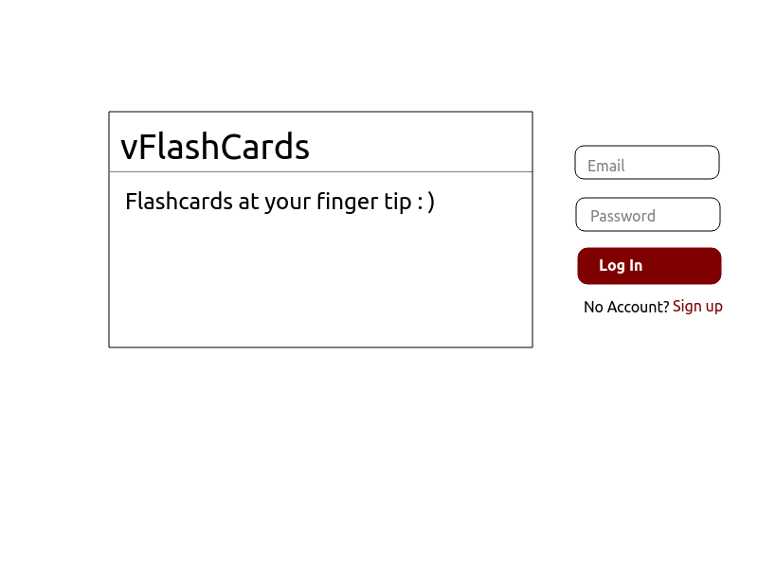
Sign up:
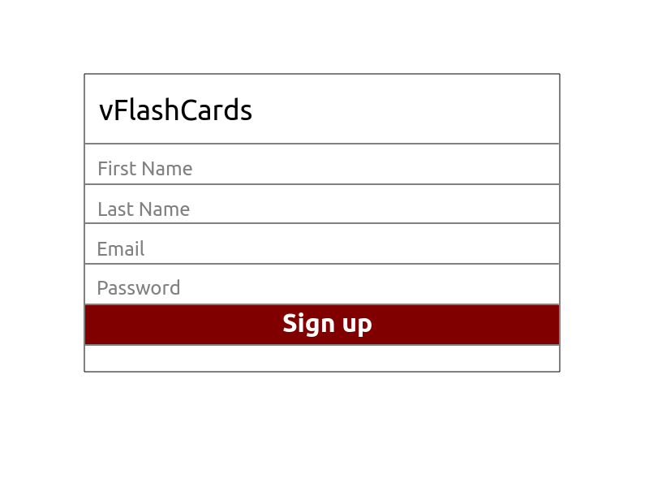

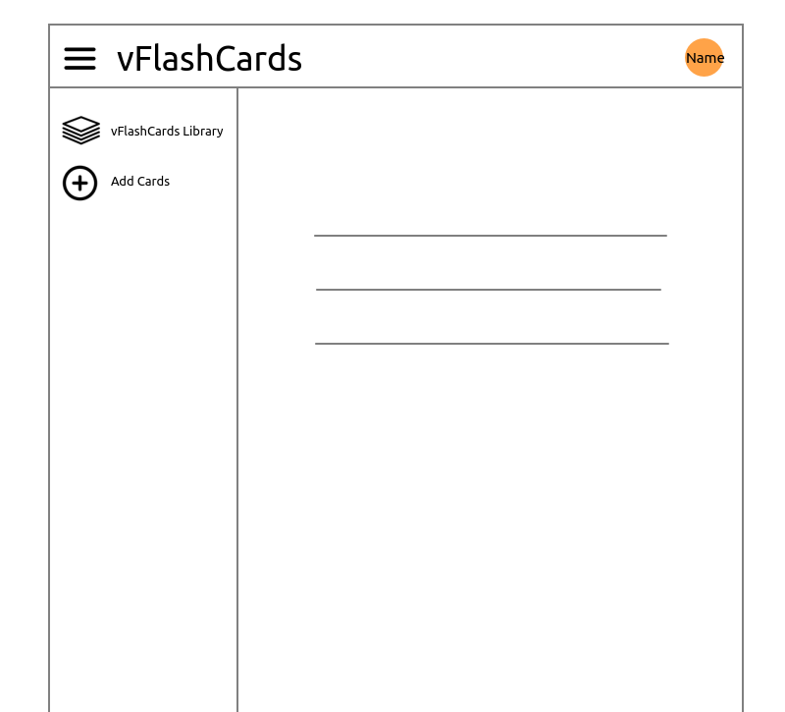
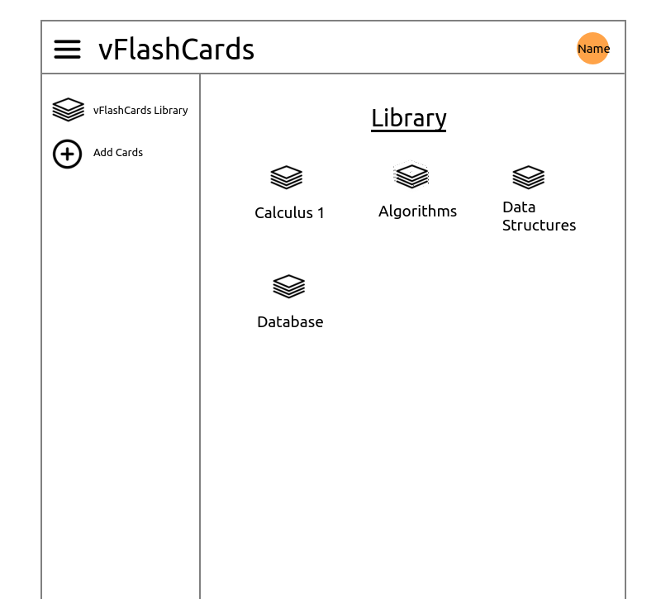
User profile page:
Flashcards library:
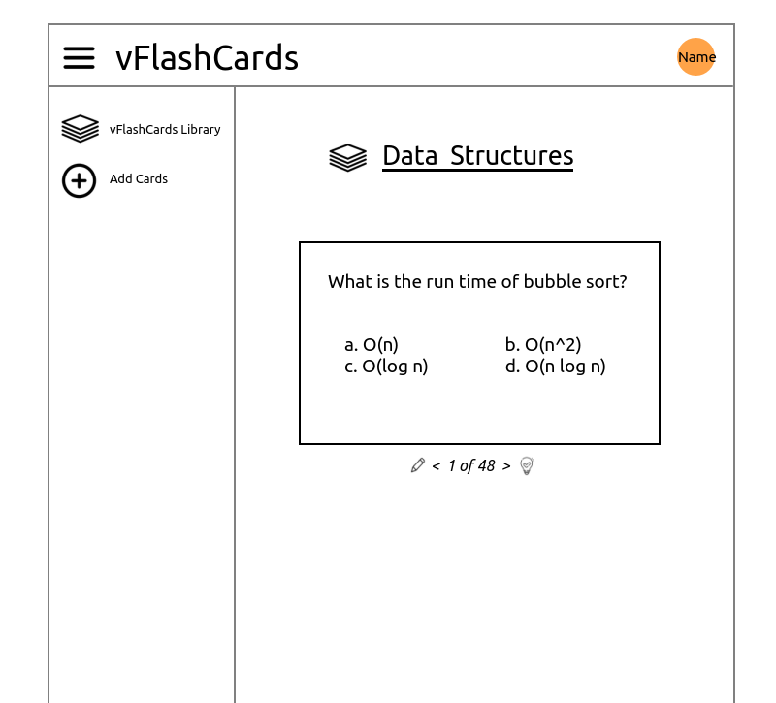
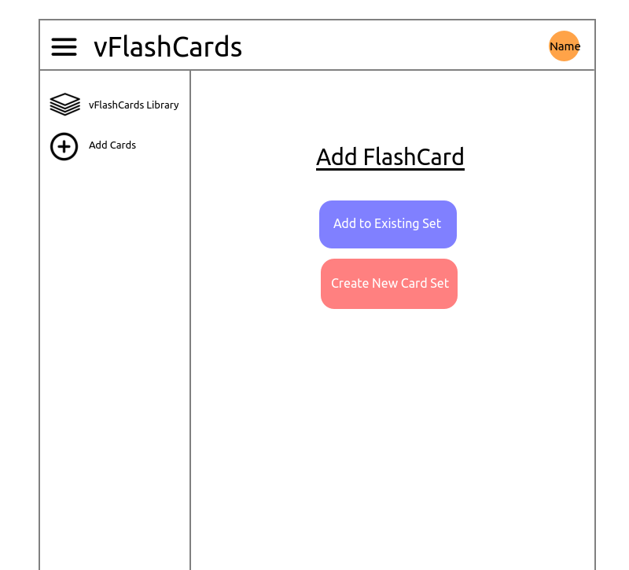
View of a flashcards set:
Add cards page-1:
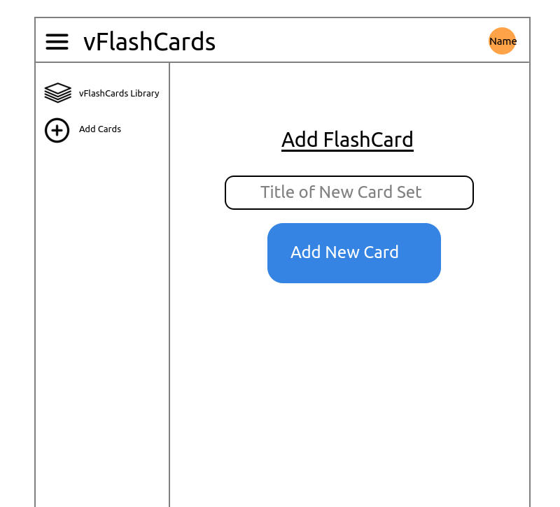
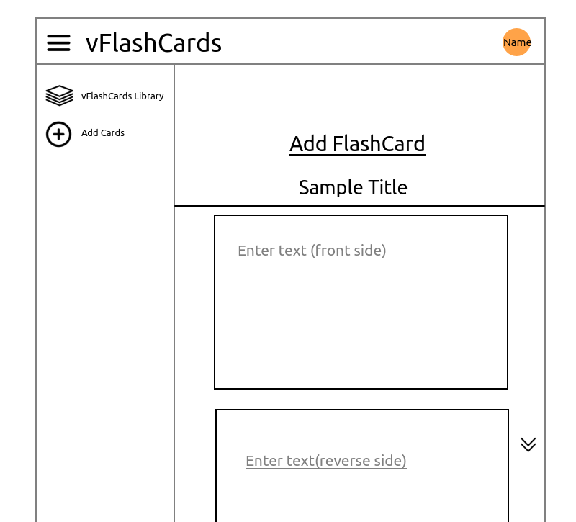
Add cards page-2:
Add cards page-3:
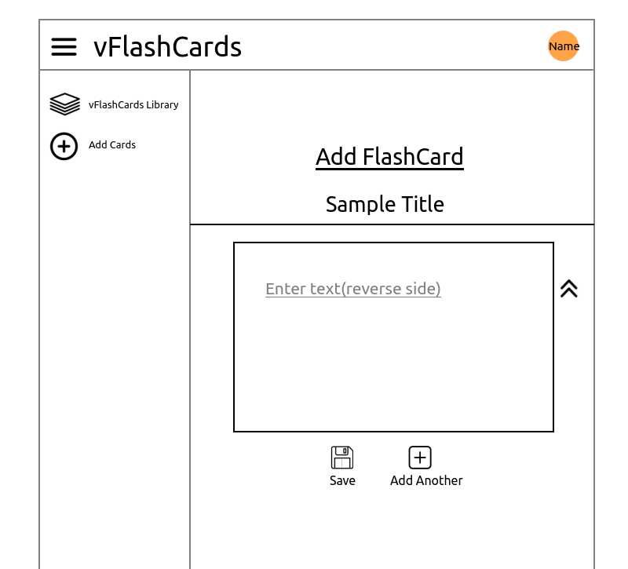
Add cards page-4:
ERD Diagram

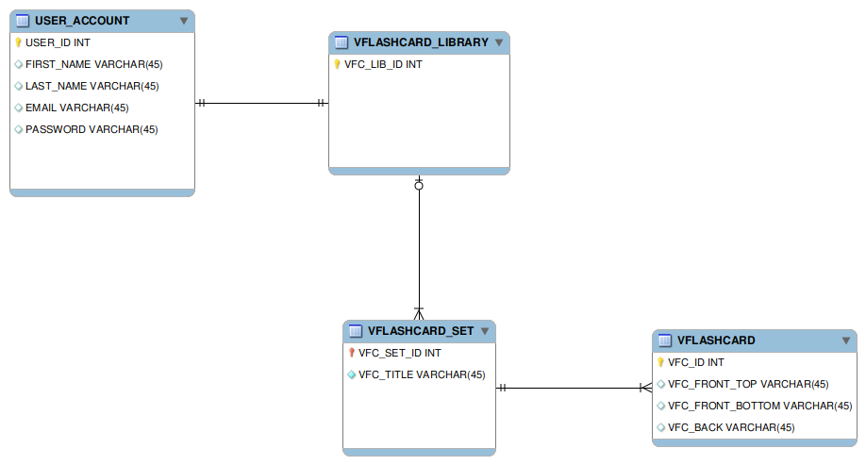
Sitemap

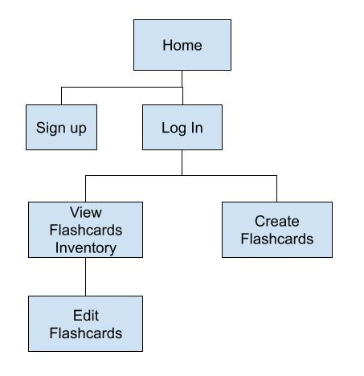

User Flow Chart

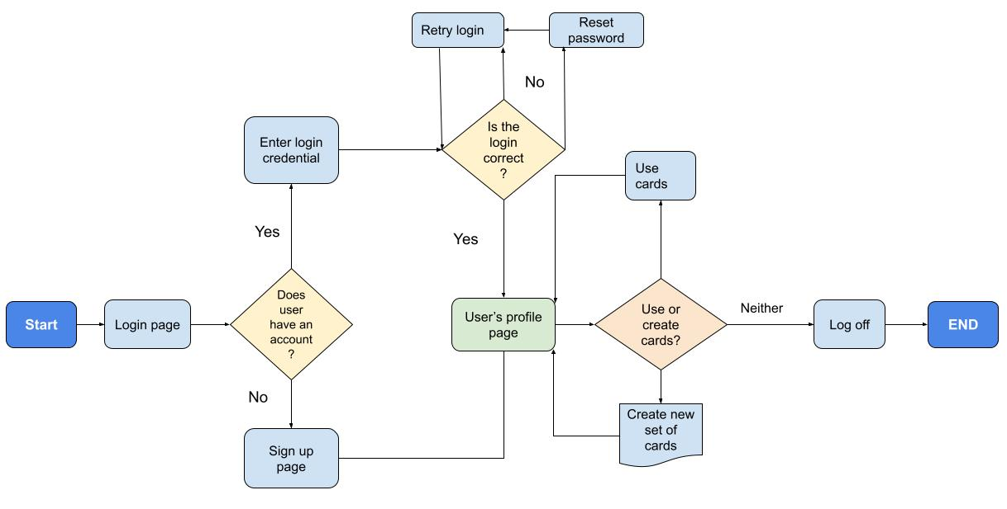
Tentative Schedule

Task | Description | Due Date
Research on the type of DB to use | Debate on whether to go with NoSQL or relational DB | 09/13/23
Refine the existing ERD model | Follow up during CTP office hours | 09/13/23
Refine user workflow | Refine the existing version as seen in initial design document | 09/17/23
Built out the backend | Using Express, NodeJS, DB (TBD) | 09/30/23
Built out the frontend | Using React | 10/15/23
Deliver minimum viable product |  | 10/30/23
Incorporate vFC sharing | Allow site members to share sets from their library | 11/15/23
Incorporate Deepl | Language translation (tentative) | 11/15/23
Incorporate localization | Tentative | 11/25/23
Incorporate internationalization | Tentative | 11/25/23

