Title
Integrating Machine Learning and High Fidelity Simulations for Design Insights in Bird Strike Impact on Aero Engine Blades.

Abstract

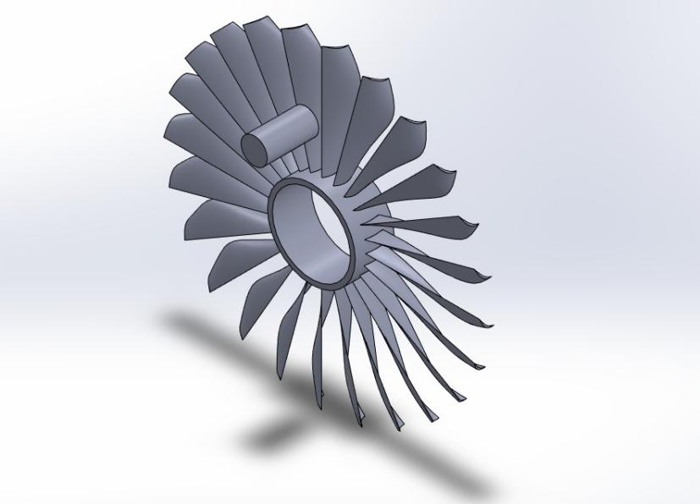
One of the leading and significant challenges in the aviation sector is Bird strike incidents, which remain a significant engineering and safety challenge, compounded by the high cost and risk of full-scale physical testing. This work presents a student-led computational approach that blends the advanced explicit dynamics simulations performed in Ansys with machine learning to accelerate design assessment and trend discovery. A numerical simulation of 50 high-fidelity simulations was performed following inputs from published journals using a detailed bird surrogate and super alloy blade model, with precise meshing and time convergence, along with mesh convergence studies, to confirm the reliability of stress and energy outcomes. Multiple ML algorithms, including Random Forest, were trained on this dataset along with hypertuning, revealing how impact velocity and rotational speed influence stress, deformation, and total energy. While small dataset size led to partial overfitting and elevated mean squared errors, the models accurately predicted general response trends and highlighted influential parameters. Comparative analysis across ML methods unveiled vital differences in sensitivity and prediction confidence, providing engineers with a practical guide for further simulation or experimental focus. This integrated workflow demonstrates how ML, leveraged alongside robust physics-based modeling, can guide rapid engineering decisions even with limited data, and lays the groundwork for more cost-effective, data-driven structural design in high-impact aerospace scenarios.
On the right you can see the cad model.
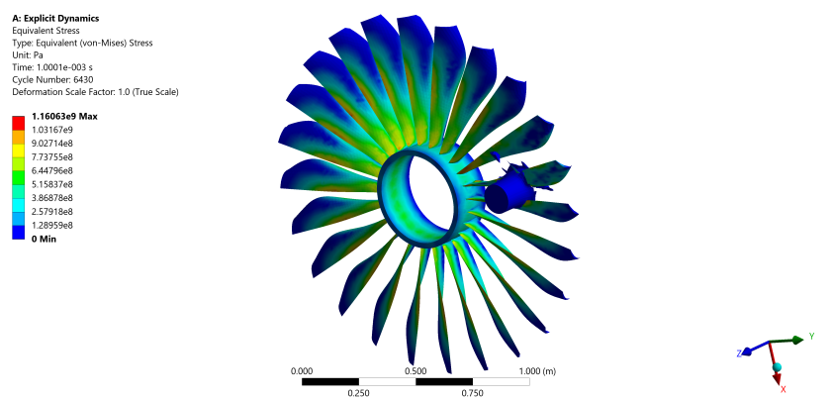
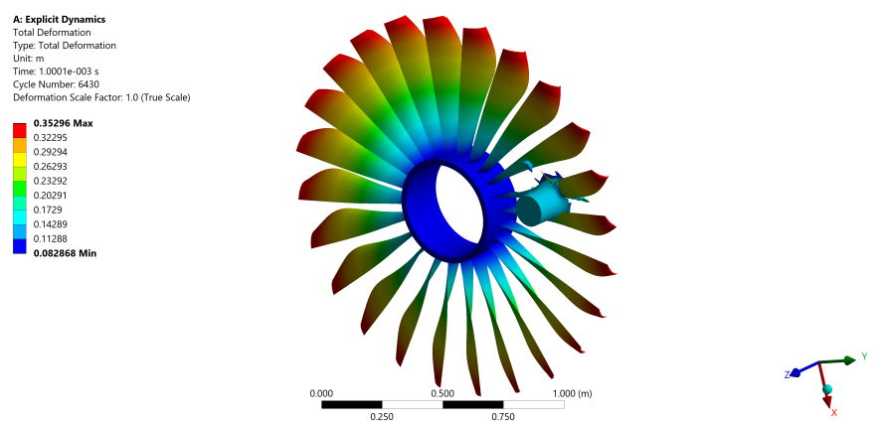
Now I am gonna do a mesh convergence study, it basically means I am gonna run the simulation with way finer mesh and if my error is within 5% than I wont need to go for a denser mesh. So I will run the mesh convergence study with 127.5 m/s and 405 rad/s blade speed and see what changes comes, so the current. mesh is on 15 mm element size, the bird is 10 mm element size. The current mesh is on (69,734 elements, 28,491 nodes). For mesh convergence we used 10 mm element size,nodes 60897 and elements 179018 we got the following results, Mesh convergence studies were conducted for the 127.5 m/s, 405 rad/s scenario, comparing 15 mm (69,734 elements) and 10 mm (179,018 elements) element sizes. Equivalent (von-Mises) stress and total internal energy deviated by less than 2%, confirming mesh independence for these metrics. Maximum deformation showed higher sensitivity, attributed to enhanced local detail at finer mesh. For the purposes of multi-case ML analysis, the 15 mm mesh was adopted as a compromise between accuracy and computational cost.

127.5 | 405 | 0.7665 m | 1.23580e9 pascal | 1.1046e+006 j

For time convergence, we decreased the time to 0.0005 sec, for 122.5 m/s and 395 rad/s
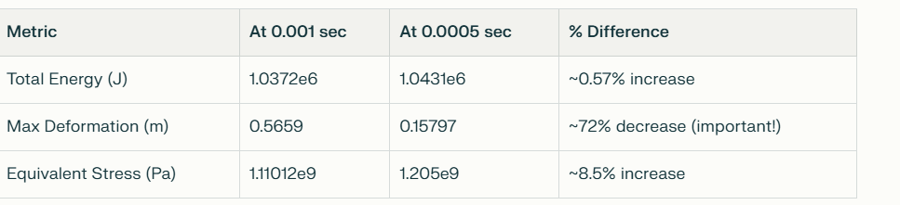

For time convergence, we increased the time to 0.002 sec,
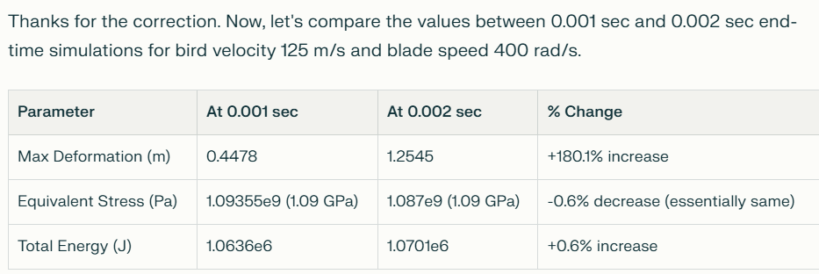
However, maximum deformation exhibited significant growth with increasing simulation time, illustrating sensitivity in capturing the full transient deformation behavior. Given computational resource constraints, an end time of 0.001 seconds was selected for the full parametric study encompassing 50 simulations. This duration reliably captures the primary mechanical response in stress and energy while offering a reasonable approximation of deformation, as supported by the convergence data.

This time convergence analysis demonstrates the trade-off between computational cost and result fidelity and justifies the simulation parameter choices deployed across the machine learning training dataset. It also provides transparent validation evidence increasing confidence in the numerical predictions reported herein.
Mesh convergence studies were conducted for the 127.5 m/s, 405 rad/s scenario, comparing 15 mm (69,734 elements) and 10 mm (179,018 elements) element sizes. Equivalent (von-Mises) stress and total internal energy deviated by less than 2%, confirming mesh independence for these metrics. Maximum deformation showed higher sensitivity, attributed to enhanced local detail at finer mesh. For the purposes of multi-case ML analysis, the 15 mm mesh was adopted as a compromise between accuracy and computational cost.
LAGRANGE METHOD
Bird Velocity(m/s) | Blade Velocity(rad/s) | Max Total Deformatn(m) | Equivalent Stress(pascal) | Total Energy(j)
- 122.5 | 395 | 0.5659 | 1.11012e9 | 1.0372e+006
- 125 | 400 | 0.4478 | 1.09355e9 | 1.0636e+006
- 127.5 | 405 | 0.3988 | 1.25407e9 | 1.0907e+006
- 130 | 410 | 0.4963 | 1.11352e9 | 1.1183e+006
- 132.5 | 415 | 0.4650 | 1.06826e9 | 1.1532e+006
- 135 | 420 | 0.50621 | 1.0594e9 | 1.1816e+006
- 137.5 | 425 | 0.41625 | 1.10006e9 | 1.2103e+006
- 140 | 430 | 0.38305 | 1.08187e9 | 1.2394e+006
- 142.5 | 435 | 0.48892 | 1.09486e9 | 1.2688e+006
- 145 | 440 | 0.35296 | 1.16063e9 | 1.2986e+006
- 147.5 | 445 | 0.76061 | 1.12349e9 | 1.3287e+006
- 150 | 450 | 0.39635 | 1.14517e9 | 1.3592e+006
- 152.5 | 455 | 0.60029 | 1.14662e9 | 1.39e+006
- 155 | 460 | 0.36903 | 1.15185e9 | 1.4212e+006
- 157.5 | 465 | 0.37158 | 1.14587e9 | 1.4527e+006
- 160 | 470 | 0.38606 | 1.15326e9 | 1.4846e+006
- 162.5 | 475 | 0.44295 | 1.16139e9 | 1.5168e+006
- 165 | 480 | 0.55854 | 1.16329e9 | 1.5494e+006
- 167.5 | 485 | 0.65193 | 1.20253e9 | 1.5823e+006
- 170 | 490 | 0.68982 | 1.17468e9 | 1.6156e+006
- 172.5 | 495 | 0.50075 | 1.16599e9 | 1.6492e+006
- 175 | 500 | 0.44730 | 1.16188e9 | 1.6831e+006
- 177.5 | 505 | 0.82909 | 1.16515e9 | 1.7175e+006
- 180 | 510 | 0.85871 | 1.17015e9 | 1.7521e+006
- 182.5 | 515 | 0.85152 | 1.16407e9 | 1.7871e+006
- 185 | 520 | 0.94336 | 1.1652e9 | 1822469.44140625
- 187.5 | 525 | 0.80794 | 1172436238.3958156 | 1858170.19140625
- 190 | 530 | 0.77349 | 1174123163.5999284 | 1894219.0078125
- 192.5 | 535 | 0.73607 | 1167648079.2648566 | 1930616.40625
- 195 | 540 | 0.82652 | 1196274811.1564751 | 1967361.375
- 197.5 | 545 | 0.83749 | 1180292244.7213781 | 2004454.3046875
- 200 | 550 | 0.82587 | 1276456096.7906036 | 2041895.5546875
- 202.5 | 555 | 0.92277473069178051 | 1178792222.4627416 | 2079684.7578125
- 205 | 560 | 0.787955945379701 | 1175218595.9657292 | 2117822.0390625
- 207.5 | 565 | 0.82459436778819384 | 1178381211.5972173 | 2156307.390625
- 210 | 570 | 0.95247144788733185 | 1195845862.3435593 | 2195140.8203125
- 212.5 | 575 | 0.919173974 | 1172689926.5645249 | 2234322.4453125
- 215 | 580 | 0.77146301 | 1172499537.5336812 | 2273852.0390625
- 217.5 | 585 | 0.71591403671914733 | 1210150901.8075297 | 2313729.8203125
- 220 | 590 | 0.72231391261502531 | 1178780355.9035897 | 2353955.5546875
- 222.5 | 595 | 0.73093463418271687 | 1185711324.8387303 | 2394529.7421875
- 225 | 600 | 0.87785320599767458 | 1216519296.5596054 | 2435451.8828125
- 227.5 | 605 | 0.75363880597643251 | 1206243281.4153361 | 2476721.9765625
- 230 | 610 | 0.785163090452137 | 1209173629.9159596 | 2518340.015625
- 232.5 | 615 | 0.76048124446770682 | 1192822274.7046404 | 2560306.25
- 235 | 620 | 0.83354339317818293 | 1200887273.8973596 | 2602620.453125
- 237.5 | 625 | 0.838493563850332 | 1213662519.5458395 | 2645282.59375
- 240 | 630 | 0.841253194076508 | 1226011904.0959656 | 2688292.9375
- 242.5 | 635 | 0.777805198655125 | 1218856324.1849694 | 2731651.484375
- 245 | 640 | 1.0181793696579502 | 1209563222.8181827 | 2819412.6875
- 247.5 | 645 | 1.2431670319254815 | 1308094278.7472045 | 2863815.3359375
- 250 | 650 | 1.3618396471791285 | 1222198217.9142339 | 2908566.4375
- 252.5 | 655 | 1.3881431717130182 | 1237863029.4198747 | 2953665.7421875
- 255 | 660 | 1.2847300941840265 | 1258754797.4050767 | 2999112.75
- 257.5 | 665 | 1.4739036314383869 | 1277017338.0310109 | 3044907.703125
- 260 | 670 | 1.402918272789671 | 1255395983.3742702 | 3091050.8671875
- 262.5 | 675 | 0.91684576183638777 | 1239806221.4704368 | 3137542.21875
- 265 | 680 | 1.0215943782723522 | 1238089426.1152575 | 3184381.28125
- 267.5 | 685 | 0.75420946155036883 | 1258339804.4869235 | 3231568.7890625
- 270 | 690 | 0.90895342690225678 | 1277399692.3427896 | 3279104.25
- 272.5 | 695 | 1.1088716081977228 | 1261827832.4405212 | 3326987.671875
- 275 | 700 | 1.0181793696579502 | 1209563222.8181827 | 2819412.6875

I have also collected 50 data sets for SPH method, which is not attached here as this is just the draft section to give you an idea sir.

