1. Implementation Logic
In this project, I implemented two distinct informed search algorithms to navigate a grid environment: A Search* and Greedy Best-First Search (GBFS). Both algorithms share a common foundation but differ in how they decide which path to explore next.
The Shared Engine: Priority Queue
Both algorithms use a data structure called a "Priority Queue." As the algorithm looks at neighboring grid squares (nodes), it calculates a score for each one. It places these nodes into the priority queue, which automatically sorts them so that the node with the best (lowest) score is always evaluated next.
Greedy Best-First Search (GBFS)
- How it works: GBFS is single-minded. It only cares about how close it looks to the goal.
- The Math: It uses the formula f(n) = h(n), where h(n) is the estimated distance (heuristic) from the current square to the target.
- Implementation: When expanding nodes, the algorithm calculates the Manhattan or Euclidean distance to the goal and pushes the nodes into the queue. It completely ignores how many steps it has already taken from the starting point.
A Search*
- How it works: A* is more balanced. It considers both the distance already traveled and the estimated distance to the goal.
- The Math: It uses the formula f(n) = g(n) + h(n) . Here, g(n) is the exact cost (number of steps) from the start to the current square, and h(n) is the estimated distance to the goal.
- Implementation: By adding the g(n) cost, A* ensures that if a path is getting too long, its total score will increase, prompting the algorithm to pause and explore other shorter, potentially better alternative routes in the queue.
Dynamic Obstacle Implementation
To handle dynamic re-planning, I integrated the obstacle generation directly into the search cycle. During the algorithm's execution, there is a random probability that a new wall will spawn on an empty grid space. Because the algorithms constantly check the validity of neighboring nodes before moving, they immediately detect if a newly spawned wall blocks their intended path. The priority queue then naturally skips the blocked route and falls back to evaluating the next best available node, effectively "re-planning" without needing to restart the entire search from scratch.

2. Pros & Cons (Based on Experimental Findings)
During the testing phase, observing both algorithms navigate various mazes and dynamic obstacles revealed clear strengths and weaknesses for each approach.

A* Search
Advantages:
- Optimal Results: The biggest advantage of A* is reliability. Because it tracks the cost of the path taken so far, it is guaranteed to find the absolute shortest path to the goal if one exists.
- Smart Backtracking: When faced with complex obstacles (like a dead end), A* handles it gracefully. It knows exactly when to stop pushing into a bad area because the path cost becomes too high, forcing it to look for better options elsewhere.
Disadvantages:
- Resource Intensive: A* explores uniformly. In an open space with no obstacles, it tends to expand heavily in all directions before locking onto the goal. This results in more "Visited Nodes" and requires more memory and computational time compared to GBFS.

Greedy Best-First Search (GBFS)
Advantages:
- High Speed: In simple environments or open grids, GBFS is incredibly fast. It makes a direct "bee-line" for the goal, expanding far fewer nodes than A* and requiring much less processing time.
Disadvantages:
- Sub-optimal Paths: Because it ignores the distance traveled, GBFS often creates longer, zig-zagging paths rather than the most direct route.
- Vulnerability to Traps: During testing, GBFS struggled significantly with "C-shaped" obstacles or concave walls. Because it only wants to move closer to the goal, it will dive deep into a trap and get stuck. It is forced to explore almost every node inside the trap before it finally gives up and routes around the outside, making it highly inefficient in complex mazes.

3. Test Cases (Visual Proof)
Based on the experimental runs, here is the breakdown of the best and worst-case scenarios for each algorithm.

A* Search Scenarios
Best Case Scenario: Complex Mazes and Traps
- Description: A* performs best when navigating environments with complex, deceptive obstacles like spirals or 'U'-shaped walls.
- Why: Because it calculates the total path cost using f(n) = g(n) + h(n) , A* recognizes when it is being led down a long dead end. The g(n) cost becomes too high, forcing the algorithm to abandon the trap and explore alternative, shorter routes. It reliably secures the optimal (shortest) path.
- 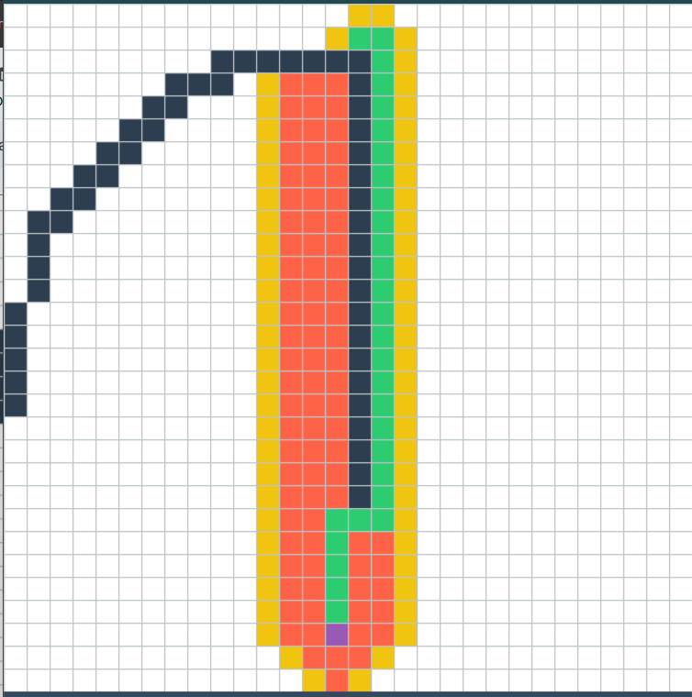
Worst Case Scenario: The Open Grid
- Description: The worst case for A* is an entirely open map with no obstacles.
- Why: A* explores uniformly. In an open field, it expands in a massive diamond or circular shape, checking almost every node around the start point before finally reaching the goal. This results in a massive number of "Visited Nodes" and slower execution times compared to a greedy approach.
- 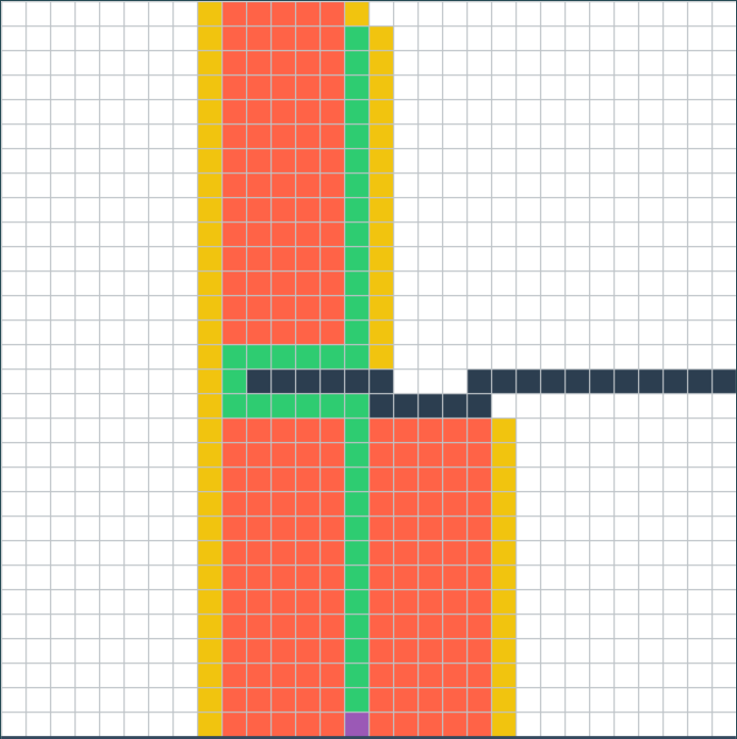

Greedy Best-First Search (GBFS) Scenarios
Best Case Scenario: Straight Paths and Open Grids
- Description: GBFS excels in open environments or simple mazes where the path to the goal is relatively unobstructed.
- Why: In our experimental findings, GBFS was incredibly fast. Because it only relies on h(n) (the estimated distance to the target), it makes a direct "bee-line" toward the goal. It expands a significantly lower number of nodes and computes the path in a fraction of the time it takes A*.
- 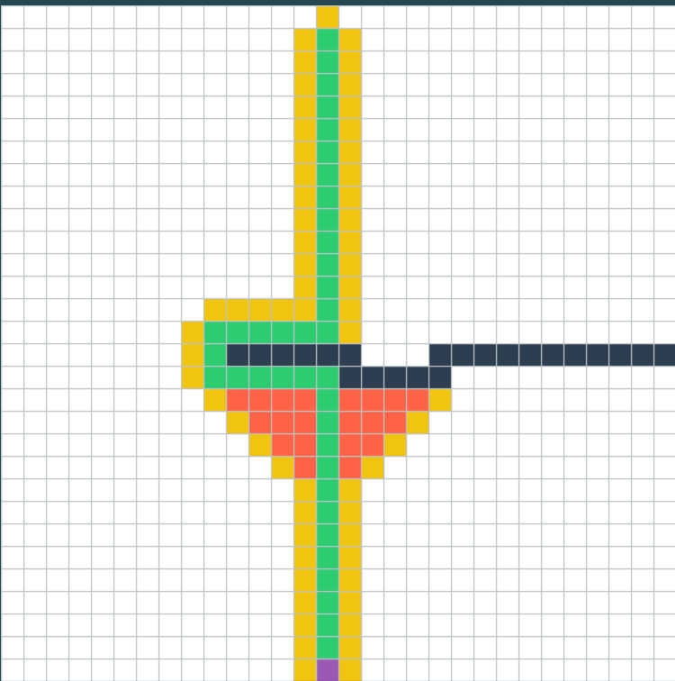
Worst Case Scenario: Local Optima (Concave Traps)
- Description: Theoretically and structurally, the worst case for GBFS is a deep concave wall (like a 'C' or 'U' shape) facing the start node.
- Why: GBFS suffers from "local optima" trapping. It pushes blindly toward the coordinates of the goal. When it hits a 'U'-shaped wall, the nodes inside the 'U' still appear to be the closest to the goal mathematically. Therefore, the algorithm gets trapped, heavily exploring the dead-end before it is finally forced to backtrack around the exterior walls. Additionally, the final path it generates is often sub-optimal and longer than necessary.
- 