## **sOut pus.CompanytomerID = o.C.CUrDate,c.CompanytomerID = o.C.CUQqqqqqqAQQQQQuestion 1: Write the input and output of the following program and explain answer**

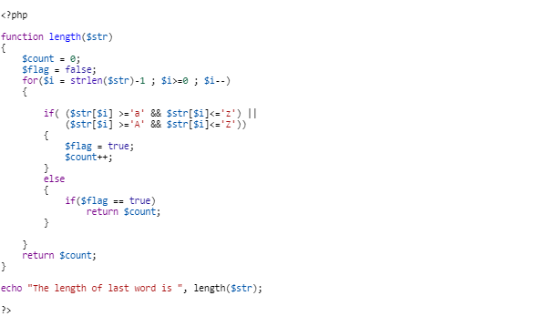

## **Answer :**

## **Question 2: Write a program/console that prints the numbers from 1 to 100 and for multiples of '3' print "Fizz" instead of the number and for the multiples of '5' print "Buzz".**

## **Output :**

## **Answer :**

## **Quesition 3: Write down the type of CSS position property?**

## **Answer :** static, relative, absolute, fixed, or sticky

## **Question 4 : What kind of type using in JavaScript and PHP ?**

**A . Dynamically Typed B. Statically Type**

## **Answer : A. Dynamically Typed, no need to compile, faster development, more flexibility.**

## **Question 5 : JavaScript is running on virtual machine ?**

**A . True B. False**

## **Answer : A . True, it is running on virtual machine also known as js engine, which embbed in browser.**

### **Question 6 : Write down some of the PHP Array Functions?**

## **Answer : There are many array functions in php. Following are commonly use – array_keys, array_values, array_merge, array_slice, array_splice, count, array_search, in_array, sort, rsort.**

### **Question 7 : Write the output of the following input**

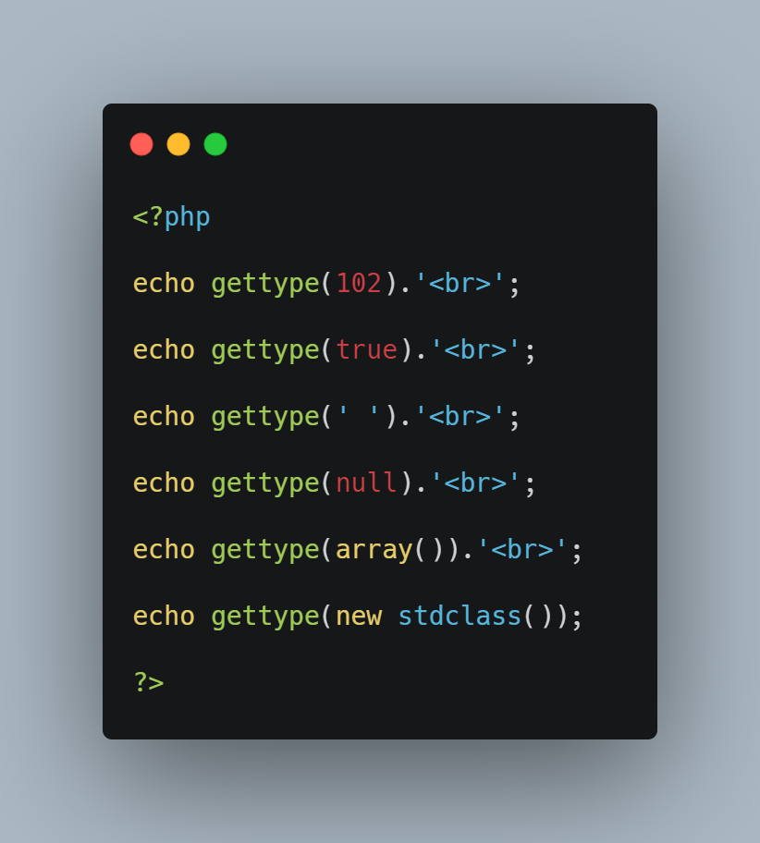

## **Answer : integer**

**boolean**

**string**

**null**

**array**

**object**

## **Question 8 : Select EmployeeID, OrderDate, CustomerName, ContactName, Address, ; from these two tables.**

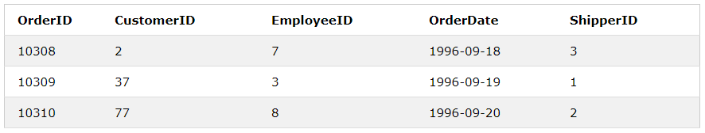

**Order Table**

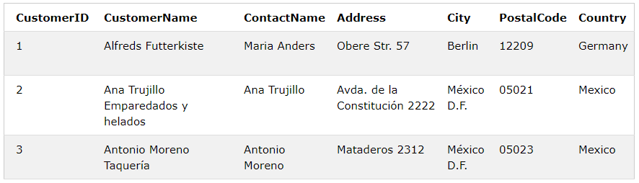

**Customer Table**

## **Answer :**

## SELECT Order.EmployeeID, Order.OrderDate, Customer.CustomerName, Customer.ContactName, Customer.Address

FROM Order

INNER JOIN Customer ON Order.CustomerID = Customer.CustomerID

## **Question 9: Write the output of the following code?**

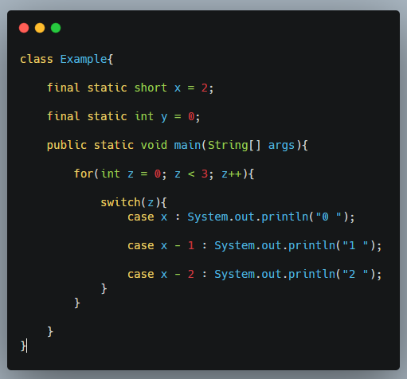

## **Answer: 2 1 0**

## **Question 10 : Choose the output of the following code and Explain the answer?**

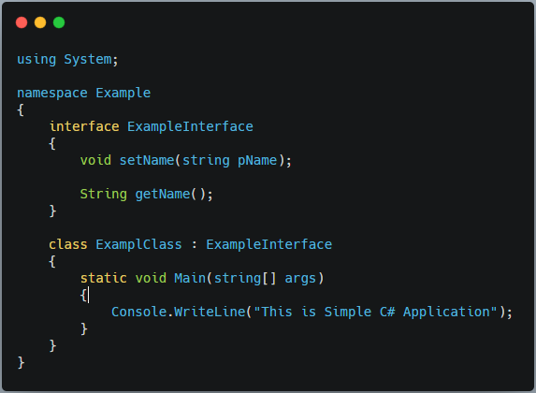

1. **“This is Simple C# Application”**
2. **“Compilation Error”**
3. **“Runtime Error”**
4. **“Other”**

**Answer : “This is Simple C# Application”;**

**Question 11: What is the virtual DOM? How does react use the virtual DOM to render the UI?**

**Answer : The virtual Document Object Model is a tree like javascript object structure. Use it to manipulate content, style and structure on client side web page in real time. In React, when state changes in component virtual DOM update the state and create new virtual tree structure. Then render to display updated UI to client side.**

**Question 12: What are the lifecycle methods in react and how they can use?**

**Answer : The lifecycle methods are use only in class base component which perform three phases in its lifecycle – mounting, updating and unmounting. Commonly Lifecycle methods are componentDidMount(), shouldComponentUpdate, componentDidUpdate() and componentWillUnmount.**

**componentDidMount() – this method called after the component is rendered or mounted to DOM also known as mounting phases. Used in sending network requests or updating the component's state.**

**shouldComponentUpdate() - we can use this method when to prevent re-render.**

**componentDidUpdate() - this method create and sending network request or calling state(this.setState) and make update component elements to DOM.**

**componentWillUnmount() - this method is final phase of lifecycle method, its makes removed component from DOM, canceling any network requests.**

**Question 13: What are the differences between controlled and uncontrolled components?**

**Answer : The differences between controlled and uncontrolled component is how to handle form or others action elements from client side in react. In controlled components value of form and others action elements are controlled by state. In uncontrolled components handle elements by event of function directly not by state.**

**Question 14 : Which method is the prevent re-render in React ?**

**Answer : In class component we can use returning false in shouldComponentUpdate() method to stop re-rendering and in functional componet we can use useMemo() method to prevent component re-render.**

**Question 15 : Please write down the demo version with your specialized language. Bussiness requirement will be following.**

**- Suppose you have finished a project! When your project is in training period, you have to make a ticketing system for a record history of feedback lists or bugs from client.**

**lists that should be included as hints**

**1. open a ticket from client side for the feedback**

**2. that ticket must be included issue type**

**3. which developers should be assigned that ticket**

**4. ticket status updating after issue was solved**