Sports Management System - User Manual

**Table of Contents**

1. Introduction 1

2. Project Setup 1

Dependencies 1

3. Running the Application 1

4. Features and Navigation 2

Home Page 2

Manage Students 2

Manage Sports Meetings 2

Manage Events 2

Manage Matches 2

Manage Records 2

Manage Judges 3

Manage Suspensions 3

5. File Structure Overview 3

6. Conclusion 3

# 1. Introduction

The **Sports Management System** is a web application designed to manage various aspects of sports events and activities, including students, meetings, events, matches, records, judges, and suspensions. This system is built using **Flask**, a Python web framework, and **MySQL** for database management.

# 2. Project Setup

To set up the project on your local machine, follow these steps.

#### Dependencies

This project uses the following Python libraries

* **Flask.** Web framework for Python.
* **Flask-Bootstrap.** Integrates Bootstrap with Flask for responsive web design.
* **mysql-connector-python.** To interact with the MySQL database.

A **requirements.txt** file is available to install these dependencies easily. Install the required by running “**pip install -r requirements.txt** “.

Ensure that MySQL is installed and running on your machine. Create a database in MySQL (e.g., sports_management) and configure it with the necessary tables (Students, Events, Matches, etc.).

# 3. Running the Application

Once the dependencies are installed and the database is set up, you can start the application.

1. **Start the Flask Server.** In the terminal, navigate to the project folder and run “python app.py” on terminal.

The application will run locally at **http://127.0.0.1:5000/**.

1. **Access the Application.** Open your web browser and go to the URL http://127.0.0.1:5000/ to start using the system.

# 4. Features and Navigation

#### **Home Page**

The home page of the Sports Management System welcomes the user with an overview of the system's purpose. From here, you can access the following sections:

#### **Manage Students**

* **Path:** /students
* This section allows you to manage student records.
* Add, update, view, or delete student information.

#### **Manage Sports Meetings**

* **Path:** /meetings
* This section allows you to manage sports meetings, including scheduling and organizing events.
* Create new meetings, update existing meetings, or view details.

#### **Manage Events**

* **Path:** /events
* Manage sports events such as matches, tournaments, and competitions.
* Add new events, update event details, and view events.

#### **Manage Matches**

* **Path:** /matches
* This section helps in managing sports matches, including setting up the schedule and tracking results.
* Create matches, assign judges, and track match results.

#### **Manage Records**

* **Path:** /records
* Manage records related to student achievements in sports, such as scores and rankings.
* View, add, and update student sports records.

#### **Manage Judges**

* **Path:** /judges
* This section allows you to manage judge information.
* Add, update, and view judges for various events and matches.

#### **Manage Suspensions**

* **Path:** /suspensions
* Manage suspensions for students who may have violated rules or regulations.
* Track and update suspensions, as well as view suspension details.

# 5. File Structure Overview

Here’s a breakdown of the folder and file structure in the **Sports Management System** project.

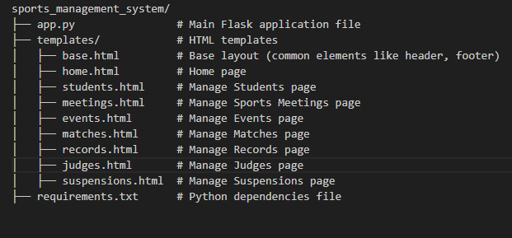

# 6. Conclusion

The **Sports Management System** is designed to help manage different aspects of sports activities efficiently. This user manual provides the necessary steps to set up, run, and navigate the application.