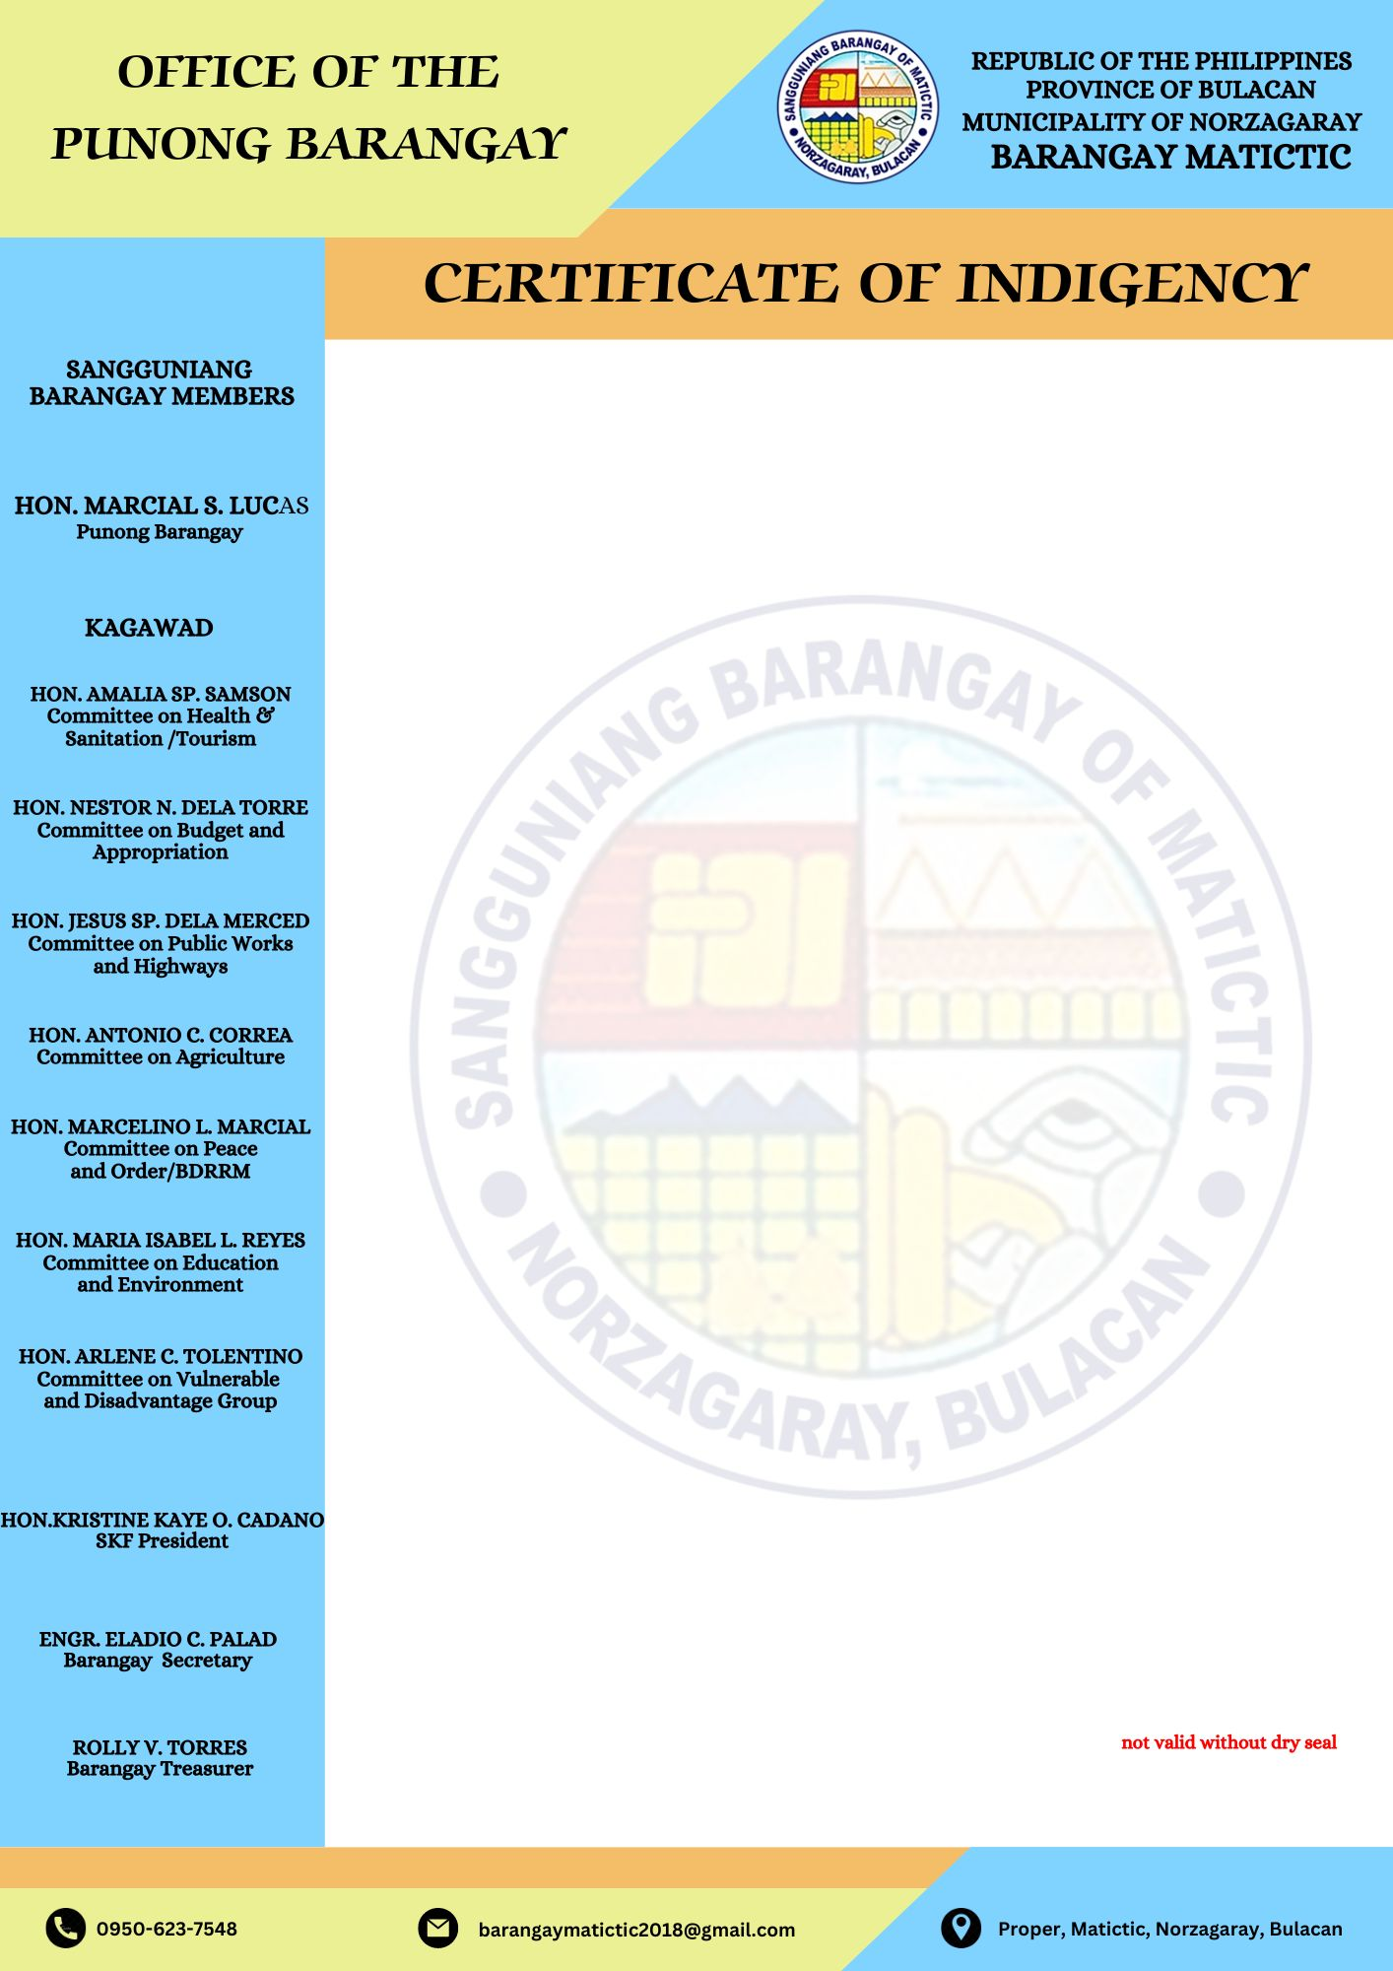

**TO WHOM IT MAY CONCERN;**

This is to certify that **${name},** is a bonafide resident of **${sitio}**, Barangay Matictic, Norzagaray, Bulacan.

This further certifies that he/she belongs to INDIGENT families in our Barangay.

This certification is being issued upon the request of the above mentioned-name for **${purpose}.**

Issued this **${date}** at Barangay Matictic, Norzagaray, Bulacan.

**MARCIAL S. LUCAS**

Punong Barangay

