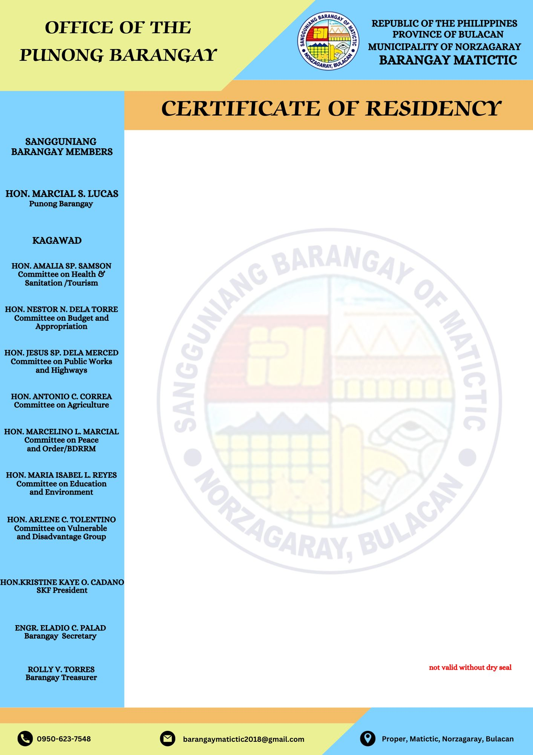

**TO WHOM IT MAY CONCERN,**

This is to certify that

${name}

of legal age**, ${civil_status}**, Filipino, is a bonafide resident of **${sitio}**, Barangay Matictic, Norzagaray, Bulacan since birth up to present.

This certification is being issued upon the request of the above- mentioned name to be used for legal intent or purpose it may serve him/her.

Issued this **${date}** at Barangay Matictic, Norzagaray, Bulacan.

**MARCIAL S. LUCAS**

Punong Barangay