TO WHOM IT MAY CONCERN;

This is to certify that **${name},** of legal age, **${civil_status}**, Filipino, is a bonafide resident of **${sitio}**, Brgy. Matictic, Norzagaray, Bulacan and that he/she has no derogatory/criminal records filed in this Barangay.

This Certification is issued upon his/her request for:

**${purpose}**

Issued this **${date}** at Barangay Matictic, Norzagaray, Bulacan.

**MARCIAL S. LUCAS**

Barangay Chairman

___________________

Signature of applicant

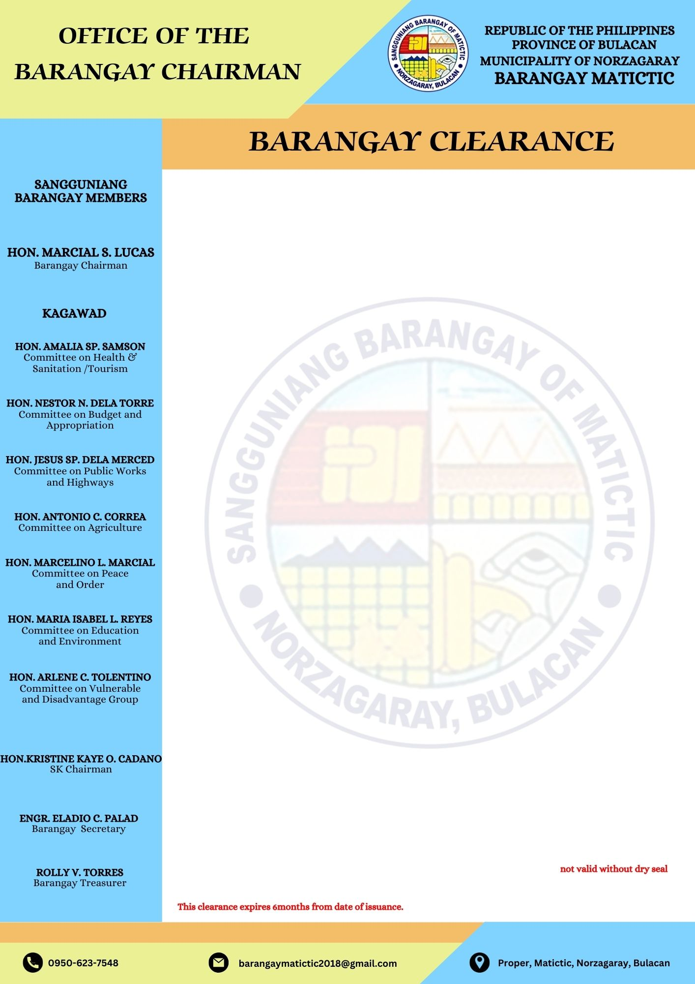

**CTC no. : 03711504**

**Issued at : Norzagaray, Bulacan**

**Issued on : August 27, 2025**