System Architecture
Overview
The proposed Barangay Online Document Request System (ReqMatic) utilizes a client–server architecture designed to streamline the process of requesting and processinng of barangay document requests. The system interconnects residents, barangay staff, and a central server with its database through a unified web platform accessible from any internet-enabled device. This architectural setup enables real-time communication between users and the system, ensuring that requests are processed efficiently and data remains consistent and secure.
By adopting this structure, ReqMatic simplifies the traditional manual method of document requests, reduces processing time, and minimizes human error. Residents can conveniently submit requests online, while barangay staff can approve, decline, and process resident’s document requests through their own interfaces. The server serves as the intermediary that processes all transactions and synchronizes data with the database, ensuring reliability, scalability, and transparency in barangay operations.
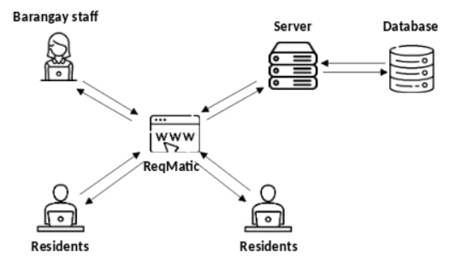
Figure ___. System Architecture
Figure __ illustrates the System Architecture of the Barangay Online Document Request System, ReqMatic. The architecture follows a client–server model, demonstrating how residents and barangay staff interact with the system via the web interface, while the server manages the system’s operations and communicates with the database. This design ensures efficient document request, processing of requests, secure data management, and convenient access for all users.
Residents: Represented at the lower section of the diagram, residents interact with ReqMatic using personal devices such as smartphones, tablets, or computers through a web browser. They can submit requests for various barangay documents, including Certificates of Indigency, Residency, Employment, and other official baranggay documents. Each request is securely transmitted to the server, ensuring data integrity and accessibility from any location with an internet connection. By allowing residents to make requests online, the system eliminates the need for physical visits to the barangay office, providing convenience and saving time.
Barangay Staff: Positioned at the upper left of the diagram, barangay staff members access the same web platform but with administrative privileges. Staff accounts enable them to manage incoming requests by verifying resident information, reviewing the submitted documents, updating the status of requests, and either approving or denying submissions. This interface allows staff to maintain organized records of all requests and ensures that processing is conducted efficiently and transparently.
ReqMatic (Web Interface): Serving as the central access point for all users, the web interface facilitates communication between clients (residents and staff) and the server. It captures user inputs, sends requests to the server, and displays real-time responses or notifications. The interface is designed to be user-friendly and responsive, ensuring seamless interaction regardless of the device used.
Server: Located at the center-right of the architecture diagram, the server functions as the backbone of the system. It handles critical operations, including authenticating users, validating requests, processing transactions, and managing communication between the frontend interface and the database. By centralizing these operations, the server ensures consistent performance, security, and reliability of the system.
Database: Connected directly to the server, the database stores all essential information required for system operation, such as resident profiles, document request records, processing logs, and system activity histories. Continuous two-way communication between the server and database allows for real-time retrieval, updating, and storage of data, ensuring data consistency and integrity. This integration supports tracking of pending, approved, and completed requests, helping barangay staff make informed decisions and maintain an organized workflow.
By integrating residents, barangay staff, the web interface, server, and database into a unified client–server architecture, ReqMatic improve the document request process, document request tracking, and promotes convenient document requests within baranggay Matictic. This architecture ensures that all interactions are secure, recorded systematically, and processed in a timely manner, ultimately improving the overall experience for both residents and barangay staffs.

Component Descriptions

1. User Interface (Frontend)
Implemented using React(Javascript). This layer serves as the presentation component of ReqMatic. It allows residents and barangay staff to interact with the system using any web browser. The interface provides forms for document requests, login pages for user authentication, and other document requests tabs for displaying request statuses.

2. Application Layer (Backend)
The backend, powered by Laravel(PHP), manages the system’s logic and processing. It receives user inputs from the frontend, validates data, executes queries, and returns the appropriate responses. This layer ensures smooth communication between users and the database while maintaining system integrity and security.

3. Database Layer
Implemented using MySQL, this layer is responsible for data storage, management, and retrieval. It keeps records of resident profiles, document requests, approval statuses, and transaction histories. Relationships between tables are maintained through primary and foreign keys, ensuring data consistency and traceability.

4. External Library
Future enhancements may include integration with external services such as:
- Google SMTP: used for all email notifications.

Technology Stack
Layer | Technology / Tool | Description
Frontend | React (Javascript), TailwindCSS,  ShadCN | Used to build the web interface and manage user interactions.
Backend | Laravel (PHP) | Handles request processing, system logic, and database communication.
Database | MySQL | Stores all system records, ensuring data integrity and fast retrieval.
Server Environment | PHP 8.3.6 | Hosts the system locally or online for user access.
Operating Environment | Linux: Ubuntu 24.04.3/ Web Browser | Provides the platform for system deployment and user interaction.

